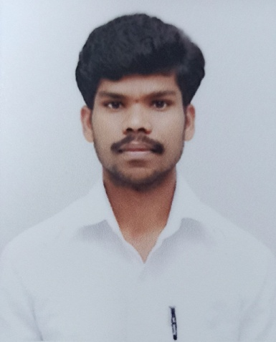**RESUME**

**NAME : HONNAPURADA RAMESHA**

**Mobile No : +91 9110485506**

**E-Mail :** **hrameshah57831@gmail.com**

**CAREER OBJECTIVE**

Aim to secure the position of **“Software Developer”** in your firm, where I can present and implement my innovative ideas and designs to develop the application for the company.

## EXPERIENCE:

Bachelor of Engineering **(BE in CSE-2021).**

* **Mindtree** || **JAVA FULL STACK DEVELOPER** || **June 2022 – (Present Working.)**

Bengaluru, Karnataka, India.

* **Jspiders Software Training Institute || JAVA FULL STACK DEVELOPER** JAVA Training and Development Center || **November 2021 – April 2022(6 months Training)**

Bengaluru, Karnataka, India.

* **Prinston Smart Engineers ||** INTERNSHIP Program **Machine Learning || March 1st to April 15th, 2021.(1.5 months Internship)**

Bengaluru, Karnataka, India

## TECHNICAL SKILLS:

* Programming Skills **: JAVA, AWS, DATA STRUCTURES AND ALGORITHMS, DATABASE, J2EE, HTML, CSS, JAVASCRIPT, MYSQL, JDBC, MYSQL, SPRINGBOOT, MICROSERVICESES, HIBERNATE, MONGODB, JUNIT, DOCKER, GIT, AJILE, JENKINS, REACT.**

## PROJECTS

* **HOSPITAL MANAGEMENT**

In a hospital There are many doctors are appointed Doctors can be categorized based on their specialist**. We use Java springboot microserviceses, Database Mysql, Angular, Junit, Jenkins, CSS Hrml,JavaScript, Hibernate.**

* **COLLEGE MANAGEMENT**

In a College there are many student are working, **We use Java springboot microserviceses, Database Mysql, postman, JPA.**

* **VEHICLE REGISTRATION**

Create a web based application for Vehivle registration.Once the vehicle will be registred it will show a successful message for registering vehicle. **We use Java springboot microserviceses, Database Mysql, Angular, Junit, Jenkins, CSS HTML ,JavaScript, Hibernate.**

## ACADEMIC PROJECT

* **A Reliable Communication model for machine-to-machine communication in marine environment.**

**Team Size**: 4members

**Technology Used**: Visual Studio code.

**Description:** In this project, the proposed model all about internet of ships. How the objects are interconnected.

* **SUB PROJECTS:**
* **CYBER CAFÉ MANAGEMENT SYSTEM:**

In Cyber Cafe Management System, we use PHPand MySQLdatabase. This is the project which keeps records of daily users of cyber cafe. Cyber Café Management System has one module i.e. admin.

* **APARTMENT VISITOR MANAGEMENT SYSTEM:**

In modern times where security becomes more & more challenging in most buildings, commercial complexes and residential apartments find it is mandatory to track visitors.

* **ONLINE JOB PORTAL:**

Online job portal is a **web** application built in PHP. It provides the candidates, ability to register to this application and search for jobs, manage their accounts. Each candidate will have an account with their own home page.

## EDUCATION AND QUALIFICATION:

* **Visvesvaraya Technological University(VTU)**

Government Engineering College Ramanagara

Bachelor of Engineering - BE, Computer Science and Engineering

CGPA : 7.33 (2017 - 2021)

* **Department Of Pre-University Education(DPUE)**

Morarji Desai Residential PU Science College, Davanagere, Karnataka

68% (2015 – 2017)

* **Karnataka Secondary Education Examination Board(KSEEB)**

Morarji Desai Residential School, Kannayakanahalli

81.76% (2015)

**INTERESTED ACTIVITIES AND PERSONAL SKILLS**

* Good Communication Skills
* Leadership Quality
* Coordinate well with Teams.
* Learning attitude with good perseverance and an agile learner.
* Trekking, Adjustable to any environment, participating in challenging tasks.

## CERTIFICATES:

* **JAVA FULL STACK**

JAVA | SQL | HTML | CSS | JavaScript | J2EE | Springboot | Hibernate| Microserviceses

Data Structures and Algorithms.

* **Prinston Smart Engineers**

INTERNSHIP Program **Machine Learning**

March 1st to April 15th, 2021.

Bengaluru, Karnataka, India

**PERSONAL DETAILS:**

* Date of Birth : 04th MAY 1999
* Marital Status : Single
* Gender : Male
* Nationality : Indian
* Languages known : English, Kannada, Hindi
* Address : VIjayanagara,Bengaluru, Karnataka,India,560040
* WEBSITE:Linkedin : [linkedin.com/in/h-ramesha-ram-60475a1b9](https://www.linkedin.com/in/h-ramesha-ram-60475a1b9)

## DECLARATION:

I declare that all the information mentioned here in my resume is correct and complete to the best of my knowledge and nothing has been concealed or distorted.

**Signature**

**Place** : Bengaluru (Honnapurada Ramesha)