Name: Himanshu Rana Date: 9/18/18

Pledge: “I pledge my honor that I have abided by the Stevens Honor System” – Himanshu Rana (hrana2)

Give the complexity of the following functions. Choose the most appropriate notation from among $Ο$, $θ$, and $Ω$.

1. **void** **function1**(**int** n) {

**for** (**int** i = 1; i <= n; i++) {

**for** (**int** j = i; j <= n; j += 2) {

cout << "*";

}

}

}

Answer: $θ$ (n^2)

1. **void** **function2**(**int** n) {

**int** count = 0;

**for** (**int** i = 1; i * i <= n; i++) {

count++;

}

cout << count;

}

Answer: $θ$ ($√n$)

1. **void** **function3**(**int** n) {

**int** count = 0;

**for** (**int** i = n/2; i <= n; i++) {

**for** (**int** j = 1; j + n/2 <= n; j++) {

**for** (**int** k = 1; k <= n; k *= 2) {

count++;

}

}

}

cout << count;

}

Answer: $θ$ (n^2(log(n)))

1. **void** **function4**(**int** n) {

**int** count = 0;

**for** (**int** i = n/2; i <= n; i++) {

**for** (**int** j = 1; j <= n; j *= 2) {

**for** (**int** k = 1; k <= n; k *= 2) {

count++;

}

}

}

cout << count;

}

Answer: $θ$ (n(log(n))(log(n)))

1. **void** **function5**(**int** n) {

**if** (n % 2 == 0) {

**return**;

}

**for** (**int** i = 1; i <= n; i++) {

**for** (**int** j = 1; j <= n; j++) {

cout << "*";

**break**;

}

}

}

Answer: $Ο$ (n)

1. **void** **function6**(**int** n) {

**int** count = 0;

**for** (**int** i = 1; i <= n/2; i++) {

**for** (**int** j = 1; j <= n/3; j++) {

**for** (**int** k = 1; k <= n/4; k++) {

count++;

}

}

}

cout << count;

}

Answer: $θ$ (n^3)

1. **void** **function7**(**int** n) {

**for** (**int** i = 1; i <= n; i++) {

**for** (**int** j = 1; j <= n; j += i) {

cout << "*";

}

}

}

Answer: $θ$ (nlogn)

1. **void** **function8**(**int** n) {

**int** i = 1, s = 1;

**while** (s <= n) {

i++;

s += i;

cout << "*";

}

}

Answer: $θ$ ($√n$)

1. Processing Arrays
   1. Suppose you have an unsorted array of integers of length $n$ and want to sum all the elements inside it. What is the running time of your algorithm? → $θ$**(n)**
      * To get the sum of all the integers you have to go through the entire array
   2. Suppose you have an unsorted array of integers of length $n$ and want to determine if all the values inside are positive. What is the running time of your algorithm? → $Ο$**(n)**
      * The best case scenario is that the first element in the array is negative and get out of the algorithm
   3. Suppose you have a sorted array of integers of length $n$ and want to determine the median value. What is the running time of your algorithm? 🡪 **(1)**
      * Because the array is already sorted all the algorithm has to do is divide n by 2 and add the two numbers up and then divide that by 2 (if n/2 is odd)
2. **T🡪** T / F $f\left(n\right)=3n^{2}+4n+2 ∈ θ\left(n^{2}\right)$

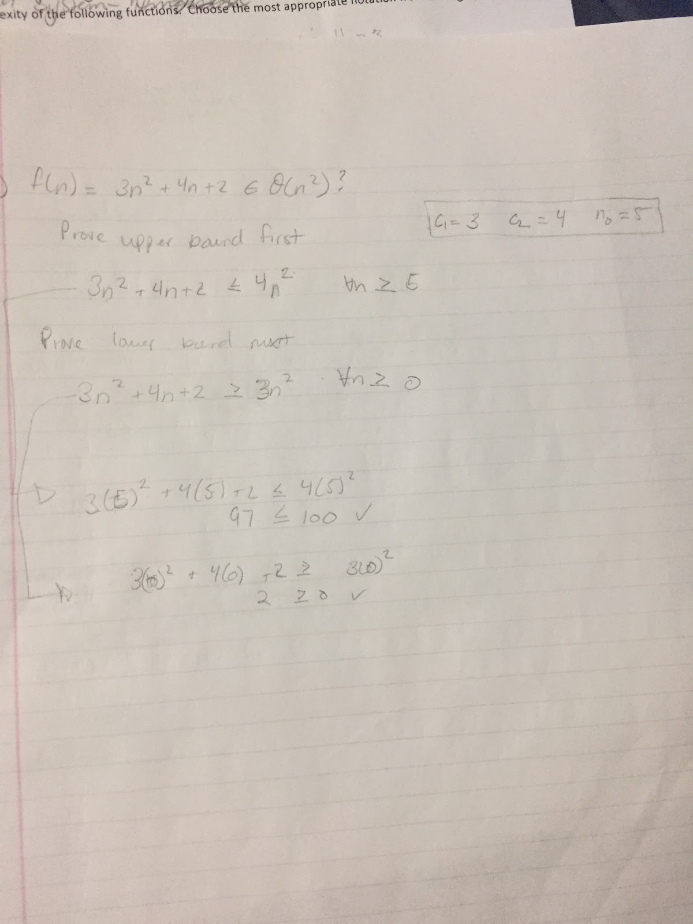If true, prove it by giving *integral* values for the required constants $c_{1}$, $c_{2}$, and $n_{0}$. Choose the tightest values possible for the $c_{1}$ and $c_{2}$ constants. If false, show the contradiction.

$c_{1}$ = 3

$c_{2}$ = 4

$n_{0}$ = 5