## Coding Standards

1. Each method/function should be small (5-10 lines at most). This will help to avoid any unnecessary design errors and easy to cover with Unit Tests
2. Each method/function should be performing 1 action. If the function is performing more than 1 action, refactor it into 2 different methods.

## GIT Config

1. Run the following command on your VM in the project directory
   1. git config --global credential.helper 'store --file ~/.my-credentials'
2. After this, run ‘git pull’. It will prompt for your username/password and store those in a file
3. From now on, you won’t have to enter your credentials every time you do a pull or commit.

## Merge Request (MR or PR-Pull Request) Standard

1. Create a new branch from main branch of the project.
2. Make your changes, and push it to your branch
3. When you’’ push your changes, Gitlab will show a button to ‘Create Merge Request’(figure1)
4. Create a MR(Ensure your destination branch is main branch of our project see figure 2 for wrong destination)
5. Click on ‘Change Branches’ and choose the correct destination branch(see figure 3 for correct destination)
6. Assign it to other team members and send a text in the group chat.
7. Wait for their approval before merging the request.
8. Keep your MRs small so that it’s easy for others to review. It means, do not change too many things in the same MR. If you want to change functionality at different places, create different branches and MRs

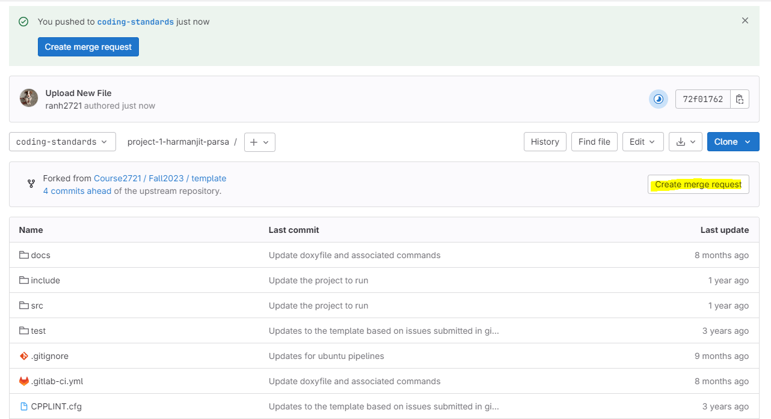

Figure 1

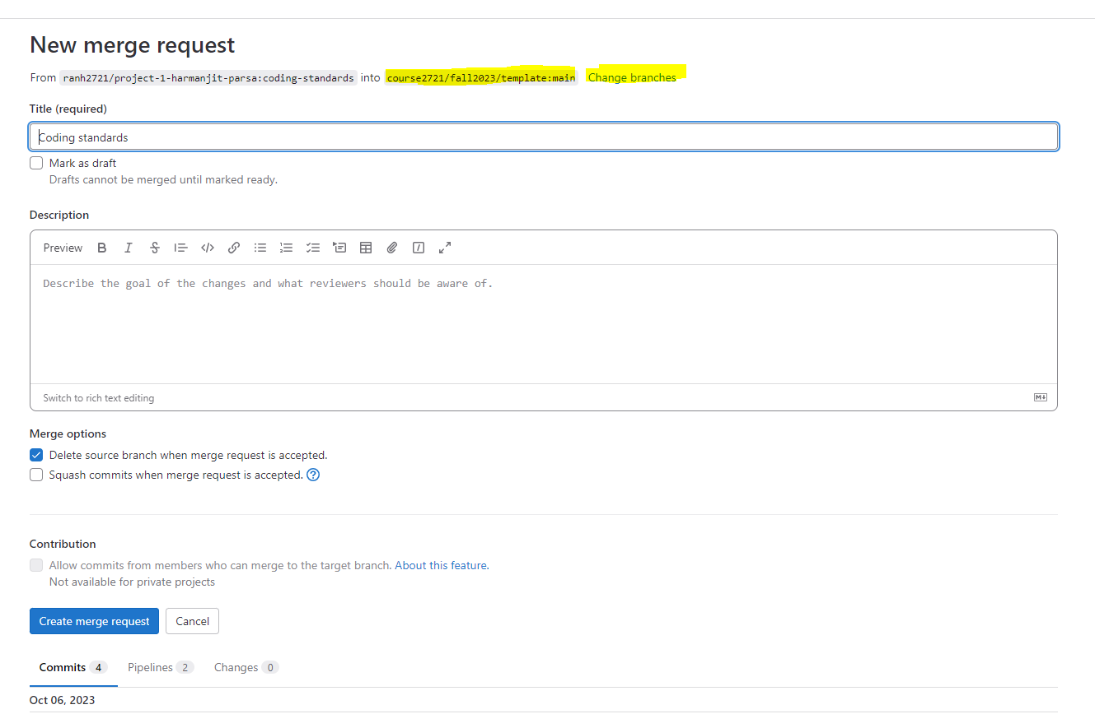

Figure2

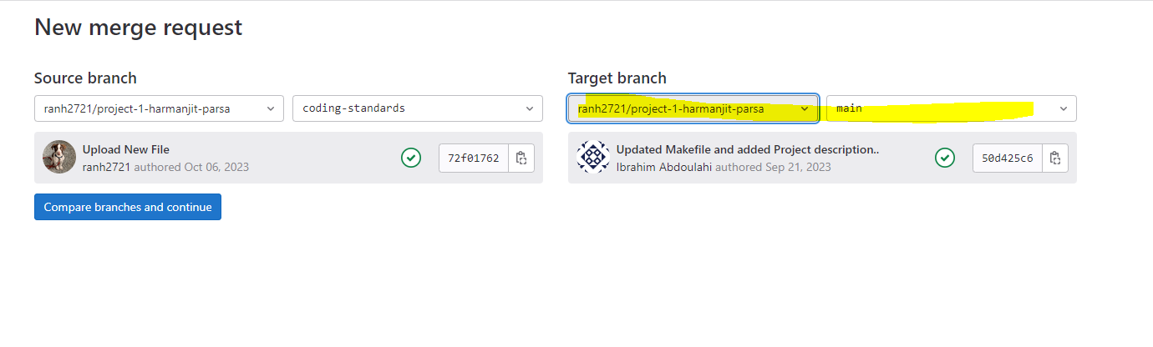

Figure 3