# Algorithm for file updates in Python

## Project description

This document outlines a general-purpose Python algorithm to read and update the contents of a file. The full algorithm is detailed [in this Python file](https://drive.google.com/file/d/11BhipHrC5x2N-Qv27LZm8POL9yW-mOjB/view?usp=sharing).

## Open the file that contains the allow list

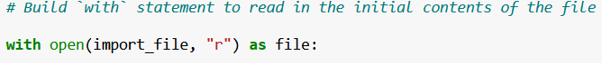

## Read the file contents



## Convert the string into a list

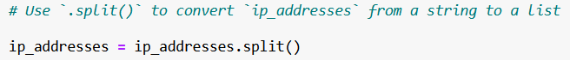

## Iterate through the remove list

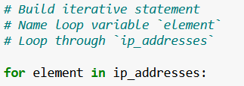

## Remove IP addresses that are on the remove list

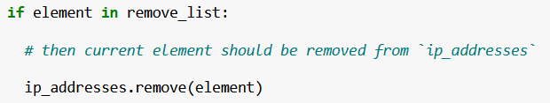

## Update the file with the revised list of IP addresses

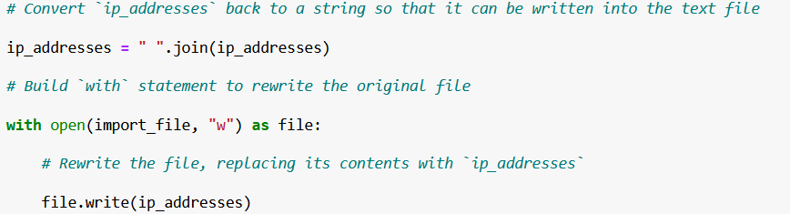

## Summary

The above code snippets show how a general-purpose file update algorithm can be created using Python to automate the update process of an example allowlist.