D210: Representation and Reporting

Hannah R. Bergman
ID: 001539744
WGU Email: hbergm3@wgu.edu
Table of Contents
Part 1: Data Dashboard & Storytelling 2
A1. Tableau Dashboard 2
Datasets 2
Data Representations 3
Interactive Controls 5
Custom Metrics 5
A2. Data Sources 6
Internal Dataset Source - wgu_churn_data.csv 6
External Dataset Source - Telco-Customer-Churn.csv 6
A3. Dashboard Installation Instructions 6
A4. Story & Dashboard Navigation 8
Part 2: Storytelling with Data 13
B. Panopto Presentation 13
My Introduction 13
Data Set Summary 13
Key Results from Analysis (including Data Representations) 13
Actionable Insights Summary 15
Part 3: Reflection Paper 16
C1. Dashboard Purpose & Function 16
C2. Dataset Insights 16
C3. Data Representations - Decision-Making 16
C4. Interactive Controls 17
C5. Accessibility Considerations 18
C6. Data Representations - Story-Telling 19
C7. Audience Analysis 20
C8. Universal Access 21
C9. Elements of Effective Storytelling 21
D. References 22

Part 1: Data Dashboard & Storytelling

A1. Tableau Dashboard
Link to public Tableau Dashboard: https://public.tableau.com/app/profile/hannah.bergman6783/viz/D210Task1TelecommunicationsAnalysisComparison/Analysis#1

The dashboard is also attached as the file:
hrbergman_d210_task1.twbx

Datasets
Our analysis makes use of two datasets:
- Internal Dataset: wgu_churn_data.csv
The initial dataset used in this analysis is the 'churn_clean.csv', obtained from the D210 Representation and Reporting Data Files and Associated Dictionary Files provided by Western Governors University. This dataset comprises 9,769 customer records from within our organization, reflecting our specific customer population.

- External Dataset: Telco-Customer-Churn.csv
The second dataset, ‘Telco-Customer-Churn.csv', was acquired from Kaggle. This dataset contains information about a competing telecommunications company, Telco, which provided home phone and internet services to 7,043 customers (IBM, 2019). This dataset aligns with our own in terms of the factors used to measure customer churn, facilitating a direct comparison.

Dataset Cleaning & Preparation
To ensure data quality and consistency, the datasets underwent data cleaning and transformation using Jupyter Notebook. The detailed pre-processing steps are outlined below. Due to the rubric's instructions to exclude .ipynb files, the Jupyter Notebook code is not included. Once the individual datasets were processed, they were merged into a single file named 'combined_churn_data.csv,' which serves as the data source for the Tableau dashboard.

Column Removal
Some alterations needed to be made to both datasets to better format them for our analysis. The initial datasets were reduced into smaller subsets, with some columns being changed or entirely removed to ensure both datasets were suitable for exact side-by-side comparison

Column Renaming
To adhere to standard, pythonic naming conventions (maintaining lowercase and separating words by underscores), I updated both the WGU and Telco churn dataset labels. For example, ‘CaseOrder’ was updated to become ‘case_order’.

Value Adjustments
- Marital: Within the marital status column of the WGU churn set, we have values indicating whether customers are ‘Divorced’, ‘Widowed’, ‘Never Married’, ‘Separated’ or ‘Married’. Since the Telco churn dataset only measures whether someone is in a domestic partnership or not, I chose to remap these values with ‘Married’ remapped to ‘Yes’ to indicate domestic partnership and the other values remapped to ‘No’.
- Children: The WGU dataset records the exact number of children in a customer's household instead of the number of dependents. To account for this, I created a new ‘Dependents’ column for the WGU dataset which marks a value of ‘Yes’ if a customer has more than 1 child and ‘No’ for childfree and childless homes.
- Tenure: There’s an excessive amount of precision for tenure in the WGU churn dataset so I rounded down tenure precision and changed these floats to integers to better match the ‘tenure’ column in the Telco churn dataset.
- MonthlyCharge: There was also excessive precision in the MonthlyCharge column of the WGU churn dataset, which I rounded down to two decimal places to match the Telco churn dataset.
- Dataset: To differentiate between the two combined datasets in the newly created file, a new column named 'dataset' was added to each dataset.

Data Representations
Data Representation #1: Side-by-side Bar Charts
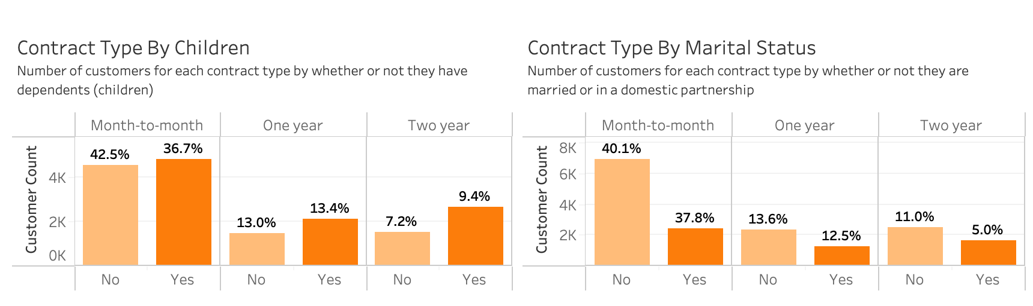
Data Representation #2: Treemap
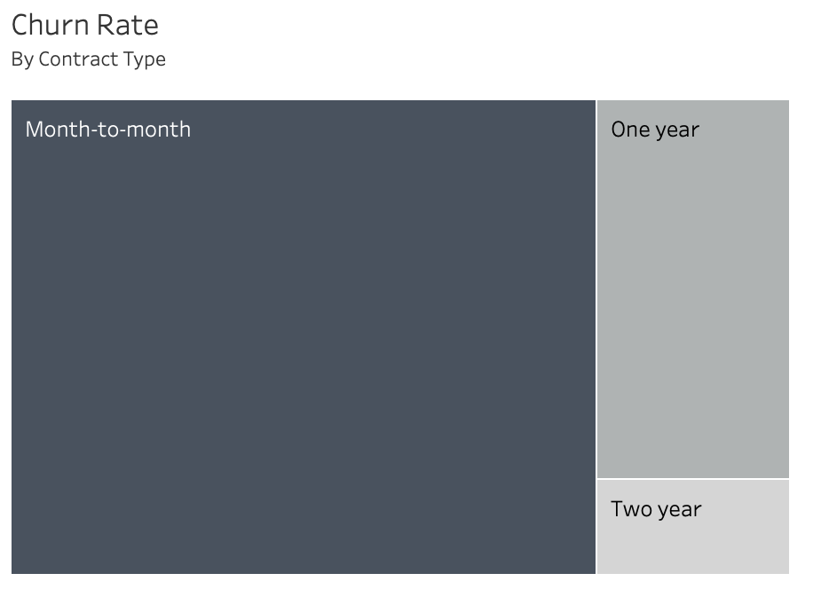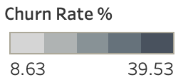

Data Representation #3: Stacked Bar Chart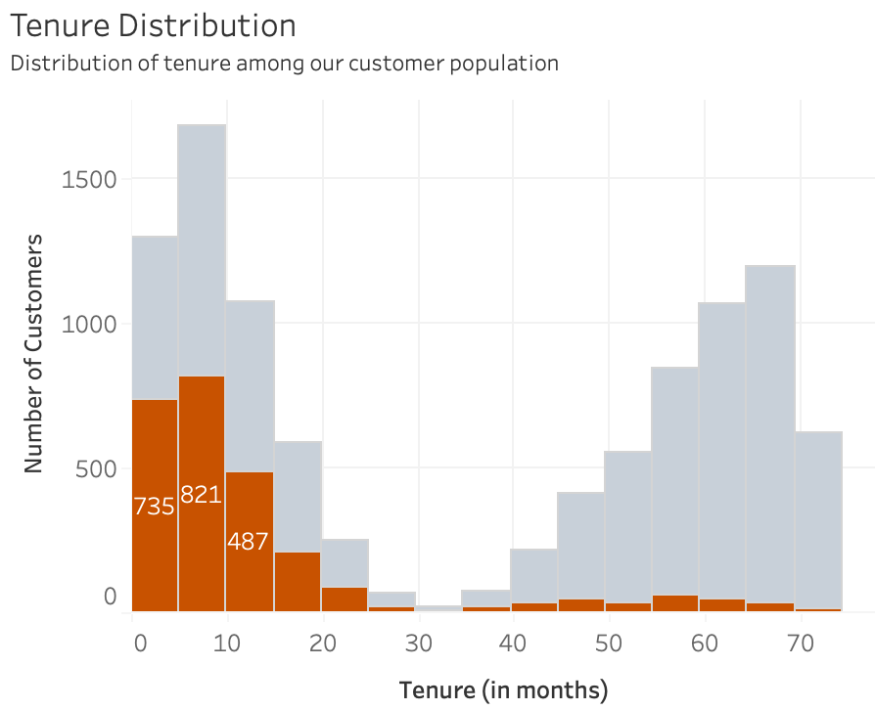

Data Representation #4: Pie Charts
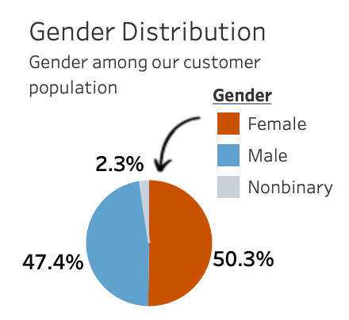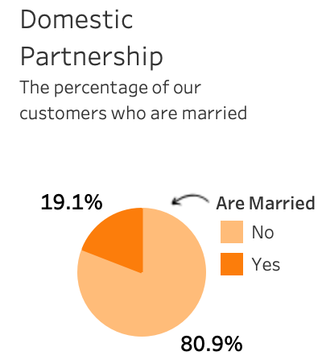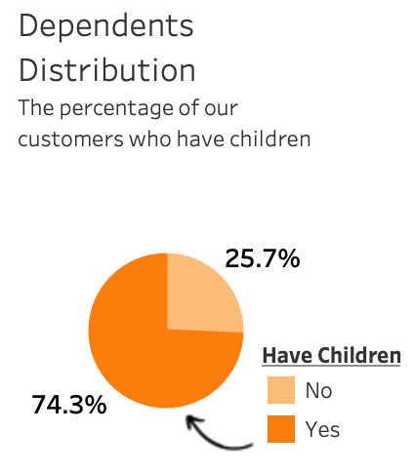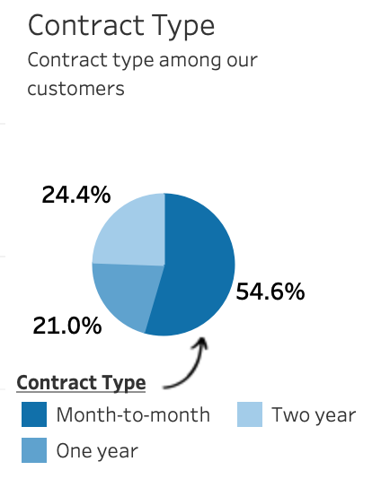

Data Representation #5: Horizontal Bar Chart with Reference Lines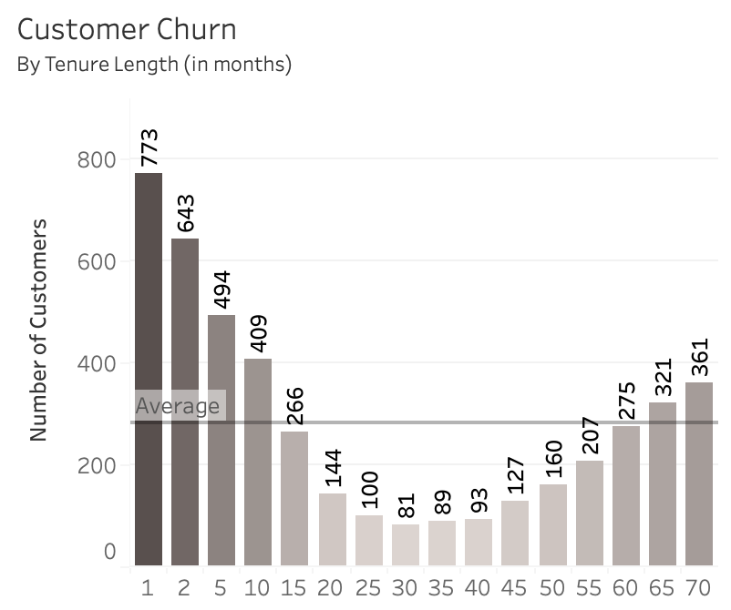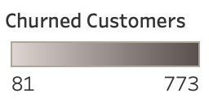
Data Representation #6: Text Tables
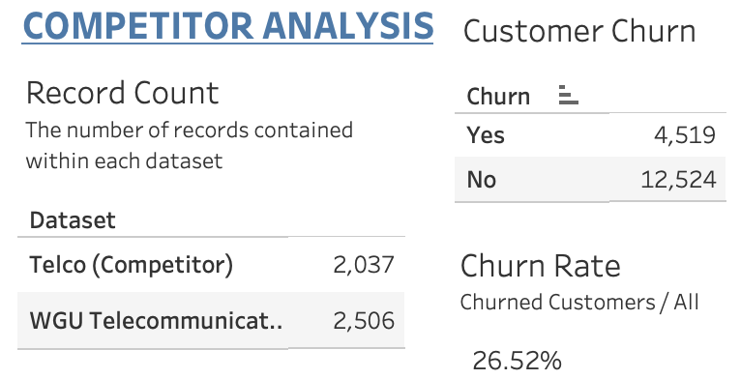

Data Representation #7: Highlight Tables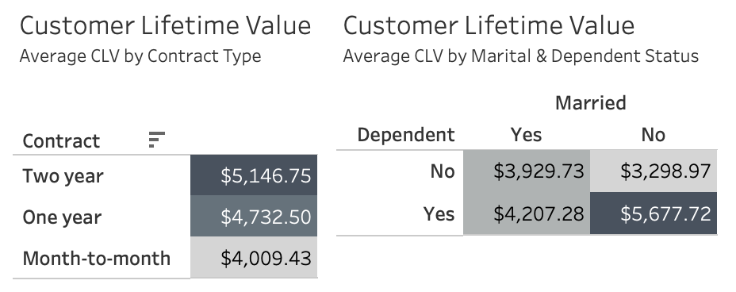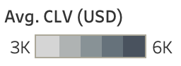

Interactive Controls
Interactive Control #1: Radio Button
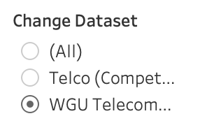
Interactive Control #2: Dropdown Menu
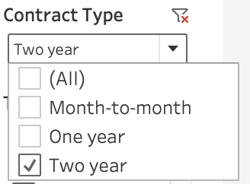

Custom Metrics
Metric #1: Churn Rate
To effectively measure our customer retention efforts, I calculated the Churn Rate using both our customer and external data. This metric was manually calculated by dividing the number of customers who canceled their service (indicated by 'Yes' in the 'Churn' column) by the total number of customers and multiplying the result by 100 to get a percentage (Barron, 2023).
The Churn Rate calculation is dynamic and automatically adjusts based on the selected dataset filter. For instance, when you choose 'WGU' from the radio button list, the Churn Rate will display as 26.50%. Conversely, selecting 'Telco' will reveal a Churn Rate of 26.54%.
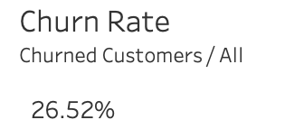

Metric #2: Customer Lifetime Value (CLV)
To assess the average value of customers across both datasets, I calculated Customer Lifetime Value (CLV) using a manual approach. As with Churn Rate, I implemented this calculation within Tableau by creating a Calculated Field. This field multiplies 'monthly_charge' by 'tenure' and calculates the average of the resulting values. This method allowed me to determine the average CLV based on contract type, marital status, and dependent status.
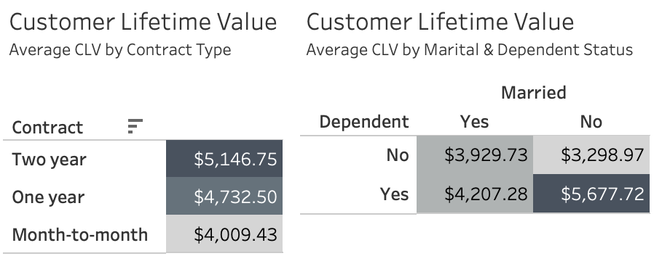

A2. Data Sources

Internal Dataset Source - wgu_churn_data.csv
Western Governors University. (2023). Churn Data and Dictionary Files. D210 Data Files and Associated Dictionary Files. [Dataset].
Retrieved October 16, 2024, from
https://access.wgu.edu/ASP3/aap/content/g9rke9s0rlc9ejd92md0.html

External Dataset Source - Telco-Customer-Churn.csv
Blastchar. (2017). Telco Customer Churn. [Dataset]. Kaggle.
Retrieved October 16, 2024, from
https://www.kaggle.com/datasets/blastchar/telco-customer-churn

A3. Dashboard Installation Instructions
For easy access, our dashboard is available publicly via Tableau Public.
No third-party software installation is needed.

Simply click this link or copy and paste the following web address into your web browser (Google Chrome, Apple Safari, Mozilla Firefox, or Microsoft Edge) to view the dashboard: https://public.tableau.com/app/profile/hannah.bergman6783/viz/D210Task1TelecommunicationsAnalysisComparison/Analysis#1

Once you visit that web address, you should see a page that looks like this:
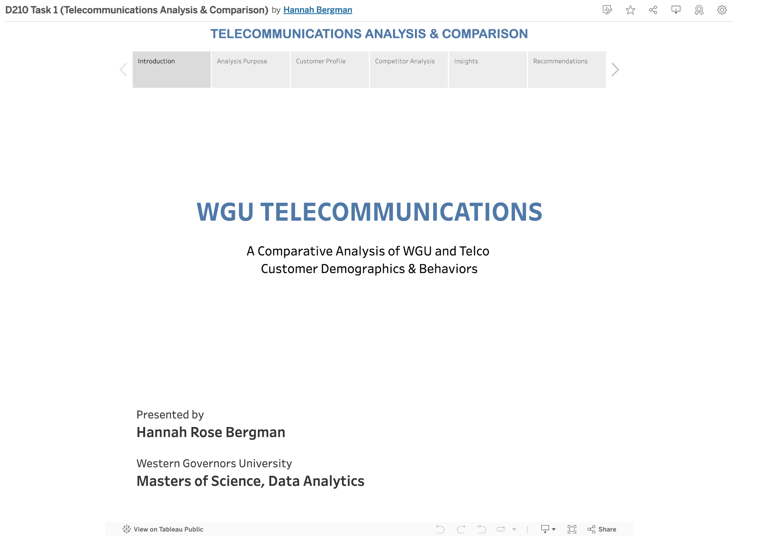

Alternatively, you can view the dashboard by downloading Tableau Public and following these steps:
- Save the file ‘hrbergman_d210_task1.twbx’ to your computer
- Go to: https://www.tableau.com/products/public/download
- Fill out the following registration form that prompts you to enter your First Name, Last Name, and E-mail. Select your Country from the dropdown (then select your corresponding State from the next dropdown that appears after you select your country)
- Click ‘DOWNLOAD THE APP’ and the download should begin automatically
- Once the download is complete, double-click on the Tableau Public execution file (.exe) to begin the installation process
- Follow the instructions prompted by the installer to complete the installation process
  - Read and accept the terms of the license agreement, check the box, click ‘Install’
  - Wait for the installation to complete, following any additional prompts that appear
- Once installation is complete, launch the Tableau Public application from your desktop.
- On the start page of Tableau Public, click ‘Open a Workbook’
- A pop-up dialog box will appear:
  - Find and select the ‘hrbergman_d210_task1.twbx’ file saved during Step 1
  - Click ‘Open’ to open this workbook in Tableau Public
  - The workbook will now be open and the dashboard should be visible

A4. Story & Dashboard Navigation
Introduction
This story point title page serves as a brief introduction to the Tableau story and the presenter, in a similar format to a PowerPoint presentation or slide deck.
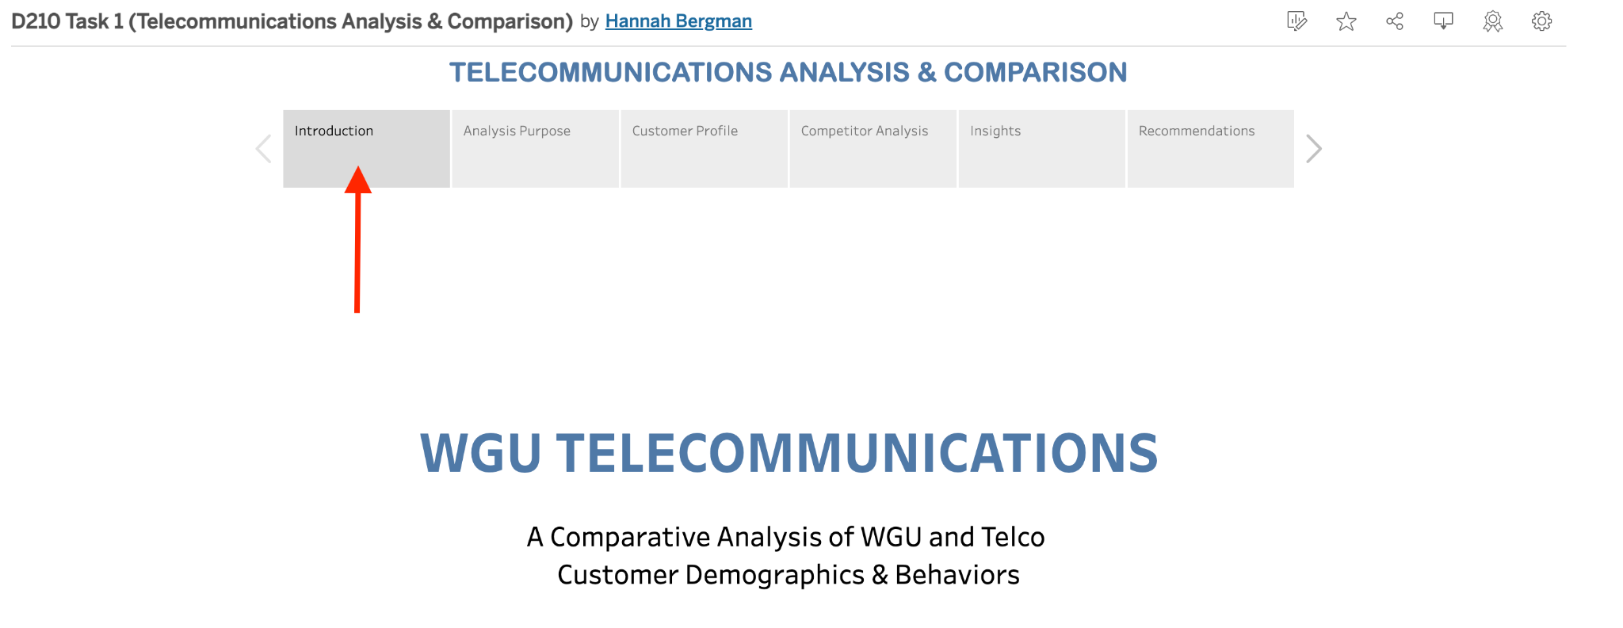

Analysis Purpose
This story point provides a brief explanation of the analysis's purpose, including key company statistics and research objectives.
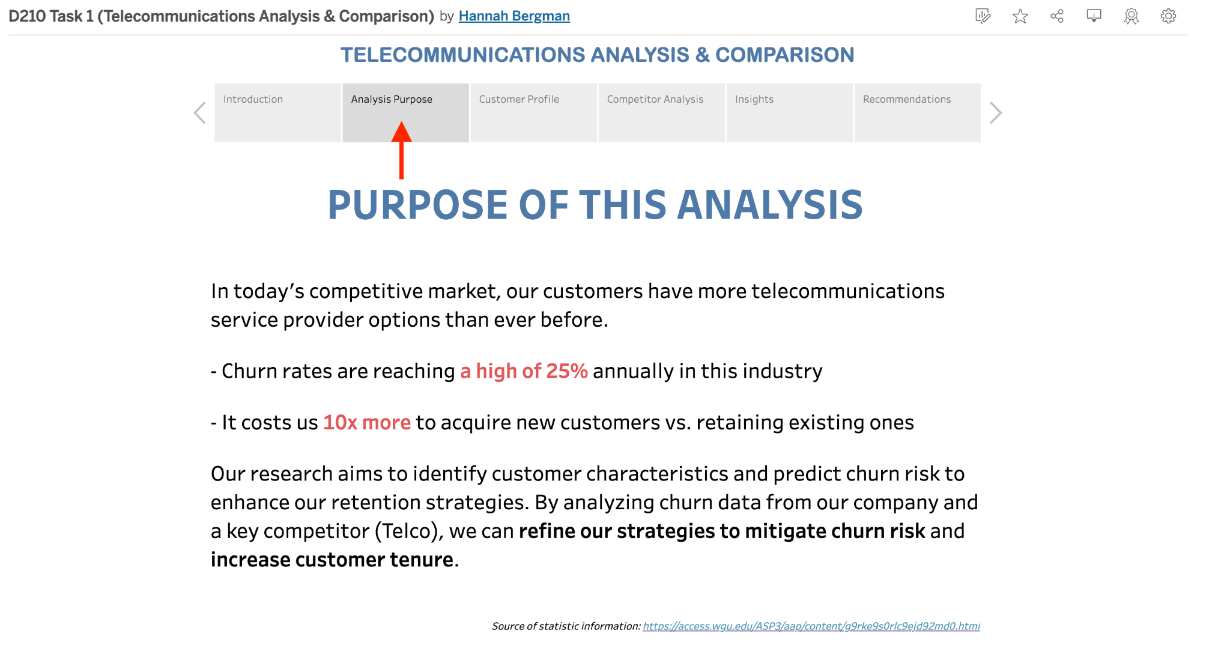

Customer Profile
This story point contains the Customer Profile Dashboard, a detailed visualization of our customer base's demographics and churn rates.
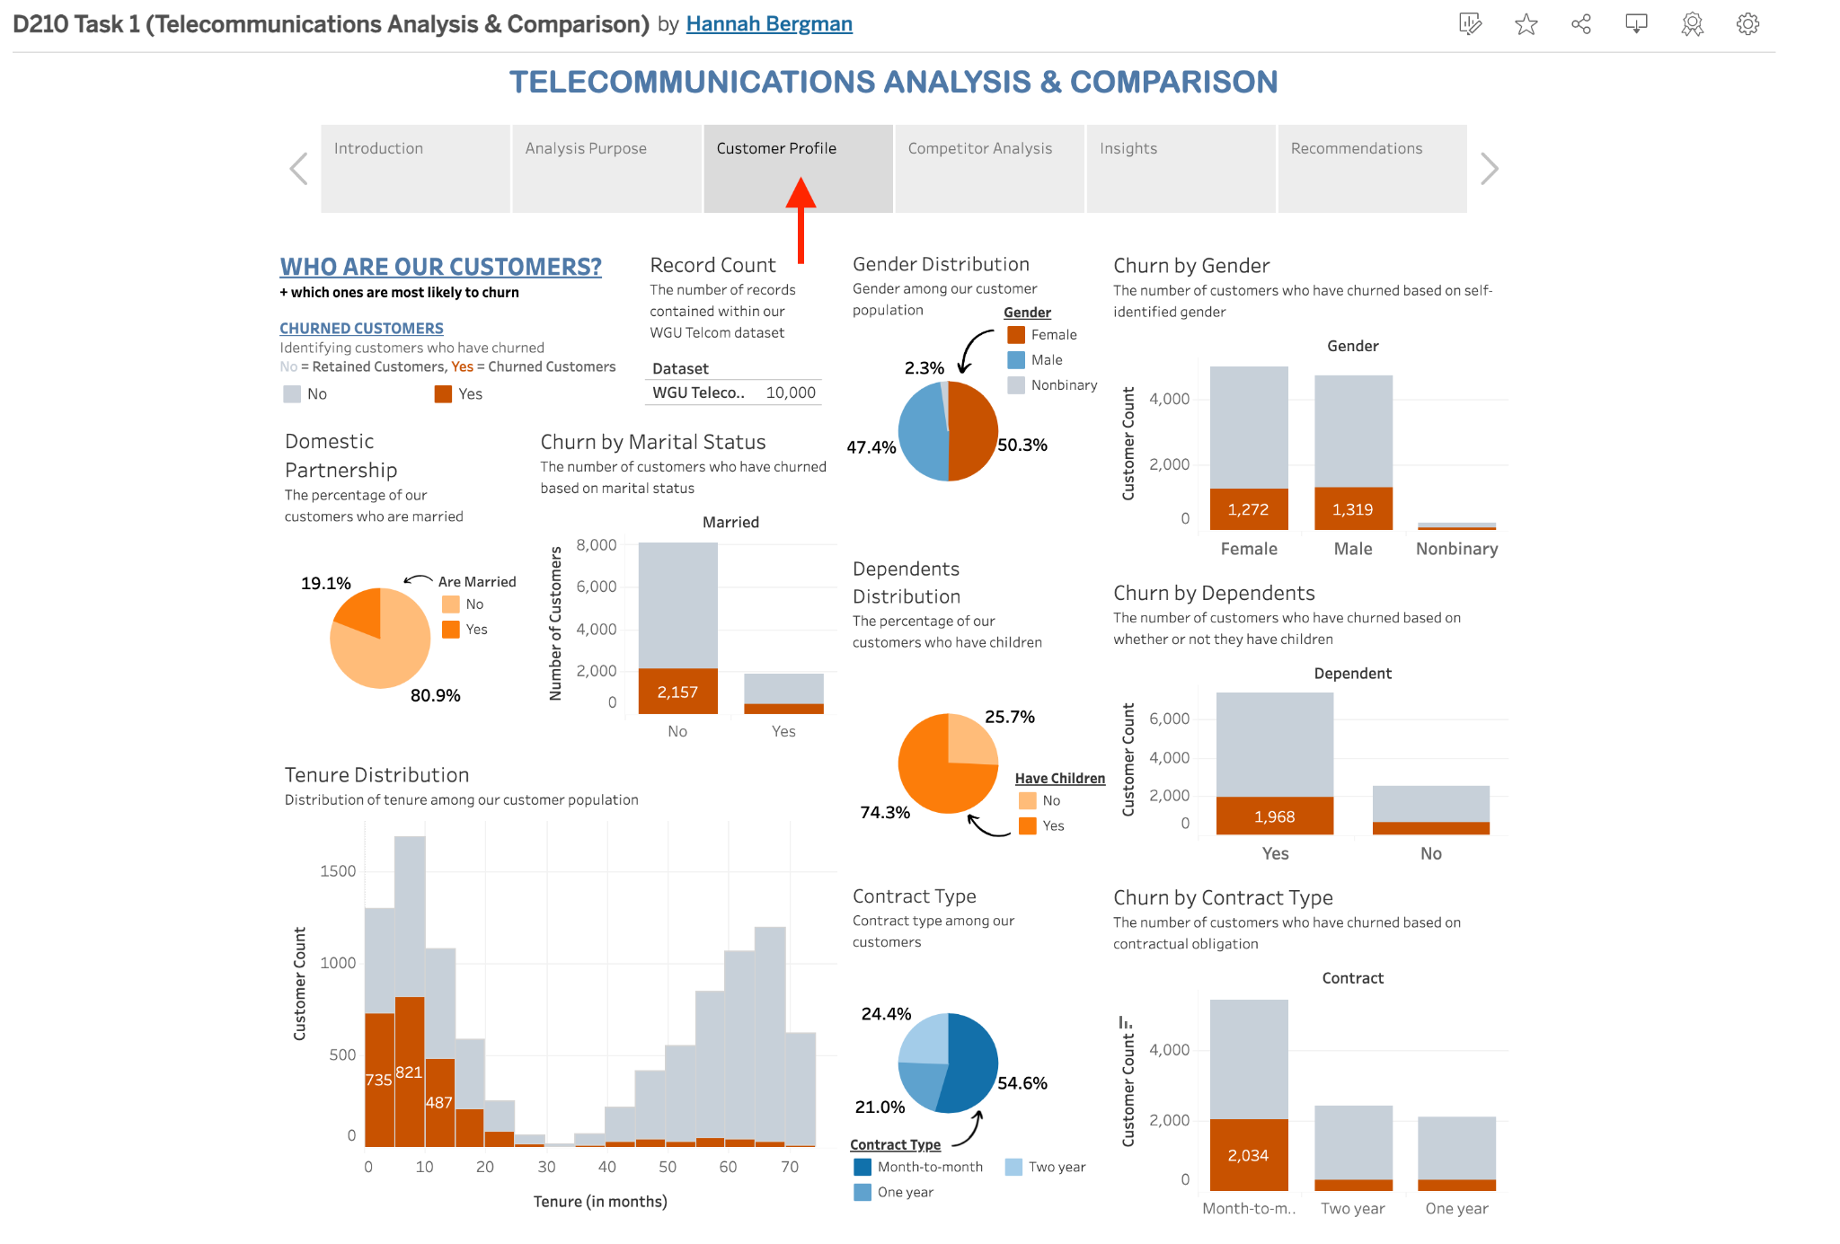
Customer Profile Dashboard Features:
- Churn Filter: Under 'CHURNED CUSTOMERS' is a filter that allows users to toggle between churned and retained customers.
- Record Count: Displays the total number of records in the WGU Telco dataset.
- Gender Distribution: A pie chart showing the gender distribution among our customer population. This also shows a legend that acts as a filter that allows the user to toggle between Female, Male, and Nonbinary.
- Churn by Gender: A stacked bar chart highlighting the number of churned customers by gender.
- Domestic Partnership: A pie chart showing the distribution of marital status (married vs. single). This visual also includes a legend acting as a filter that allows the user to toggle between those who are married (Yes) and those who aren’t (No).
- Churn by Marital Status: A stacked bar chart displaying the number of churned customers by marital status.
- Dependents Distribution: A pie chart showing the distribution of customers with and without dependents.This also has a legend that doubles as a filter to toggle between those who have children (Yes) and those who don’t (No)
- Churn by Dependents: A stacked bar chart highlighting the number of churned customers by dependency status.
- Tenure Distribution: A histogram showing the distribution of customer tenure.
- Contract Type: A pie chart illustrating the distribution of contract types. Again, the legend for this chart is also a filter that allows the user to toggle between Month-to-month, Two year, and One year contract type.
- Churn by Contract Type: A stacked bar chart showing the number of churned customers by contract type.
Competitor Analysis
This story point contains the Competitor Analysis Dashboard, which makes use of both the internal and external datasets to show information about our company and our competitor.
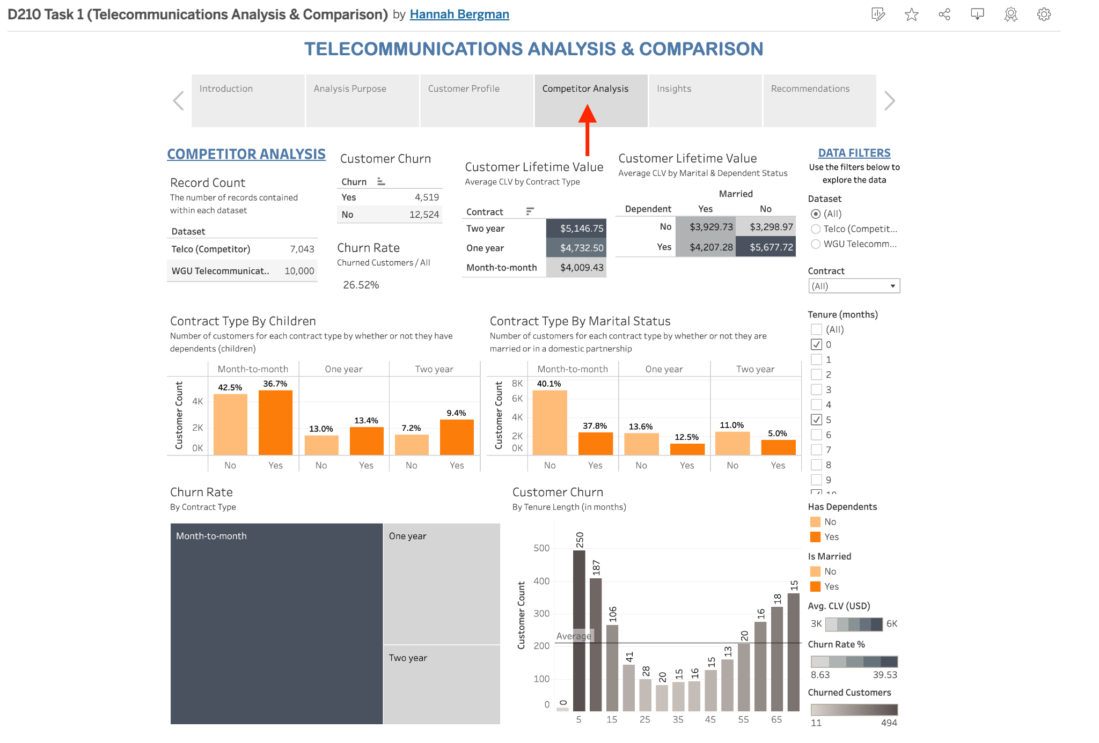
Competitor Analysis Dashboard Features:
- Record Count: Displays the total number of records in the WGU Telco dataset and/or Telco Dataset(s).
- Customer churn: Shows the total count of customers who did and did not churn in either or both datasets.
- Churn Rate: Displays the individual or combined Churn Rate percentage which was manually calculated within this worksheet as the number of churned customers divided by the total number of customers multiplied by 100 to get this percentage.
- Customer Lifetime Value (by Contract Type): Shows the average Customer Lifetime Value (CLV) by contract type. These numbers were manually calculated within the worksheet related to this highlight table, by multiplying tenure by monthly charges and taking the average of the totals to get the average lifetime value of each customer by contract type.
- Customer Lifetime Value (by Marital & Dependent Status): Shows the average Customer Lifetime Value (CLV) by marital and dependent status. These numbers were manually calculated within the worksheet related to this highlight table, by multiplying tenure by monthly charges and taking the average of the totals to get the average lifetime value of each customer by dependent and marital status.
- Contract Type By Children: This side-by-side bar chart shows the total number of customers (Customer Count) for each contract type by whether or not they have children (Yes/No) and displays a comparative churn rate percentage as a label above each bar.
- Contract Type By Marital Status: This side-by-side bar chart shows the total number of customers (Customer Count) for each contract type by whether or not they are married (Yes/No) and displays a comparative churn rate percentage as a label above each bar.
- Average Tenure Length: This treemap displays the average tenure length by contract type.
- Customer Churn: This bar chart provides the number of customers who churned by their average tenure length. A reference line has been added to show the average churn across all tenures.
- Data Filters: This column provides various filters to better explore the data provided within this dashboard
  - Change Dataset: This interactive radio button list allows the user to change datasets to view All, only the Telco dataset, or only the WGU Telco dataset
  - Contract Type: This dropdown allows the user to select a single, multiple or all contract types to filter data.
  - Tenure (months): This checklist filters the Customer Churn visual, allowing the user to select all or individual tenure length (by number of months).
  - Has Dependents: This is a legend for the Contract Type By Children that also acts as a filter for this visual and the CLV by Martial & Dependent Status highlight table.
  - Is Married: This is a legend for the Contract Type By Marital Status that also acts as a filter for this visual and the CLV by Martial & Dependent Status highlight table.
  - Avg. Tenure (months): This legend explains the meaning of the colors used in the Average Tenure Length treemap.
  - Avg. CLV (USD): This legend explains the meaning of the colors used in the Customer Lifetime Value highlight tables.
  - Churned Customers: This legend explains the meaning of the colors used in the Customer Churn graph.

Insights
This story point provides a summary of the key results (insights) of this analysis.
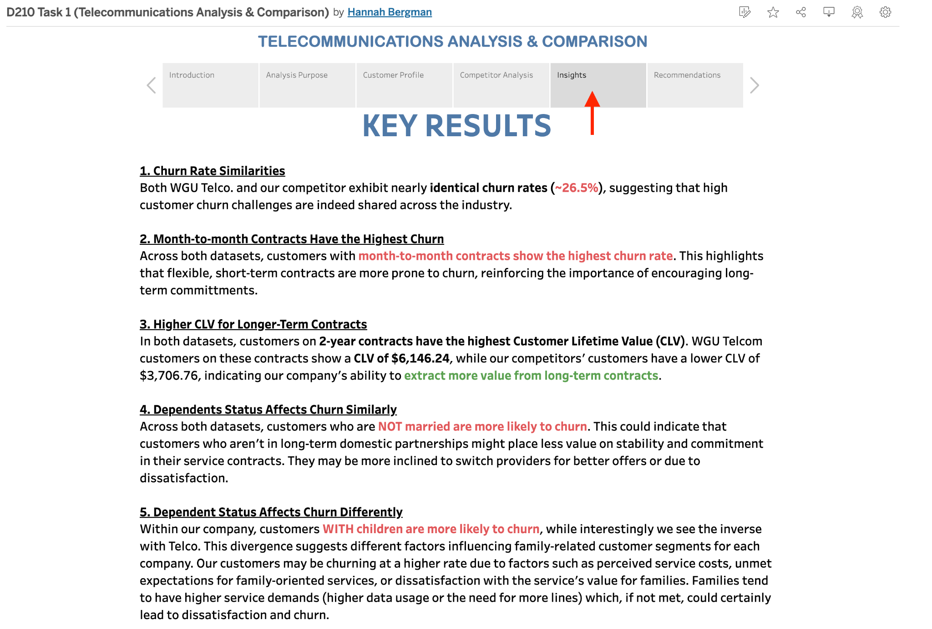

Recommendations
This story point provides a summary of recommended actions based on this analysis.
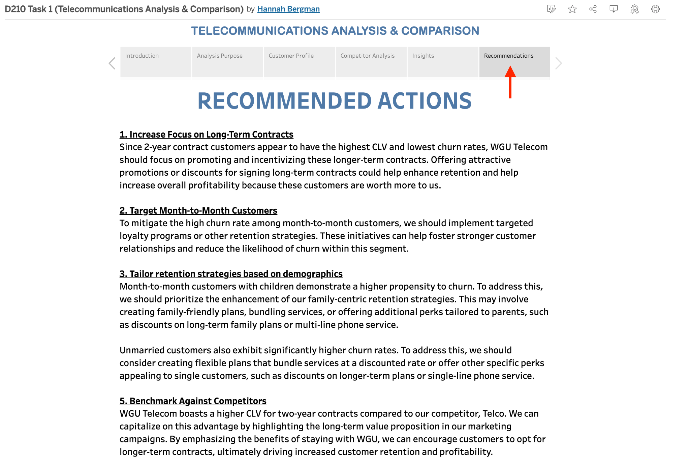

Part 2: Storytelling with Data

B. Panopto Presentation
Panopto video presentation: https://wgu.hosted.panopto.com/Panopto/Pages/Viewer.aspx?id=fea18fe9-cfdc-4de0-aad8-b21a012c7606#

My Introduction
Hello, my name is Hannah Rose Bergman. My role in this project was to collaborate with the analytics team to process and analyze our company's churn data. This data was used to create an interactive dashboard, enabling our executive leadership to explore the data, identify trends, and compare critical metrics. During this meeting, I'll delve into the factors that define our customer base and provide insights into general customer behavior.

Data Set Summary
In today's competitive telecommunications market, customers have numerous service provider options. While this certainly benefits consumers, it also presents a significant challenge for companies like ours. High churn rates, reaching up to 25% annually, are prevalent in this industry (Western Governors University, 2023). Considering the cost of acquiring new customers compared to retaining existing ones, customer retention is crucial. Our research aims to identify customer characteristics and predict churn risk to enhance our retention strategies. By analyzing churn data from our company and a key competitor, we can refine our strategies to mitigate churn risk and increase customer tenure.

Key Results from Analysis (including Data Representations)
The supplemental competitor dataset's variables were carefully chosen due to their similarity to our own data, providing valuable insights into our own customer base. By comparing our data with the competitor data, we can gain a deeper understanding of customer demographics and churn factors.

1. Churn Rate Similarities Across Competitors: Both WGU Telecom and our competitor exhibit nearly identical churn rates (~26.5%). This suggests that customer churn challenges are shared across the industry.
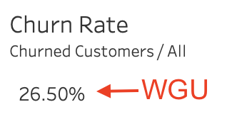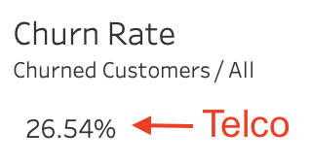

2. Month-to-Month Contracts Have the Highest Churn: Across both datasets, customers with month-to-month contracts show the highest churn rate. This highlights that flexible, short-term contracts are more prone to churn, reinforcing the importance of encouraging long-term commitments.
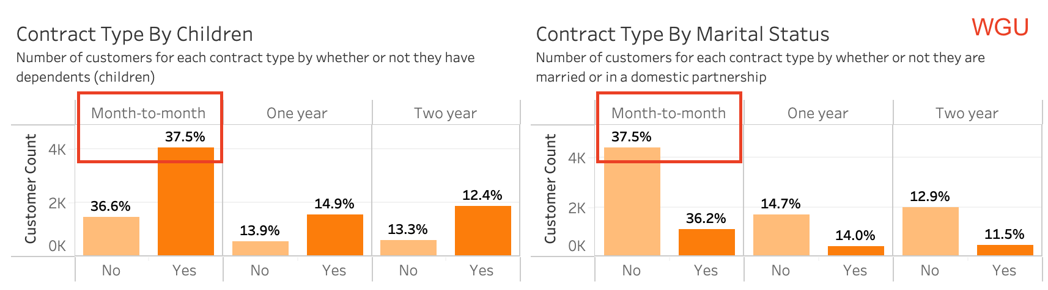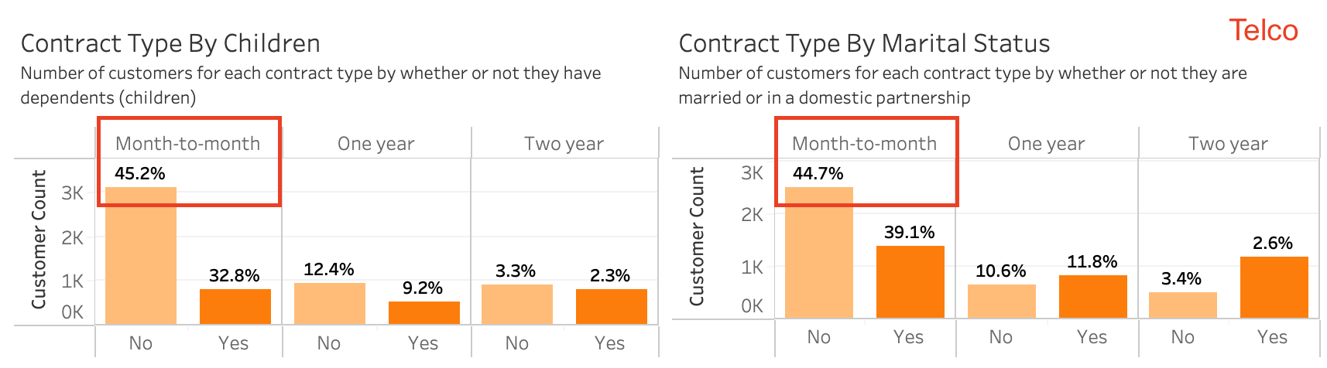

3. Higher CLV for Longer-Term Contracts: In both datasets, customers on Two-Year Contracts have the highest Customer Lifetime Value (CLV). WGU Telecom customers on these contracts show a CLV of $6,146.24, while our competitors’ customers have a lower CLV of $3,706.76, indicating our company’s ability to extract more value from long-term contracts.
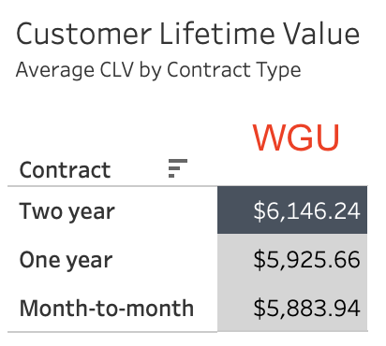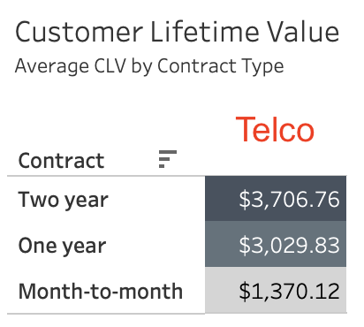

4. Marital Status Affects Churn Similarly:
Across both datasets, customers who are not married are more likely to churn. This could indicate that individuals who are not in long-term domestic partnerships might place less value on stability and commitment in their service contracts. They may be more inclined to switch providers for better offers or due to dissatisfaction.
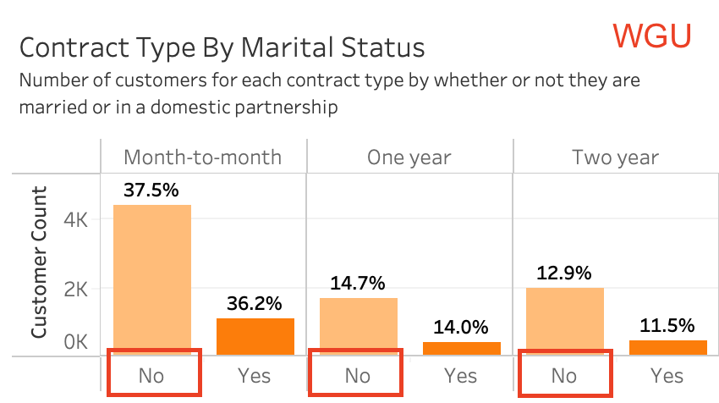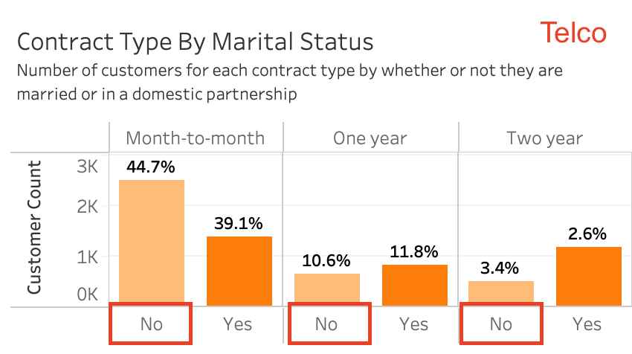

5. Dependent Status Affects Churn Differently:
For WGU Telecom, customers with children are more likely to churn, while interestingly in Telco’s dataset, it’s the customers without children who churn more. This divergence suggests different factors influencing family-related customer segments for each company. Our customers may be churning at a higher rate due to factors such as perceived service costs, unmet expectations for family-oriented services, or dissatisfaction with the service’s value for families. Families tend to have higher service demands (higher data usage or more lines) which, if not met, could certainly lead to dissatisfaction and churn.
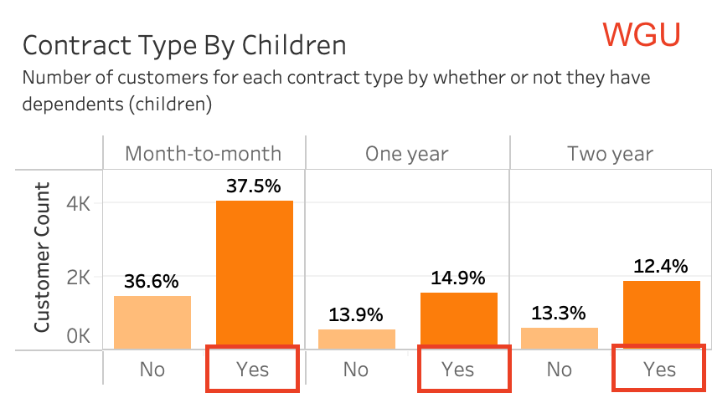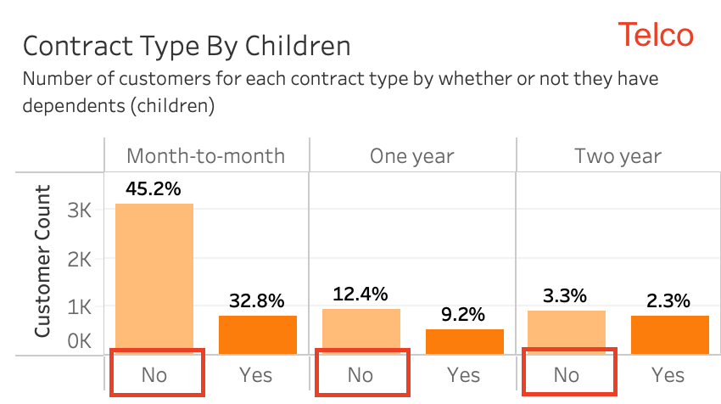

Actionable Insights Summary
1. Increase Focus on Long-Term Contracts
Given the substantial CLV and significantly lower churn rates associated with two-year contracts, WGU Telecom should prioritize strategies to encourage customers to opt for longer-term commitments. By offering compelling promotions or discounts for signing two-year contracts, we can enhance customer retention and drive increased profitability. These customers, with their higher lifetime value, represent a valuable asset to our business.

2. Target Month-to-Month Customers
To mitigate the high churn rate among month-to-month customers, we should implement targeted loyalty programs or other retention strategies. These initiatives can help foster stronger customer relationships and reduce the likelihood of churn within this segment.

3. Tailor retention strategies based on demographics
Month-to-month customers with children demonstrate a higher propensity to churn. To address this, we should prioritize the enhancement of our family-centric retention strategies. This may involve creating family-friendly plans, bundling services, or offering additional perks tailored to parents, such as discounts on long-term family plans or multi-line phone service.

Unmarried customers also exhibit significantly higher churn rates. To address this, we should consider creating flexible plans that bundle services at a discounted rate or offer other specific perks appealing to single customers, such as discounts on longer-term plans or single-line phone service.

5. Benchmark Against Competitors
WGU Telecom boasts a higher CLV for two-year contracts compared to our competitor, Telco. We can capitalize on this advantage by highlighting the long-term value proposition in our marketing campaigns. By emphasizing the benefits of staying with WGU, we can encourage customers to opt for longer-term contracts, ultimately driving increased customer retention and profitability.

Part 3: Reflection Paper

C1. Dashboard Purpose & Function
In today's competitive telecommunications market, customers have numerous service provider options. While this certainly benefits consumers, it also presents a significant challenge for companies like ours. High churn rates, reaching up to 25% annually, are prevalent in this industry. Considering the cost of acquiring new customers compared to retaining existing ones, customer retention is crucial. Our dashboard and research aims to identify customer characteristics and predict churn risk to enhance our retention strategies. With our dashboard, we can analyze churn data from our company and a key competitor, to help refine our strategies to mitigate churn risk and increase customer tenure.

C2. Dataset Insights
The supplemental competitor dataset's variables were carefully chosen due to their similarity to our own data, providing valuable insights into our own customer base. By comparing our data with the competitor data, we can gain a deeper understanding of customer demographics and churn factors.

C3. Data Representations - Decision-Making
Data Representation #1: Contract Type By Children & Marital Status
Filtered by dataset to show our (WGU) data:
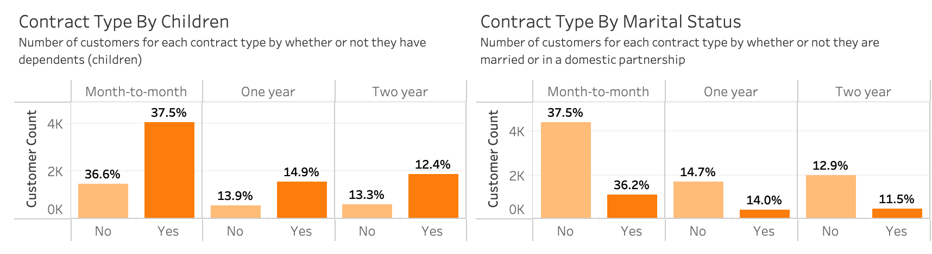
Filtered by dataset to show competitors (Telco) data:
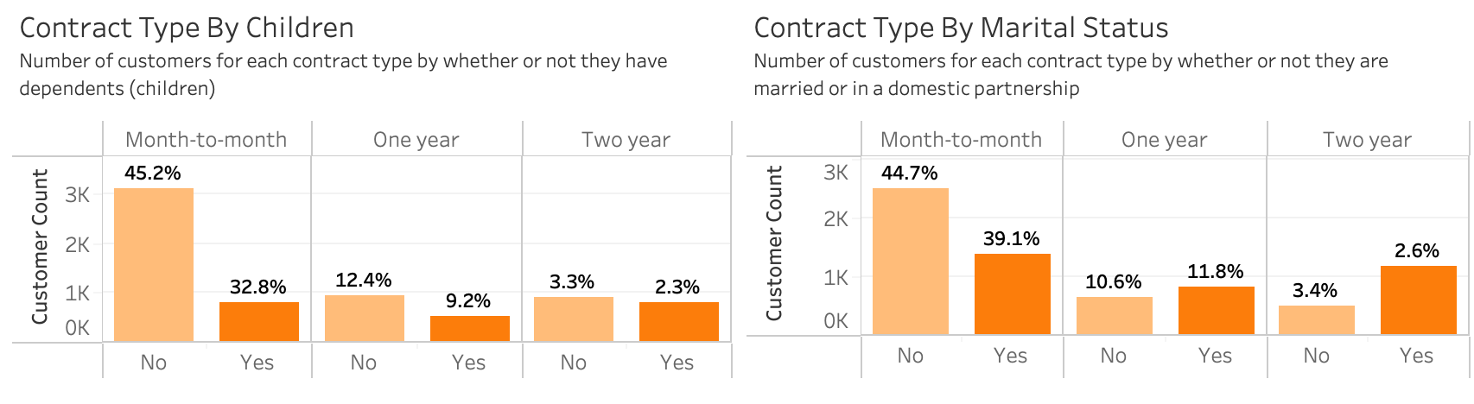
Customers who are not married and have dependents exhibit significantly higher churn rates, especially those on month-to-month contracts. This trend is mirrored by our competitor, when it comes to marital status, suggesting a broader industry issue. However, our churn rates are consistently lower across all customer segments compared to our competitor, demonstrating our superior overall customer retention.
This is particularly noteworthy in our west coast region, given Telco's California-based operations. This positive distinction can be leveraged in marketing campaigns to highlight our higher customer satisfaction and longer-term retention at WGU Telecommunications, attracting customers away from our competitor.
Families (customers with children) tend to have lower churn rates when on long-term contracts, both within our company and our competitor's. This suggests that family-focused promotions or plans could be strategic for enhancing customer retention.
Furthermore, our analysis reveals that non-married customers are at a significantly higher risk of churn. To address this, retention efforts should prioritize offering more flexible or personalized plans to single customers, helping to mitigate churn rates within this segment.
Data Representation #2: Contract Type Prevalence, Churn & CLV
Our ‘CLV by Contract Type’ highlight table (pictured below, left) reveals a significant disparity in customer lifetime value (CLV) across different contract types. Two-year contract holders exhibit substantially higher CLVs, exceeding $6,000, compared to the more modest $5,000 CLV of month-to-month customers. This value is nearly double that of our competitor, who exhibits a two-year contract CLV of $3,706.76 (pictured below, right).

Given these insights, WGU should prioritize strategies to convert our month-to-month customers into longer-term commitments. By offering targeted promotions, such as discounts or loyalty points, we can incentivize customers to transition to one-year or two-year contracts. This shift will not only enhance customer retention but also drive substantial increases in overall profitability.

C4. Interactive Controls
Interactive Control #1: Radio Button
A single-value radio button list (shown below) is provided to allow users to interactively filter data by dataset ('All,' 'Telco,' or 'WGU'). This interactive control enables seamless switching between datasets while ensuring at least one dataset is always selected, to help prevent a blank dashboard. By using radio buttons, we minimize the risk of accidental deselection, enhancing the overall user experience and data exploration process.

Interactive Control #2: Dropdown Menu
A multi-option dropdown menu (shown below) enables users to select one or more contract types: All, Month-to-month, One year, or Two year. This interactive control enables users to customize data visualization by focusing on specific contract types of interest. By selecting multiple contract types, users can gain insights into their performance across different contractual commitments.

C5. Accessibility Considerations
To ensure accessibility for users with color vision deficiency (CVD), also known as colorblindness, I utilized Tableau's built-in colorblind-friendly color palette, 'Color Blind 10'. This palette was specifically designed to accommodate both deuteranopes (those who are unable to perceive green) and protanopes (those unable to perceive red), as demonstrated in the following images (Shaffer, 2019). The left image shows the original color palette, while the right image illustrates how the palette is perceived by individuals with CVD.

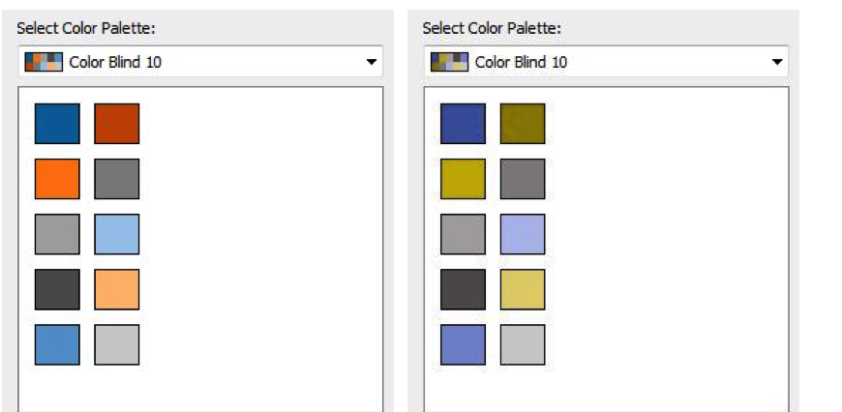
Research suggests that greyscale variations are generally more accessible for individuals with colorblindness (Kilin, 2022). So to further enhance accessibility for users with color vision deficiency, I also utilized Tableau's 'Gray' and ‘Gray Warm’ color palettes, which each feature a single-hue palette of various shades of grey. These grey palettes may be more inclusive than 'Color Blind 10,' which is specifically designed for deuteranopes and protanopes but may not accommodate other types of CVD like tritanopia, which affects blue perception.
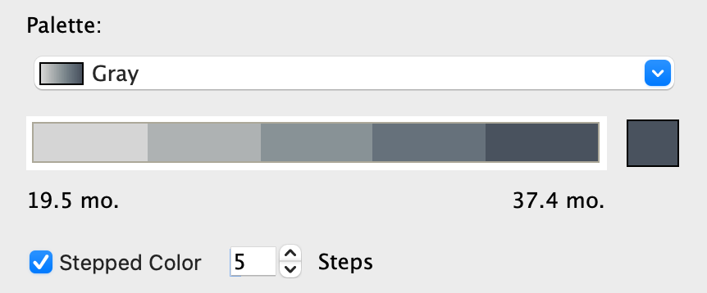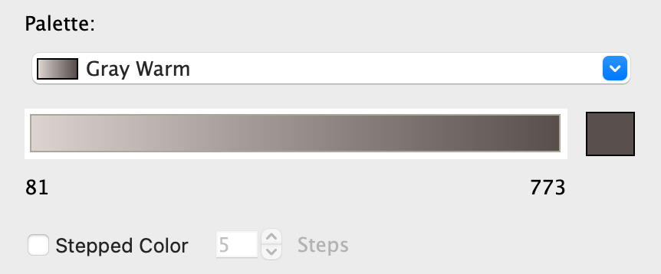

C6. Data Representations - Story-Telling
Data Representation #1: Churn by Contract Type
As our pie chart (image below, left) demonstrates, a significant majority (54.6%) of WGU Telecommunications customers are currently enrolled in month-to-month contracts.
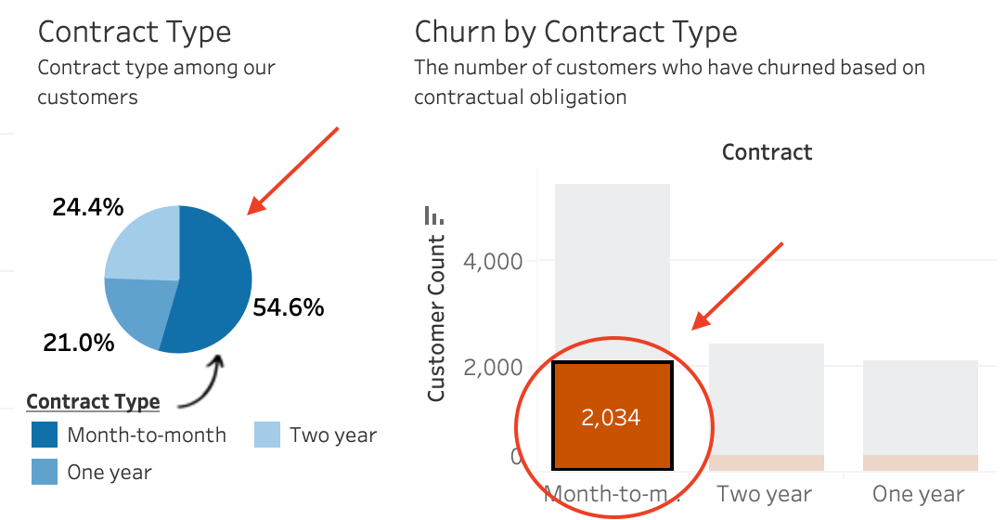
Unfortunately, this segment also exhibits the highest churn rate, as depicted in the 'Churn by Contract Type' stacked bar chart (image below, right). An alarming 2,034 month-to-month customers have terminated their services, substantially impacting our overall customer base.

This chart provides a detailed breakdown of customer churn by contract type, revealing that Month-to-Month contracts have the most significant churn rate compared to one-year and two-year contracts. This finding underscores the notion that customers with greater contractual flexibility (month-to-month) are more prone to churn, highlighting the importance of long-term contracts in customer retention.

Data Representation #2: Customer Churn by Tenure
The Customer Churn by Tenure Length chart highlights that churn tends to decrease the longer customers remain with our company (image below, left).
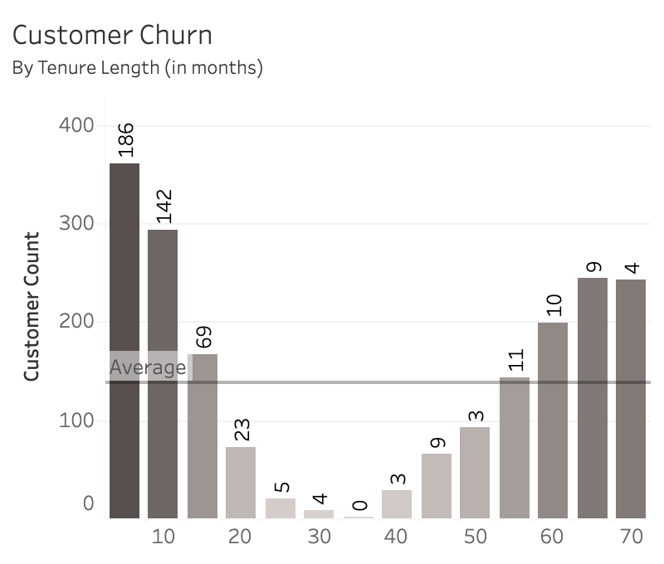
If you examine the tooltips associated with each bar in the above graph, you'll notice that the bars represent the total number of customers at each specific Tenure Length (measured in months), while the labels indicate the number of customers who have churned. The image below illustrates a comparison between Tenure Length at 5 months (where we observe a total of 361 customers, of which a significant portion, precisely 186, have churned) and Tenure Length at 70 months (where we see a total of 242 customers, with only 4 having churned). This data supports the assertion that longer-term contracts not only reduce churn but also foster longer customer relationships.

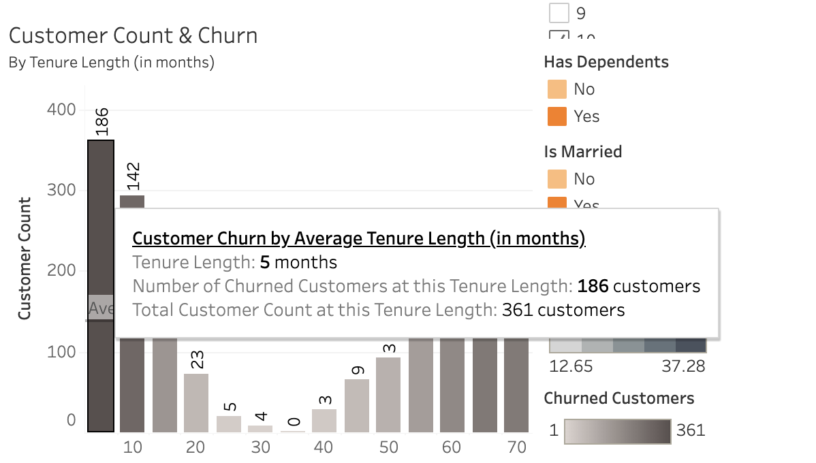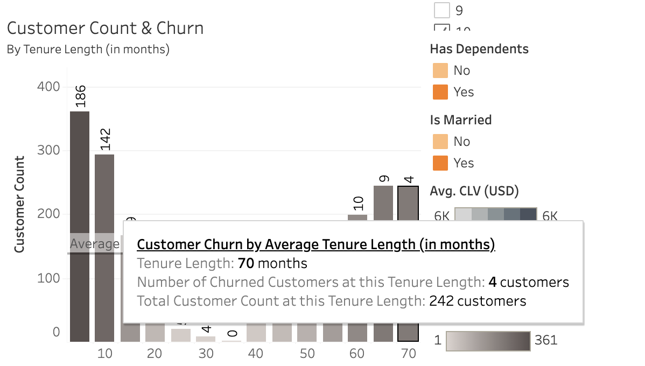

C7. Audience Analysis
Given the executive-level audience consisting of non-technical leaders, the dashboard was adapted to focus on very high-level insights. Metrics such as churn rate, customer count, and contract type breakdown are presented in simple visual formats (bar charts, pie charts) that are easy to understand without requiring technical expertise. Clear visualizations were specifically chosen to highlight key patterns (churn rate by contract type, tenure, and demographics), making it easy for executives to quickly grasp the most important trends and actionable areas. By including filters for contract type, tenure, and dataset selection, executive leaders can explore specific customer segments relevant to their areas of responsibility, allowing for tailored decision-making.

C8. Universal Access
Color Accessibility
To accommodate users with color vision deficiencies (CVD), the dashboard employs a color palette specifically designed for color blindness. For instance, the 'Color Blind 10' palette, a built-in feature of Tableau, is utilized in conjunction with various shades of gray. This combination enables viewers with diverse color vision challenges to effectively distinguish data points without relying solely on color differentiation.
Consistent Layout and Labeling
The layout is designed to be clear and consistent. Labels were placed directly on charts and detailed information was added to the Tooltips of each visual, providing immediate context for data points such as 'Percentage of Churn by Gender' and 'Number of Customers by Contract Type.' This design ensures that key insights can be easily grasped at a glance.
Interactive Features
To cater to the diverse needs of leadership roles, the dashboard incorporates interactive filters for contract type, dataset, and tenure. These dynamic features empower leaders to customize their view, focusing on specific customer segments and contract types. This adaptability ensures that the dashboard remains valuable across various levels of leadership, from SVPs and EVPs to Regional VPs.
By prioritizing color accessibility, consistent layout, and interactive features, the dashboard is designed to be inclusive and accessible to all leaders, regardless of their technical proficiency or visual abilities. This accessibility approach empowers users to navigate the dashboard effortlessly and extract actionable insights for informed decision-making.

C9. Elements of Effective Storytelling
Story-telling Element #1: Data Segmentation
I segmented customers based on key demographic factors and contract types, including Gender, Marital Status, Number of Dependents, and Contract Type, within my dashboards. This segmentation enables the audience to concentrate on specific groups, facilitating the identification of patterns, such as the elevated churn rate observed among customers without children and those enrolled in month-to-month contracts.

Story-telling Element #2: Visual Emphasis on Churn & Lifetime Value
By combining Churn Rate with Customer Lifetime Value (CLV), the dashboard effectively ties together our two custom metrics, showing how churn directly impacts profitability. This clear connection between churn and CLV was intended to engage the audience by highlighting the financial significance of customer retention.

D. References
Barron, S. (2023, July 13). How To Calculate Churn Rate in 5 Easy Steps [Definition + Formula]. HubSpot. [Blog Article].
Retrieved October 22, 2024, 2024, from
https://blog.hubspot.com/service/what-is-churn-rate
Blastchar. (2017). Telco Customer Churn. Kaggle. [Dataset].
Retrieved October 16, 2024, from
https://www.kaggle.com/datasets/blastchar/telco-customer-churn
Kilin, I. (2022, April 27). The Best Charts for Color Blind Viewers. Dataviz Best Practices. [Blog Article.
Retrieved October 22 2024, 2024, from
https://www.datylon.com/blog/data-visualization-for-colorblind-readers
Macko, S. (2019, July 11). Telco Customer Churn (11.1.3+). IBM Community: Business Analytics. [IBM Community Resource].
Retrieved October 16, 2024, 2024, from
https://community.ibm.com/community/user/businessanalytics/blogs/steven-macko/201907/11/telco-customer-churn-1113
Nielson, J.. (2004, September 26). Checkboxes vs. Radio Buttons. [Blog Article].
Retrieved October 22, 2024, 2024, from
https://www.nngroup.com/articles/checkboxes-vs-radio-buttons
Shaffer, J. (2016, April 20). 5 Tips on Designing Colorblind-Friendly Visualizations. Tableau. [Blog Article].
Retrieved October 22, 2024, from
https://www.tableau.com/blog/examining-data-viz-rules-dont-use-red-green-together
Western Governors University. (2023). Churn Data and Dictionary Files. D210 Data Files and Associated Dictionary Files. [Dataset & Data Dictionary].
Retrieved October 16, 2024, from
https://access.wgu.edu/ASP3/aap/content/g9rke9s0rlc9ejd92md0.html

