Cucumber photo 131055.jpg:

(in setup003, shot on 2022-06-14)

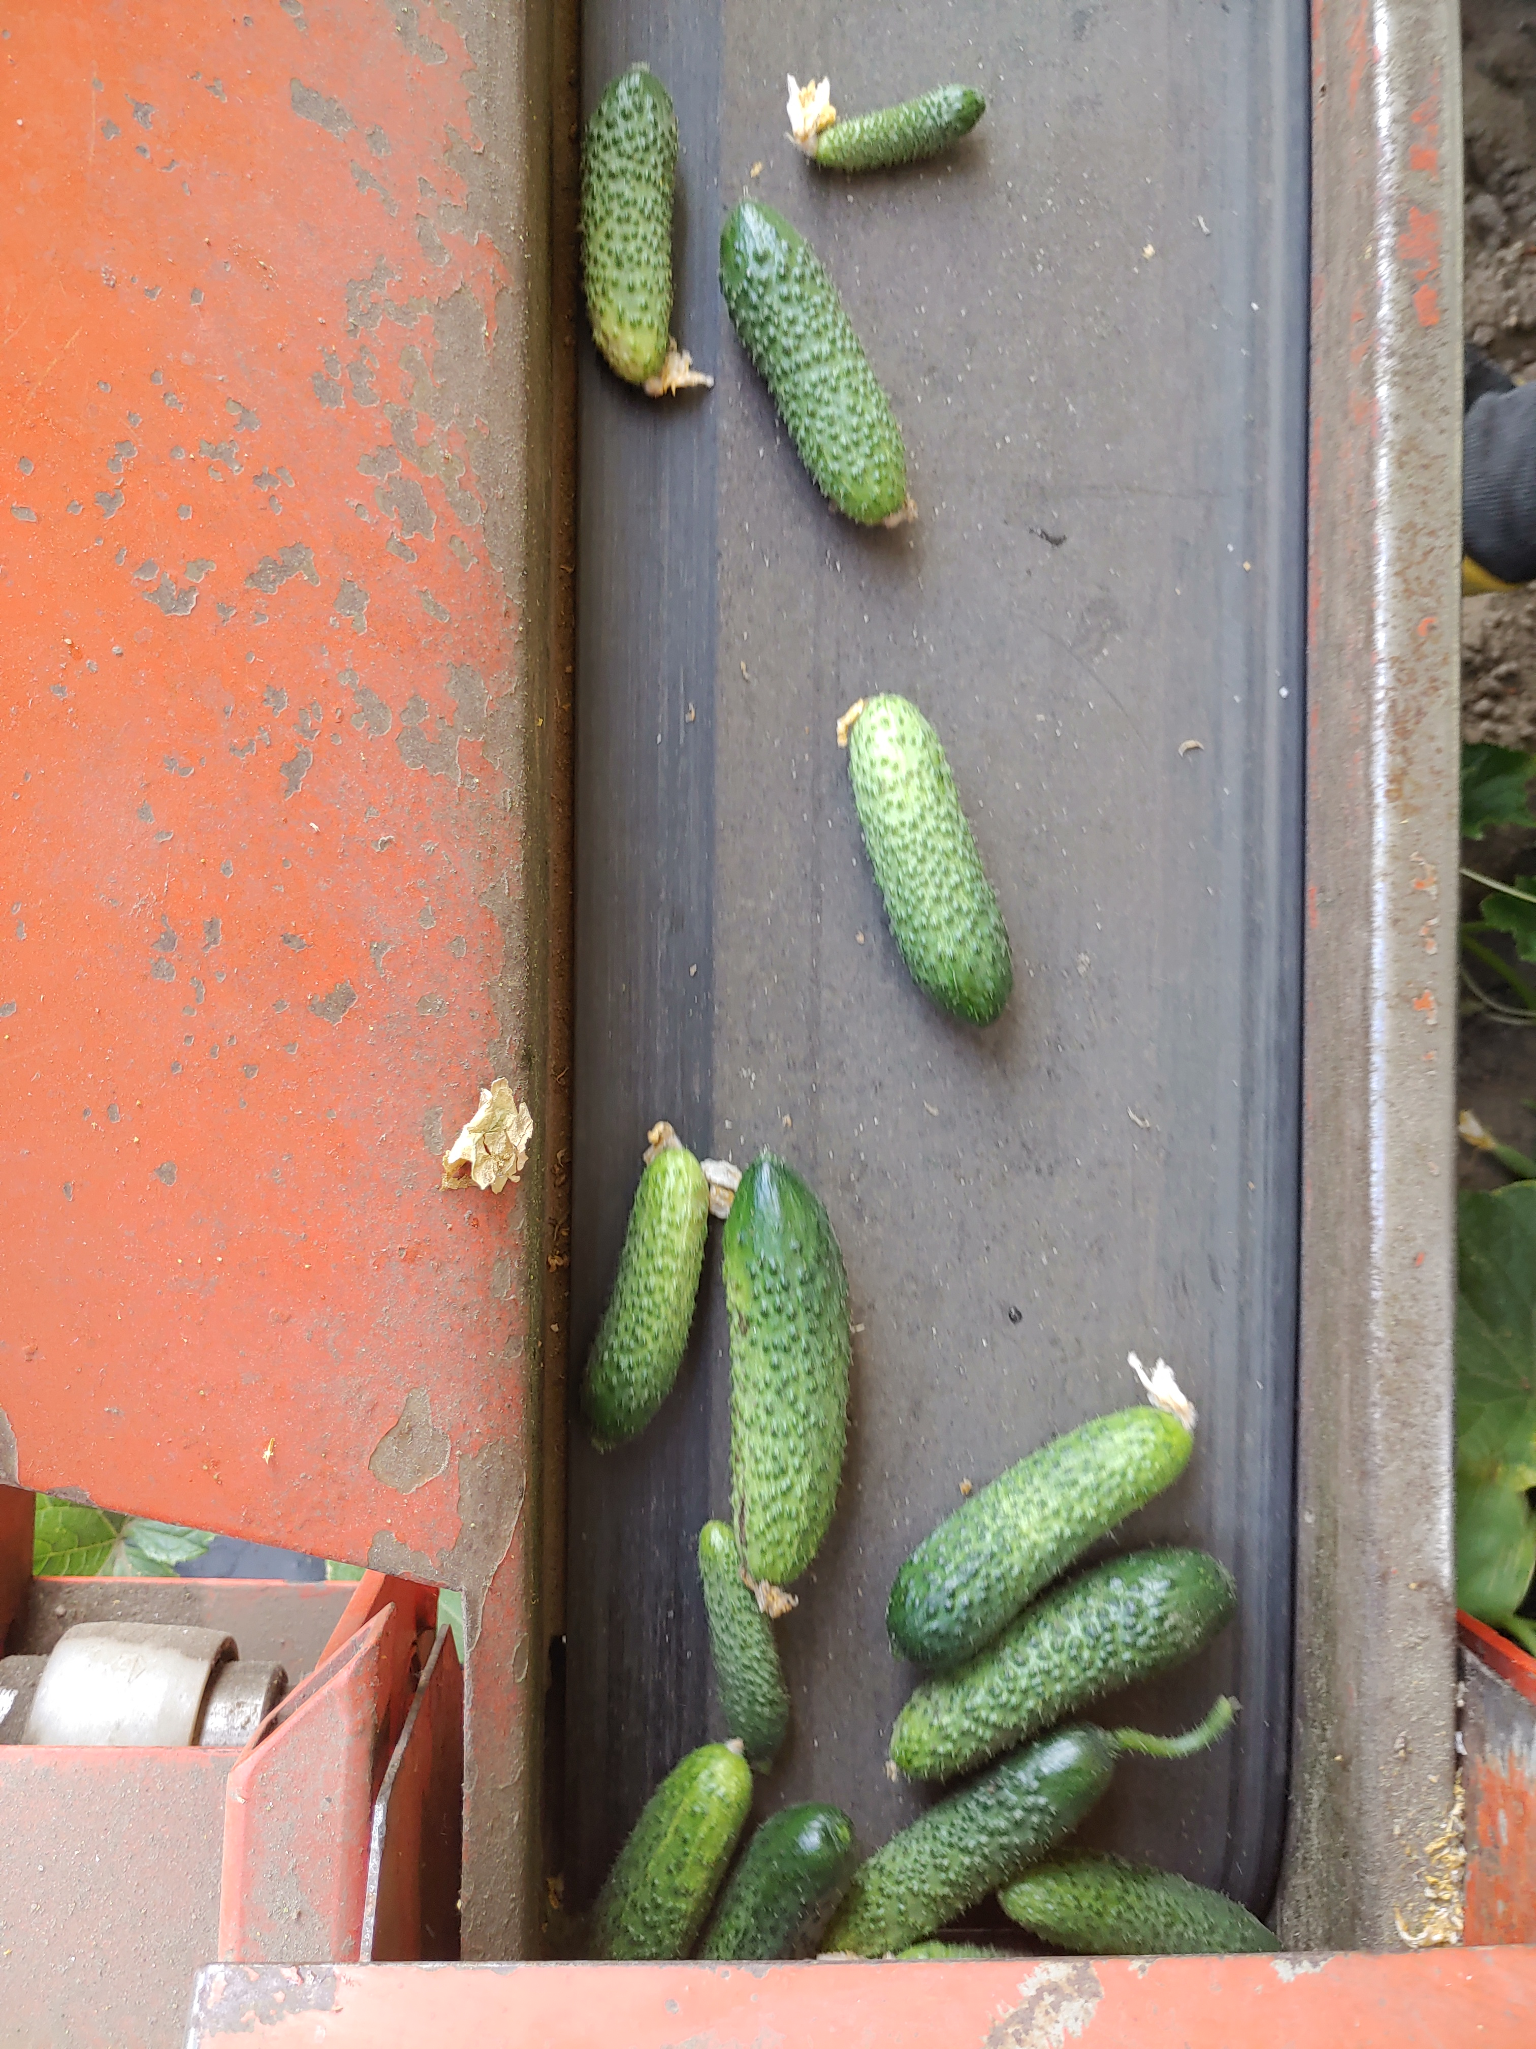
Single-image annotations:
{
"version": "5.0.1",
"flags": {},
"shapes": [
{
"label": "Cucumber",
"points": [
[
173.1958762886598,
1113.4020618556701
],
[
164.94845360824743,
1152.5773195876288
],
…………………….
],
"group_id": null,
"shape_type": "polygon",
"flags": {}
},

Collective annotations.json: … only:

{
"images": [
{
"height": 3024,
"width": 4032,
"id": 0,
"file_name": "20220614_131055.png"
},

… so this file is only a list of the available annotations!

… WRONG! See continuation on next page:

"categories": [
{
"supercategory": "Cucumber",
"id": 0,
"name": "Cucumber"
}
],
"annotations": [
{
"segmentation": [
[
173.1958762886598,
1113.4020618556701,
164.94845360824743,
1152.5773195876288,
178.35051546391753,
1196.9072164948454,
207.21649484536084,
1255.6701030927836,
231.95876288659795,
1331.958762886598,
(...)
1265.979381443299,
305.1546391752577,
1193.8144329896907,
271.1340206185567,
1121.6494845360826,
215.4639175257732,
1077.319587628866,
190.7216494845361,
1087.6288659793815
]
],
"iscrowd": 0,
"area": 34193.85694547789,
"image_id": 0,
"bbox": [
164.0,
1077.0,
174.0,
340.0
],
"category_id": 0,
"id": 1
},

