Communicating Visually

Visual Communication is not a Natural Skill

The concept of visual communication being a skill one must work to learn and master should not be a huge revelation to anyone who has lived through the Geocities and MySpace eras of the Internet. Yet, many of those who would shudder at the thought of bringing back the <blink> tag to our web browsers have virtually no issues schlepping a column or two of data into an Excel spreadsheet and walking away with a default chart image that can be cut and pasted into a PowerPoint presentation for an upcoming meeting. What causes this dichotomy between the acts of creation and perception and what can we do to fill in the gap?

John Debes, co-founder of the International Visual Literacy Association, coined the term1 “visual literacy” and offered the following definition for it:

*“Visual Literacy refers to a group of vision-competencies a human being can develop by seeing and at the same time having and integrating other sensory experiences. The development of these competencies is fundamental to normal human learning. When developed, they enable a visually literate person to discriminate and interpret the visible actions, objects, symbols, natural or man-made, that he encounters in his environment. Through the creative use of these competencies, he is able to communicate with others. Through the appreciative use of these competencies, he is able to comprehend and enjoy the masterworks of visual communication.”*

From that definition, we see that comprehension is not a passive act but a very deliberate one, with our eyes taking in images and our brains interpreting, processing and deriving some meaning from them—a process also known as *decoding*. While humans may have wrapped a definition around this process in the 20th century, this is old news…approximately 60,000 years old (give or take a century).



Cave paintings remain to this day sole artifacts of one of the first forays into visual communication. While it’s impossible for our modern minds to derive definitive meaning from these images, they do serve as evidence of the notion of *visual literacy* in action. A spark occurred in the minds of a scant few prehistoric PowerPoint creators that both drove *and enabled them* to transcribe items from their three dimensional world into two dimensions with as much precision as implements at that time would allow. We can posit that the visual fragments we see today survive as successful artifacts of an immediate, in-person feedback loop that occurred to help judge whether the stories were being correctly received.

Fast-forward 50,000 years or so to when the first petroglyphs were created and we see a creative evolution occurring which produced images that are more intricate and complex, demonstrating that the visual literacy of both the senders—still limited in number—and receivers increased significantly. The widespread discovery of similar-styled petroglyphs across nearly every continent provides further evidence of our collective need to communicate and be understood visually.

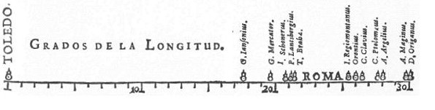

As we push up through the ages to the 17th century, we find evidence of a dramatic increase in the visual literacy of humans of that era in van Langren’s graph of longitude distances from Toledo to Rome. This first known instance of a graph of statistical data did not just “happen”. The creator (van Langren) wanted to tell a story of distance and fused the ideas and concepts from predecessors such as Nicole Oresme, Albert of Saxony, Leonardo da Vinci, Nicholas of Cusa and, no doubt, many others. He relied on the fact that his audience was also familiar with the teachings of these esteemed scholars and apparently felt confident that it would take just a bit of extra decoding for the message to be received as intended. If only the 17th century had a github equivalent for us to be able to peek at the iterations of the day that did not survive the test of successful communication.

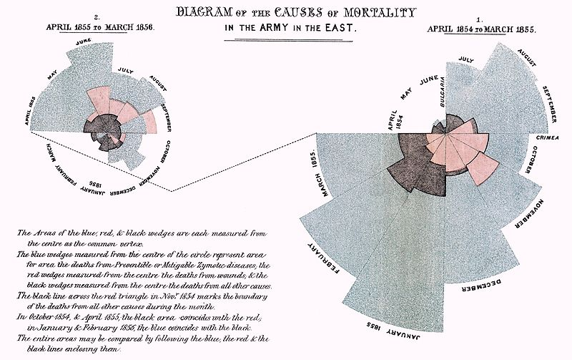

The mid-1800’s saw medicine charging to the take the lead when it comes to pushing our decoding boundaries to help communicate both complex and critical analyses. Florence Nightingale was one of these visual pioneers, with one of her best-known creations being the “Nightingale rose diagram”, the first of which illustrated seasonal sources of patient mortality in the military field hospital she managed. This chart became a trademark communication tool for her and she regularly compiled them together into reports she dubbed coxcombs. The goal of these diagrams was not to reproduce the underlying data with precision, but to visually connect with the receiver and show trends and interdependencies in a compelling way.

Since that time, we have had a wealth of opportunity to both enhance our encoding capabilities and investigate the science behind how we go about decoding these images. The dawn of the 20th century brought with it many psychological, medical discoveries that have enabled visual communicators to move from mere trial-and-error to understanding foundational decoding capabilities and building upon them.

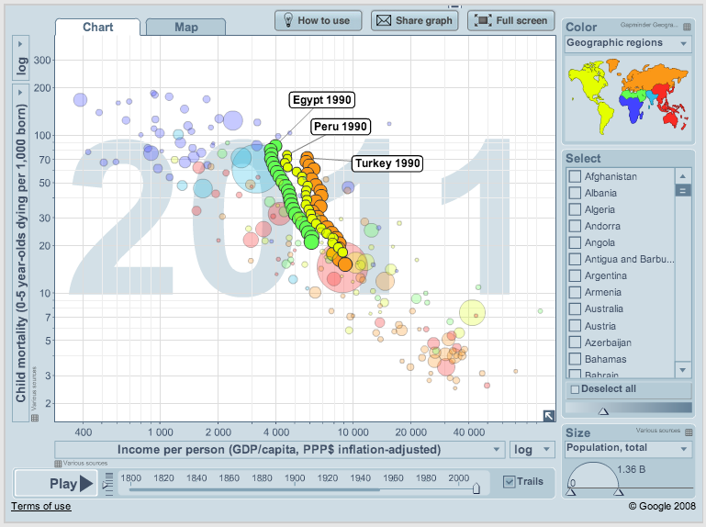

A modern example that builds upon this work comes from Gapminder, a non-profit foundation that promotes sustainable global development. A key component of their mission is fulfilled through the use of dynamic visualizations to “*…[fight] devastating ignorance with fact-based worldviews everyone can understand.”*  The tools that help produce these data-infused visual stories were designed with the knowledge of how we best decode these images, providing a pre-configured canvas to aid even the most nascent communicator.

Even with well-designed toolsets, it’s vital that we understand how the image-to-understanding decoding process works, especially if we wish to bring multiple elements together or become 21st century visual literacy pioneers.

Cognitive Science: Decoding the Decoding Process

Paul Thagard defines cognitive science as “*the interdisciplinary study of mind and intelligence, embracing philosophy, psychology, artificial intelligence, neuroscience, linguistics, and anthropology*.”2 The core tenet of cognitive science is that how we think is best defined by how our minds represent things and what operations they perform on those representations. In other words, to understand how something we create will be received, we need to understand how the biology and neurology of our eyes will decode the images that we are sending to it.

Biologists have determined that it takes our eyes just 1/20th of a second to recognize the meaning of a complex visual scene. Even though we will undoubtedly have more time than that to ponder the content of an image, much of that reflection will be based and biased on that initial information retrieval. What elements, then, should we focus on “getting right” to ensure our signals aren’t misperceived as noise.

Signal Detection and Magnitude Estimation

To get an idea of the concepts of signal and noise in action take a look at the following image:





You should see two rows of rectangles that appear to be filled with different levels of gray. What you are actually seeing is an artifact of the decoding process since the top row of rectangles are all the same shade and the bottom row of rectangles are also all the same shade (just a lighter one). The background gradient is the surrounding “noise” and the elements of the rows of rectangles are the “signals”. While this is a gentle reminder that our innate assumptions about what the receiver “should” interpret can often be wrong, it is also a good introduction to visual signal detection.

Dr. Ernst Heinrich Weber conducted numerous empirical studies in an attempt to determine the relationship between a physical stimulus and the perception of the intensity of the physical stimulus. This test was performed across many senses, including vision and culminated in the principle of just noticeable difference, or the smallest detectable difference between two levels.



Comparing and Ranking Elementary Perceptual Tasks

Encoding Multiple Attributes

Understanding Gestalt

Visual Processing