

IUBAT- International University of Business Agriculture and Technology
Project Report
Crouse code: CSC 470

Submitted to
Snaholata Mondal
Lecturer,
CSE Department,
IUBAT

Submitted by
Member Name | ID
Md Fazla Rabbi | 22303068
MD. Harun Or Rashid | 21303175
Tanvir Islam Arpon | 22303285

Program: BCSE
Section: I

Submission date: 20/01/2026

Table of Contents
Chapter 1: Introduction 4
1.1 Objectives 4
1.2 System Benefit 4
1.3 Software Process Model 5
1.4 Why Chosen? 5
Chapter 2: Requirement Engineering 6
2.1 System Analysis and Requirements 6
2.2 Functional Requirements 7
2.3 Non-functional requirements (Security) 8
2.4 Use Case Diagram 9
Chapter 3: Analysis Modelling 10
3.1 Activity Diagrams 11
3.1.1 User Activity Diagram 11
3.1.2 Admin Activity Diagram 12
3.2 Swimlane diagrams 13
3.3 Sequence Diagram 14
3.4 CRC 15
3.5 Class diagrams 16
Chapter 4: Project Management 17
4.1 Risk identification Table 17
Chapter 5: Project Planning and Scheduling 18
5.1 Function Point Estimation 18
5.1.1 Function input output 18
5.1.2 Identify Complexity (TF) 19
5.1.3 Identify Complexity (DF) 20
5.1.4 UFP (TF) 21
5.1.5 UFP (DF) 21
5.1.6 TDI 22
5.1.7 Final Calculation 23
5.2 Project Schedule Chart 23
Chapter 6: Project Estimation 24
6.1 Personal cost 24
6.2 Hardware cost 24
6.3 Software cost 24
6.4 Other Cost 25
6.5 Accounts table 25
Chapter 7: Designing 25
7.1 Data Flow Design 26
7.3 ERD 30
7.4 Interface Design (Interface Images of Your Software) 30
Chapter 8: Testing 31
8.1 Produced Test Cases (For all requirements) 31
Chapter 9: Conclusion 32
9.1 Brief Overview of Project 33
9.2 Limitation of Project 33

Chapter 1: Introduction
This project is a comprehensive restaurant ordering and reservation system developed to modernize traditional dining and delivery workflows. By integrating a dynamic web interface with a robust backend, the system allows customers to browse menus, manage digital carts, and make table reservations seamlessly. The platform is designed for educational and demonstration purposes, emphasizing core software engineering principles such as session-based authentication and database relationship management.​

1.1 Objectives
The primary objective of this system is to provide an end-to-end digital solution for restaurant management that bridges the gap between customer convenience and administrative oversight. Specific goals include:
- Implementing a secure user authentication system with distinct roles for customers and administrators.​
- Developing a real-time reservation module that prevents double-booking through precise date and time conflict checking.​
- Facilitating an efficient ordering workflow that supports both Cash on Delivery and digital payment methods like bKash.​
- Providing administrators with a centralized dashboard to manage menu availability, view order histories, and handle user profiles.​

1.2 System Benefit
The system offers significant improvements over manual restaurant operations by automating data handling and customer interactions.
- For Customers: It provides a user-friendly platform to explore categorized menus, track order history, and download PDF invoices for record-keeping.​
- For Management: Automated inventory and order tracking reduce human error, while the digital reservation system optimizes table turnover and staffing.​
- Scalability: The use of a relational database (SQLite/SQLAlchemy) and modular Python-based architecture allows for easy feature expansion, such as adding more payment gateways or detailed analytics.​

1.3 Software Process Model
The development of this project followed the Incremental Model, which allowed for the iterative delivery of core functionalities.
- Phase 1: Focused on establishing the backend skeleton using Flask and setting up the basic user registration and login modules.​
- Phase 2: Introduced the menu management system and session-based cart functionality.​
- Phase 3: Integrated complex features like table reservation logic, bKash configuration, and automated invoice generation in PDF format.​

1.4 Why Chosen?
The Incremental Model was selected due to the project's educational nature and the need for frequent testing of individual components.
- Risk Management: Developing the system in stages ensured that core authentication and database structures were stable before implementing third-party integrations like payment gateways.​
- Flexibility: It allowed for adjustments to the user interface and database schema based on immediate feedback from preliminary local runs.​
- Parallel Development: Different modules, such as the admin dashboard and the public-facing menu, could be refined independently to ensure a cohesive final product.

Chapter 2: Requirement Engineering

2.1 System Analysis and Requirements
Actor 1: Customer/User
- User Requirement 1: User wants to browse and search for menu items.
  - 1.1 The system will display a categorized menu with item names, prices, and ingredients.​
  - 1.2 A search bar will allow users to find specific dishes using keywords.​
  - 1.3 The homepage will automatically filter and show only currently available items.​
- User Requirement 2: User wants to manage a digital shopping cart.
  - 2.1 Users can add multiple food items to a session-based cart.​
  - 2.2 The cart interface will calculate the subtotal and total price automatically.​
  - 2.3 Users can remove items or clear the entire cart before proceeding to checkout.​
- User Requirement 3: User wants to book a table reservation.
  - 3.1 The system will provide a reservation form for selecting date, time, and table number.​
  - 3.2 The system will perform a real-time overlap check to ensure the table is not double-booked.​
  - 3.3 Users must complete their profile (phone, address) before a reservation is confirmed.​
- User Requirement 4: User wants to process payments and receive invoices.
  - 4.1 The system will support both Cash on Delivery and bKash mobile payment options.​
  - 4.2 After a successful order, the system will generate a downloadable PDF invoice.​
Actor 2: Administrator
- User Requirement 1: Admin wants to manage the restaurant menu.
  - 1.1 Admins can add new food items with images and categorize them (e.g., Appetizers, Main Course).​
  - 1.2 Admins can toggle the "Availability" status of any item to hide it from the customer view.​
- User Requirement 2: Admin wants to oversee orders and reservations.
  - 2.1 A dashboard will display all customer orders with their current status (e.g., Placed, Completed).​
  - 2.2 Admins can view and manage all table bookings made by users.​
- User Requirement 3: Admin wants to manage user data.
  - 3.1 Admins can view, update, or delete user accounts through the administrative interface.​
  - 3.2 Secure login is enforced using an admin_required decorator to protect sensitive data.​

2.2 Functional Requirements
For Customer/User
- The system shall provide registration and login functionality using session-based authentication.​
- The system shall allow users to search the menu and filter items by category.​
- The system shall support a persistent shopping cart during the active user session.​
- The system shall validate table availability for reservations and prevent conflicting schedules.​
- The system shall integrate with the bKash API for processing digital payments.​
- The system shall generate and provide a PDF invoice for every completed order.​
For Administrator
- The system shall restrict access to management routes to authorized administrative accounts only.​
- The system shall provide CRUD (Create, Read, Update, Delete) functionality for the menu database.​
- The system shall allow administrators to update the status of customer orders.​
- The system shall permit the manual update of user profile information and account deletion.​
- The system shall automatically create a default admin account during the initial database setup.

2.3 Non-functional requirements (Security)
- The system shall enforce role-based access control by utilizing an @admin_required decorator to protect sensitive administrative functions from unauthorized access.​
- The application shall secure user sessions using a cryptographic SECRET_KEY to prevent session hijacking and unauthorized data manipulation.​
- The system shall utilize the secure_filename utility for all media uploads to mitigate risks associated with directory traversal attacks.​
- The system shall implement an Object-Relational Mapping (ORM) layer through SQLAlchemy to protect against SQL injection by parameterizing all database queries.​
- The application shall generate non-sequential, unique 12-character identifiers for all orders and reservations to prevent predictable ID enumeration.​
- The system shall isolate sensitive bKash payment API credentials within a dedicated configuration file to ensure modularity and data protection.​
- The system shall require users to have a fully completed profile before allowing them to access reservation or ordering functionalities to ensure data accountability.​
- The system shall manage user authentication through secure server-side sessions that are cleared upon logout to prevent session fixation.​

2.4 Use Case Diagram

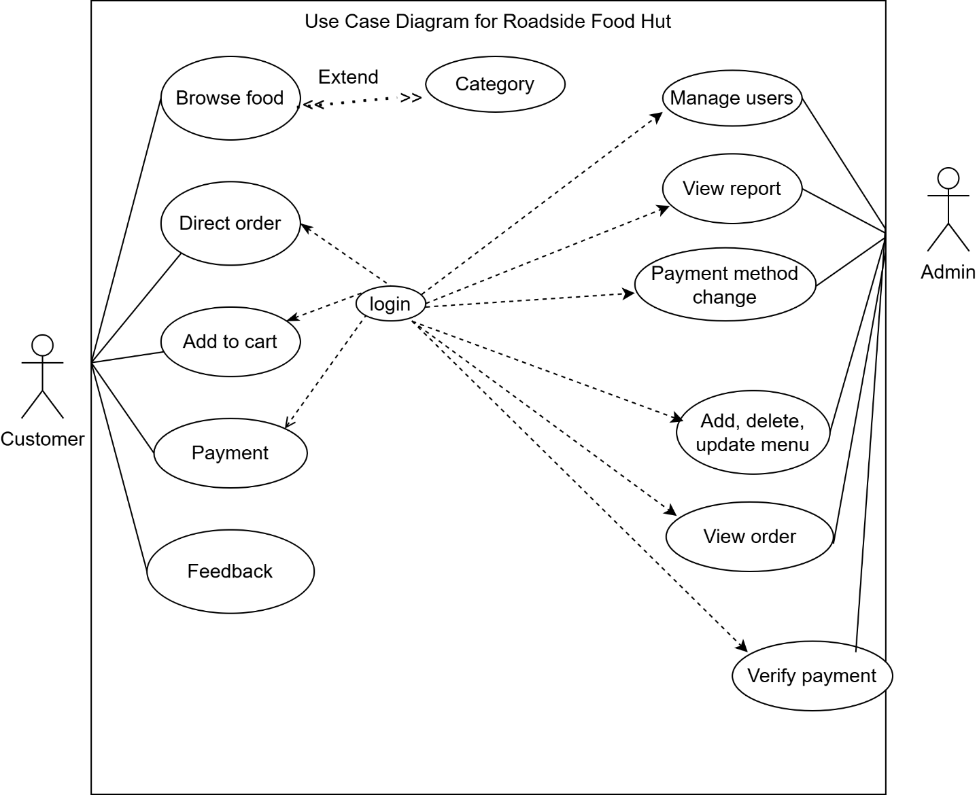

Chapter 3: Analysis Modelling

3.1 Activity Diagrams

3.1.1 User Activity Diagram
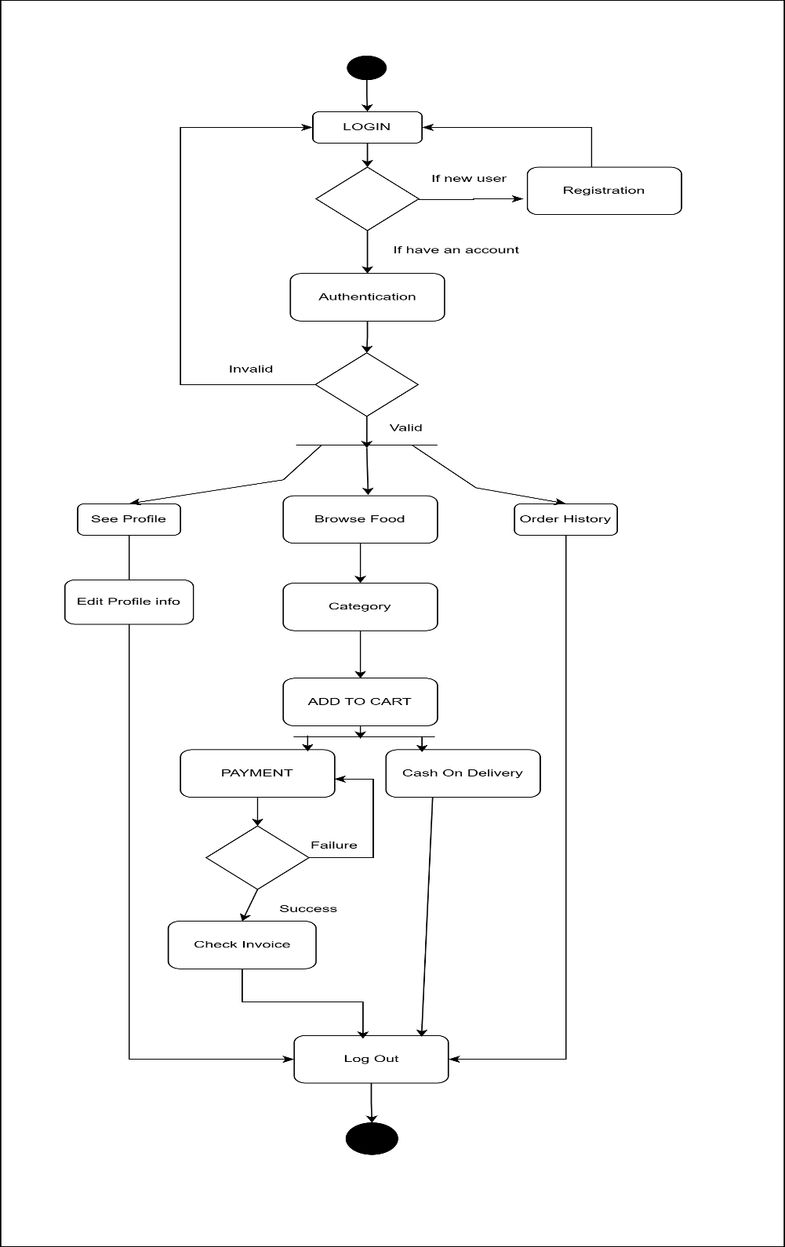

3.1.2 Admin Activity Diagram
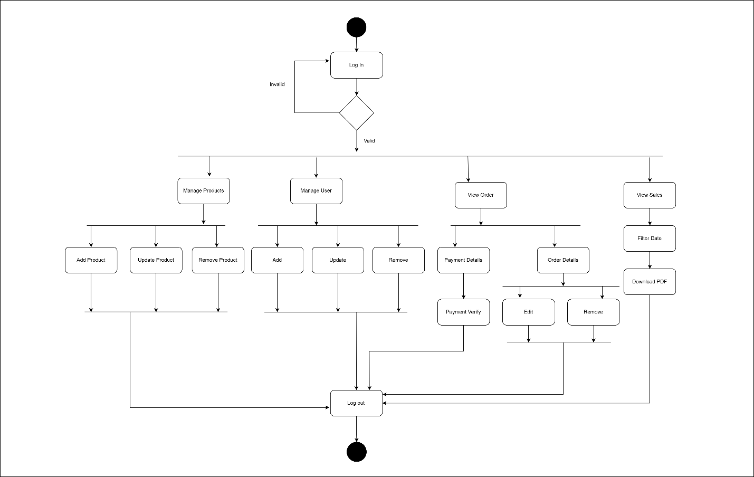

3.2 Swimlane diagrams

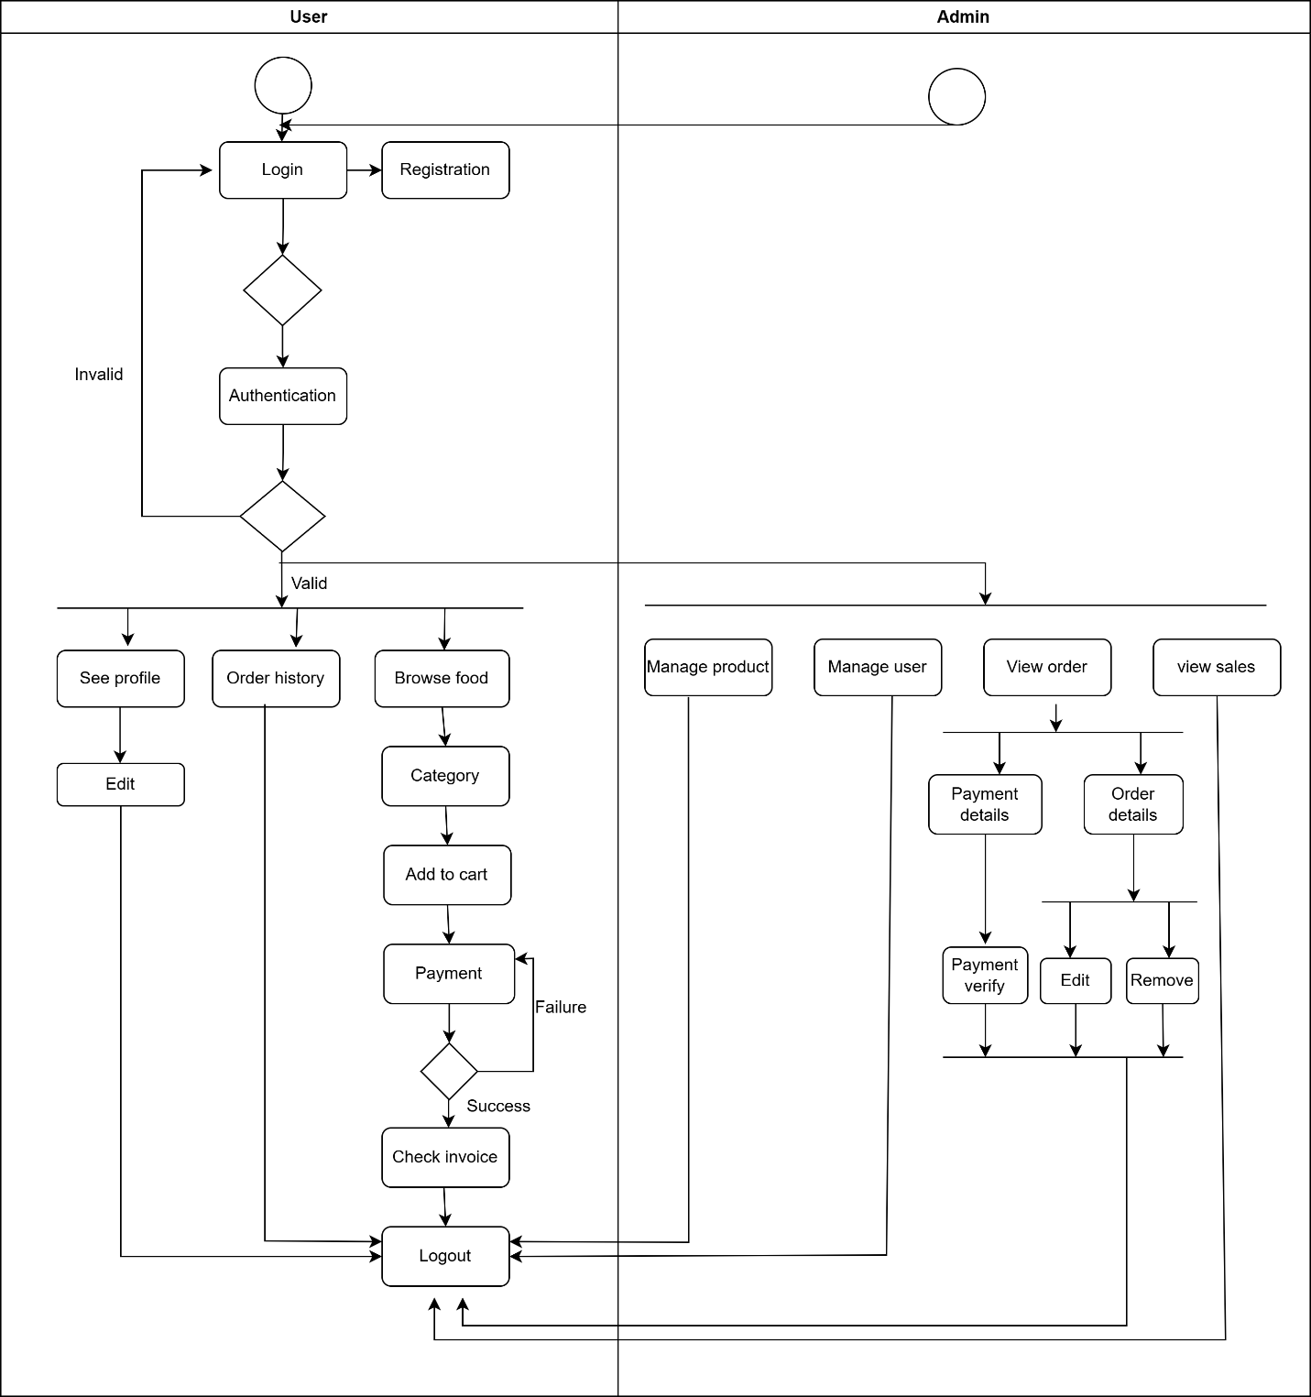

3.3 Sequence Diagram
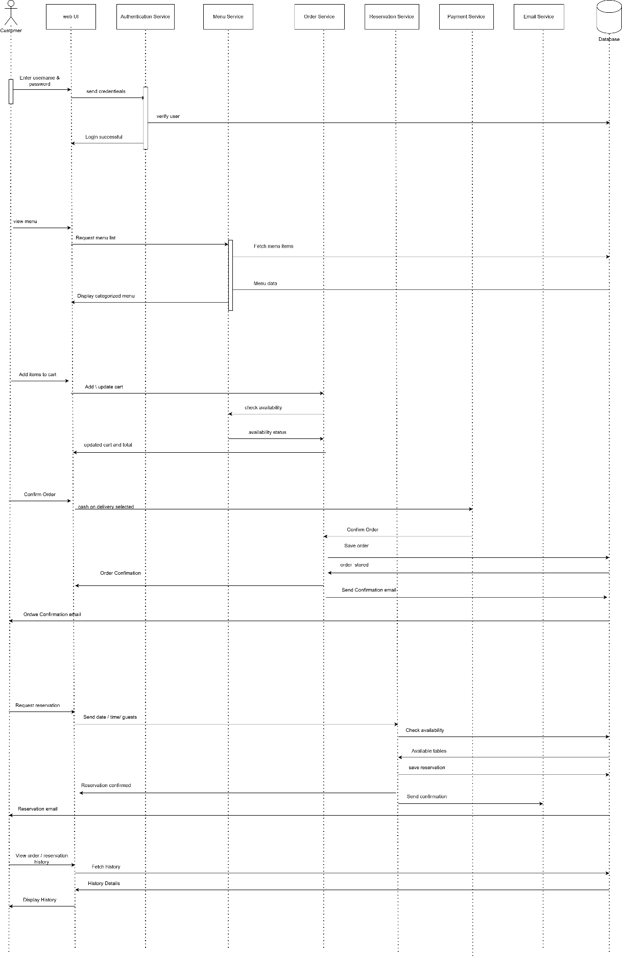

3.4 CRC
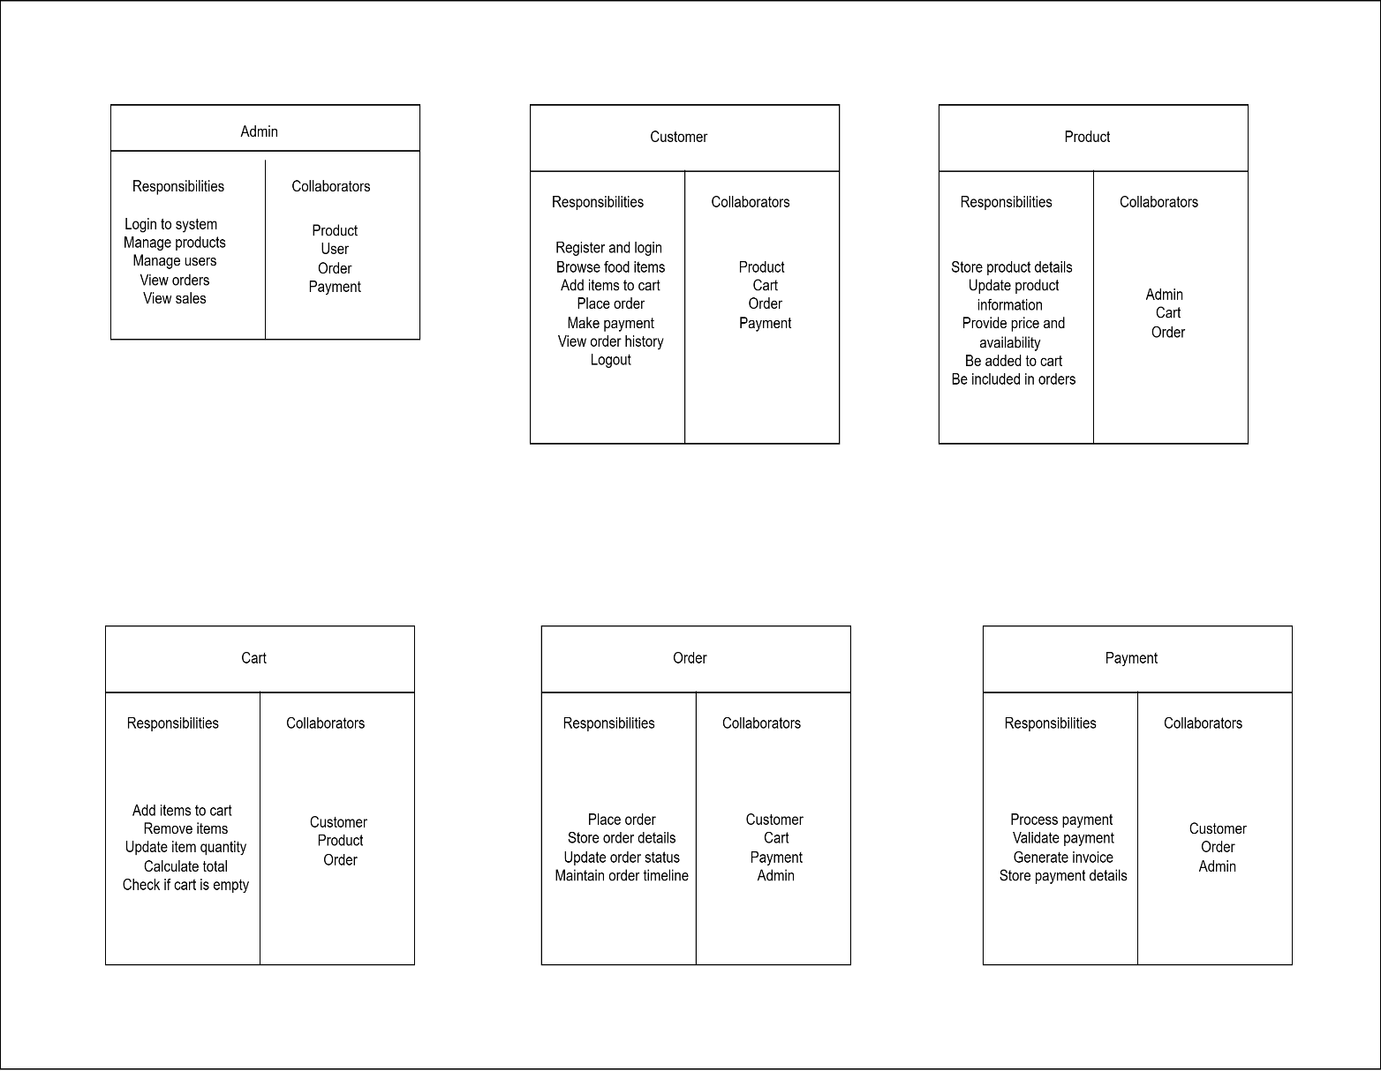

3.5 Class diagrams

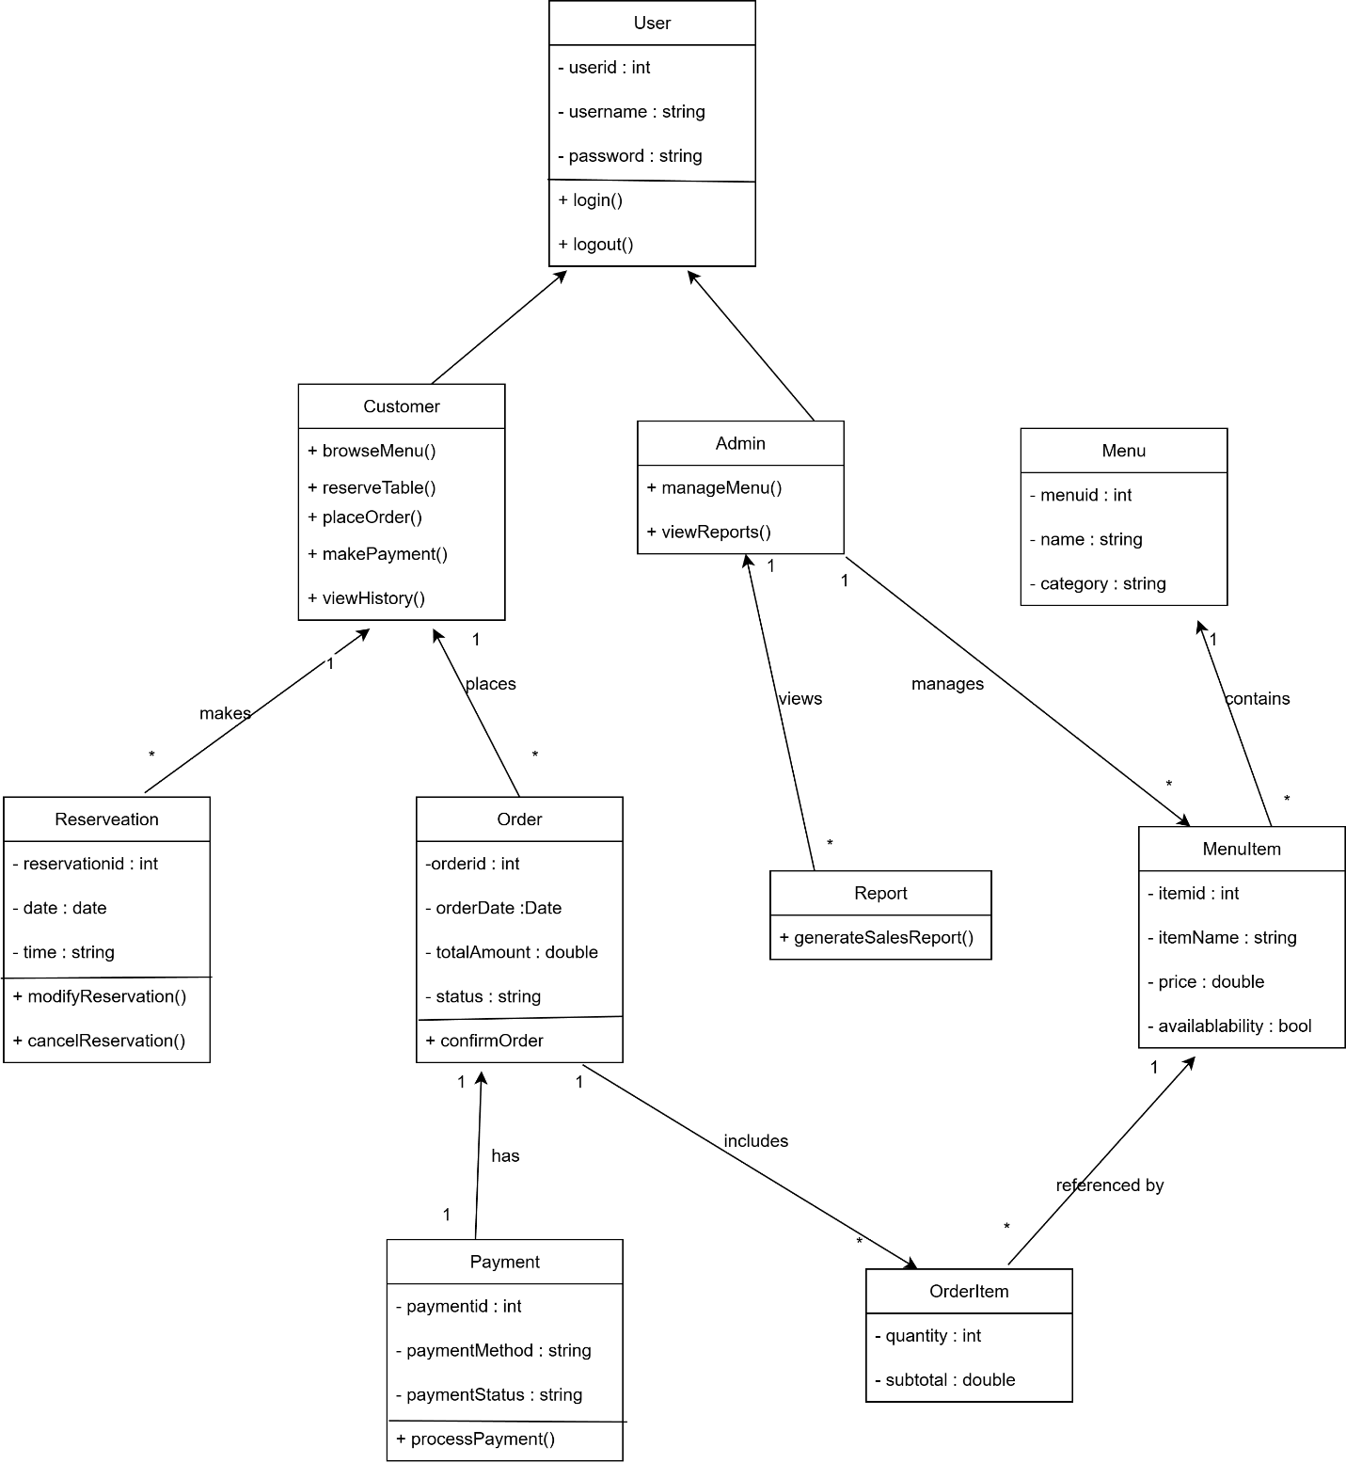

Chapter 4: Project Management

4.1 Risk identification Table
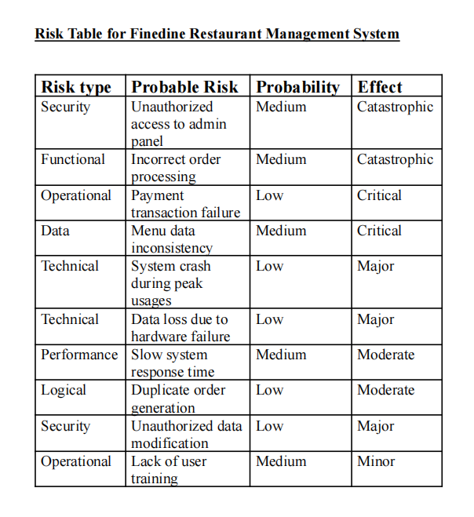

Chapter 5: Project Planning and Scheduling

5.1 Function Point Estimation

5.1.1 Function input output

 | No. | Functionality | Input | Output
 | 1 | Admin Add Menu Item | Item Name, Price, Category, Ingredients, Image, Availability | Confirmation Message or Error Message
 | 2 | Admin Edit Menu Item | Updated Item Details | Confirmation Message or Error Message
 | 3 | Admin Delete Menu Item | Delete Button | Confirmation Message
 | 4 | User Registration | Username, Password | Registration Success or Error Message
 | 5 | User Login | Username, Password | Login Success or Error Message
 | 6 | User Logout | Logout Button | Logout Confirmation
 | 7 | User Update Profile | Full Name, Email, Phone, Address, Profile Image | Profile Updated Message or Error
 | 8 | Email Verification | Email Address, Verification Code | Email Verified or Error Message
 | 9 | User View Menu | Category / Search Query | Display Menu Items
 | 10 | Add Item to Cart | Item Selection, Quantity | Item Added Confirmation
 | 11 | View Cart | Cart Button | Display Cart Items & Total
 | 12 | Update / Remove Cart Item | Quantity Change / Remove Button | Cart Updated Message
 | 13 | Checkout Order | Address, Phone, Payment Method | Order Placed Confirmation
 | 14 | Online Payment (bKash) | Payment Confirmation | Payment Success or Failure Message
 | 15 | View Order History | Orders Page | List of User Orders
 | 16 | Download Invoice | Order ID | PDF Invoice Download
 | 17 | Table Reservation | Date, Time, Guests, Table No | Reservation Confirmation or Error
 | 18 | Cancel Reservation | Cancel Button | Reservation Canceled Message
 | 19 | Rate Menu Item | Item ID, Rating (1–5) | Rating Saved Confirmation
 | 20 | AI Chatbot Assistance | User Message | Menu Info / Cart Update / Redirect

5.1.2 Identify Complexity (TF)

No | Transaction Functions | TF (EI/EO/EQ) | Fields / File Involvement | FTR | DET
1 | Admin Add Menu Item | EI | Fields: Item Name, Price, Category, Ingredients, Image, Availability, MessageFile: MenuItem Table | 1 | 7
2 | Admin Edit Menu Item | EI | Fields: Item ID, Updated Details, MessageFile: MenuItem Table | 1 | 4
3 | Admin Delete Menu Item | EI | Fields: Item ID, Delete Button, MessageFile: MenuItem Table | 1 | 2
4 | User Registration | EI | Fields: Username, Password, MessageFile: User Table | 1 | 3
5 | User Login | EQ | Fields: Username, Password, MessageFile: User Table | 1 | 3
6 | User Update Profile | EI | Fields: Name, Email, Phone, Address, Image, MessageFile: User Table | 1 | 6
7 | Email Verification | EI | Fields: Email, Verification Code, MessageFile: User Table | 1 | 3
8 | View Menu Items | EQ | Fields: Category, Search QueryFile: MenuItem Table | 1 | 2
9 | Add Item to Cart | EI | Fields: Item ID, Quantity, MessageFile: Session (Cart) | 1 | 3
10 | View Cart | EQ | Fields: Cart ButtonFile: Session (Cart), MenuItem Table | 2 | 2
11 | Update / Remove Cart Item | EI | Fields: Item ID, Quantity, MessageFile: Session (Cart) | 1 | 3
12 | Checkout Order | EI | Fields: Address, Phone, Payment Method, MessageFile: Order Table | 1 | 4
13 | Online Payment (bKash) | EI | Fields: Payment ID, Amount, StatusFile: Order Table | 1 | 3
14 | View Order History | EQ | Fields: User IDFile: Order Table | 1 | 1
15 | Download Invoice | EO | Fields: Order ID, PDF OutputFile: Order Table | 1 | 2
16 | Table Reservation | EI | Fields: Date, Time, Guests, Table No, MessageFile: Reservation Table | 1 | 5
17 | Cancel Reservation | EI | Fields: Reservation ID, MessageFile: Reservation Table | 1 | 2
18 | Admin Confirm Order | EO | Fields: Order ID, Status Update, MessageFile: Order Table | 1 | 3
19 | Rate Menu Item | EI | Fields: Item ID, Rating Score, MessageFile: Rating Table | 1 | 3
20 | AI Chatbot Interaction | EQ | Fields: User Message, System ResponseFile: MenuItem, Session (Cart) | 2 | 2

5.1.3 Identify Complexity (DF)

 | No | Data Functions (ILF / EIF) | Fields / File Involvement | RET | DET
 | 1 | MenuItem Table (ILF) | Item Name, Price, Category, Ingredients, Availability, Image | 1 | 6
 | 2 | User Table (ILF) | Username, Password, Email, Full Name, Phone, Address, Profile Image, Email Verified | 1 | 8
 | 3 | Order Table (ILF) | Order ID, User ID, Items, Total, Status, Phone, Address, Created Date | 1 | 8
 | 4 | Reservation Table (ILF) | Reservation ID, User ID, Date, Time, Duration, Guests, Table No, Status | 1 | 8
 | 5 | Rating Table (ILF) | Rating ID, Item ID, User ID, Score, Created Date | 1 | 5
 | 6 | Admin User Data (ILF) | Admin ID, Username, Password, Role, Created Date | 1 | 5
 | 7 | Session Cart Data (ILF) | Item ID, Quantity | 1 | 2
 | 8 | Payment Transaction Data (ILF) | Transaction ID, Amount, Payment Status, Order ID, Date | 1 | 5
 | 9 | Invoice Data (ILF) | Invoice ID, Order ID, PDF File, Generated Date | 1 | 4
 | 10 | Email Notification Log (ILF) | Email ID, Recipient, Subject, Status, Sent Date | 1 | 5
 | 11 | Password Reset Data (ILF) | Reset Token, User ID, Expiry Time | 1 | 3
 | 12 | Email Verification Data (ILF) | Verification Code, User ID, Verification Status | 1 | 3
 | 13 | Chat History Data (ILF) | User ID, Message, Timestamp | 1 | 3
 | 14 | Admin Action Logs (ILF) | Admin ID, Action Type, Target ID, Timestamp | 1 | 4
 | 15 | Uploaded Image Files (EIF) | Image Name, Path, File Type | 1 | 3
 | 16 | bKash Payment Gateway (EIF) | Payment ID, Transaction Status, Amount | 1 | 3
 | 17 | Environment Configuration (EIF) | API Keys, Mail Server, Credentials | 1 | 3
 | 18 | PDF Generator Service (EIF) | Order Data Input, PDF Output | 1 | 2
 | 19 | Chatbot Processing Engine (EIF) | User Message, System Response | 1 | 2
 | 20 | Rating Summary Data (ILF) | Item ID, Average Rating, Total Ratings | 1 | 3

5.1.4 UFP (TF)

No | Transaction Functions | FTR | DET | Complexity | UFP | Total UFP
1 | Admin Add Menu Item | 1 | 7 | LOW | 3
2 | Admin Edit Menu Item | 1 | 4 | LOW | 3
3 | Admin Delete Menu Item | 1 | 2 | LOW | 3
4 | User Registration | 1 | 3 | LOW | 3
5 | User Login | 1 | 3 | LOW | 3
6 | User Update Profile | 1 | 6 | LOW | 3
7 | Email Verification | 1 | 3 | LOW | 3
8 | View Menu Items | 1 | 2 | LOW | 3
9 | Add Item to Cart | 1 | 3 | LOW | 3
10 | View Cart | 2 | 2 | LOW | 3
11 | Update / Remove Cart Item | 1 | 3 | LOW | 3
12 | Checkout Order | 1 | 4 | LOW | 3
13 | Online Payment | 1 | 3 | LOW | 3
14 | View Order History | 1 | 1 | LOW | 3
15 | Download Invoice (PDF) | 1 | 2 | LOW (EO) | 4
16 | Table Reservation | 1 | 5 | LOW | 3
17 | Cancel Reservation | 1 | 2 | LOW | 3
18 | Rate Menu Item | 1 | 3 | LOW | 3
19 | AI Chatbot Interaction | 1 | 3 | LOW | 3
20 | Chatbot Cart Processing | 2 | 2 | AVERAGE (EQ) | 6 | 64

5.1.5 UFP (DF)
Unadjusted Function Point Contribution

 | Data Function |  | RET | DET | Complexity | UFP | Total UFP
No |  | Type
1 | BookInfoTable | ILF | 1 | 6 | LOW | 7
2 | UserTable | ILF | 1 | 8 | LOW | 7
3 | AdminTable | ILF | 1 | 8 | LOW | 7
4 | CategoryTable | ILF | 1 | 8 | LOW | 7
5 | OrderTable | ILF | 1 | 5 | LOW | 7
6 | CartTable | ILF | 1 | 5 | LOW | 7
7 | RatingTable | ILF | 1 | 2 | LOW | 7
8 | ReservationTable | ILF | 1 | 5 | LOW | 7
9 | PaymentTable | ILF | 1 | 4 | LOW | 7
10 | InventoryTable | ILF | 1 | 5 | LOW | 7
11 | LoginHistoryTable | ILF | 1 | 3 | LOW | 7
12 | ReviewTable | ILF | 1 | 3 | LOW | 7
13 | ChatHistoryTable | ILF | 1 | 3 | LOW | 7
14 | NotificationTable | ILF | 1 | 4 | LOW | 7
15 | AddressTable | ILF | 1 | 3 | LOW | 7
16 | WishlistTable | ILF | 1 | 3 | LOW | 7
17 | OrderItemTable | ILF | 1 | 3 | LOW | 7
18 | SupplierTable | EIF | 1 | 2 | LOW | 5
19 | ExternalPaymentGateway | EIF | 1 | 2 | LOW | 5
20 | EmailServiceData | EIF | 1 | 3 | LOW | 5 | 134

5.1.6 TDI

No | General System Characteristic | Brief Description | DI
1 | Data communications | How many communication facilities are there to aid in the transfer or exchange of information with the application or system? | 5
2 | Distributed data processing | How are distributed data and processing functions handled? | 0
3 | Performance | Was response time or throughput required by the user? | 3
4 | Heavily used configuration | How heavily used is the current hardware platform where the application will be executed? | 5
5 | Transaction rate | How frequently are transactions executed daily, weekly, monthly, etc.? | 0
6 | On-Line data entry | What percentage of the information is entered online? | 5
7 | End-user efficiency | Was the application designed for end-user efficiency? | 0
8 | On-Line update | How many ILFs are updated by online transactions? | 0
9 | Complex processing | Does the application have extensive logical or mathematical processing? | 5
10 | Reusability | Was the application developed to meet one or many users’ needs? | 1
11 | Installation ease | How difficult is conversion and installation? | 3
12 | Operational ease | How effective/automated are startup, backup, and recovery procedures? | 3
13 | Multiple sites | Was the application designed for multiple sites or organizations? | 3
14 | Facilitate change | Was the system designed to facilitate future changes? | 5

Value Adjusrment Factor (VAF) = | (.65+(.01x38)
 | 1.03

5.1.7 Final Calculation

Effort for C# = | AFP * Productivity for C#
Effort for C# = | 138.02 | * 54
Effort for C# = | 7453.08 |  | Person Hours
Effort for C# = | 931.635 |  | Person Days (8 Hours Per Day)
Effort for C# = | 40.50586957 |  | Man Months (23 Days Per Month)
Effort for C# = | 10.12646739 |  | Months (4 person for developing the project)

5.2 Project Schedule Chart

Week | Phase | Task Description
W1 | Requirement Analysis | Identifying user/admin needs and defining functional specifications
W2 | System Design | Designing the database schema and UI wireframes for the Flask frontend
W3 | Core Development | Implementing user authentication and database models (User, MenuItem)
W4 | Feature Expansion | Developing the shopping cart and menu management modules
W5 | Advanced Integration | Implementing reservation logic and PDF invoice generation
W6 | Payment Gateway | Configuring and testing the bKash payment API integration
W7 | Testing & QA | Conducting unit tests for authentication and overlap checks for tables
W8 | Deployment | Final environment setup and documentation of the README and requirements

Chapter 6: Project Estimation

6.1 Personal cost

The personnel cost accounts for the human resources required to design and program the system. For this project, the primary role is a Full-Stack Developer responsible for backend Flask logic, database management, and frontend UI design. Given an 8-week timeline and local market rates for a junior to mid-level developer, the estimated cost covers requirement analysis, coding, and the integration of the bKash payment gateway.

6.2 Hardware cost

Hardware costs include the physical equipment used during development and the infrastructure required for hosting. This covers the developer's workstation (laptop/PC) and the local testing environment where the SQLite database and Flask server are initialized. Additionally, it includes the cost of a dedicated hosting server or cloud-based VPS (Virtual Private Server) required to make the application accessible to public users.

6.3 Software cost

Software costs are minimal due to the utilization of open-source technologies and frameworks. The core stack—Python, Flask, and SQLAlchemy—is free to use, as is the SQLite database engine. Specific software costs are primarily associated with domain name registration and SSL certificates required to secure user sessions and bKash transactions.

6.4 Other Cost

Other costs include miscellaneous expenses such as internet connectivity for API testing, electricity, and promotional materials. This also covers the potential fees associated with bKash merchant account registration and any transaction-based commissions charged by the payment gateway provider.

6.5 Accounts table

Item Category | Description | Estimated Cost (BDT)
Personal | Lead Developer (2 Months) | 60,000
Hardware | Cloud Hosting / VPS (Annual) | 12,000
Software | Domain Registration & SSL | 3,500
Integration | bKash Merchant Setup Fees | 5,000
Miscellaneous | Internet, Utilities, and Marketing | 4,500
Total |  | 85,000

Chapter 7: Designing

7.1 Data Flow Design
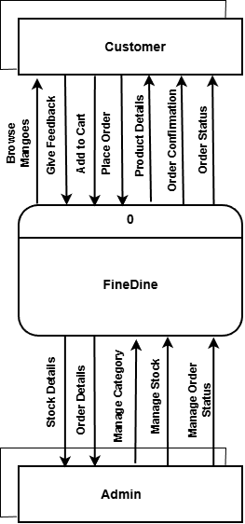

DFD1

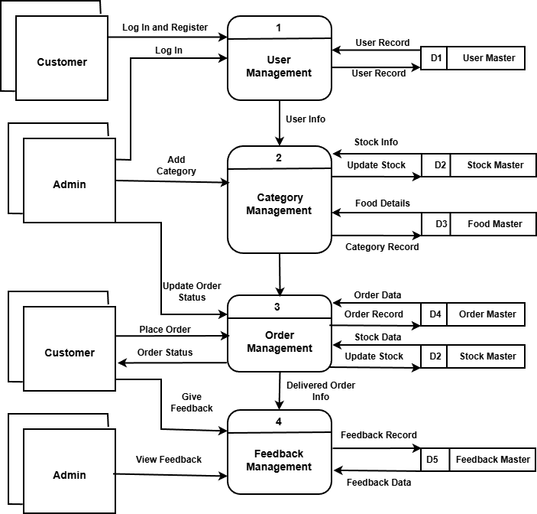

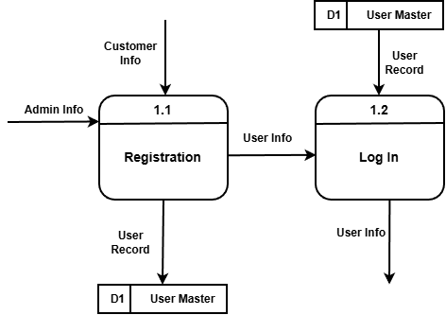

DFD1 Process 1

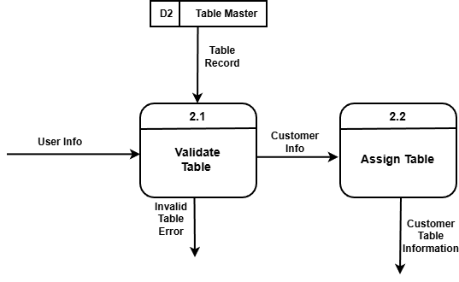

DFD2 process 2

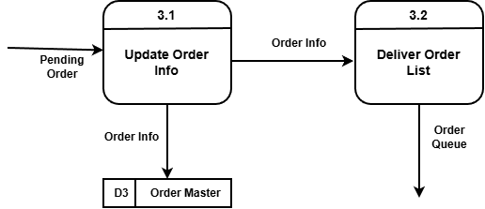

DFD2 process 3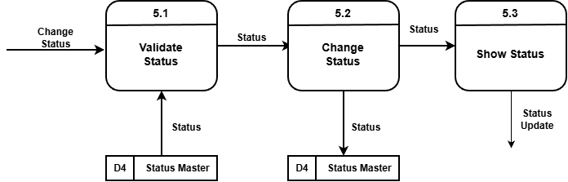

DFD2 Process 4

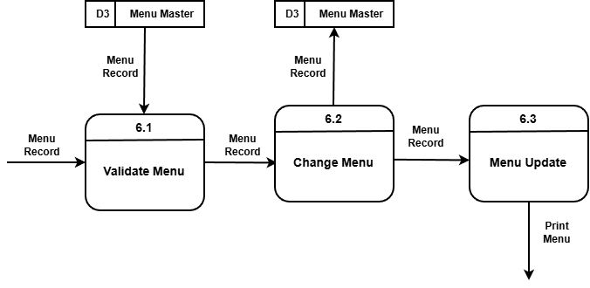

7.2 ERD
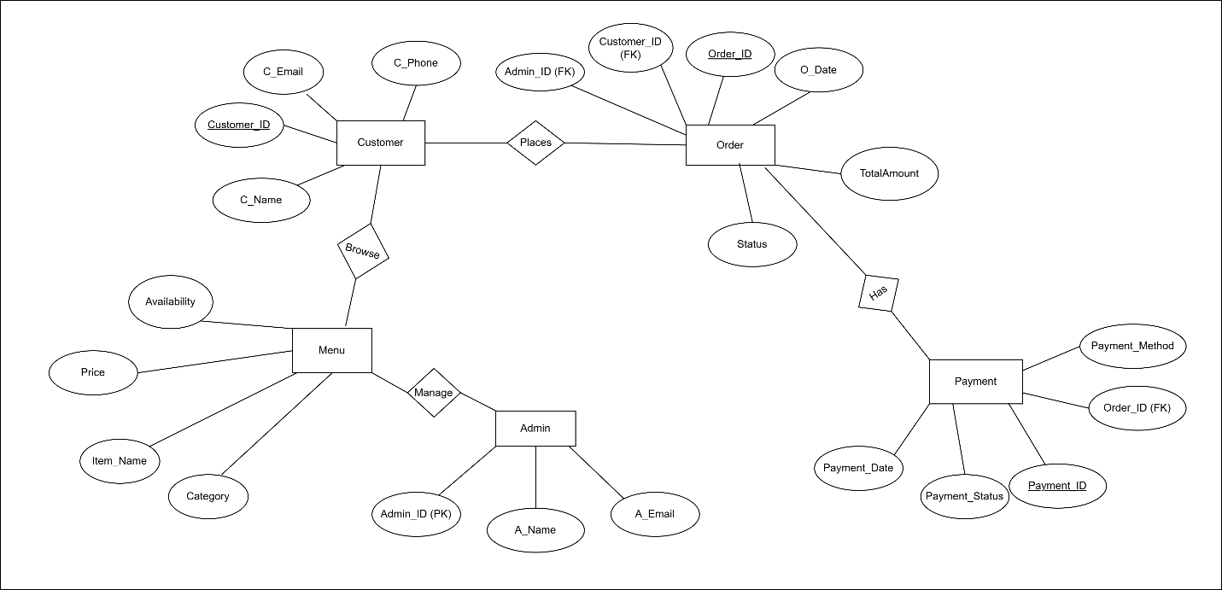

7.3 Interface Design

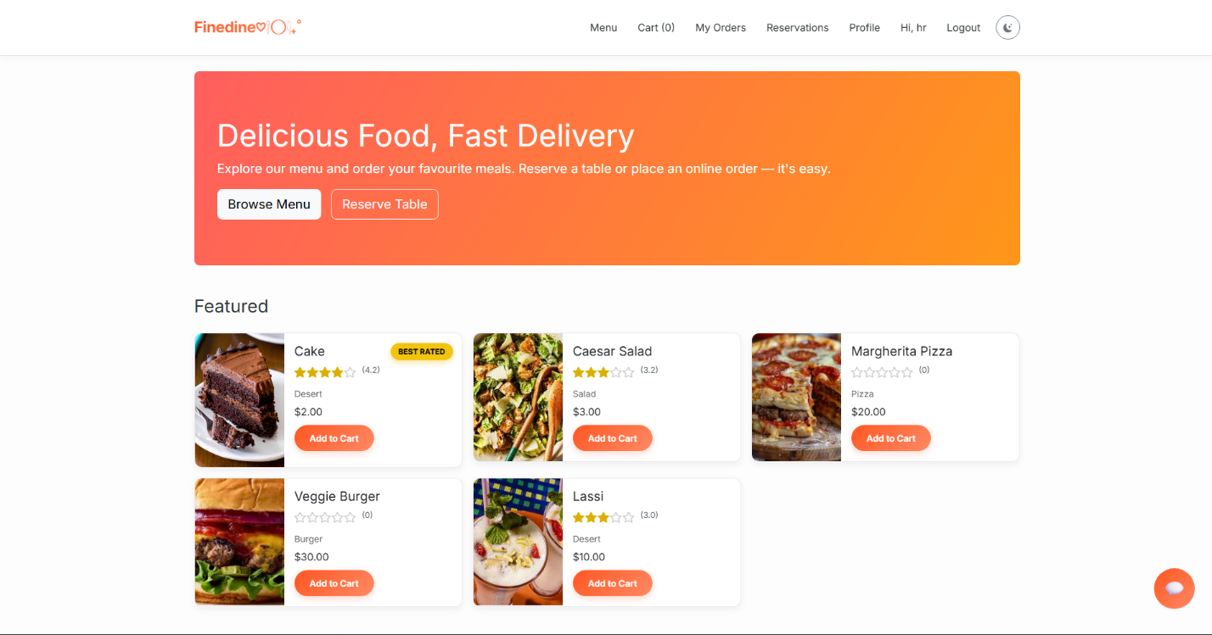

Chapter 8: Testing

8.1 Produced Test Cases (For all requirements)

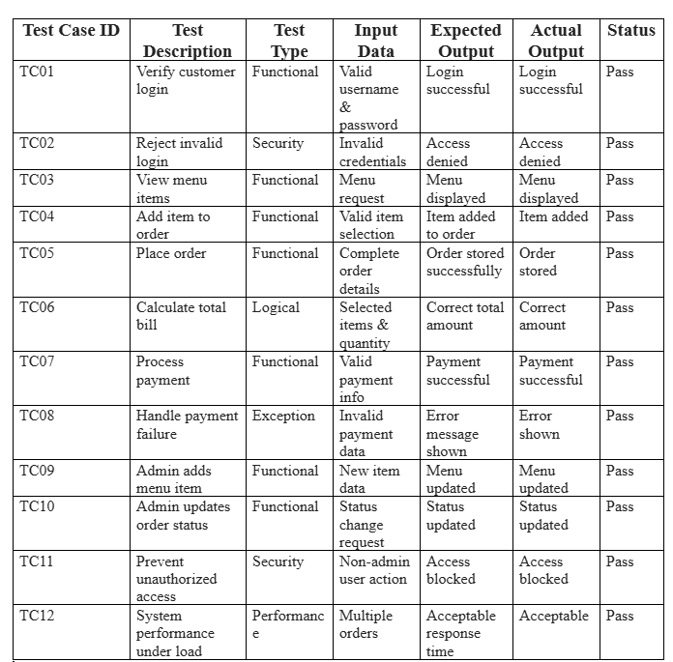

Chapter 9: Conclusion

9.1 Brief Overview of Project

The development of the Restaurant Management System successfully demonstrates the application of modern web frameworks to solve real-world service industry challenges. By centralizing menu management, table reservations, and digital payments into a single platform, the system enhances operational efficiency and improves the overall customer experience.
This project is a Flask-based web application designed to streamline the operations of a modern restaurant through a dual-interface system for customers and administrators. Key features include:​
Comprehensive Ordering System: Users can browse categorized menus, manage a digital shopping cart, and choose between Cash on Delivery or integrated bKash mobile payments.​
Dynamic Table Reservation: The system includes logic to prevent double-booking by validating table availability against existing schedules in the database.​
Administrative Control: A secure backend allows staff to update menu availability, manage user accounts, and generate automated PDF invoices for customers.​
Data Integrity: The application utilizes a relational SQLite database managed via SQLAlchemy to ensure structured storage of all user, order, and reservation data.

9.2 Limitation of Project

Despite its robust core functionality, the current version of the system has certain limitations that provide opportunities for future enhancement:
Security Constraints: The system currently uses simple session-based authentication and is not yet optimized for production-level security environments.​
Notification Services: There is no integrated email or SMS notification system to alert users of order confirmations or reservation reminders.​
Real-time Analytics: While the admin can view orders, the system lacks an advanced graphical dashboard for real-time sales analytics and trend reporting.​
Manual Image Management: Images are currently handled via local storage placeholders; a more scalable solution would require integration with a cloud-based content delivery network (CDN).​
Single Gateway: The digital payment system is exclusively configured for bKash, limiting options for users who prefer other mobile wallets or credit card processors.

