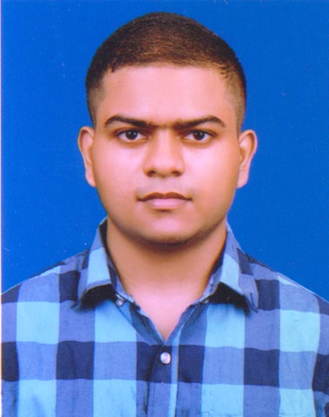
CURRICULUM VITAE
of
MD. HARUN OR RASHID
Contact No: +8801850049891
E-mail: hr1349891@gmail.com
Career Objective:
To work as a responsible person where I could use my Interpersonal skills, Creative and above all my learning experience in order to develop my career as well as to contribute in any sector.
Educational Qualification:
B.Sc-in- Computer Science & Engineering
➢ Name of Institute : International University of Business Agriculture and Technology
➢ Technology : Computer Science and Engeneering
➢ Duration : 4 years
➢ Passing Year : [ Studying ]
Higher Secondary Certificate (H.S.C)
➢ Name of Institute : Rajendrapur Cantonment Public School & College, , Gazipur
➢ Board : Dhaka
➢ Group : Science
➢ Duration : 2 years
➢ Passing Year : 2019
➢ Result : CGPA- 5.00 Out of 5.00
Secondary School Certificate (S.S.C)
➢ Name of Institute : Rajendrapur Cantonment Public Scool & College, Gazipur
➢ Board : Dhaka
➢ Group : Science
➢ Passing Year : 2017
➢ Result : GPA- 4.78 Out of 5.00
Personal Information:
➢ Name : Md. Harun Or Rashid
➢ Father’s Name : Md. Rashidur Rahman
➢ Mother’s Name : Fardoushi Rahman
➢ Date of Birth : 13th June, 2001
➢ Nationality : Bangladeshi (By Birth)
➢ Religion : Islam (Sunni)
➢ Marital Status : Un-married
➢ Sex : Male
➢ Height : 5′-3″
➢ Weight : 65 kg
➢ Blood Group : O⁺ (ve)
➢ National Id No : 4665238012
➢ Contact No : +8801850049891

Present Address:
 Name : Md. Harun Or Rashid
 C/O : Md. Rashidur Rahman
 Vill : Kawa Poshcim Khondo
 Post : Mawna
 P.S : Sreepur
 Dist : Gazipur
Permanet Address:
 Name : Md. Harun Or Rashid
 C/O : Md. Rashidur Rahman
 Vill : Shalgaria
 Post : Pabna
 P.S : Pabna Sadar
 Dist : Pabna
Language Skills:
Language Writing/Reading Spoken
 Bengali Excellent Excellent
 English Excellent Excellent
(Certified by- “British Council”)
Interested:
➢ I have interested in Singing, Sports, Traveling, Sports and so on..
Hobby:
➢ Public Speaking, Making Presentations, Teaching and Stage Performing.
Computer Skills:
- Webpage Developing(Full Stack), Ms- Word, Ms- Excel, Ms- Power Point, Ms- Excel & Browsing.
Experience:
★ Office Executive, Ultimos IT Solution
★ Junior Web Developer, Nordhex
★ Web Executive, DCodes
★ Telesales And Marketing Executive, Skytech
Declaration:
I do hereby declare the information presented above is true the extent of my knowledge. If required & where applicable these documents can be supported by appropriate authentic papers.

Signature:

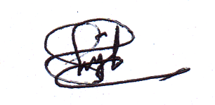
……………….............
(Md. Harun Or Rashid)
Date………….

