import java.io.*;

public class pass {

public static void main(String[] args) throws IOException {

mdt[] MDT = new mdt[20];

mnt[] MNT = new mnt[10];

arglist[] formal_parameter = new arglist[10];

arglist[] actual_parameter = new arglist[10];

int macro_addr = -1;

boolean macro_start = false, macro_end = false;

int macro_call = -1;

int mdt_cnt = 0, mnt_cnt = 0, formal_arglist_cnt = 0, actual_arglist_cnt = 0, temp_cnt = 0, temp_cnt1 = 0;

BufferedReader br1 = new BufferedReader(new FileReader("D:\\TCOB10\\MacroAssembler2\\src\\MNT.txt"));

String line;

while ((line = br1.readLine()) != null) {

String[] parts = line.split("\\s+");

MNT[mnt_cnt++] = new mnt(parts[0], Integer.*parseInt*(parts[1]), Integer.*parseInt*(parts[2]));

}

br1.close();

System.***out***.println("\n\t*************MACRO NAME TABLE***************");

System.***out***.println("\n\tINDEX\tNAME\tADDRESS\tTOTAL ARGUMENTS");

for (int i = 0; i < mnt_cnt; i++)

System.***out***.println("\t" + i + "\t" + MNT[i].name + "\t" + MNT[i].addr + "\t\t" + MNT[i].arg_cnt);

br1 = new BufferedReader(new FileReader("D:\\TCOB10\\MacroAssembler2\\src\\argmnt.txt"));

while ((line = br1.readLine()) != null) {

String[] parameters = line.split("\\s+");

formal_parameter[formal_arglist_cnt++] = new arglist(parameters[0]);

if (parameters.length > 1)

formal_parameter[formal_arglist_cnt - 1].value = parameters[1];

}

br1.close();

System.***out***.println("\n\n\t*************FORMAL ARGUMENT LIST*********");

System.***out***.println("\n\tINDEX\tNAME\tVALUE");

for (int i = 0; i < formal_arglist_cnt; i++)

System.***out***.println("\t" + i + "\t" + formal_parameter[i].argname + "\t" + formal_parameter[i].value);

br1 = new BufferedReader(new FileReader("D:\\TCOB10\\MacroAssembler2\\src\\MDT.txt"));

while ((line = br1.readLine()) != null) {

MDT[mdt_cnt] = new mdt();

MDT[mdt_cnt++].stmnt = line;

}

br1.close();

System.***out***.println("\n\t**************MACRO DEFINITION TABLE************");

System.***out***.println("\n\tINDEX\t\tSTATEMENT");

for (int i = 0; i < mdt_cnt; i++)

System.***out***.println("t" + i + "\t" + MDT[i].stmnt);

br1 = new BufferedReader(new FileReader("D:\\TCOB10\\MacroAssembler2\\src\\input4.txt"));

BufferedWriter bw1 = new BufferedWriter(new FileWriter("D:\\TCOB10\\MacroAssembler2\\src\\output.txt"));

while ((line = br1.readLine()) != null) {

line = line.replaceAll(",", " ");

String[] tokens = line.split("\\s+");

temp_cnt1 = 0;

for (String current_token : tokens) {

if (current_token.equalsIgnoreCase("macro")) {

macro_start = true;

macro_end = false;

}

if (macro_end && !macro_start) {

if (macro_call != -1 && temp_cnt < formal_arglist_cnt - 1) {

if (formal_parameter[actual_arglist_cnt].value != "")

actual_parameter[actual_arglist_cnt++] = new arglist(formal_parameter[actual_arglist_cnt - 1].value);

actual_parameter[actual_arglist_cnt++] = new arglist(current_token);

if (formal_parameter[actual_arglist_cnt].value != "")

actual_parameter[actual_arglist_cnt++] = new arglist(formal_parameter[actual_arglist_cnt - 1].value);

}

for (int i = 0; i < mnt_cnt; i++) {

if (current_token.equals(MNT[i].name)) {

macro_call = i;

temp_cnt1 = temp_cnt1 + MNT[i].arg_cnt;

break;

}

temp_cnt1 = temp_cnt1 + MNT[i].arg_cnt;

}

if (macro_call == -1)

bw1.write("\t" + current_token);

}

if (current_token.equalsIgnoreCase("mend")) {

macro_end = true;

macro_start = false;

}

}

if (macro_call != -1) {

macro_addr = MNT[macro_call].addr + 1;

while (true) {

if (MDT[macro_addr].stmnt.contains("mend") || MDT[macro_addr].stmnt.contains("MEND")) {

macro_call = -1;

break;

} else {

bw1.write("\n");

String[] temp_tokens = MDT[macro_addr++].stmnt.split("\\s+");

for (String temp : temp_tokens) {

if (temp.matches("#[0-9]+")) {

int num = Integer.*parseInt*(temp.replaceAll("[^0-9]+", ""));

// Check if actual_parameter[num-1] is not null

if (actual_parameter[num - 1] != null) {

bw1.write(actual_parameter[num - 1].argname + "\t");

} else {

bw1.write("undefined_arg\t"); // Handle undefined argument case

}

} else {

bw1.write(temp + "\t");

}

}

}

}

}

if (!macro_start)

bw1.write("\n");

macro_call = -1;

}

br1.close();

bw1.close();

System.***out***.println("\n\n\t*****************ACTUAL ARGUMENT LIST***************");

System.***out***.println("\n\tINDEX\tNAME\tADDRESS");

for (int i = 0; i < actual_arglist_cnt; i++)

System.***out***.println("\t" + i + "\t" + actual_parameter[i].argname);

}

}

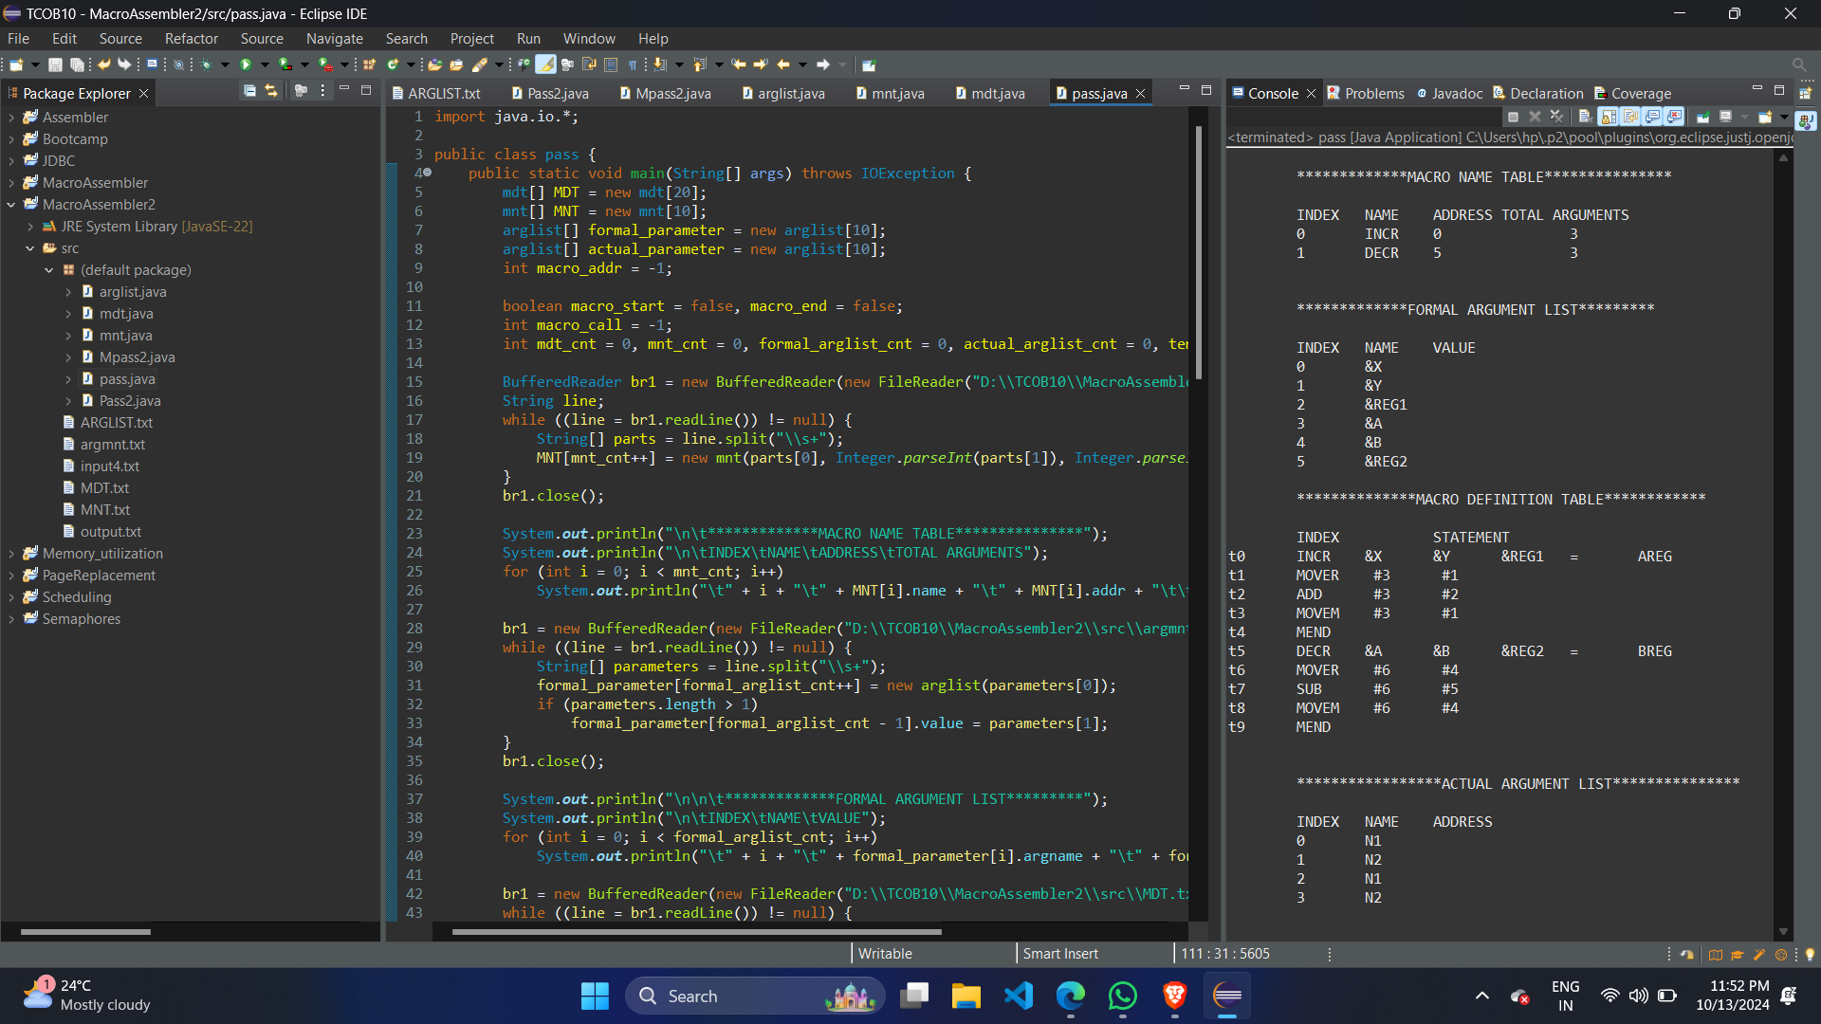**OUTPUT:-**