Cognitive Ceiling: Learning Efficiency Analytics

BY,
Data Science Team
Hithesh Reddy
Asad Tafheem
Hari Charan Reddy
Yashraf Khan

TABLE OF CONTENTS

SI NO | CONTENTS |  |  |  |  |  |  | PAGE NO
 | ABSTRACT
1 | INTRODUCTION
2 | PROBLEM STATEMENT
3 | SOFTWARE REQUIREMENT SPECIFICATION
 | 3.1 | PURPOSE
 | 3.2 | OBJECTIVES
 | 3.3 | REQUIREMENTS
 |  | 3.3.1 |  |  |  |  | SOFTWARE REQUIREMENTS
 |  | 3.3.2 |  |  |  |  | HARDWARE REQUIREMENTS
4 | DATASET & METHODOLOGY
 | 4.1 |  | DATASET DESCRIPTION
 | 4.2 |  | DATA COLLECTION
 | 4.3 |  | DATASET STRUCTURE
 | 4.4 |  | METHODOLOGY
 | 4.5 |  | KEY PERFORMANCE INDICATORS
5 | IMPLEMENTATION
 | 5.1 |  |  | SYSTEM IMPLEMENTATION AND OVERVIEW
 | 5.2 |  |  | DATA INTEGRATION
 | 5.3 |  |  | DATA MODELING
 | 5.4 |  |  | DASHBOARD DEVELOPMENT
 | 5.5 |  |  | INTERACTIVITY FEATURES
 | 5.6 |  |  | TESTING AND VALIDATION
6 | RESULT ANALYSIS
 | 6.1 |  |  |  | PERFORMANCE EVALUATION
 | 6.2 |  |  |  | ANALYSIS & INSIGHTS
7 | CONCLUSION &FUTURE SCOPE
 | 7.1 |  |  |  |  | CONCLUSION
 | 7.2 |  |  |  |  | FUTURE SCOPE

ABSTRACT
In the modern learning environment, students often equate long study hours with productivity. However, this leads to a phenomenon known as the Illusion of Competence, where increased effort does not result in improved learning outcomes. Existing tools focus only on tracking study time or performance independently, without analyzing the relationship between them.
This project introduces Cognitive Ceiling, a data analytics solution developed using Power BI to measure learning efficiency by correlating study duration, learning strategies, and performance outcomes. The system identifies the Cognitive Ceiling, the point at which additional study hours lead to diminishing or negative returns.
By leveraging key performance indicators such as Retention Rate, Retention per Hour (RPH), Active Learning Ratio, and Burnout Risk Index, the dashboard provides actionable insights that help students optimize study strategies, reduce burnout, and improve academic performance.

1. INTRODUCTION
In today’s academic landscape, students dedicate significant time to studying, yet often fail to achieve proportional results. This inefficiency arises due to passive learning methods, cognitive fatigue, and the lack of structured feedback on learning effectiveness.
Traditional tools such as timers, to-do lists, and grading systems provide only surface-level insights. While they measure how long students study or what scores they achieve, they fail to capture the deeper relationship between effort and actual learning outcomes. As a result, students struggle to identify their optimal study durations, effective learning techniques, and peak productivity periods.
One of the major underlying issues is the concept of the Illusion of Competence, where learners feel productive simply by spending more time studying, even if retention and understanding remain low. This leads to inefficient study patterns, poor time management, and increased mental fatigue.
The Cognitive Ceiling project addresses this critical gap by applying data analytics to study behaviour. Using Power BI, the system integrates study session data, learning strategies, and assessment performance into a unified analytical framework. It focuses not only on measuring performance but also on evaluating learning efficiency.
A key innovation of this project is the identification of the Cognitive Ceiling—the point at which additional study time no longer improves performance and may even reduce efficiency due to fatigue. By detecting this threshold, the system enables students to optimize their study schedules and avoid burnout.
Furthermore, the project emphasizes the importance of active learning strategies over passive ones. By comparing different methods such as reading, watching videos, and practice-based learning, the dashboard provides actionable insights into which approaches yield the highest retention.
Overall, the Cognitive Ceiling system transforms raw study data into meaningful intelligence. It empowers students to shift from time-based studying to outcome-based learning, enabling smarter decisions, improved academic performance, and sustainable study habits.

2.PROBLEM STATEMENT
Students frequently encounter the following challenges:
- Spending long hours studying with low retention
- Over-reliance on passive learning methods (videos, reading)
- Lack of awareness of optimal study duration
- Increased burnout due to inefficient study patterns
Existing tools fail to answer a critical question:
When does studying more stop being useful?
This project aims to solve this problem by identifying the Cognitive Ceiling and providing insights to improve study efficiency and decision-making.

3.SOFTWARE REQUIREMENT SPECIFICATION
3.1 PURPOSE
The primary purpose of this project is to design and develop an interactive Power BI dashboard that evaluates and improves learning efficiency by analyzing the relationship between study time, learning methods, and performance outcomes.
Unlike traditional productivity tools that focus only on tracking time or scores, this system aims to provide a holistic view of the learning process. It integrates multiple factors such as study duration, focus levels, learning strategies (active vs passive), and assessment results to generate meaningful insights.
A key objective of this system is to identify the Cognitive Ceiling, which represents the threshold at which additional study time no longer contributes positively to learning and may lead to reduced efficiency due to cognitive fatigue. By detecting this point, the system helps users optimize their study schedules and avoid burnout.
Furthermore, the project aims to transform raw study data into actionable intelligence, enabling students to make informed decisions about how they study, rather than how long they study. Ultimately, the system promotes a shift from effort-based learning to outcome-driven and efficient learning practices.

3.2 OBJECTIVES
The key objectives of this project are as follows:
1)To measure learning efficiency instead of just study duration:
The system focuses on evaluating how effectively a student learns within a given time frame, rather than simply tracking the number of hours spent studying.
2)To Identify the cognitive ceiling point:
To determine the threshold at which additional study hours result in diminishing or negative returns in performance, helping students avoid over-studying.
3)To analyse active vs passive learning strategies:
To compare the effectiveness of different learning methods such as reading, watching videos, and practicing problems, and highlight the benefits of active learning techniques.
4)To detect burnout risk using performance trends:
To monitor patterns of declining performance over time and identify early signs of cognitive fatigue and burnout using data-driven indicators.
5)To provide data-driven insights for better study planning:
To generate actionable recommendations that help students optimize study schedules, improve retention, and enhance overall academic performance.
6)To improve decision-making in learning strategies:
To enable students to make informed choices about when to study, how long to study, and which methods to use for maximum effectiveness.

7) To enhance productivity and reduce wasted effort:
To minimize inefficient study habits and ensure that time invested in learning yields meaningful outcomes.

3.3 REQUIREMENTS:
3.3.1 SOFTWARE REQUIREMENTS
- Power BI Desktop
- Microsoft Excel / CSV
- Power Query
- DAX (Data Analysis Expressions)
- SQL
- VS Code
- Web Browser (Chrome/Edge)
- Operating System – Windows 10/11 (recommended for full Power BI support).

3.3.2 HARDWARE REQUIREMENTS
The hardware requirements for the system are as follows:
1)Processor – Intel i3/i5 or higher (i7 recommended for better performance).
2)RAM – Minimum 8 GB (16 GB recommended for handling large datasets).
3)Storage – Minimum 256 GB (SSD recommended for faster performance).
4)Display – Full HD monitor (1920×1080)
5)Graphics Support – Integrated GPU sufficient.
6)Keyboard & Mouse.

4.DATASET & METHODOLOGY
4.1 DATASET DESCRIPTION
The dataset consists of structured study session data and assessment results designed to analyze learning efficiency.
It follows a Star Schema model, ensuring efficient data relationships and analysis.

4.2 DATA COLLECTION
Source of Data
- Self-tracked study logs
- Simulated datasets for analysis
Type of Data
- Study session data (duration, method, focus)
- Assessment data (scores, difficulty)

4.3 DATASET STRUCTURE
Fact Tables
Fact Sessions
- SessionID
- Date
- ResourceID
- MethodID
- Duration Minutes
- Focus Score
- Passive Flag
- Hour
- Date Time

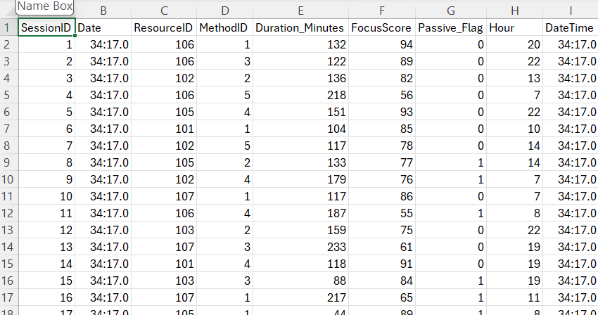
Fact Assessments
- AssessmentID
- SessionID
- Subject
- Questions Total
- Questions Correct
- Difficulty Rating
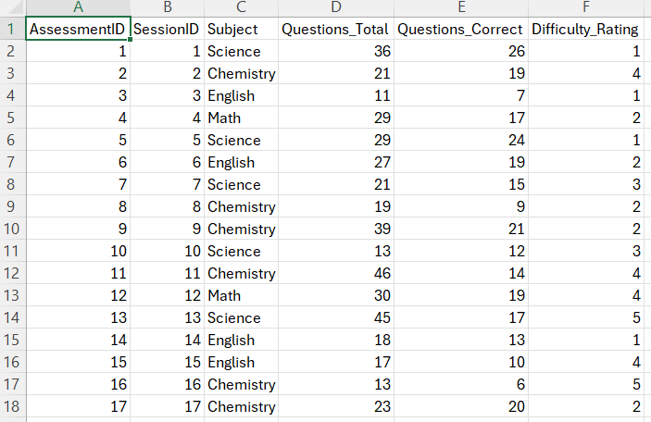

Dimension Tables
Dim Methods
- MethodID
- Method Name (Pomodoro, Deep Work, etc.)
- Strategy Type (Active / Passive)

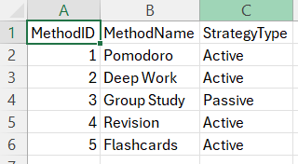
Dim Resources
- ResourceID (PK)
- Resource Type (Video, Book, Article)
- Title
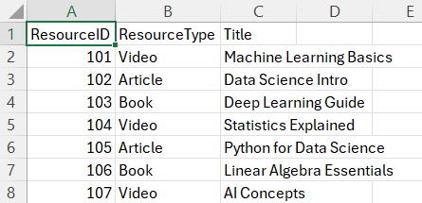

Dim Date
- Date, Month, Weekday, Is Weekend
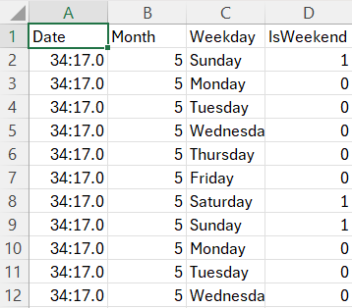
4.4 METHODOLOGY:
1) Data Cleaning using Power Query
2)Data Modelling using Star Schema
3)KPI creation using DAX
4) Dashboard design using Power BI visuals

4.5 KEY PERFORMANCE INDICATORS:

Retention %
Avg Retention % =
DIVIDE (SUM (Fact Assessments [Questions_Correct]),
SUM (Fact Assessments [Questions_Total]), 0)

Total Study Hours
Total Study Hours =SUM (Fact Sessions [Duration_Minutes]) / 60

RPH
RPH =DIVIDE ([Avg Retention %] * 100, [Total Study Hours], 0)

Active Ratio
Active Ratio =
VAR Active Hours =CALCULATE ([Total Study Hours],
Dim Methods [Strategy Type] = "Active")
RETURN DIVIDE (Active Hours,
[Total Study Hours], 0)

Burnout Alert:
Burnout Alert =IF ([Avg Retention %] < 0.6 &&
[Total Study Hours] > 6,
"High Risk", "Optimal")

5. IMPLEMENTATION
5.1 SYSTEM IMPLEMENTATION AND OVERVIEW
The system is implemented using Power BI to convert raw study data into meaningful insights through interactive dashboards.

5.2 DATA INTEGRATION
- Import datasets into Power BI
- Clean data using Power Query

5.3 DATA MODELING
- Create relationships between tables
- Implement Star Schema

5.4 DASHBOARD DEVELOPMENT
Page 1: Efficiency Overview
- KPI Cards (RPH, Retention %, Active Ratio)
- Scatter Chart (Hours vs Score)
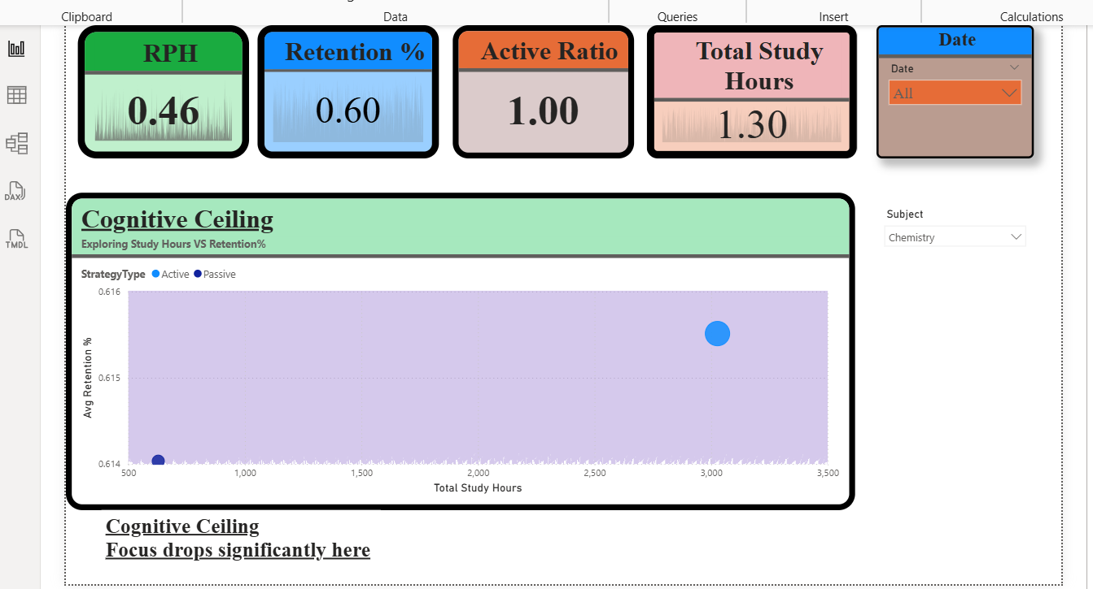

Page 2: Learning Strategy Analysis
- Donut Chart (Active vs Passive)
- Line Chart (Retention comparison)
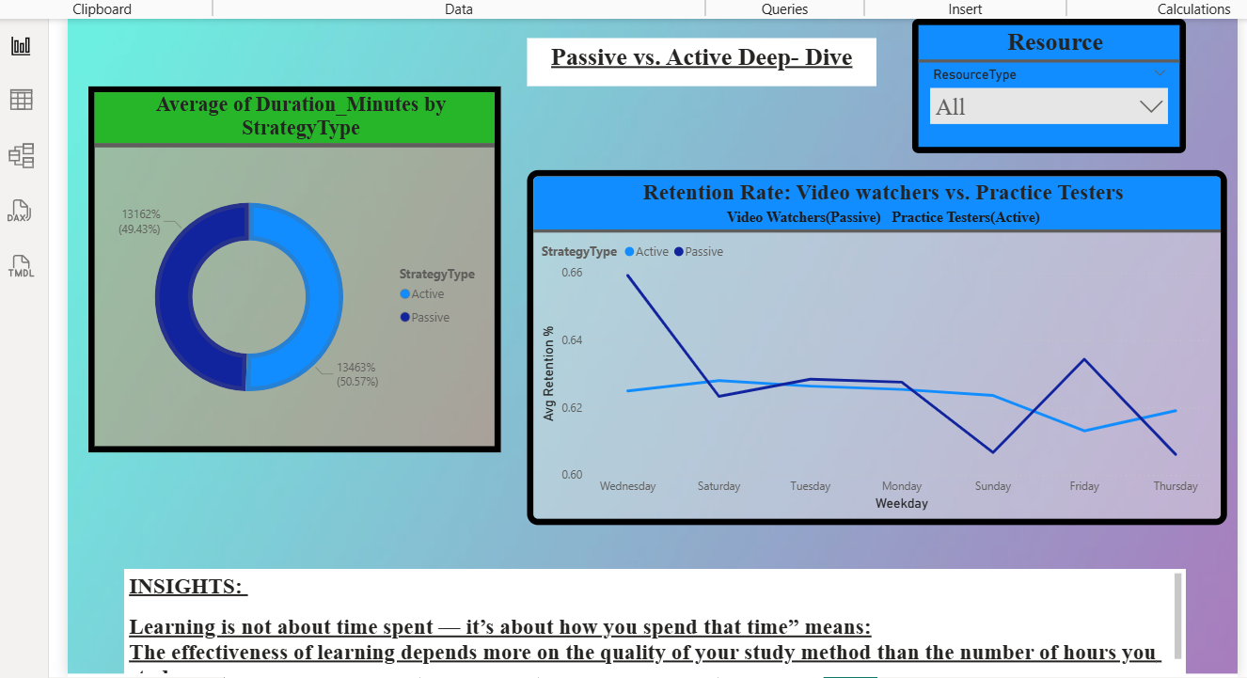

Page 3: Burnout Analysis
- Heatmap (Focus Score vs Time)
- Trend Chart (Performance over time)

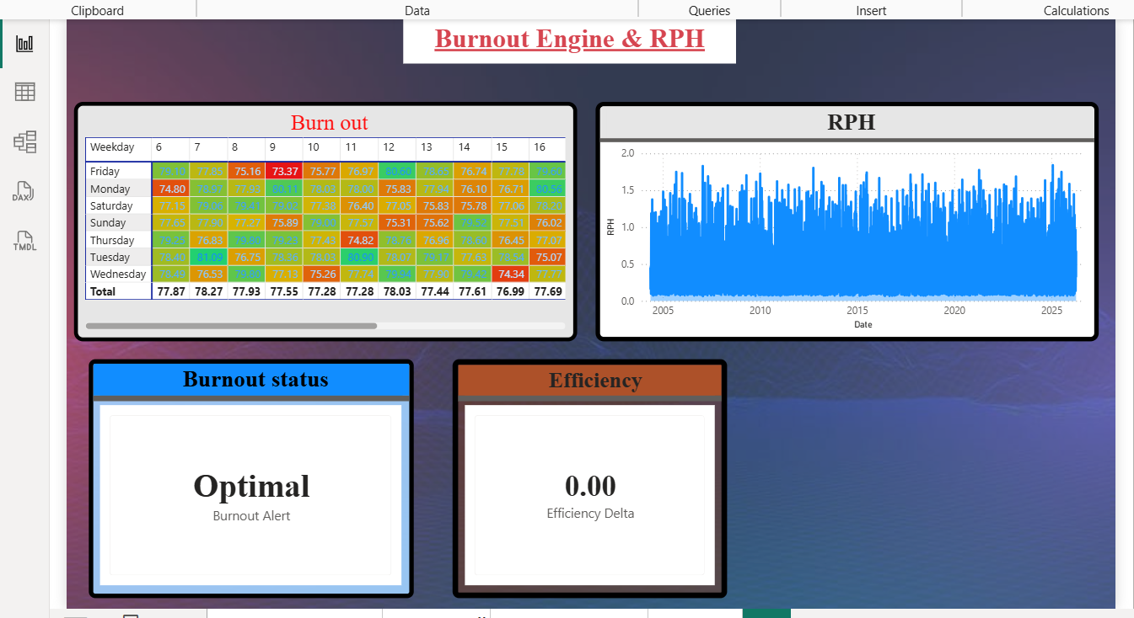

Page4: Summary

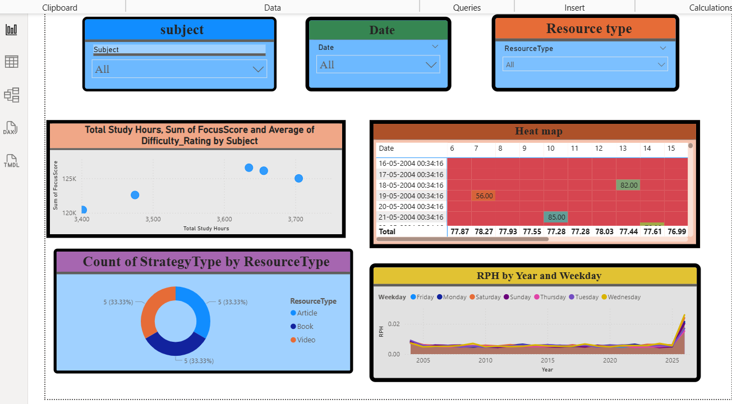

5.5 INTERACTIVITY FEATURES
- Subject Filter
- Date Range Slicer
- Drill-through Analysis

5.6 TESTING AND VALIDATION
- Verified DAX calculations
- Validated relationships
- Tested dashboard responsiveness

6. RESULT ANALYSIS
6.1 PERFORMANCE EVALUATION
- Identified decline in performance after certain study hours
- Active learning methods showed higher retention
- Passive methods resulted in lower efficiency
6.2 ANALYSIS AND INSIGHTS
- More study time ≠ better results
- Learning efficiency depends on method and focus
- Burnout occurs after exceeding Cognitive Ceiling
- Active learning significantly improves retention

7. CONCLUSION & FUTURE SCOPE
7.1 CONCLUSION
The Cognitive Ceiling project successfully demonstrates how data analytics can be leveraged to improve learning efficiency and study effectiveness. By integrating study session data, learning methods, and performance metrics, the system provides a comprehensive understanding of how students learn over time.
One of the key achievements of this project is the identification of the Cognitive Ceiling, which represents the point where additional study effort leads to diminishing or negative returns. This insight helps users avoid over-studying and manage their time more effectively.
The project also highlights the importance of active learning strategies, showing that methods such as practice and problem-solving lead to better retention compared to passive techniques like reading or watching videos. Additionally, the system is capable of detecting early signs of burnout by analyzing declining performance trends.
Overall, the Cognitive Ceiling dashboard transforms raw data into meaningful insights, enabling students to make smarter, data-driven decisions. It promotes a shift from time-based studying to efficiency-focused learning, ultimately improving academic performance and reducing wasted effort.

7.2 FUTURE SCOPE
The project can be further enhanced by incorporating advanced features and technologies to make the system more powerful and scalable:
- Integration with real-time study tracking applications:
The system can be connected with mobile or web-based study tracking apps to collect real-time data automatically, improving accuracy and usability.
- AI-based personalized study recommendations:
Machine learning algorithms can be used to suggest personalized study plans based on individual learning patterns, strengths, and weaknesses.
- Predictive analytics for performance forecasting:
Advanced predictive models can be implemented to forecast future performance and identify potential risks in advance.
- Mobile-based dashboard development:
Developing a mobile-friendly version of the dashboard will improve accessibility and allow users to track their learning efficiency on the go.
- Integration with educational platforms:
The system can be integrated with e-learning platforms to analyze course-specific performance and provide deeper insights.
- Advanced visualization and automation:
Enhancing dashboard visuals and automating report generation can improve user experience and decision-making efficiency.

