REGEN_Analysis
Hannah Redford
2025-08-07

Methods for analyzing post-fire regeneration amounts of conifer, oak, and shrub vegetation compositions.
This write up details the statistical methods I used to model conifer, oak and shrub regeneration 7+ years after high severity fire in Yosemite National Park. Here, I include figures, model tests, and results of the analysis. The purpose of this document is to validate the methods and make sure everything I have done is solid and we can move on with the manuscript writing. I will also include an outline for the manuscript write up, but I wanted to make sure everything was working well before that.
The inputs to the models are metrics derived from understory vegetation averaged to 20x20m pixels (this is the size of the field plots used or ground truth validation). The understory vegetation segmentation will be published as a seperate paper and GitHub package.
Field data provided us with vegetation counts from each plot of oaks and conifers as well as percent cover of shurbs. This data is heavily zero inflated, therefor the analysis uses three seperate hurdle models (one for each vegetation type) to predict vegetation amounts (non, low, medium, and high). The first step in the hurdle model removes zeros from the data using a logistic regression to predict vegetation presence/ absence. Then, using the non-zero counts, the oak and conifer data are sorted into ordinal catagories (low, medium, and high) and predicted using an ordinal logistic regression. The shrub percent covers are modeled using a beta-regression.
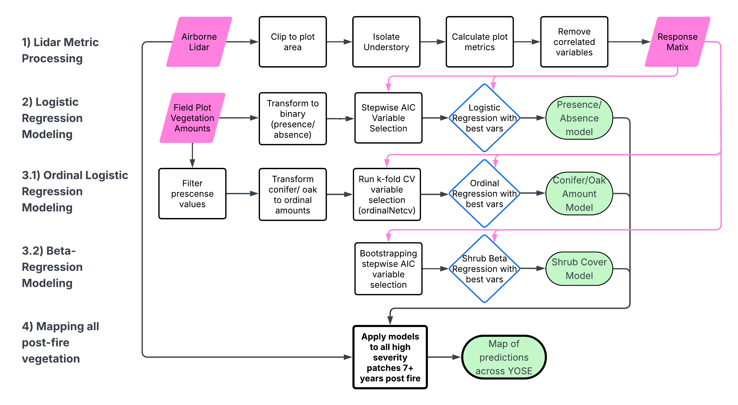 # Logistic Regregression

Variable Selection
With only 113 plots and over 100 variables, the variable selection process had to narrow down the number of metrics. To reduce dimensionallity of the variables, the highly correlated variables were removed from the metric data frame. The findCorrelation() function identifies pairwise correlated variables and removes the variable with the largest mean absolute correlation while keeping the other one. This allows us to retain potentially important variables that may account for a large amount of variance within the models.
The resulting response matrix is reduced from 105 variables to 25 variables, which is a much easier data set to work with. The top model is chosen using a stepwise AIC process looking at all possible combinations of the 25 variables.
## Best formula Conifer Model: success ~ zmean_55to85 + curv_90to99 + b2 + b8w + ndviw + ndirw
## Best AIC Conifer Model: 111.8162
## Best formula Shrub Model: success ~ iqr95_90to99 + b2 + b12w + ndvi + ndirs + ndviw
## Best AIC Shrub Model: 77.85273
## Best formula Oak Model: success ~ curv_90to99 + curv_TAO + lin_TAO + ndvi + ndviw + ndirw
## Best AIC Oak Model: 70.50494
PARAGRAPH ON CONIFER VARS
PARAGRAPH ON OAK VARS
PARAGRAPH ON SHRUB VARS

Logistic regression model test statistics:
The formulas that came out as important are then tested using leave one out cross validation (LOOCV). LOOCV trains a model using all but one record in the data set. The single record is then predicted using the model. This way, we can test accuracy on a small data set without training and testing data. The test statistic is refered to as an F-Score, and the closer to 1 the better the model preformance. Here are the f-scores from each of the logistic regression models:
## Conifer F-score: 0.7352941
## Oak F-score: 0.7586207
## Shrub F-score: 0.8648649

Ordinal Logistic Regression Models (OLR)
Variable selection for the OLR models and the beta-regression models are slightly different. First, the OLR only used structural metrics rather than both structural and spectral metrics to determine the amounts. The spectral metrics were not behaving well in the OLR models and often times drastically decreased performance.
Furthermore, since we are running the models on a subsample of the data, the sample sizes tended to be even smaller. The function ordinalnetCV() from the ordinalNet package addresses this by applying elastic net regularization, which combines lasso and ridge regularization to improve the model fit. Through tuning, we enabled both parallelTerms and nonparallelTerms to fit a semi-parallel model, allowing certain variables to vary between classes while most share a common slope. Essentially, what seperates the classes from each other will be different (e.g., what separates Low from Medium is different than what separates Medium from High).
The model was trained using 5-fold cross-validation and lambda values were selected based on minimizing misclassification error. The output of the function is a list of usable metrics ranked by their lambda values.

Conifer Ordinal Logistic Regression Model
Model Variables:
## [1] "(Intercept)" "emax_TAO" "planar_85to95" "emid_55to85"
## [5] "rumple_90to99"
Summary of Conifer Model Coefficients by Predictor
 | Predictor | Parallel_Effect | Deviation_Threshold1 | Deviation_Threshold2 | Interpretation
emax_TAO | emax_TAO | -0.3790 | 0.0000 | -0.2151
planar_85to95 | planar_85to95 | 1.9593 | 0.0000 | 0.3408
emid_55to85 | emid_55to85 | -1.4917 | -2.7166 | 0.0000
rumple_90to99 | rumple_90to99 | -0.2650 | -0.0010 | 0.0000
Test Statistics for Conifer Ordinal Logistic Regression:
## Confusion Matrix and Statistics
##
## Reference
## Prediction Low Medium High
## Low 12 4 0
## Medium 7 16 5
## High 2 3 20
##
## Overall Statistics
##
## Accuracy : 0.6957
## 95% CI : (0.5731, 0.8008)
## No Information Rate : 0.3623
## P-Value [Acc > NIR] : 1.916e-08
##
## Kappa : 0.5409
##
## Mcnemar's Test P-Value : 0.3451
##
## Statistics by Class:
##
## Class: Low Class: Medium Class: High
## Sensitivity 0.5714 0.6957 0.8000
## Specificity 0.9167 0.7391 0.8864
## Pos Pred Value 0.7500 0.5714 0.8000
## Neg Pred Value 0.8302 0.8293 0.8864
## Prevalence 0.3043 0.3333 0.3623
## Detection Rate 0.1739 0.2319 0.2899
## Detection Prevalence 0.2319 0.4058 0.3623
## Balanced Accuracy 0.7440 0.7174 0.8432

Oak Ordinal Logistic Regression
Model Variables:
## [1] "(Intercept)" "emid_55to85" "emin_90to99" "linear_90to99"
## [5] "emin__TAO"
Test Statistics for Oak Ordinal Logistic Regression:
## Confusion Matrix and Statistics
##
## Reference
## Prediction Low Medium High
## Low 7 1 1
## Medium 1 9 3
## High 1 1 6
##
## Overall Statistics
##
## Accuracy : 0.7333
## 95% CI : (0.5411, 0.8772)
## No Information Rate : 0.3667
## P-Value [Acc > NIR] : 4.876e-05
##
## Kappa : 0.5973
##
## Mcnemar's Test P-Value : 0.8013
##
## Statistics by Class:
##
## Class: Low Class: Medium Class: High
## Sensitivity 0.7778 0.8182 0.6000
## Specificity 0.9048 0.7895 0.9000
## Pos Pred Value 0.7778 0.6923 0.7500
## Neg Pred Value 0.9048 0.8824 0.8182
## Prevalence 0.3000 0.3667 0.3333
## Detection Rate 0.2333 0.3000 0.2000
## Detection Prevalence 0.3000 0.4333 0.2667
## Balanced Accuracy 0.8413 0.8038 0.7500

Shrub Beta Regression
The beta-regression model is ideal for proportional data that is bounded between zero and one. While it does not handle zeros well, we dealt with that using a hurdle model framework. Let’s take a look at the values of the shrub presence values: 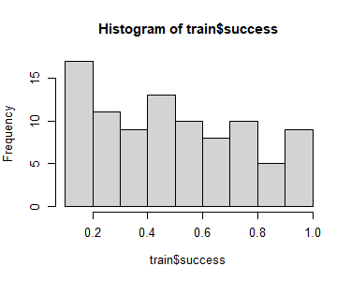
Variable Selection:
After the data frame is filtered to only the shrub presence values, and colinear variables are subsequently removed, all potential combinations of the remaining variables are tested and filtered using a stepwise AIC selection. The model chosen through this selection process includes the following variables:
- The minimum eigenvector of the TAOs - Structural metric that describes the flatness of the TAOs identified in the point cloud
- Sentinel II near-infrared Difference (between June and October) - Higher shrub cover is associated with a greater difference in photosynthetic activity between the growing season and the dry season
- Sentinel II Band 12 Difference (June and October) - This is the SWIR band that measures vegetation water content. Greater drying over the summer would lead to less of a shrub presence
- Sentinel II Band 12 (October) - High SWIR2 in October can reflect low moisture or less of a shrub presence
K-Fold Cross Validation:
The k-fold cross validation allows us to test the data in five folds using the above variables in the beta-regression model. The resulting model is as follows:
##
## Call:
## betareg(formula = form, data = train)
##
## Quantile residuals:
## Min 1Q Median 3Q Max
## -1.6966 -0.6267 -0.2041 0.3642 4.2879
##
## Coefficients (mean model with logit link):
## Estimate Std. Error z value Pr(>|z|)
## (Intercept) 1.458188 0.918103 1.588 0.112227
## emin__TAO -1.625145 0.544806 -2.983 0.002855 **
## nir 0.019524 0.003086 6.327 2.49e-10 ***
## b12 -11.452977 3.282274 -3.489 0.000484 ***
## b12w -20.599009 3.756171 -5.484 4.16e-08 ***
##
## Phi coefficients (precision model with identity link):
## Estimate Std. Error z value Pr(>|z|)
## (phi) 3.8837 0.5343 7.269 3.63e-13 ***
## ---
## Signif. codes: 0 '***' 0.001 '**' 0.01 '*' 0.05 '.' 0.1 ' ' 1
##
## Type of estimator: ML (maximum likelihood)
## Log-likelihood: 30.01 on 6 Df
## Pseudo R-squared: 0.3339
## Number of iterations: 27 (BFGS) + 5 (Fisher scoring)
And the error statistics:
## Mean RMSE: 0.1941818
## Mean MAE: 0.1571514
Shrub Beta Regression Residuals:
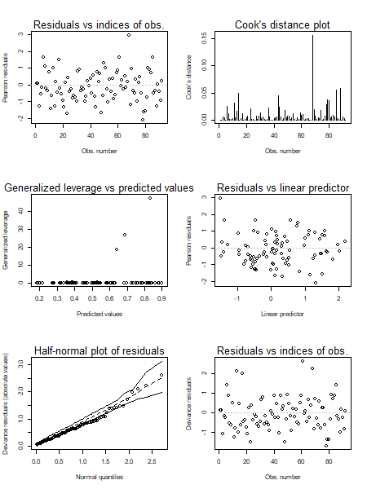
The residual diagnostics for the shrub model don’t show any major issues. The Pearson and deviance residuals are fairly evenly scattered, though there’s one observation with high leverage and Cook’s distance that might be worth checking. The half-normal plot of residuals follows the expected line pretty well, suggesting a decent fit. Overall, the model seems to be performing reasonably, with no obvious violations of assumptions.

Results
IMAGE DESCRIBING THE DIFFERENT CONIFER/OAK/SHRUB AMOUNTS
MAP OF PREDICTIONS

