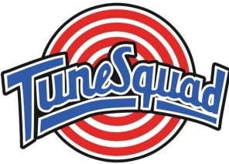

**Client Meeting Agenda**

**2/13/2015**

**Begin 2:00 p.m. – _:__ p.m**

**Topics**

1. Discuss Mockups & Proposal
2. Possible names for software
3. Client Questions