Software Requirements Specification

for

Lions Final Exam Scheduler (L.I.F.E.S.)

Version 1.4

Prepared by



|  |  |  |
| --- | --- | --- |
| Team Leader | Scott Smoke | ssmoke@una.edu |
| SQA | Riley Smith | msmith9@una.edu |
| SQA | Jordan Beck | jbeck@una.edu |
| Engineer | Joshua Ford | jford@una.edu |
| Technical Writer | Jeffrey Allen | jallen2@una.edu |

Instructor: Patricia Roden, Ph.D

Course: CS455 Software Engineering

|  |  |
| --- | --- |
|  |  |
|  |  |

Contents

RevisioNs iii

1 Introduction 1

1.1 Document Purpose 1

1.2 Product Scope 1

1.3 Intended Audience and Document Overview 1

1.4 Definitions, Acronyms and Abbreviations 1

1.5 References and Acknowledgments 2

1.6 Overview 2

2 Overall Description 2

2.1 Product Perspective 3

2.2 Product Functionality 3

2.3 Users and Characteristics 3

2.4 Operating Environment 3

2.5 Design and Implementation Constraints 4

2.6 User Documentation 4

3 Specific Requirements 3

3.1 External Interface Requirements 4

3.2 Functional Requirements 5

4 Non-functional Requirements 6

4.1 Safety and Security Requirements 6

4.2 Software Quality Attributes 6

4.3 Input File Format 7

4.4 output File Format 7

4.5 Error Format 8

5 Deliverables 8

6 client- developer agreement 8

Appendix A – Interface prototypes 8

Revisions

| Version | Primary Author(s) | Description of Version | Date Completed |
| --- | --- | --- | --- |
| 1.0 | Jeffrey Allen | Initial draft  Added document’s purpose  Added definitions and acronyms section  Added references and acknowledgements  Added user documentation  Defined intended audience  Added overview of document  Added Product Overview  Added application perspective  Added product functionality  Edited References  Added line numbers  Added Name of Application  Removed unnecessary sections | 2/20/15 |
| 1.1 | Scott Smoke, Jeffrey Alllen | Made revisions to every section added in sections 4.3 and 4.4 | 2/27/15 |
| 1.2 | Riley Smith | Added screen shots, fixed grammatical errors | 2/27/15 |
| 1.3 | Scott Smoke | Changed section 2.5, 4.1, and 3.1.1. Also removed a non important screen shot. Fixed table of contents, font, and spacing | 2/27/15 |
| 1.4 | Jeffrey Allen | Updated section 3 to reflect that of IEEE Std 830-1998 standard.  Updated font size and font type  Updated Table of Contents  Updated definitions, acronym, abbreviations | 2/28/15 |
| 1.5 | Scott Smoke | Modified 2.5, 3.2. Added new requirement in functional requirements section. | 3/4/15 |
| 1.6 | Scott Smoke | made changes to denote that two different versions will be delivered.  Added in the input and output files in the appendix.  Added information to the deliverables chapter | 3/5/15 |

# 

# Introduction

This section gives a scope description and overview of everything included in this SRS document. Also, the purpose for this document is described and a list of abbreviations and definitions is provided.

## Document Purpose

The purpose of this document is to give a detailed description of the requirements for the Lions Final Exam Scheduler (L.I.F.E.S.) software package. It will illustrate the purpose and complete declaration for the functionality of the system. It will also explain system constraints, interface and interactions with other external applications. This document is primarily intended to be proposed to a client for its approval and a reference for developing the first version of the system for the development team. Upon agreement of this specification document between the client, Dr. Patricia Roden, and the Tune Squad, both parties will provide their signatures (see section 5).

## Product Scope

L.I.F.E.Sis a desktop application with a graphical user interface which will allow for two administrative users and multiple general users in the University of North Alabama’s Office of the Registrar to generate a final exam schedule. The application will make use of the data from a previous similar semester to determine trends in popular class times. The L.I.F.E.S. application can be installed on a computer with a CD-ROM or a flash drive.

The goal of this software is for a user to be able to display a final exam schedule that has been generated using the software in a similar format presented on the UNA website as of the year 2015. Previously, a person had to compose schedules by hand which could take days or even weeks to produce a schedule with minimal conflicts. This software attempts to speed up the process by providing a single user with an easy and intuitive work environment by providing a small subset of data to produce a high quality exam schedule.

## Intended Audience

This document is intended to be read by the client professor, VPAA, the individuals located in the Office of the Registrar that will be using this application, and the Tune Squad development team.

## Definitions, Acronyms and Abbreviations

|  |  |
| --- | --- |
| **Term** | **Definition** |
| Admin/Administrator | System administrator who is given specific permission for managing and controlling the system |
| Total Enrollment File | Second input data file of this final exam scheduling application |
| Developer | A member of the Tune Squad |
| L.I.F.E.S. | Lions Final Exam Scheduler |
| S.R.S. | Software Specification Document |
| Time Constraint File | First input data file of this final exam scheduling application |
| U.N.A. | University of North Alabama |
| User | Someone who interacts with the desktop application |
| V.P.A.A. | Vice President of Academic Affairs |
| Wish | A desirable level of achievement that may not be attainable through available means contained in a language statement |

## References and Acknowledgments

[1] IEEE Software Engineering Standards Committee, “IEEE Std 830-1998, IEEE Recommended Practice for Software Requirements Specifications”, October 20, 1998.

[2] University of North Alabama Official Colors, http://www.una.edu/graphic-standards/print-web/

## Overview

Section 2 of this SRS describes the application’s functionality at a high-level. In section 3, a detailed description of its requirements is presented, including functional requirements. Located in section 4 are the non-functional requirements such as security, error handling, and help messages.

# Overall Description

## This section of the SRS describes application at a high-level. The L.I.F.E.S. application will be explained in its context to show how users interact with it and introduce its basic functionality.

## Application Perspective

L.I.F.E.S. is a desktop application for the University of North Alabama. Its only dependency is an external printer in the event a user wishes to print a final exam schedule generated by the application.

## Product Functionality

A user will be able to generate final exam schedules after successfully authenticating themselves during the login processes. The result of generating a final exam schedule will be based on two separate data files provided by the user. The first file provides the application with details that define the timing constraints of the exam schedule. This file can either be created manually by using the application or it can be loaded from a separate input file. The second file must be one that is loaded from a separate file, which will provide the application with the data gathered from a previous semester.

The resulting final exam schedule that is generated from the two valid data input files will immediately be displayed in a similar format the University’s website presents the schedule of final exams (see figure 1 in Appendix A). A user can either view a single date of class schedules or the schedule in its entirety.

If an administrative user is operating the application, he/she will have the option to finalize a schedule that has been generated. This will label the schedule as “Administratively Approved,” which will apply a seal of approval to all printed documents associated with the finalized schedule.

A user that has questions about the application can refer to the help menu. This menu will demonstrate to the user how to use the application.

The L.I.F.E.S. application will come in two versions: one with the different levels of users and one without.

## Users and Characteristics

The users of this application will be the VPAA and individuals at the Office of the Registrar. All users should be familiar with opening desktop applications and maneuvering file systems. There are two categories of users, which are either considered an administrative or a general user. At maximum there can be two administrators. Privileges are the separating factor between these two different categories of users.

General users have the privilege to authenticate themselves as valid users. These general users are users who have been verified by an administrator and may operate the application. General users will be able to open, view schedule, run schedule, reschedule, view total enrollments by class times, and modify the schedule.Administrators have all of the same privileges as the general users. Additionally, they are able to create and delete general user accounts, reset passwords, finalize exam schedules, and unlock accounts. If the L.I.F.E.S application without the users is being used then everything the General User can do every user can do.

## Operating Environment

The environment in which the application will be operated upon is in an HP Pro running a 64-bit running a Windows 7 operating system.

## Design and Implementation Constraints

L.I.F.E.S. is expected to be executed on a HP pro desktop computer with a Windows 7 operating system installed. Creating a user interface which is both effective and easily navigable will pose a difficult challenge. The L.I.F.E.S. program will be created using the C# programming language.

### C# Programming Language

The Tune Squad proposes that L.I.F.E.S. be written in the C# programming language. The Microsoft Corporation developed this language and maintains it still to this day. It is a modern, object-oriented, general-purpose programming language that has much strength which its community continues to build upon to this day. As with all programming languages though, C# does have weaknesses.

Strengths: easy to learn, compiled on a variety of computer platforms, GUI-based, concurrency/threading

Weaknesses: Memory leaks with dynamic memory/prone to spaghetti code

## User Documentation

The user manual for this application can be found electronically by first clicking the tab labeled “Help” in the menu bar of the application, and then clicking “User’s Manual”. A hard copy of the manual will accompany the final submission of the project.

# Specific Requirements

Descriptions of all functional requirements are described in this section. There are detailed descriptions of all the interfaces in the system and all of the application’s features.

## External Interface Requirements

This section provides a detailed description of all inputs into and outputs from the application. It also contains a description of the hardware and software interfaces. Basic prototypes of the user interface are also provided in this section.

### User Interfaces

A first-time user of L.I.F.E.S. should see the log-in page when he/she opens the application (See Appendix A). If the user has not been registered by the VPAA, he/she should not be able to access any other interface. If the user is not a first-time user, he/she should be able to login directly when the application is opened. Here the user chooses the type of search he/she wants to conduct.

The main interface will have a table that will display a generated schedule for viewing either the entire schedule or a single day. Above the table there will be two buttons to select the two input files. Below the table there will be a button to generate an exam schedule and a button to reschedule the currently displayed schedule and a swap button. The main interface will contain a menu bar with the following menu options: File, Help, and Log In/Log out (depending on version). Under the file option there will be the sub options: new, open, save, save as, print, and close. The main interface will contain the following dialogs.

All colors and logos used in L.I.F.E.S. will adhere to the University of North Alabama graphics standards. Examples of these interfaces are in the appendix.

#### Login Dialog

The login dialog will ask for the username and password and will have the buttons login and cancel. Optional depending on the version of L.I.F.E.S being used.

#### Open File Dialog

The open file dialog will prompt the user to enter a file name or search for the required file. This dialog will contain the buttons open and cancel. This dialog will be used to have the user search for the data constraints and the total enrollments file.

#### Save File Dialog

The save file dialog will ask the user for the filename and the format to save the file. The save dialog will contain the buttons save and cancel.

#### Print Dialog

The print dialog will ask for the printer to print to.

#### Error Dialog

The error dialog will display the error and have an ok button.

#### Data input dialog

The data input dialog will prompt the user to enter the data that would otherwise be in the first file that is required for the exam schedule. This information is the data that will be used to generate the schedule.

### Hardware Interfaces

The product will be able to communicate with printers through libraries available to the programming language of choice.

### Software Interfaces

The product will be able to communicate with the Windows 7 operating system and link with libraries to link with a printer.

## Functional Requirements

The L.I.F.E.Sapplication will allow its users to create a final exam schedule that will make use of data from previous similar semesters to determine trends in popular class times. The application has two levels of users: General Users and Administrators. There will be two versions of the L.I.F.E.S. program delivered. One will have the users and one without. The version without the different levels of users will be able to do all the functions the General User can perform.

#### 3.2.1 Identification & Authentication

The user will be prompted for a username and password. The username must be the users’ University of North Alabama email address. The password must be between seven and nine characters long. The password must start with an alphabetical character followed by any number of alphanumeric characters and may contain any of the following *, #, or $. The password is not case sensitive. Optional depending on the version of L.I.F.E.S being used.

### General User

All the functionality listed beneath will appear in both versions of this application. However, the version without the user levels the user will need not be authenticated.

#### Open Schedule

A user will be able to open a previously generated final exam schedule. They will be able to choose the entire schedule or a single day.

#### Generate Schedule

The user will generate a schedule using two valid input files.

#### Reschedule

When a user generates a final exam schedule, the option to rerun the final exam schedule will be available.

#### Modify Schedule

A General User will be able to swap final time slots.

#### Save Schedule

The General User will be able to save the file as either a pdf, csv, or plain text file.

#### Print Schedule

The General User will be able to print the generated schedule in portrait form.

#### View Schedule

The General User will be able to view a single day or the entire final exam schedule in the GUI.

#### View Class times by enrollment

The General User will be able to view a list of popular class time by total enrollment. This list will be displayed in descending order.

### Administrative User

Administrators have all privileges of a General User in addition to the following privileges described in this section. At maximum, there will be no more than two administrators.Optional depending on the version of L.I.F.E.S being used.

#### Create/Delete General Users

An Administrator will have to create accounts for this software.

#### Reset Passwords

An Administrator will be able to change a user’s password at any time.

#### Finalize Exam Schedule

An Administrator will finalize an final exam schedule t making it so that no more changes can be made.

#### Unlock Account

An Administrator will be able to unlock an account after it has been locked due to too many failed long in attempts.

# Non-functional Requirements

## Safety and Security Requirements

Administrative and general users are the two types of users that can be authenticated in this application. Both types of users will be required to provide login credentials, including a username and password.

1. Usernames will be the user’s UNA email address
2. Passwords will consist of 7-9 characters with the first character being alphabetic and the rest being alphanumeric or the symbols *, #, $. Passwords are not case sensitive
3. The list of username and passwords will be stored in an encrypted text file.
4. A general user that enters invalid login credentials four consecutive times will be locked out of the application to where it can only be unlocked by an administrative user
5. In the event a user enters the wrong login credentials, an error message will display whether the username or password was incorrect
6. Only an administrative user will be allowed to finalize exam schedules

## Software Quality Attributes

|  |  |
| --- | --- |
| Flexibility: | The program will allow for manual modification to the exam schedule. |
| Usability: | The user interface will be designed to be easy to learn and use. There will also be an included user manual in the program’s help menu. |
| Reliability: | The program will generate an exam schedule that will always work, having no time conflicts. |
| Testability: | The software will be written with testability in mind. Each module of the software will be written with test cases in mind to allow for the finding of faults. |
| Availability: | The software will be available on a CD-ROM and/or flash-drive. |
| Maintainability: | The software will achieve maintainability through the use of modules. |

## Input Data Files

L.I.F.E.S. uses the ISO 8601 24-hour format as a standard convention to represent time.

### Time Constraint File

The first file provides the application with details which define the time constraints of the exam schedule. This file can either be created manually by using the application, or it can be loaded from a separate input file. Figure 1.2 in Appendix A.

#### Number of days to schedule

This integer value will be between 3 and 5.

#### Beginning time of the first exam of the day

The beginning time of each exam is 0700. The final time for exams is either 1700 or 1715.

#### Length of time for each exam

The minimum is one hour fifteen minutes for each exam, and there is no maximum. Every exam can begin on the quarter hour, half hour, or hour.

#### Length of time between exams

The minimum is ten minutes and the maximum is thirty minutes.

#### Length of time for a lunch period

This value will be optional, and there are no limits for this value.

### Total Enrollments File

The format of this file is a CSV file with the first column specifying the day and time of the class, and the second column containing the total number of students in the class. See figure 1.3 in appendix A.

## Output File

The first line will contain the semester and the year. The second line will specify the class data file used to generate the schedule. Then, all the data from the first file or the manually inputted data will be included in this file. Then the generated schedule which will use standard times. The format of this file will either be plain text, PDF, or CSV. See figure 1.4 in appendix A.

## Input Errors

Every error dealing with the two input files will be given in a pop up dialog that will list the line number and the type of error.

5 Deliverables

The L.I.F.E.S. application will be delivered in two different versions: one with the different levels of users and one without. These two versions will be delivered via CD-ROM and or a flash drive. The application will be able to install itself on the computer. Along with the application, everything pertaining to the development will be delivered. This includes all test files, design documents, emails concerning the development, requirements documentation, test code, and entire application code.

6 Client-Developer Agreement

|  |  |  |
| --- | --- | --- |
|  |  |  |
| *Patricia L. Roden, Ph.D, Client* |  | *Date* |
|  |  |  |
| *Scott Smoke, Team Leader* |  | *Date* |
|  |  |  |
| *Riley Smith, SQA* |  | *Date* |
|  |  |  |
| *Jordan Beck, SQA* |  | *Date* |
|  |  |  |
| *Joshua Ford, Engineer* |  | *Date* |
|  |  |  |
| *Jeffrey Allen, Technical Writer* |  | *Date* |

Appendix A – Interface Prototypes

Figure 1.1

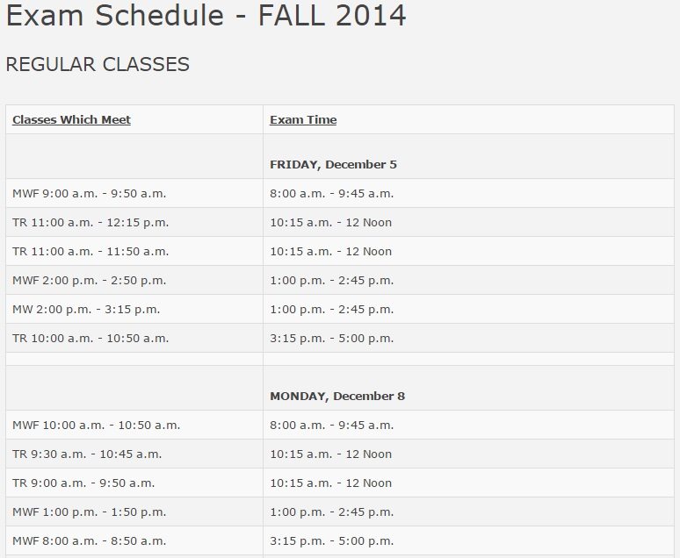

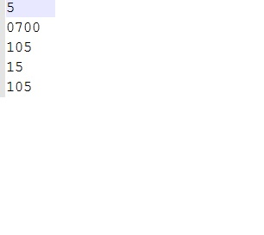

Figure 1.2 Constraint File

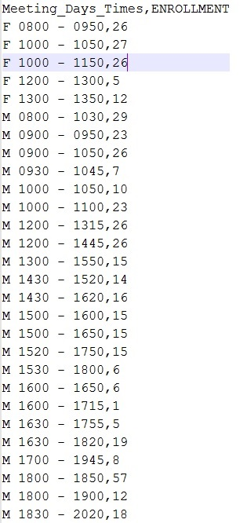

Figure 1.3

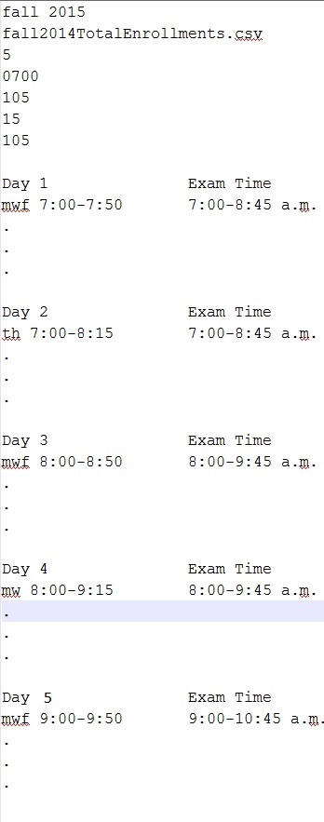

Figure 1.4

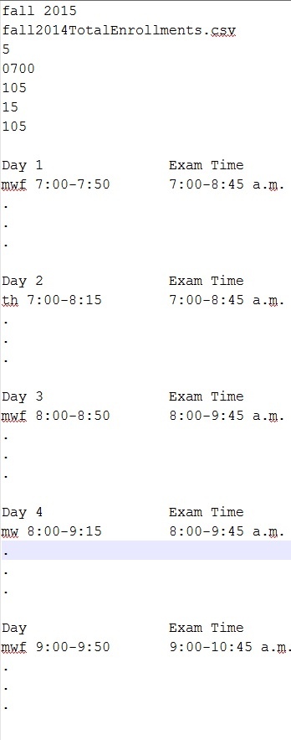

Figure 2 1.2

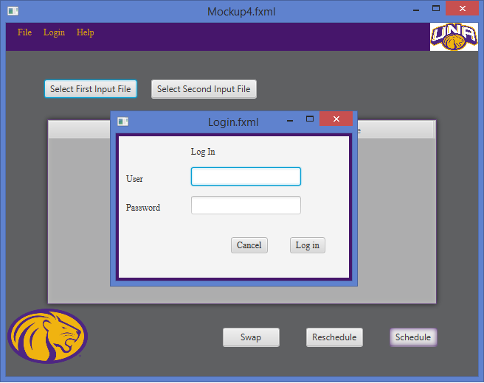

Figure 3 1.2

