L.I.F.E.S.V1

|  |
| --- |
| User Guide  excludes  ADMIN Section |

Table of Contents

Introduction 2

The Home Screen 2

Creating a Final Examination Schedule 2

Step 1: Enter Time Constraints of Schedule 2

Number of days 3

Beginning Time of the First Day 3

Length of Time for Each Exam (in minutes) 3

Length of Time between Exams (in minutes) 3

Length of time for a lunch period (in minutes) 3

Step 2: Entering an Enrollment File 3

Step 3: Actually Running the Scheduler 4

Step 4: Rescheduling 4

Step 5: Swapping a Schedule That Was Generated 4

Saving a Schedule 4

Opening a Previously Generated Schedule 4

# Introduction

Welcome to the user guide for L.I.F.E.S.V1! We hope this guide will help you get comfortable with the Lions Final Exam Scheduler application. The developers of this application encourage you to have L.I.F.E.S open on your computer while you look through this guide, so you can “click around” and get familiar with everything. Let’s get started!

# The Home Screen

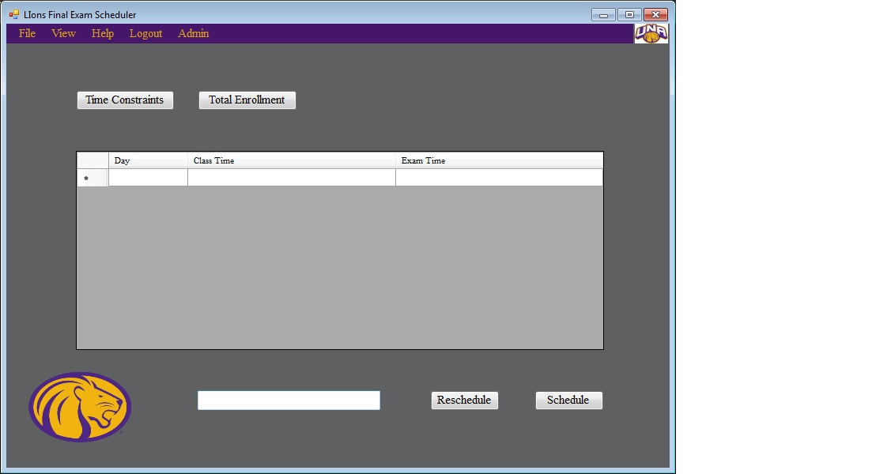

# Creating a Final Examination Schedule

This section provides details necessary for how to create a final examination schedule.

## *Step 1: Enter Time Constraints of Schedule*

It is essential to know that L.I.F.E.S. adheres to ISO 8601 24-hour standards.

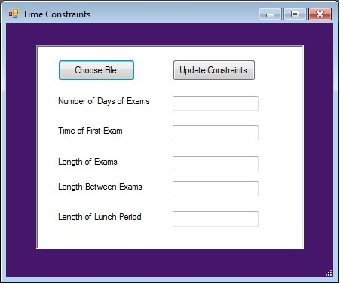

### Number of days

This number indicates the amount of days the final exam schedule. The minimum number of days an examination schedule may contain is 3 days. The maximum number is 5.

### Beginning Time of the First Day

The beginning time of each exam **must** begin at 0700.

### Length of Time for Each Exam (in minutes)

The minimum is one hour fifteen minutes for each exam, and there is no maximum. Every exam can begin on the quarter hour, half hour, or hour.

### Length of Time between Exams (in minutes)

The minimum is ten minutes and the maximum is thirty minutes.

### Length of time for a lunch period (in minutes)

This value is optional, and there are no limits for this value.

## *Step 2: Entering an Enrollment File*

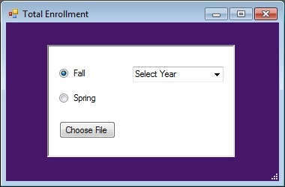

There are three things to think about within the enrollments file window. First, a user must specify either fall or spring semesters. Next, a user must specify the year the exam schedule is going to be built for. Lastly, a user specifies choose an enrollment file that contains all the class times from a previous semester. When “Choose File” is clicked, the user must navigate to the file that contains enrollment details.

## *Step 3: Actually Running the Scheduler*

After all the previous steps have been completed, all a user must do is click on the “Schedule” button.

## *Step 4: Rescheduling*

If a user isn’t satisfied with the current examination schedule, a user has the option to reschedule. This button will rearrange the class times within the current examination schedule window. To do this, all a user must do is press the “Reschedule” button.

## *Step 5: Swapping a Schedule That Was Generated*

In order to modify a schedule that has been generated a user will first need to click on a final exam time schedule they would like to change. This time slot will become highlighted. A user must then select a second schedule by **holding down the control button while clicking the second timeslot as well**. This time slot will also become highlighted. After the user has selected the two times, they’ll need to press the swap button. The user will have then successfully modified a schedule.

# Saving a Schedule

From the drop down menu, all a user has to do is click “Save as”. This will save the current state of LIFES, including the Time constraints specification and total enrollments file.

# Opening a Previously Generated Schedule

By navigating to the “File” menu, an clicking “Open”, you are able to open a previously create exam schedule.