L.I.F.E.S.V2

|  |
| --- |
| User Guide  includes  ADMIN Section |

Contents

Introduction 2

Getting Started 2

Administrative Functionality 2

Create User 2

Delete User 2

Resetting Passwords 3

Unlocking a User Account 3

Logging In 3

The Home Screen 3

Creating a Final Examination Schedule 4

*Step 1: Enter Time Constraints of Schedule* 4

Number of days 4

Beginning Time of the First Day 4

Length of Time for Each Exam (in minutes) 5

Length of Time between Exams (in minutes) 5

Length of time for a lunch period (in minutes) 5

*Entering an Enrollment File* 6

*Actually Running the Scheduler* 6

*Rescheduling* 6

*Modifying a Schedule That Was Generated* 6

Saving a Schedule 6

# Introduction

Welcome to the user guide for L.I.F.E.S.V2! This guide is intended to be read by anybody operating the L.I.F.E.S.V2 desktop application. We hope this guide will help you get comfortable with the Lions Final Exam Scheduler application. The developers of this application encourage you to have L.I.F.E.S open on your computer while you look through this guide, so you can “click around” and get familiar with everything. Let’s get started!

# Getting Started

First time use of the application will require an administrative user to type in a special username and password that is provided by the application developers. General users must contact an administrator in the event they have not already created an account.

# Administrative Functionality

If the user is logged in as an administrator, the tool bar will contain the “Admin” menu option. An administrative user will be able to execute the following functionalities:

### Create User

When this option is chosen, a new form will be displayed to the user as seen below:

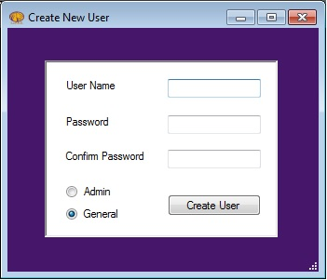

It is imperative for administrators to conform to L.I.F.E.S. credential standards while creating new users:

1. Usernames will be the user’s UNA email address
2. Passwords will consist of 7-9 characters with the first character being alphabetic and the rest being alphanumeric or the symbols *, #, $. Passwords are not case sensitive

### Delete User

Clicking Delete User will open the “Delete User” dialog box. To delete a user’s account from L.I.F.E.S., an administrator must click on the user they wish to delete and then press the “Delete User” button.

### Resetting Passwords

In the case a user would like to change their password, an administrator must click on the user that wishes to change their password, and proceed to change it by clicking “Reset Password”. Passwords must consist of 7-9 characters with the first character being alphabetic and the rest being alphanumeric or the symbols *, #, $. Passwords are not case sensitive

### Unlocking a User Account

To unlock an account, an administrator must reset the password of that user. A user account that is locked will be highlighted red in the “Resetting Passwords” dialog box (as seen in the figure above). It is recommended to refer back to the previous section labeled “Resetting Passwords,” for details on how to unlock an account.

# Logging In

We’re ready to log in! This is the first screen a user should see when the application is opened. If a general user is attempting to access the full functionality of L.I.F.E.S., the general user must use a UNA email address to login, and the password the user discussed with the administrator that helped set up that account.

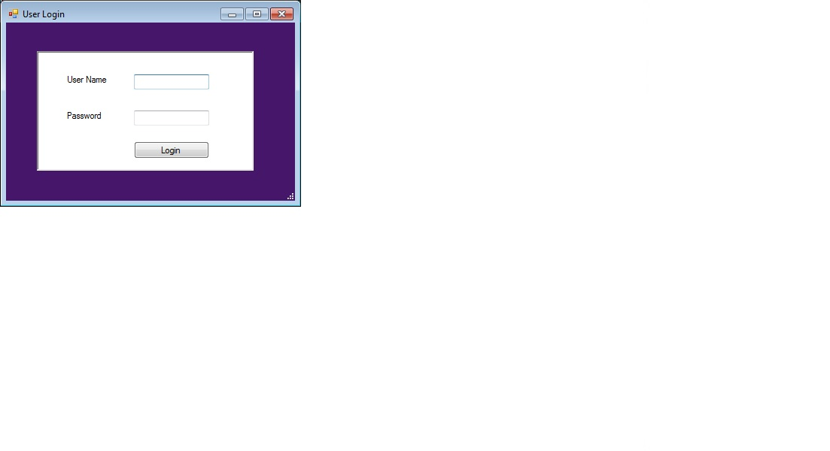

***Tip:*** Here are some things that will cause an unsuccessful login:

* CAPS lock key is on. The login fields are case sensitive.
* A space at the front or end of either your email address or password

# The Home Screen

The home screen above is the first thing seen when logged into the L.I.F.E.S. application.

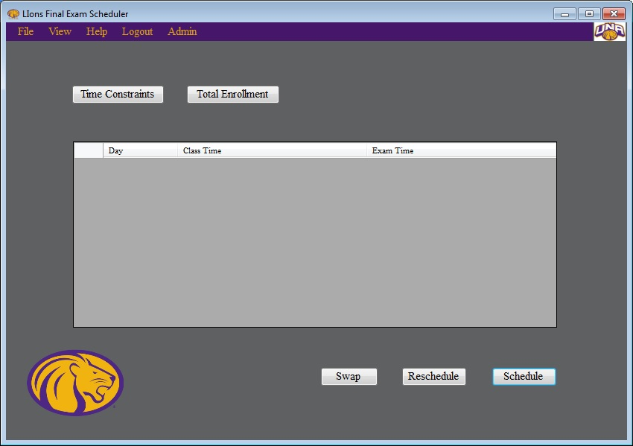

# Creating a Final Examination Schedule

This section provides details necessary for how to create a final examination schedule.

## *Step 1: Enter Time Constraints of Schedule*

**It is essential to understand that L.I.F.E.S. adheres to ISO 8601 24-hour standards.**

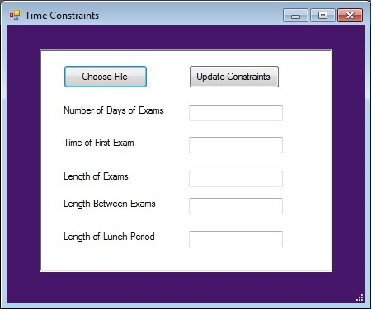

### Number of days

This number indicates the amount of days the final exam schedule. The minimum number of days an examination schedule may contain is 3 days. The maximum number is 5.

### Beginning Time of the First Day

The beginning time of each exam **must** be 0700.

### Length of Time for Each Exam (in minutes)

The minimum is one hour fifteen minutes for each exam, and there is no maximum. Every exam can begin on the quarter hour, half hour, or hour.

### Length of Time between Exams (in minutes)

The minimum is ten minutes and the maximum is thirty minutes.

### Length of time for a lunch period (in minutes)

This value is optional, and there are no limits for this value.

## *Step 2: Entering an Enrollment File*

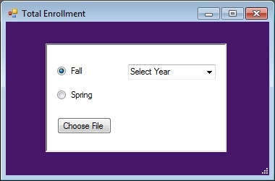

There are three things to think about within the enrollments file window. First, a user must specify either fall or spring semesters. Next, a user must specify the year the exam schedule is going to be built for. Lastly, a user specifies choose an enrollment file that contains all the class times from a previous semester. When “Choose File” is clicked, the user must navigate to the file that contains enrollment details.

## *Step 3: Actually Running the Scheduler*

After all the previous steps have been completed, all a user must do is click on the “Schedule” button.

## *Step 4: Rescheduling*

If a user isn’t satisfied with the current examination schedule, a user has the option to reschedule. To do this, all a user must do is press the “Reschedule” button.

## *Step 5: Modifying a Schedule That Was Generated*

INSERT SWAP SCREEN SHOT

In order to modify a schedule that has been generated a user will first need to click on a final exam time schedule they would like to change. This time slot will become highlighted. A user must then select a second schedule by clicking it as well. This time slot will also become highlighted. After the user has selected the two times, they’ll need to press the swap button. The user will have then successfully modified a schedule.

# Saving a Schedule

From the drop down menu, all a user has to do is click “Save as”. This will save the current state of LIFES, including the time constraints and total enrollments file used to generate the schedule. If an administrator has approved the schedule, it will also label the saved schedule as “administratively approved.”