Getting Started:

Ref: https://docs.angularjs.org/guide

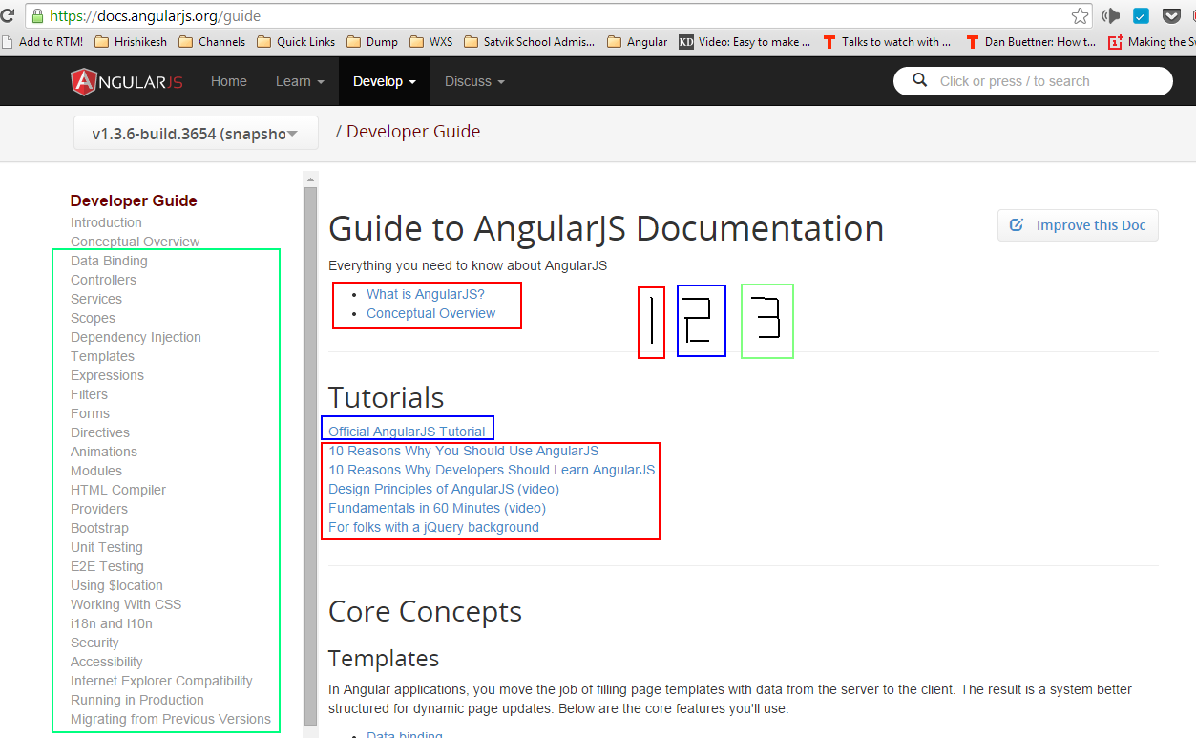

https://docs.angularjs.org/guide/introduction

https://www.youtube.com/watch?v=i9MHigUZKEM

https://www.youtube.com/watch?v=HCR7i5F5L8c

http://www.sitepoint.com/10-reasons-use-angularjs/

http://www.wintellect.com/blogs/jlikness/10-reasons-web-developers-should-learn-angularjs

https://docs.angularjs.org/tutorial
(my own version of the tutorial)

