|  |  |  |
| --- | --- | --- |
| Design Intent Document for Arbor Press | | |
| Revision Date | Author | Assembly Description |
| 4/21/18 | James Hribal  Harrison Leece | Arbor Press |

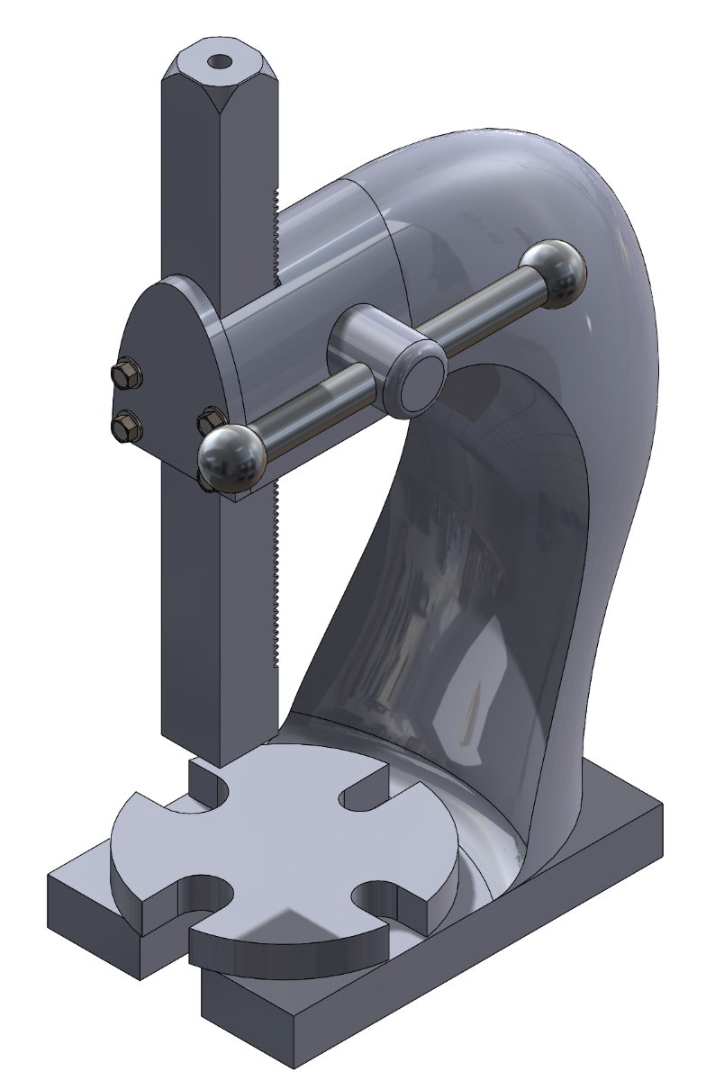

Figure 1. ARBOR PRESS

|  |  |
| --- | --- |
| Assembly Overview | |
| General Description | This assembly is an arbor press which uses a crank operated ram that operates through the use of a gear inside the main housing. The base has a cutout with enough clearance for the ram. There is a plate with different sized cutouts, allowing for material to be pressed in various ways. The profile of the arbor press was given a shark-like visage to market a younger audience. |
| Purpose | This arbor press is made to allow an individual to have a small crank operated press that can perform small jobs, such as staking, riveting, installing, configuring and removing bearings and other press fit work. |
| Basic Operation | The operator would place a part that needs to be staked, riveted, or have a bearing installed or removed underneath the ram. Punches, inserters, or other tools/dies may be added to the end of the ram depending on the desired task. Then the operator would turn the crank until the required pressure has been applied before removing the part. |

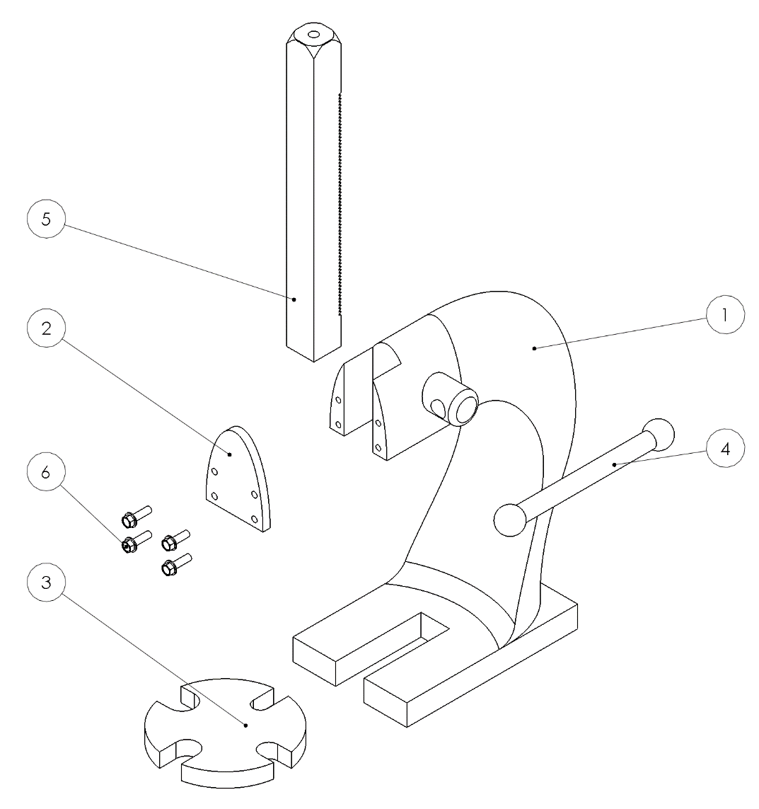

*Figure 2. ARBOR PRESS Parts View*

|  |  |  |
| --- | --- | --- |
| Assembly Component/Feature Descriptions | | |
| Ref | Component/Feature | Purpose |
| **1** | Housing | Holds gear rack in place against gear and orients the rack to press flat against the base plate surface. |
| **2** | Face plate | Holds the gear rack against the Housing, and teeth in contact with gear. |
| **3** | Base plate | Holds the item being pressed flat, has holes to allows the pressing of different items by the ram. |
| **4** | Crank shaft | Allows the user to apply force to push the ram into the item on the plate with high pressure. |
| **5** | Gear rack | Presses the item onto the baseplate. Is moved up and down by the crank shaft. |
| **6** | 91247A628  Fastener | Fasteners hold the faceplate against the housing of the press. |

|  |  |
| --- | --- |
| Arbor Press Design Iterations | |
| **1st Design**  **Final Design** |  |
| The cylindrical ends of the crank shaft were difficult to use and the aluminum bronze would bend uncomfortably if too much force was applied. |
|  |
|  | The ends of the crank shaft were redesigned to be more ergonomic and the material was changed to 1040 steel in order to withstand the force applied by the operator. |

|  |  |
| --- | --- |
| Functionally Critical Dimensions / Tolerance Analysis | |
| Critical Dimension Name | Description and Value of Critical Dimension |
| Flatness of housing base | The dimension is critical because it keeps housing flat in order to help ensure that the ram will make flat contact with the item, by making sure the top of the housing is not tilted. Flat to within .020 inches |
| Top of base parallelism | The dimension is critical because it keeps the top of the base parallel to the bottom datum of the housing to ensure the base plate is flat relative to the rest of the housing. Parallel to .030 inches |
| Perpendicularity to gear rack slot’s sides | The dimension is critical because it controls the centerline formed between the two sides to ensure the gear rack is not tilted. Chosen to be a tight tolerance of .020 inches, due to any deviation in angle having a large effect on the ability to press flatly. |
| Profile tolerance to housing’s front 2 upper section surfaces. | This dimension is critical because it allows the easy mounting of front plate to the housing and keeps the alignment of the gear rack flat. Tolerance to within .010 on both surfaces, because the gear rack is sensitive to deviations in angle. |
| Flatness of ram end of gear rack | This dimension is critical because flatness helps ensure a flat pressing surface. Flat to within .030 inches. |
| Flatness of bottom base plate | This dimension is critical because flatness helps ensure a flat pressing surface. Flat to within .020 inches |
| Parallelism of top of base plate | This dimension is critical because parallelism of the top surface of the base plate ensures a flat pressing surface relative to the housing of the press. Parallel to within .030 inches. |

|  |  |  |
| --- | --- | --- |
| Order of Assembly | | |
| **Step Number** | **Step Name** | **Step Description** |
| **1** | Install crank shaft | The crank shaft must be inserted into the hole in the housing |
| **2** | Install gear rack | The gear rack is inserted into the slot in the housing with the teeth facing towards the housing. |
| **3** | Install face plate | The face plate must be bolted to the housing. |
| **4** | Install base plate | The base plate sits on top of the flat surface in the housing. |

Appendices

APPENDIX A) Detail Part Drawings for all Non-Standard Parts

APPENDIX B) Installation Drawing

APPENDIX C) Interface Tolerance Analysis

APPENDIX D) Drawing Checklists for each Drawing

Appendix A – Part Drawings

Appendix B – Installation Drawing

Appendix C – Interface Tolerance Analysis

# Face Plate to Housing (4-bolt Pattern)

Fastener Conditioned = Fastener

Face Plate Hole Pattern

Hole Size = 0.406 +.006/-.001 inches

Hole Size MMC = 0.406 -.001 = .405 inches

Position Tolerance = 0.010 inches

Hole Pattern

Thread Size = .375 –16 UNC – 2B

Position Tolerance = 0.020 inches

T (.030) = H (.405) – F (.375)

(.030)*(1/3) = .010 inches goes to the clearance hole which matches the tolerance on the drawings

(.030)*(2/3) = .020 inches goes to the insert which matches tolerance on the drawings

Appendix D – Drawing Checklists

Part Drawing - Housing

|  |  |
| --- | --- |
| Check (Y/N) | Item |
| Y | Does the drawing meet all Dimensioning Guidelines in this Presentation? |
| N | Does the drawing have any duplicate dimensions? |
| Y | Does the drawing control the size of the interface with the other parts in the assembly? |
| Y | Does the drawing have a True Positional tolerance for any 4-bolt patterns? |
| Y | Does the drawing tell the user what size bolts will go through the 4-bolt pattern? |
| Y | Does the drawing use standard hole sizes and tolerances of hole sizes? |
| Y | Does the drawing have enough views to show all aspects of the design? |
| Y | Does the drawing have the name of the part shown on the drawing? |

Part Drawing – Base Plate

|  |  |
| --- | --- |
| Check (Y/N) | Item |
| Y | Does the drawing meet all Dimensioning Guidelines in this Presentation? |
| N | Does the drawing have any duplicate dimensions? |
| Y | Does the drawing control the size of the interface with the other parts in the assembly? |
| N/A | Does the drawing have a True Positional tolerance for any 4-bolt patterns? |
| N/A | Does the drawing tell the user what size bolts will go through the 4-bolt pattern? |
| N/A | Does the drawing use standard hole sizes and tolerances of hole sizes? |
| Y | Does the drawing have enough views to show all aspects of the design? |
| Y | Does the drawing have the name of the part shown on the drawing? |

Part Drawing – Crank Shaft

|  |  |
| --- | --- |
| Check (Y/N) | Item |
| Y | Does the drawing meet all Dimensioning Guidelines in this Presentation? |
| N | Does the drawing have any duplicate dimensions? |
| Y | Does the drawing control the size of the interface with the other parts in the assembly? |
| N/A | Does the drawing have a True Positional tolerance for any 4-bolt patterns? |
| N/A | Does the drawing tell the user what size bolts will go through the 4-bolt pattern? |
| N/A | Does the drawing use standard hole sizes and tolerances of hole sizes? |
| Y | Does the drawing have enough views to show all aspects of the design? |
| Y | Does the drawing have the name of the part shown on the drawing? |

Part Drawing – Gear Rack

|  |  |
| --- | --- |
| Check (Y/N) | Item |
| Y | Does the drawing meet all Dimensioning Guidelines in this Presentation? |
| N | Does the drawing have any duplicate dimensions? |
| Y | Does the drawing control the size of the interface with the other parts in the assembly? |
| N/A | Does the drawing have a True Positional tolerance for any 4-bolt patterns? |
| N/A | Does the drawing tell the user what size bolts will go through the 4-bolt pattern? |
| Y | Does the drawing use standard hole sizes and tolerances of hole sizes? |
| Y | Does the drawing have enough views to show all aspects of the design? |
| Y | Does the drawing have the name of the part shown on the drawing? |

Part Drawing – Face Plate

|  |  |
| --- | --- |
| Check (Y/N) | Item |
| Y | Does the drawing meet all Dimensioning Guidelines in this Presentation? |
| N | Does the drawing have any duplicate dimensions? |
| Y | Does the drawing control the size of the interface with the other parts in the assembly? |
| Y | Does the drawing have a True Positional tolerance for any 4-bolt patterns? |
| Y | Does the drawing tell the user what size bolts will go through the 4-bolt pattern? |
| Y | Does the drawing use standard hole sizes and tolerances of hole sizes? |
| Y | Does the drawing have enough views to show all aspects of the design? |
| Y | Does the drawing have the name of the part shown on the drawing? |

Installation Drawing

|  |  |
| --- | --- |
| Checked (Y/N) | Item |
| Y | Does the drawing have a Bill of Materials? |
| Y | Is each item number shown in the exploded view? |
| Y | Does the exploded view clearly show each part? |
| Y | Does the drawing have the name of the assembly shown on the drawing? |