**CG-Assignment**

**Flood Fill and Boundary Fill**

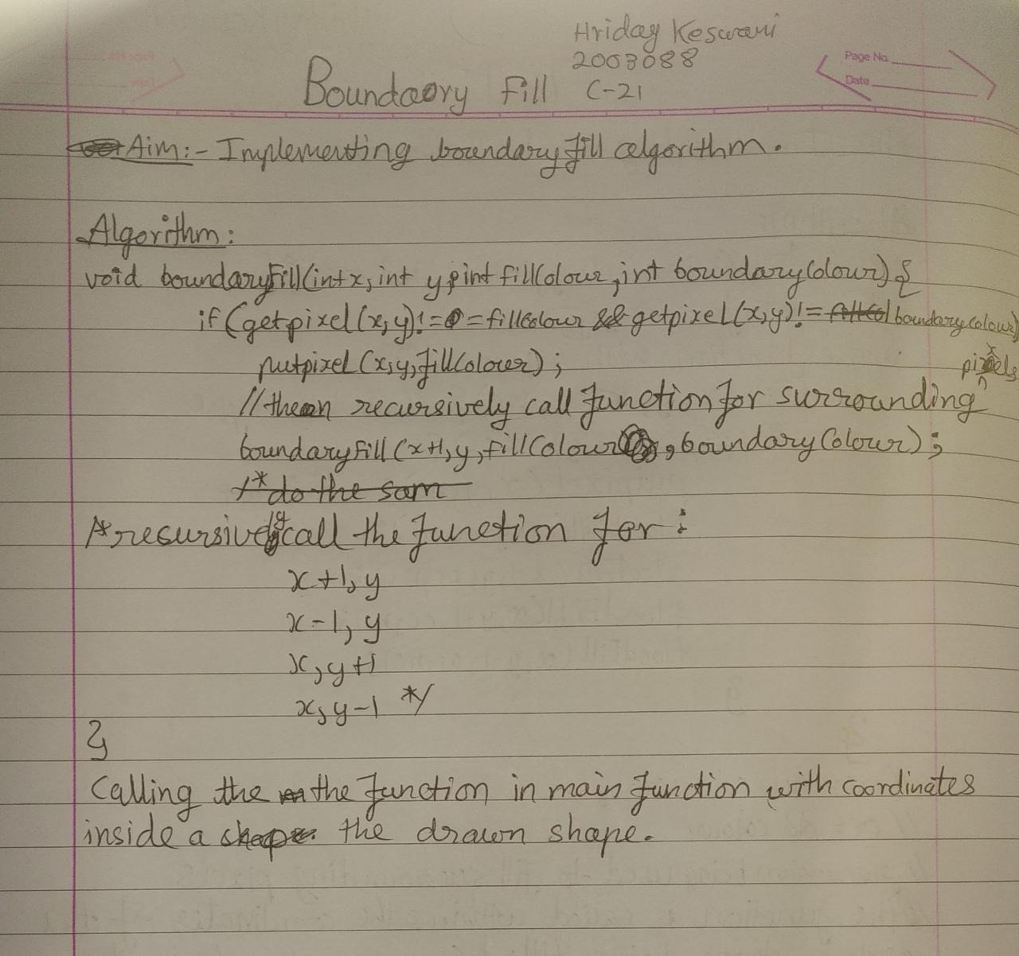

**Program:**

Implementing Boundary Fill Algorithm

**Code:**

#include<stdio.h>

#include<graphics.h>

#include<conio.h>

void boundaryFill(int x, int y, int fillColour, int boundaryColour){

if(getpixel(x,y)!=fillColour && getpixel(x,y)!=boundaryColour){

putpixel(x,y,fillColour);

boundaryFill(x+1,y,fillColour,boundaryColour);

boundaryFill(x,y+1,fillColour,boundaryColour);

boundaryFill(x-1,y,fillColour,boundaryColour);

boundaryFill(x,y-1,fillColour,boundaryColour);

}

}

void main()

{ int a,b,c,d;

int gd = DETECT,gm;

clrscr();

initgraph(&gd,&gm,"C:\\turboc3\\bgi");

printf("Enter the coordinates for start point\n");

scanf("%d%d",&a,&b);

printf("Enter the coordinates for the second point\n");

scanf("%d%d",&c,&d);

rectangle(a,b,c,d);

printf(“\nHriday Keswani\n2003088”);

boundaryFill(a+4,b+4,3,15);

getch();

closegraph();

}

**Output:**

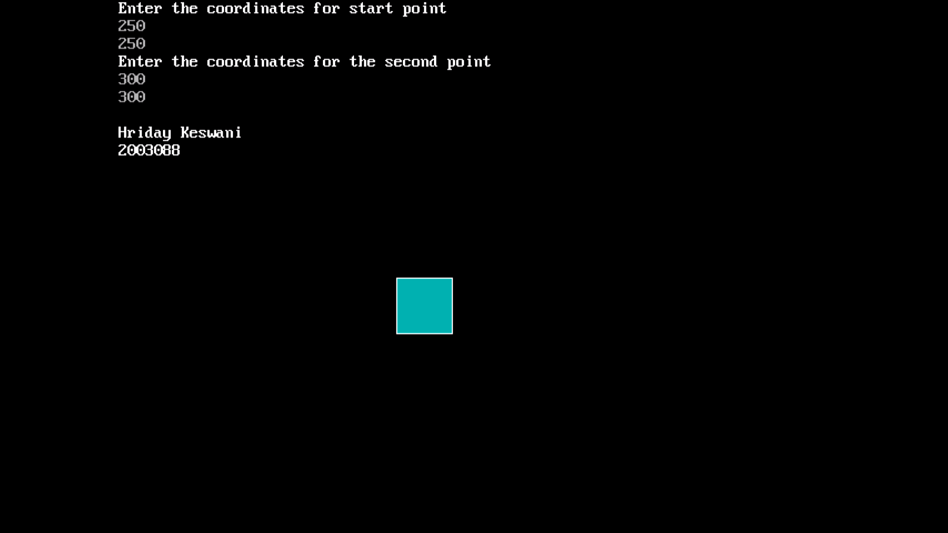

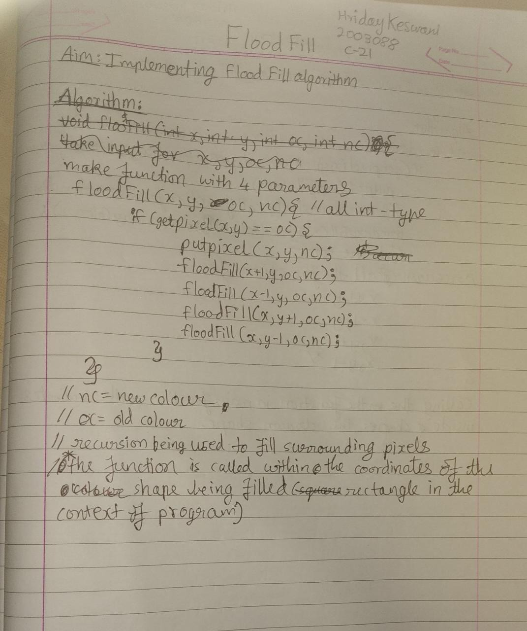**Program:**

Implementing Flood Fill Algorithm

**Code:**

#include<stdio.h>

#include<graphics.h>

#include<conio.h>

#include<stdio.h>

#include<graphics.h>

#include<conio.h>

void floodFill(int x, int y, int oc, int nc){

if(getpixel(x,y)==oc){

putpixel(x,y,nc);

floodFill(x+1,y,oc,nc);

floodFill(x-1,y,oc,nc);

floodFill(x,y+1,oc,nc);

floodFill(x,y-1,oc,nc);

}

}

void main()

{ int a,b,c,d;

int gd = DETECT,gm;

clrscr();

initgraph(&gd,&gm,"C:\\turboc3\\bgi");

printf("Enter the coordinates for start point\n");

scanf("%d%d",&a,&b);

printf("Enter the coordinates for the second point\n");

scanf("%d%d",&c,&d);

rectangle(a,b,c,d);

floodFill(a+10,b+10,0,15);

printf("\nHriday Keswani\n2003088");

getch();

closegraph();

}

**Output:**

