**CG-Assignment**

**Generalized Bresenhams Line drawing Algorithm**

**Program:**

Drawing lines with Generalized Bresenham’s line drawing algorithm

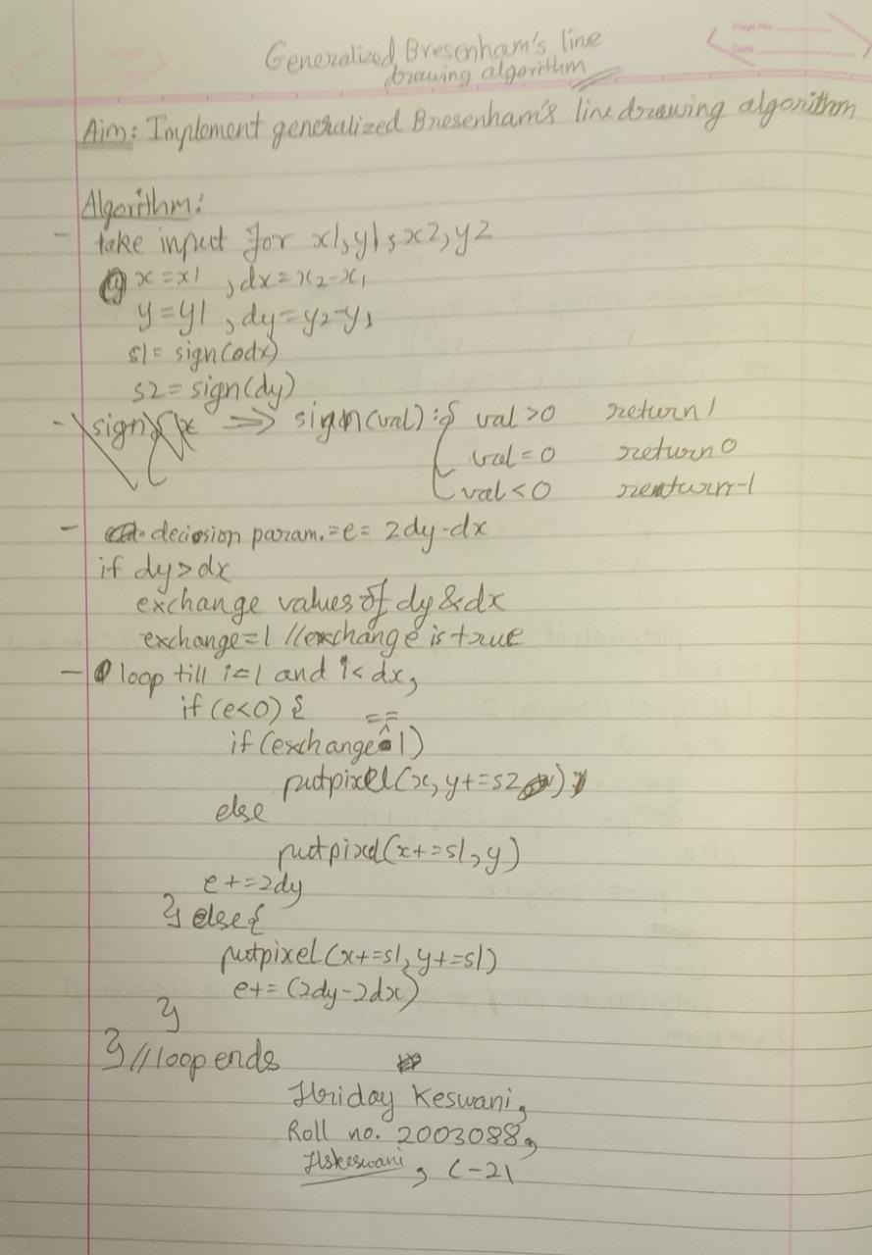

**Code:**

#include<stdio.h>

#include<conio.h>

#include<graphics.h>

#include<math.h>

int sign(int a){

if(a<0)

return -1;

else if(a>0)

return 1;

else

return 0;

}

void bresenham(int x1, int y1, int x2, int y2){

int x = x1, y = y1, dx, dy, e, swap = 0, i, s1, s2, temp;

putpixel(x1, y1, WHITE);

dx = abs(x2 - x1);

dy = abs(y2 - y1);

s1=sign(dx);

s2=sign(dy);

e=2*dy-dx;

if(dy > dx){

temp = dy;

dy = dx;

dx = temp;

swap = 1;

}

for(i = 1;i < dx;i++){

if(e<0){

if(swap)

putpixel(x, y = y + s2, WHITE);

else

putpixel(x = x + s1, y, WHITE);

e = e + 2*dy;

}else{

putpixel(x = x + s1, y = y + s2, WHITE);

e = e + 2*dy - 2*dx;

}

}

}

void main(){

int x1, y1, x2, y2;

int gd = DETECT, gm;

clrscr();

initgraph(&gd, &gm,"c://TURBOC3//BGI");

printf("Enter starting coordinates\n");

scanf("%d %d",&x1,&y1);

printf("Enter ending coordinates\n");

scanf("%d %d",&x2, &y2);

bresenham(x1,y1,x2,y2);

printf("\nHriday Keswani\nRoll no.:2003088\n");

getch();

closegraph();

}

**Output:**

