CG-Assignment
DDA Line Drawing

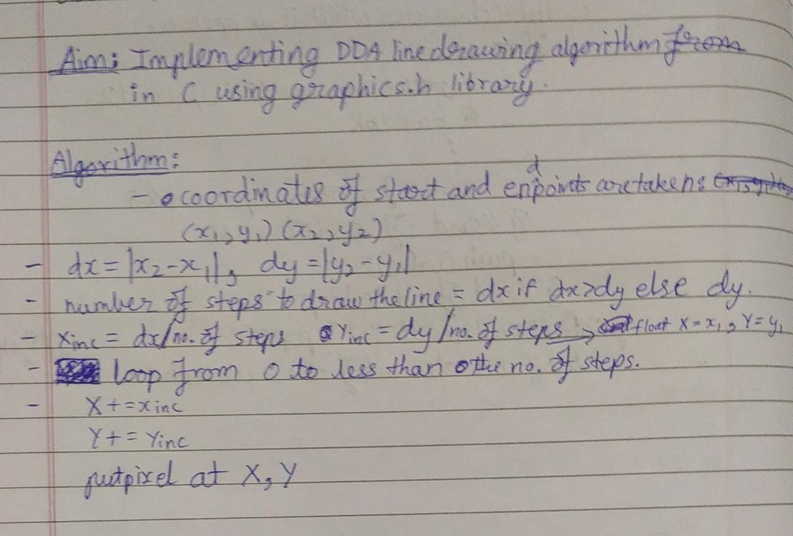
Program:
Drawing lines with DDA algorithm

Code:

#include<stdio.h>
#include<graphics.h>
#include<conio.h>

int round(float x){
return (int) x+0.5;
}

int abs(int x){
int out;
if(x>0)
out=x;
else
out=x*(-1);
return out;
}

void DDA(int x1, int y1, int x2, int y2){
int dx,dy,steps,i;
float X,Y,xi,yi;
dx=x2-x1;
dy=y2-y1;
if(abs(dx)>abs(dy))
steps=abs(dx);
else
steps=abs(dy);
xi = dx/(float)steps;
yi = dy/(float)steps;

X=x1;
Y=y1;

for(i=0;i<steps;i++){
X+=xi;
Y+=yi;
putpixel(round(X),round(Y),WHITE);
}

}

void main()
{ int a,b,c,d;
int gd = DETECT,gm;
clrscr();
initgraph(&gd,&gm,"C:\\turboc3\\bgi");
printf("Enter the coordinates for start point\n");
scanf("%d%d",&a,&b);
printf("Enter the coordinates for the second point\n");
scanf("%d%d",&c,&d);
DDA(a,b,c,d);
printf("Hriday Keswani\nRollno. 88\nC21");
getch();
closegraph();
}

Output:
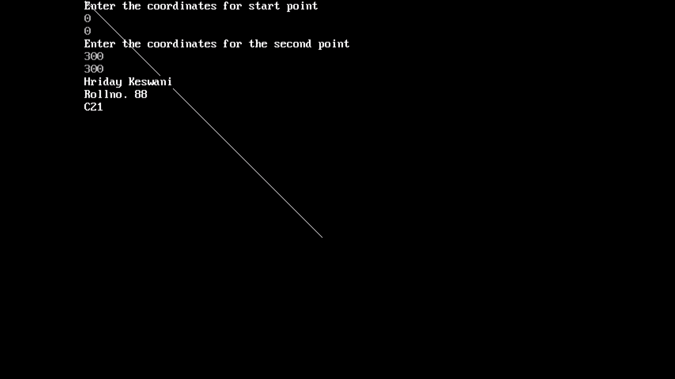

Program:
Drawing dashed lines with DDA algorithm

Code:

#include<stdio.h>
#include<graphics.h>
#include<conio.h>

int round(float x){
return (int) x+0.5;
}

int abs(int x){
int out;
if(x>0)
out=x;
else
out=x*(-1);
return out;
}

void DDA(int x1, int y1, int x2, int y2){
int dx,dy,steps,i;
float X,Y,xi,yi;
dx=x2-x1;
dy=y2-y1;
if(abs(dx)>abs(dy))
steps=abs(dx);
else
steps=abs(dy);
xi = dx/(float)steps;
yi = dy/(float)steps;

X=x1;
Y=y1;

for(i=0;i<steps;i++){
X+=xi;
Y+=yi;
if(i%4!=0)
putpixel(round(X),round(Y),WHITE);
}

}

void main()
{ int a,b,c,d;
int gd = DETECT,gm;
clrscr();
initgraph(&gd,&gm,"C:\\turboc3\\bgi");
printf("Enter the coordinates for start point\n");
scanf("%d%d",&a,&b);
printf("Enter the coordinates for the second point\n");
scanf("%d%d",&c,&d);
DDA(a,b,c,d);
printf("Hriday Keswani\nRollno. 88\nC21");
getch();
closegraph();
}

Output:
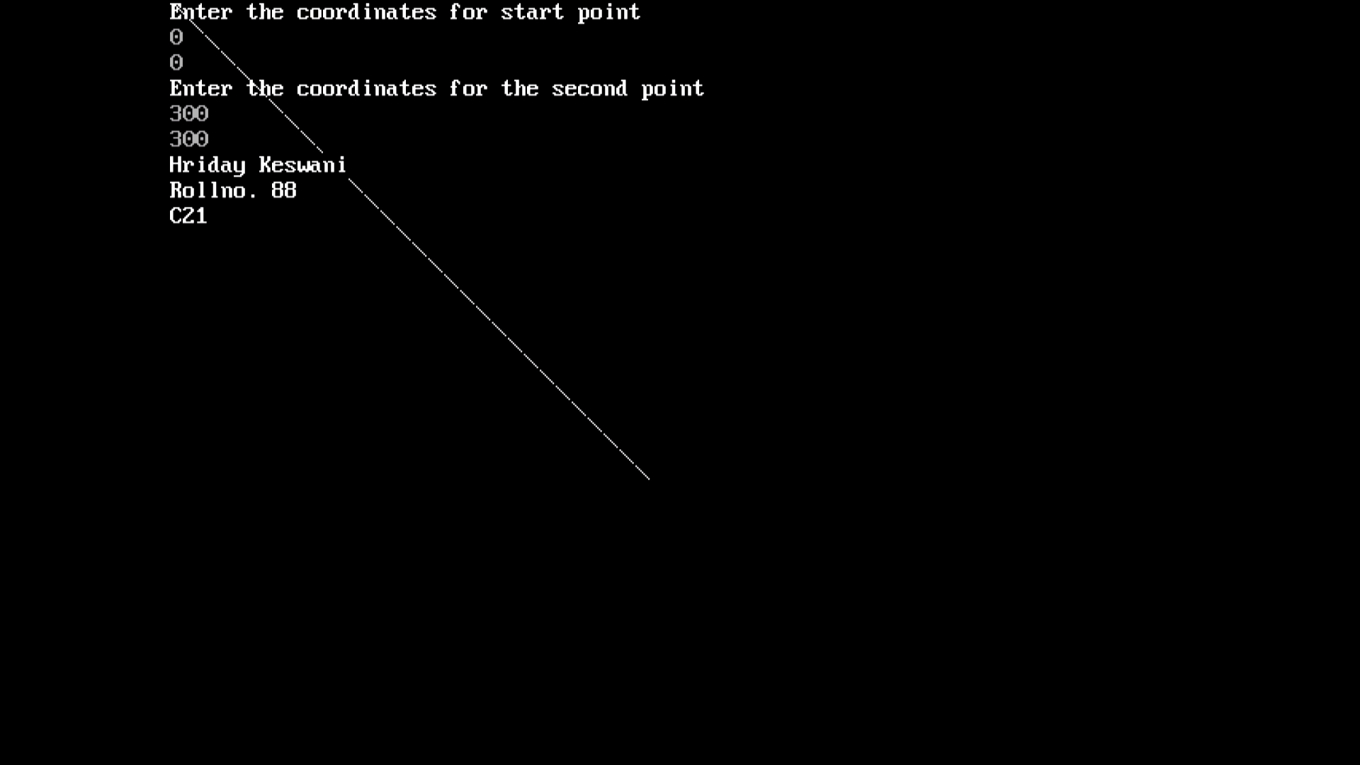

Program:
Drawing dotted lines with DDA algorithm

Code:

#include<stdio.h>
#include<graphics.h>
#include<conio.h>

int round(float x){
return (int) x+0.5;
}

int abs(int x){
int out;
if(x>0)
out=x;
else
out=x*(-1);
return out;
}

void DDA(int x1, int y1, int x2, int y2){
int dx,dy,steps,i;
float X,Y,xi,yi;
dx=x2-x1;
dy=y2-y1;
if(abs(dx)>abs(dy))
steps=abs(dx);
else
steps=abs(dy);
xi = dx/(float)steps;
yi = dy/(float)steps;

X=x1;
Y=y1;

for(i=0;i<steps;i++){
X+=xi;
Y+=yi;
if(i%2!=0)
putpixel(round(X),round(Y),WHITE);
}

}

void main()
{ int a,b,c,d;
int gd = DETECT,gm;
clrscr();
initgraph(&gd,&gm,"C:\\turboc3\\bgi");
printf("Enter the coordinates for start point\n");
scanf("%d%d",&a,&b);
printf("Enter the coordinates for the second point\n");
scanf("%d%d",&c,&d);
DDA(a,b,c,d);
printf("Hriday Keswani\nRollno. 88\nC21");
getch();
closegraph();
}

Output:

