CG-Assignment
Generalized Bresenhams Line drawing Algorithm

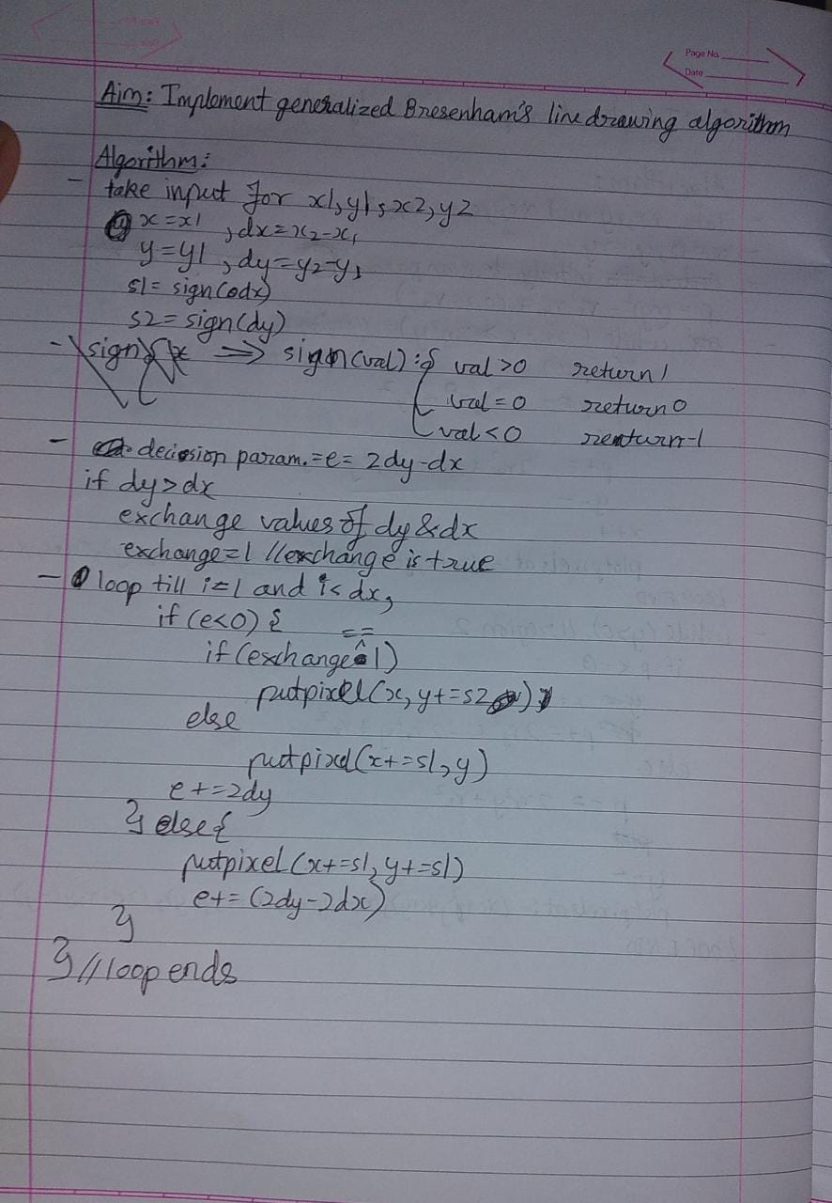

Program:
Drawing lines with Generalized Bresenham’s line drawing algorithm

Code:

#include<stdio.h>
#include<conio.h>
#include<graphics.h>
#include<math.h>

int sign(int a){
if(a<0)
return -1;
else if(a>0)
return 1;
else
return 0;
}

void bresenham(int x1, int y1, int x2, int y2){
int x = x1, y = y1, dx, dy, e, swap = 0, i, s1, s2, temp;
putpixel(x1, y1, WHITE);
dx = abs(x2 - x1);
dy = abs(y2 - y1);
s1=sign(dx);
s2=sign(dy);
e=2*dy-dx;
if(dy > dx){
temp = dy;
dy = dx;
dx = temp;
swap = 1;
}
for(i = 1;i < dx;i++){
if(e<0){
if(swap)
putpixel(x, y = y + s2, WHITE);
else
putpixel(x = x + s1, y, WHITE);
e = e + 2*dy;
}else{
putpixel(x = x + s1, y = y + s2, WHITE);
e = e + 2*dy - 2*dx;
}
}
}
void main(){
int x1, y1, x2, y2;
int gd = DETECT, gm;
clrscr();
initgraph(&gd, &gm,"c://TURBOC3//BGI");
printf("Enter starting coordinates\n");
scanf("%d %d",&x1,&y1);
printf("Enter ending coordinates\n");
scanf("%d %d",&x2, &y2);
bresenham(x1,y1,x2,y2);
printf("\nHriday Keswani\nRoll no.:2003088\n");
getch();
closegraph();
}

Output:
