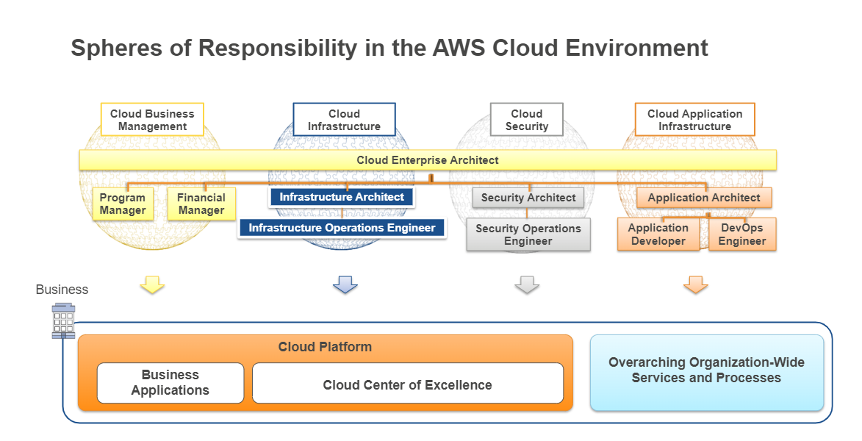

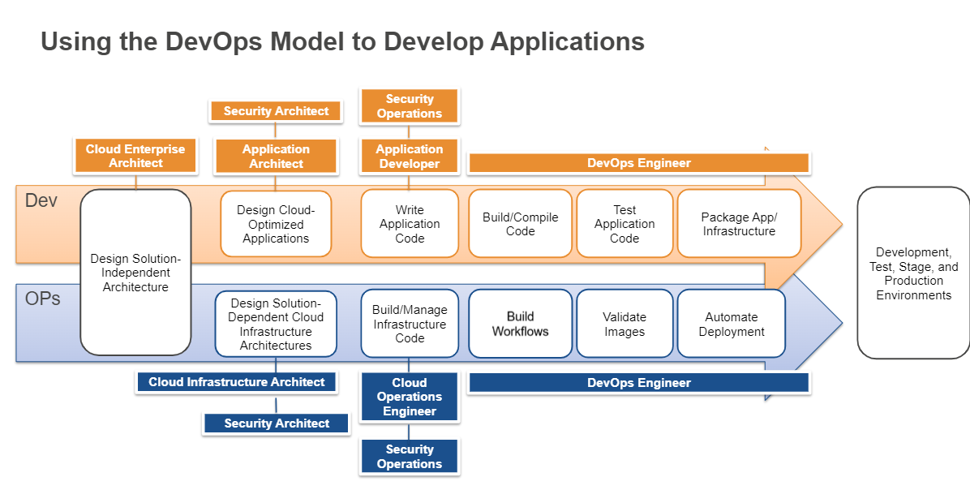

**Database Services:**

* **Relational Data Service (RDS):** It’s a PaaS, Database as a Service
* **DynamoDB:** NoSQL DB
* **Redshift:** DatawarehousingService. Cloud DWH.
* **Data Migration Service (DMS):** To get data from one RDS to RDS. From Cloud to cloud.

It can move the data b/w homogeneous/heterogeneous DB, until they have the same schema (if not, then we can do Schema generation and then perform Data Migration).

|  |  |  |  |
| --- | --- | --- | --- |
| **Name/ Features** | **DynamoDB** |  |  |
| **Server** | Serverless DB |  |  |
| **Relational** | Non-relational, NoSQL |  |  |
| **Response time** | In 0-9 ms |  |  |
| **Accessing rate** | Low |  |  |
| **Scalability** | High |  |  |

* AWS Snowball types:

