DAY 1-10:



DAY 11-30:



DAY 31-45:

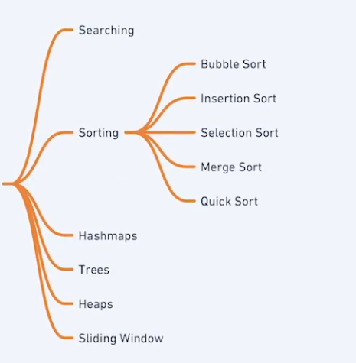

DAY 46-70:

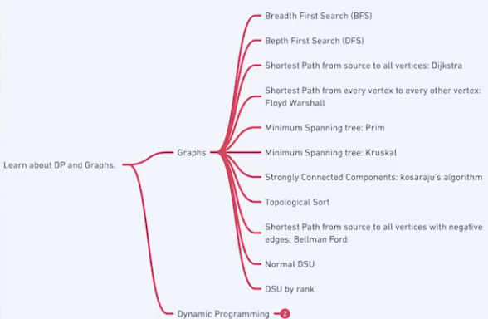

DAY 71-80:



DAY 81-90:

