**Kathmandu University**

**Department of Computer Science and Engineering Dhulikhel, Kavre**



**A Project Report**

**On**

**“RCMS - Recreational Centre Management System”**

**[Code No.: ENGG 102]**

**(For partial fulfillment of I Year/ II Semester in Computer Science/Engineering)**

**Submitted by**

**Hridayanshu Raj Acharya (01)**

**Dikshit Bhatta (13)**

**Sanjib Dahal (18)**

**Aryaman Giri (21)**

**Submitted to**

**Mr. Dhiraj Shrestha**

**Department of Computer Science and Engineering**

**Submission Date: 1st January, 2024**

**Bonafide Certificate**

**This project Work on**

**“RCMS - Recreational Centre Management System”**

**is the bona fide work of**

**Hridayanshu Raj Acharya**

**Dikshit Bhatta**

**Sanjib Dahal**

**Aryaman Giri**

**who carried out the project work under my supervision.**

**Project Supervisor**

**Mr. Amrit Dahal**

**Lecturer**

**Department of Computer Science and Engineering**

**Date:**

**Abstract**

**The Recreation Center Management System (RCMS)** is an innovative project designed to streamline and enhance the administrative experience in a multi-facility recreational environment, encompassing a swimming pool, spa and sauna. This project focus on developing a comprehensive software solution that efficiently records and manages booking processes for the facilities, ensuring an easier and user-friendly interaction.

RCMS aims to address the challenges faced by recreational centers in effectively managing the diverse amenities by storing the user’s unique data in a database, which is created with the help of **SQLite.** By leveraging modern technology and user-centric design made possible via **Qt** GUI designer and coded in **C++**, RCMS will offer the administrators the convenience of a unified platform for accessing various user details and management of bookings in such recreational activities.

**Keywords:** C++, SQLite, Qt.

**Table of Contents**

Abstract

List of Figures

List of Tables

Acronyms/ Abbreviations

Chapter 1 Introduction

* 1. Background
  2. Objectives
  3. Motivation and Significance

Chapter 2 Related Works/ Existing Works

2.1 UM Sports Facilities Booking System

2.2 WePlay Nepal

Chapter 3 Design and Implementation

3.1 System Requirement Specifications

3.1.1 Software Specifications

3.1.2 Hardware Specifications

Chapter 4 Discussion on Achievements

Chapter 5 Conclusion and Recommendation

5.1 Future Enhancements

5.2 Recommendations

**List of Figures**

Figure 2.1.1 UM Sports Facilities Online Booking System

Figure 2.2.1 WePlay Nepal

Figure 3.1 Software Development Roadmap

Figure 3.2 Case Diagram

Figure 3.3 ER Diagram

Figure 3.4 Mechanism of Member Addition or Removal

**Acronyms/Abbreviations**

GUI – Graphical User Interface

**Chapter 1: Introduction**

* 1. **Background**

In today’s fast-paced world, the importance of recreational activities for maintaining a healthy lifestyle and relieving stress cannot be disregarded. Recreational centers play a pivotal role in providing individuals with a diverse range of activeness, from fitness and sports to relaxation and wellness. However, the management of these facilities often presents challenges related to booking and user experience. As technology continues to evolve, there is a growing need for innovative solutions that enhance the overall experience for admins while optimizing the efficiency for facility managers.

Recreational Center Management System (RCMS) seeks to bridge the gap by using technology to modernize the way recreational facilities are managed and experienced. By providing a centralized platform for the administrators, RCMS enhances the admin’s usage for satisfaction. Simultaneously, the project also aims to empower managers with data-driven insights to optimize resource allocation and management efforts.

RCMS aligns with the broader trend of digital transformation across industries, enabling the recreational centers to stay dynamic in a competitive landscape. As technology continues to play a pivotal role in reshaping various sectors, RCMS acts as an innovation within the scope of recreational facility management. Through a whole blend of design, dynamic programming and real time information alongside mobile accessibility, RCMS strives to elevate the recreational experience for users while enabling administrators to efficiently manage and grow their facilities.

* 1. **Objectives**
* To design a user-friendly interface to add/ remove members.
* To centralize booking and management.
* To optimize resource allocation.
* To enhance facility management.
* To promote growth and marketing.

**1.3 Motivation and Significance**

The motivation behind developing the Recreational Center Management System (RCMS) stems from several key factors. The key motivation however, for the development of this project is our survey with the local recreation center owners which had poor to no management systems as such.

RCMS simplifies the admin work by providing a seamless experience for adding the member details, editing them or removing them whenever required. The centralized platform reduces administrative workload by automating the database. This frees up staffs to focus on other aspects of facility management, leading to improved overall efficiency. As recreational center centers expand their offerings or facilities, RCMS can be easily scaled and adapted to accommodate new activities, additional facilities as well as the number of members involved. The admins can also keep track of what the consumers have done or took part with the help of the system’s intelligent database management system.

**Chapter 2: Related Works/ Existing Works**

There are similar management systems that help in management of such recreational activities in various recreational centers. Some of which are described as follows.

**2.1 UM Sports Facilities Online Booking System**

This system allows users to enquire availabilities and make bookings of UM sports facilities more easily using mobile phones. In addition to the new mobile-friendly design, the system has also been enhanced to support session-based timeslot spanning multiple hours. This new feature extended the system capabilities to handle bookings for sports as well as other recreational facilities.

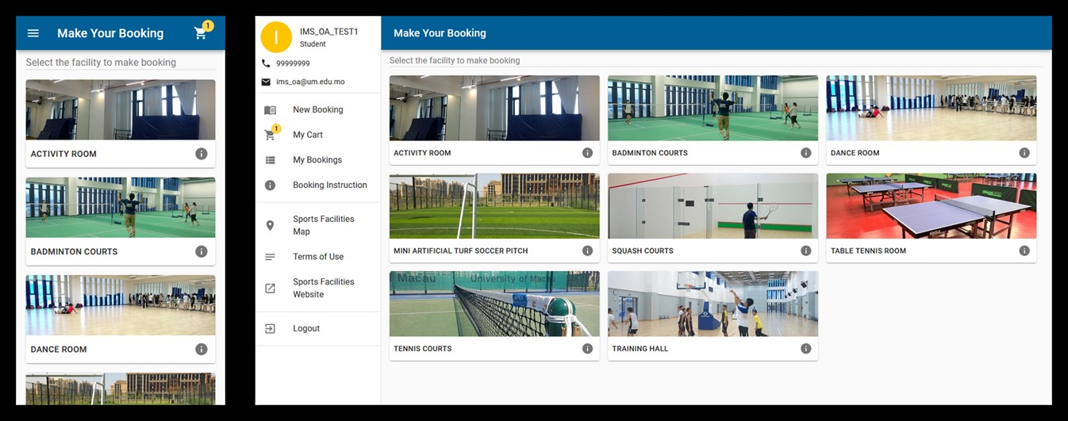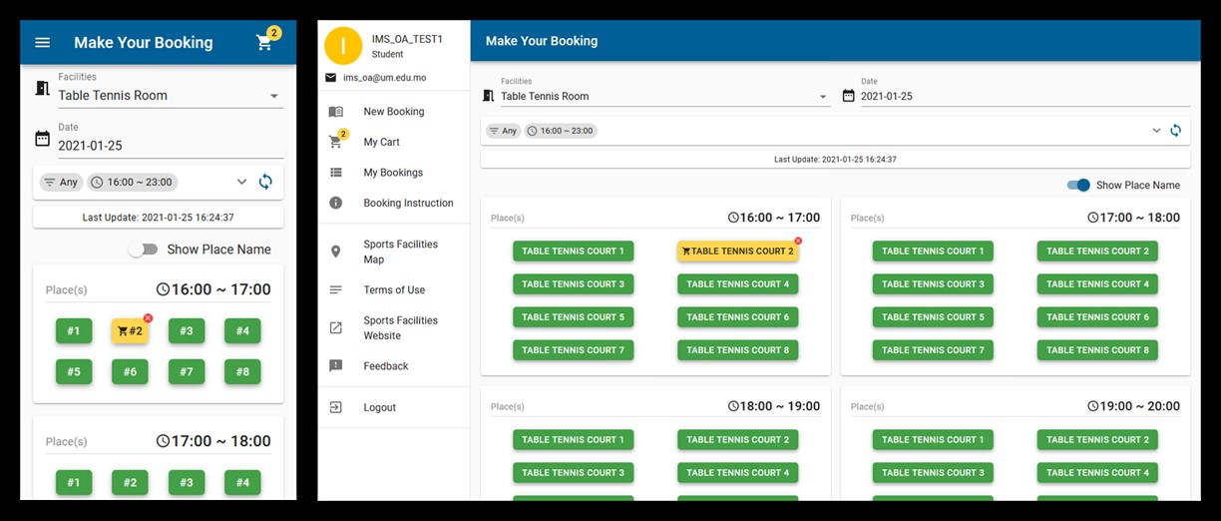

***Figure 2.1.1 UM Sports Facilities Online Booking System***

**2.2 We Play Nepal**

WePlay is the first futsal and sport venues booking mobile app in Nepal. Anyone’s favorite sport in the preferred location and venue of choice is now readily available in their mobile phones. Through the app, users can: book Futsal and other sports Venues, find venues they love and book their time slot in just a couple of taps. Users can also find venues based on location, prices and more, create their team and even invite other players and build their team.

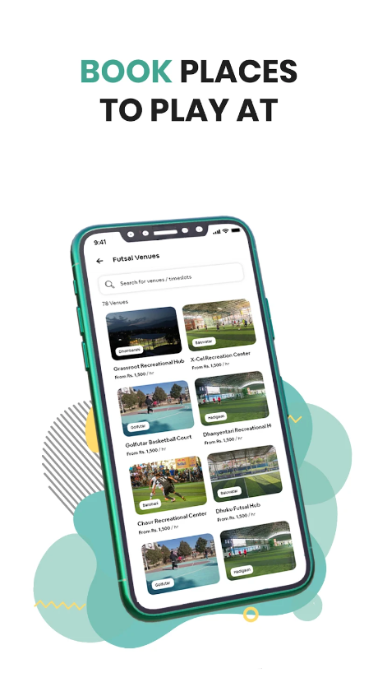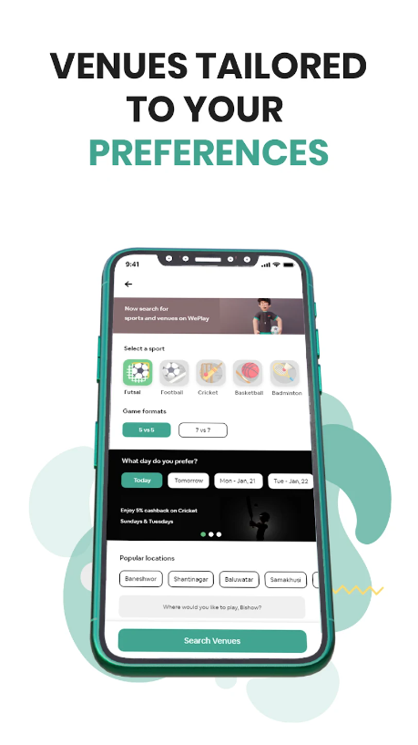

***Figure 2.2.1 WePlay Nepal***

**Chapter 3: Design and Implementation**

After task division among the group members, we initially researched about Qt framework and database (SQLite). In the very beginning, we started our project by designing the GUI in Figma. Following the design, we had a hard time dealing with the Qt framework. On top of that, prior to our project we were just laymen in database, thereby connecting database to Qt wasn’t easy for us. The syntaxes were different in the QLibrary which made the job even more difficult. As we got familiar with the framework, we built a basic admin UI. We also added Login system where admin could access to the dashboard. We also connected database to the login system so that when a admin inserts username and password, the program checks whether the entered credentials matches with the stored data and redirects him to the admin page. After that, we approached to the member page and slowly moved on to the booking management page where we had some problems inserting and scaling the images that were used. We then made another tab for Miscellaneous management and also made a tab for logout. Then we interconnected all of the tabs together and made an integrated GUI.

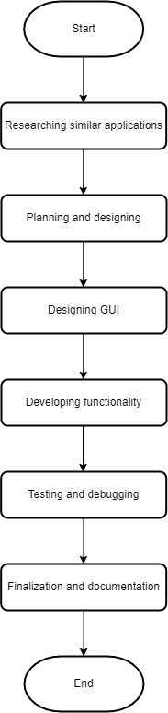

***Figure 3.1 Software Development Roadmap***

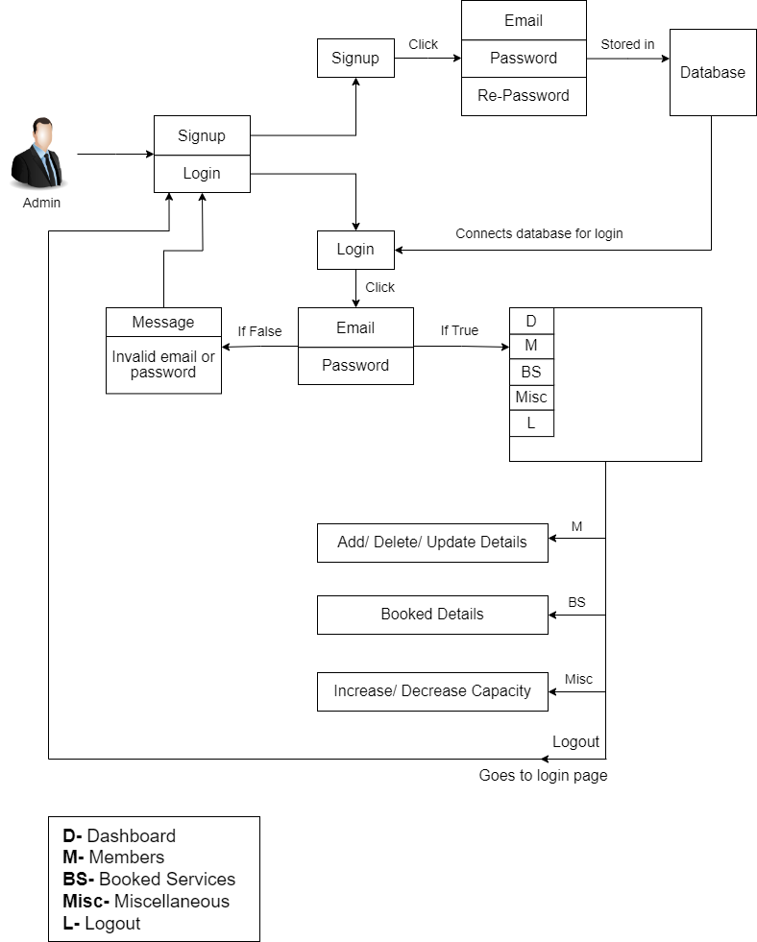

***Figure 3.2 Case Diagram***

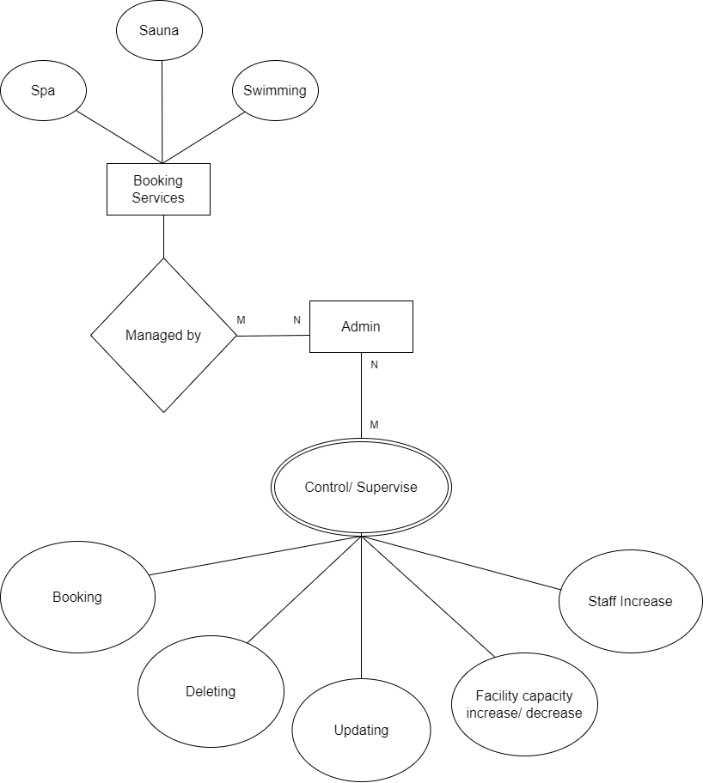

***Figure 3.3 ER Diagram***

**3.1 System Requirement Specification**

Software and Hardware Specifications are as follows:

**3.1.1 Software Specification**

* **C++ Programming Language:** C++ is a statically typed multi-paradigm general-purpose programming language developed by Bjarne Stroustrup as an extension of C programming language. It is widely used in coding by programmers all over the world.
* **Qt:** An open-source cross-platform multi-language widget toolkit that helps in developing GUI applications.
* **SQLite:** A RDBMS System contained in C library embedded into an end program which has bindings to many other programming languages including C++.

**3.1.2 Hardware Specifications**

Approximate minimum hardware requirements for running Qt and SQLite are: 2GB of RAM. 500 MHz CPU, 1 GHz preferred for 60-FPS smooth UI.

**Chapter 4: Discussion on Achievements**

**4.1 Features**

The path we paved at first in our mind couldn’t be executed as expected. However, we brought various changes and improvements as we progressed on our project. Due to limited time and apprehensions, we could not implement as planned but we did replace with other possible features that could be executed.

* **Login System:** It allows the admins to log into the Software. If they don’t have an account, they can quickly create one to use the system.
* **Dashboard:** It includes the details of the recreation center that consists of total capacity, booked services, estimated earnings and total staffs.
* **Members:** It is a panel for entering booked details for members with the options for removing or updating the details of members.
* **Booking Management:** It shows the amount of slots that are booked for services and also the remaining slots of the given recreational activity service.
* **Miscellaneous:** It has the option to add, update or remove the details of staffs in the recreational center. Also, it consists the option to increase or decrease the capacity of the recreational service.
* **Logout:** It takes the admin back to the user page, where he/she can re-enter his/her credentials for another session.

**Chapter 5: Conclusion and Recommendation**

**5.1 Limitations**

This project could not be polished due to the inadequate time in this squished semester. Some of the limitations of our project are:

* **Manual Data Entry:** The consumer details for booking cannot be entered online via any the system because of a local database.
* **User Panel:** The system lacks a user panel where user can themselves enter their details rather than telling them to the admin to add them manually.
* **Notification Panel:** The admin isn’t notified about the time of completion of a consumer’s used recreational activity.
* **Payment System:** There lacks any sort of online payment services such as payment via Fonepay, Esewa or Khalti.

**5.2 Future Enhancements**

Some enhancements that could be made with the help from various other sites and learning platforms, are as follows:

* **Globalizing Database:** This could help in solving most of the limitations of our project as users can enter their details from their homes.
* **Notification Panel Upgrade:** This would help the admins to keep track of the time spent by consumers in such recreational activities.
* **Multiple Data Entry:** This would help the admin to manage the members who want to take part in various recreational activities at carious timestamps.
* **Including Payment Methods:** This would help the user to make any sort of payments straight from their homes.

**5.3 Recommendation:**

As a suggestion to anyone interested in our project and those who want to commit, we would like to recommend you to separate significant time to learn about Qt framework and SQLite database so that you can have a clear concept about how an idea can be implemented. Better understanding of the framework by all the group can lead to suggest better ideas and overall help in the betterment of the project.

**References**

**APPENDIX**