Install VirtualBox

Install CentOS 7

Create a user as your first letter in the first name and last name.

Ex: Kranthi kavuri = kkavuri

Go to your home directory.

Create subdirectories in your home directory with your username + 1 & 2.

Create a file with your username.

Change the permissions for the file to read and write but not execute.

Change the permission for the file to read and execute but not write.

Write two lines in a file and display it to the screen.

Install VirtualBox

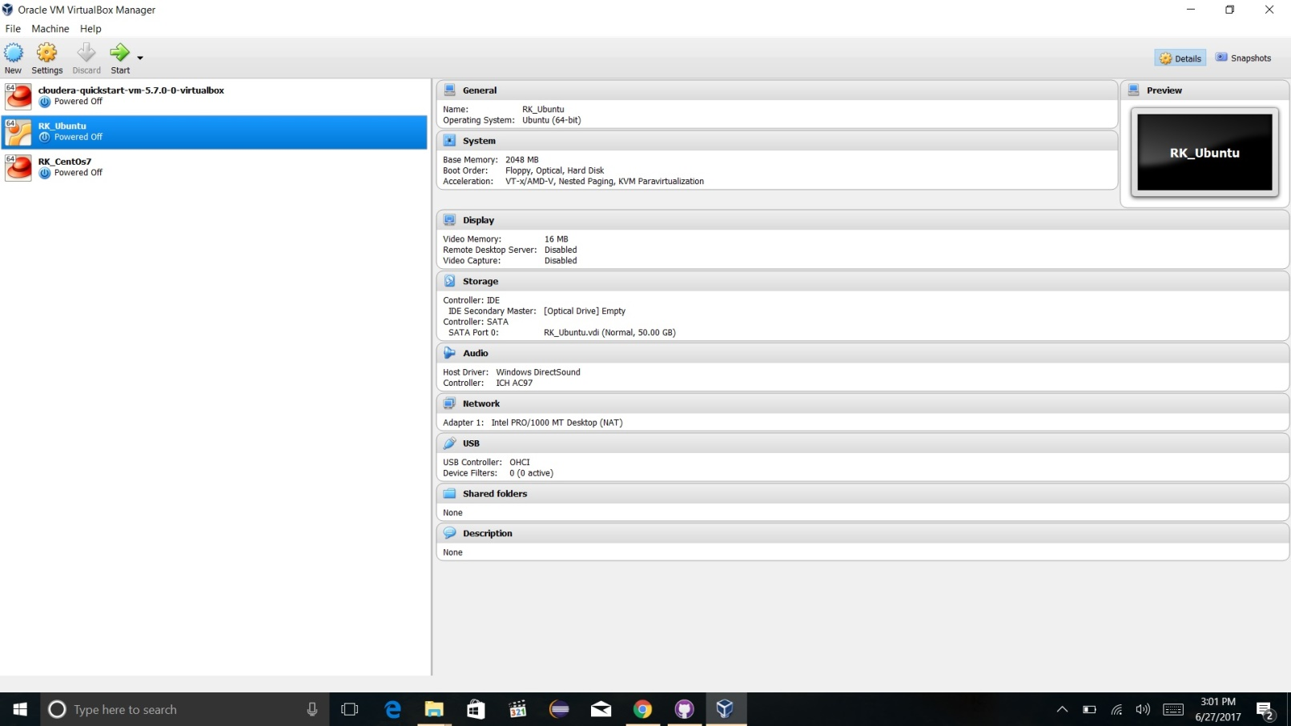

Install Ubuntu

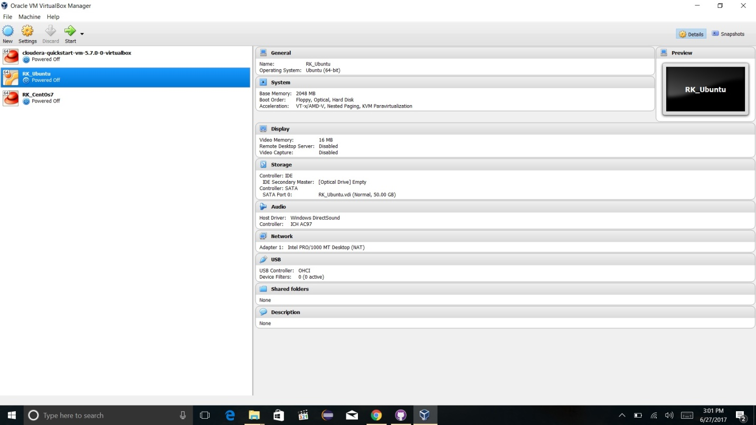

User name: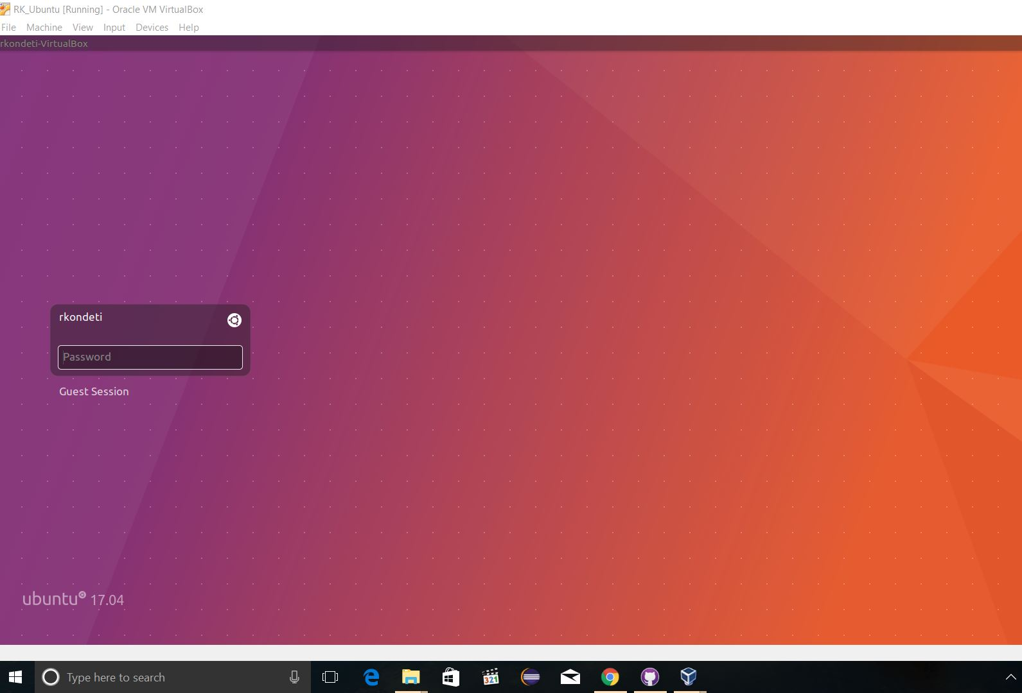

Create subdirectories in your home directory with your username + 1 & 2

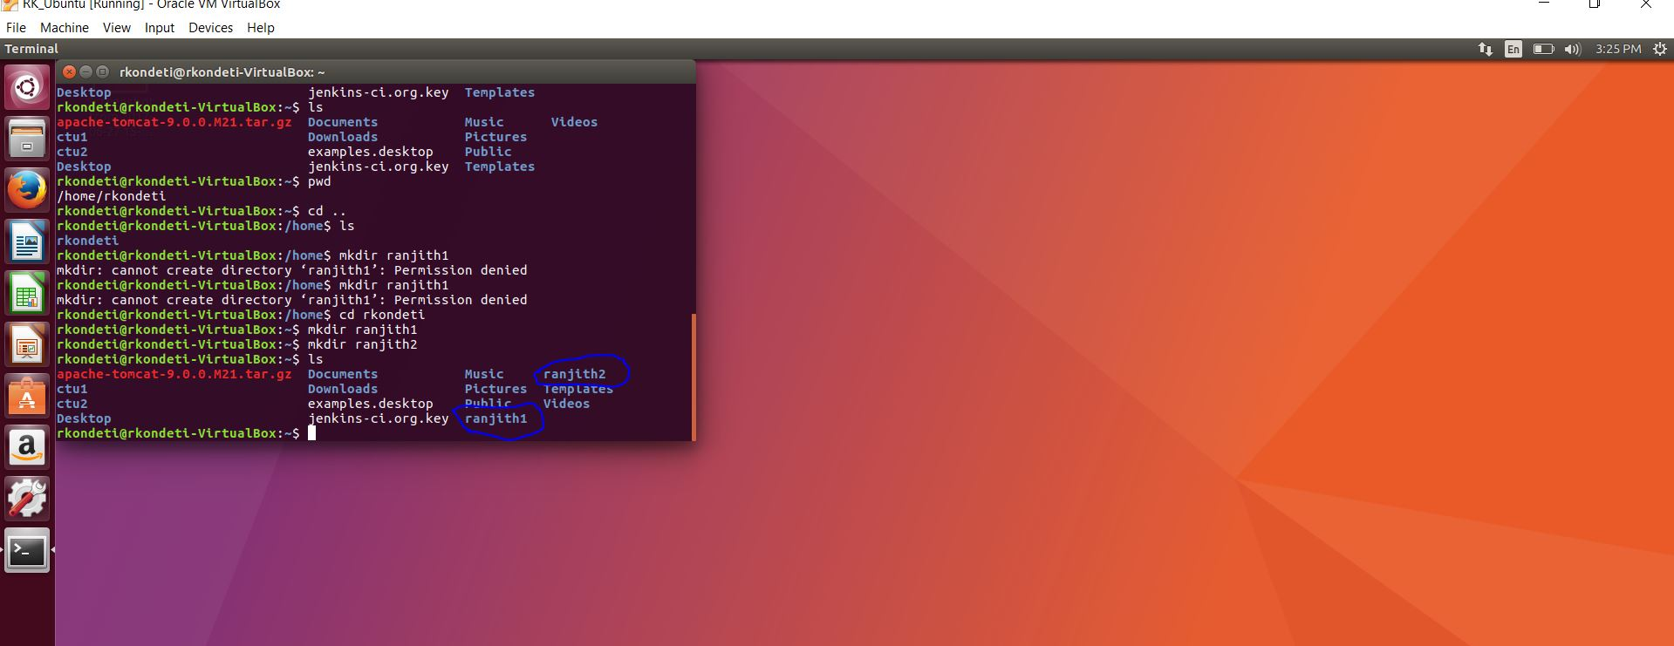

Create a file with your username.

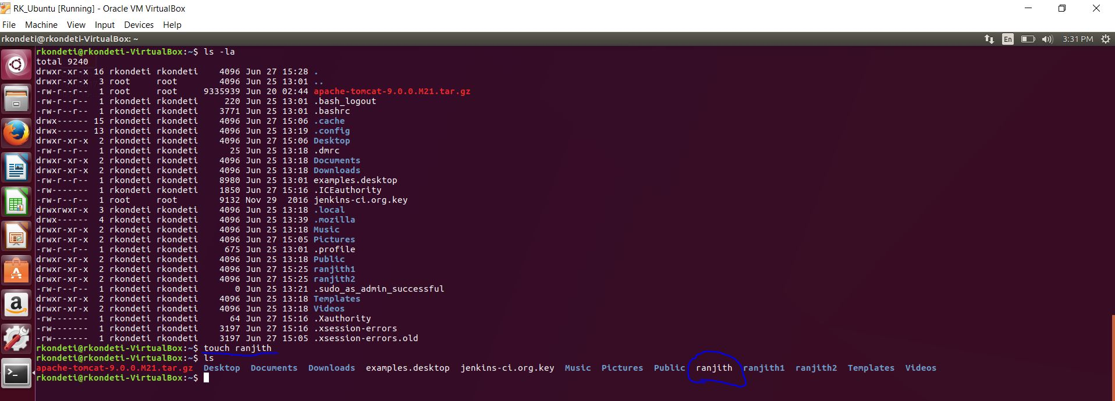

Change the permissions for the file to read and write but not execute.

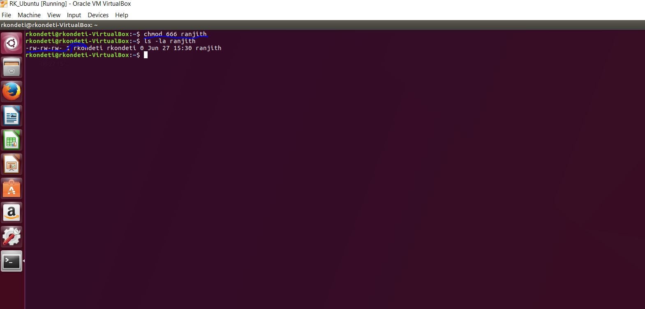

Change the permission for the file to read and execute but not write.

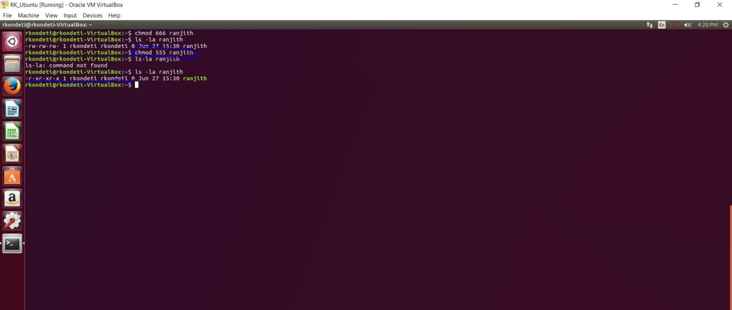

Write two lines in a file and display it to the screen.

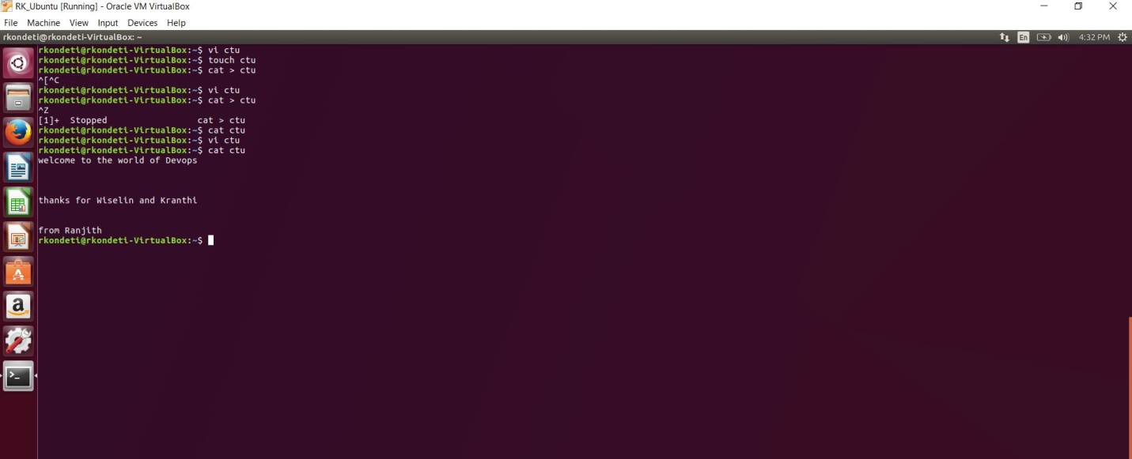

Some more screen shots permissions before changing

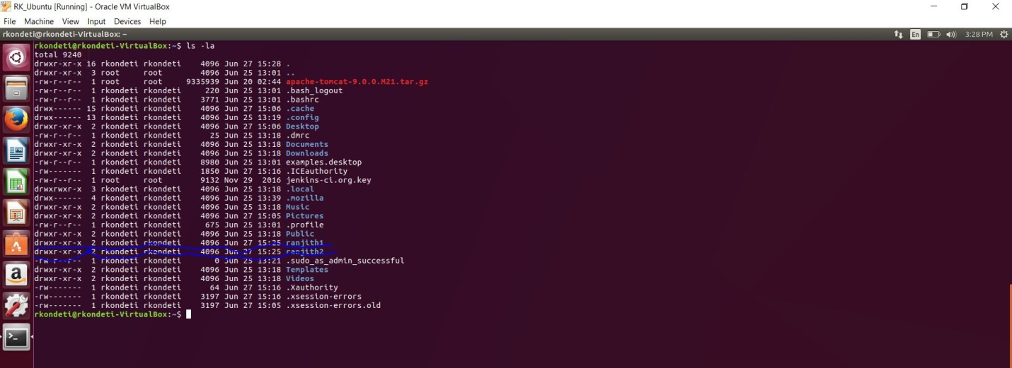

Installing Git Sheel

