**Article #3: What is Negation Test and How to use it?**

**Introduction**

This is the third and the final article in the series of Negation Test Articles. In the first article you learnt about the concept of logical negation and sample spaces. You also learnt how to represent various sample spaces on the Possibility Line. In the second article you applied this understanding to negate various statements. In this article, we’ll go one-step further and logically negate option choice statements through the **Negation Test to figure out the correct answer to an Assumption Question with a 100% surety**.  
  
All set to master the Negation Test? Let’s get rolling!

**What is Negation Test?**

The Negation Test is a tool that we use to determine with full confidence as to whether a given answer choice in an Assumption question is the correct answer. How do we do that? We simply **take an answer choice and logically negate the information given in it**. If by negating the information, **the conclusion is falsified**, the answer choice at hand is indeed an assumption made by the author, and is, hence, the **correct answer**. You can mark it and move on to the next question. As simple as that!  
  
Of course **if negating** the information given in the answer choice under consideration **does not falsify the conclusion**, you need to evaluate other contenders, since this one’s NOT the correct answer – it is **not the assumption**; it is not vital for the argument.

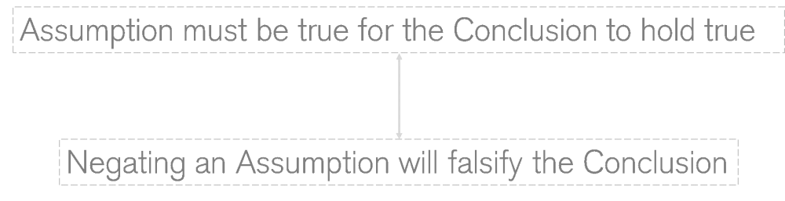

**Why does Negation Test work?**

Now you may ask as to why is that the case – why does negating the assumption falsify the conclusion?  
  
The Negation Test exploits a key feature of any assumption – that the assumption has to be true for the conclusion to hold valid. Let’s understand this quality a bit more.  
  
By definition, an **assumption is a vital piece of information** that is never actually given to us in the argument but is supposed/**assumed by the author while drawing the conclusion**. What does this mean? This means that if **we take away the assumed piece of information**, the author will not be able to draw the given conclusion and **the argument falls apart**. This is the feature that the Negation Test utilizes.  
  
Now that you know in principle why the Negation test works, let’s see it in action. But before that, you need to understand when exactly to use the test.

**When to use Negation Test?**

To use the Negation test successfully, you need to understand when exactly to use it. The reasons for the same are simple:

1. **Negation Test is not meant as a first line of defence**: The purpose of the test is to help you figure out the correct answer when you are stuck between two answer choices (ideally) that are close as per your understanding. This means that you will have done some analysis before using the test – we will show you what kind of analysis we mean.  
  
2. **Using the test on each and every choice means wastage of precious prep/exam time**: The test is meant to clear your doubt and help you save time while making a decision between answer choices that you think are close; however, if you apply it to each and every choice, then you are not only wasting your time but also missing a key gap in your understanding. The fact that you are confused among more than two answer choices shows that you didn’t understand the argument well. Applying the Negation Test will not work here since your understanding of the argument is not clear to begin with.

Now that you are clear about when to apply the Negation Test, **let’s address the analysis you should do leading up to its application**.  
  
Let’s say after you read an argument, you spend a little time on thinking about the argument, but, despite your best effort, the assumption doesn’t jump right at you. You, therefore, get confused when you go in to the answer-choice evaluation.  
  
Now here’s how you should approach the question from this point on:

1. **Discard all the answer choices that do not provide new information**: As discussed earlier, an assumption is something that is supposed/assumed but not stated by the author while making the conclusion. Therefore, it cannot be a repetition of what’s already given to us.  
  
2. **Discard answer choices that do not support the conclusion**: As e-GMATers know, an assumption must always support the conclusion. The logic is the same. Assumption provides a piece of information that the author has taken in to account while drawing the conclusion – even though he/she doesn’t state it in the passage. So, basically, the assumption facilitates the author in drawing the conclusion.  
  
3. **Apply the Negation Test**: After following the above two steps, you will be left with 2 (maybe 3 in the beginning when you are stilling learning concepts) answer choices. Now, without wasting any more time, get the Negation Test rolling.

Let’s see the above process in action.

**Negation Test in Action: Example 1**

**Question**

**Argument**: Investments that are not subject to market risk are categorised as conservative investment options. These options are generally safe to invest in but generate a lower than average market-yield. Therefore, some people over 60 are likely to get returns that are lower than the market average.  
  
Which of the following is an assumption made by the author?

A. Most people over 60 are likely to invest in conservative investment options.  
B. At least one person over 60 is likely to invest in conservative investment options.  
C. Some investors over 60 are likely to invest in options other than the ones generally considered conservative.

Before we apply the Negation Test to the three choices under consideration, let’s first understand the argument.

**Passage Analysis**

The argument first tells us about a kind of investment option - conservative investment option. These investments have two features – safe to invest but yield lower than the market average. On the basis of this information, the author draws a conclusion about “some people over 60”. The author says that these people are likely to get return that are lower than the market average.

**Initial Answer Choice Evaluation**

Now, let’s say you rejected a few answer choices on some basis or the other – they did not give any new information or they did not support the conclusion, and so they were irrelevant. For instance, in the given argument, Choice C is irrelevant. Now before we tell you why that’s the case, think for yourself. Does it talk about the relevant segment? NO. Does it give any information that increases our belief in the conclusion? NO- because it talks about the relevant group’s likelihood to invest in options other than the one the author concludes about.  
  
So, here we are now:  
  
**Argument**: Investments that are not subject to market risk are categorised as conservative investment options. These options are generally safe to invest in but generate a lower than average market-yield. Therefore, some people over 60 are likely to get returns that are lower than the market average.  
  
Which of the following is an assumption made by the author?

A. Most people over 60 are likely to invest in conservative investment options.   
*Seems like a contender as it increases my faith in the conclusion - we now know that most people make such investments so their chances of getting lower than market average returns increase.*  
  
B. At least one person over 60 is likely to invest in conservative investment options.   
*Seems like a contender as it talks about the same segment making the mentioned investments but isn’t information about “most” above better than “at least” one here?*  
  
C.   
*Rejected for reasons mentioned above*

Now is the time you should apply the Negation Test to choices A and B and see what impact the respective negated statements have on the conclusion. Let’s start with choice A.

**Choice A**

**Choice A**: Most people over 60 are likely to invest in conservative investment options.  
  
**Understand the Sample Space**: We know that choice A talks about the relevant segment, so we can move to the step where we understand the sample space covered by choice A. Since it talks about “most” people over 60, the sample space it covers is:

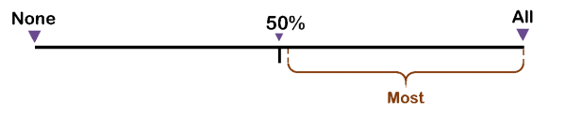

Now that we know the sample space it covers, we are ready to move to determining the possibilities that lie outside this sample space.  
  
**Understand the possibilities that lie outside the sample-space**: Let’s see what possibilities lie outside the sample space covered by the group-marker *most*.

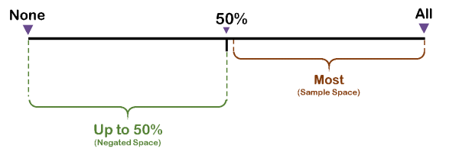

*Negated space = possibilities not covered by the original sample space  
  
So, the negated statement we arrive at is:  
  
**Negated statement for choice A**: *Up to 50% of people over 60 are likely to invest in conservative investment options*.  
  
**Impact of the negated statement on the Conclusion of the argument**: The negated statement offers a range of possibilities. We’ll consider the extreme two ones for a clear understanding. They are:

1. *No people over 60 are likely to invest in conservative investment options. – falsifies the conclusion as it negates the possibility that people over 60 are likely to invest in such options.*  
  
2. *50% of people over 60 are likely to invest in conservative investment options. – strengthens the conclusion, as it indicates that half of the people in the segment are likely to invest in such options.*

Now, **since the negated version of answer choice A does not falsify the conclusion in all possibilities under it, choice A is NOT the correct answer; it is not assumption made by the author.**  
  
By default, we are left with only one choice now - Choice B. But let’s apply the Negation Test and be a 100% sure that it is indeed the correct answer.

**Choice B**

**Choice B**: At least one person over 60 is likely to invest in conservative investment options.  
  
**Understand the Sample Space**: Choice B says that at least one person in the segment is likely to invest in the mentioned investment options. Now, we know that logically speaking, “at least one” has the same meaning as “some” – we covered this derivation in the second article How to Negate Statements (read above). So, we can rephrase Choice B as: *Some people over 60 are likely to invest in conservative investment options.* Let’s represent the same on the Possibility Line:

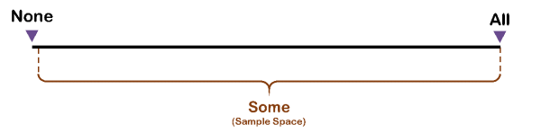

**Understand the possibilities OUTSIDE the sample space**: As you can see in the above section, the sample space covered by *some*is 1-100. Therefore, we are left with only one possibility on the Possibility Line that is OUTSIDE this space – the possibility of *none/no* or 0 people in the concerned segment. This is indeed the negated space. Let’s see it on the Possibility Line:

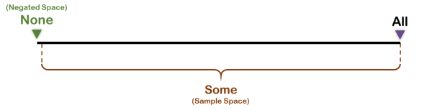

Let’s now deduce the negated statement of Choice B by replacing the original group-marker by the negated space:  
  
**Choice B**: *At least one person over 60 is likely to invest in conservative investment options.*  
  
**Negated version of Choice B**: *None of the people over 60 are likely to invest in conservative investment options.*  
  
**Impact of the negated statement on the Conclusion of the argument**: Is the conclusion falsified with the negated statement above? The answer to this question is a firm YES! The **negated statement** says that no one over 60 is likely to invest in such options. If that is indeed the case, then can the author draw the conclusion that “some” people over 60 are likely to get lower than average market-yield? Certainly not! The basis of the author’s conclusion is negated.  
  
**Since the negated version of answer choice B falsifies the conclusion distinctly- without any ambiguity - answer choice B is the CORRECT answer; it is indeed an assumption made by the author.**  
  
Note that in the examples we are going in to diagrammatic representations time and again. It is to illustrate what impact logical negation has on different statements. In the actual exam, you most likely won’t need to do so, as, with the right practice, you will have mastered logical negation in CR. Just in case you face a confusion then, you can use the Possibility Line to clear your doubt.  
  
Now that you have seen how the Negation Test works in simple arguments, let’s apply it to an Official Question, which we have modified slightly.

**Negation Test in Action: Example 2 (Official Question - Modified)**

**Argument**: *Although parapsychology is often considered a pseudoscience, it is in fact a genuine scientific enterprise, for it uses scientific methods such as controlled experiments and statistical tests of clearly stated hypotheses to examine the questions it raises.*  
  
Remember the above argument? You must have tried it while reading the first article in the Negation Test series: What is Negation and What are Various Sample Spaces (read above). In the modified version, we have limited the answer choices to three, retained some of the original answer choices, and added some more from our end – this modification has been done to address some key gaps observed in students’ understanding of this question. Have a fresh look at the question:

**Question**

**Argument**: Although parapsychology is often considered a pseudoscience, it is in fact a genuine scientific enterprise, for it uses scientific methods such as controlled experiments and statistical tests of clearly stated hypotheses to examine the questions it raises.  
  
The conclusion above is properly drawn if which of the following is assumed?

A. Every genuine scientific enterprise has to use scientific methods to examine the questions it raises.  
B. Any field of study that employs scientific methods is a genuine scientific enterprise.  
C. There is no other parameter, besides the use of scientific methods, that can singlehandedly determine whether a field is a genuine scientific enterprise.

Let’s see how the Negation Test helps us mark the right answer in this question, with full confidence. But before we do that, we must come to a common understanding of the argument. Accordingly, let’s analyse what the argument is all about.

**Passage Analysis**

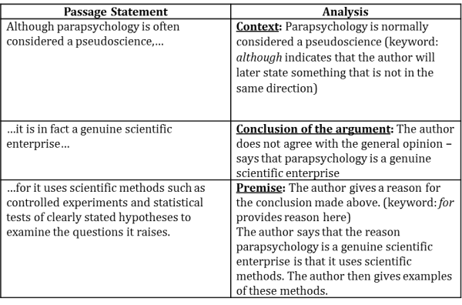

As you see, **the author’s conclusion rests on the fact that parapsychology uses scientific methods to examine the questions it raises**. With this understanding in mind, let’s evaluate the answer choices:

**Initial Answer Choice Evaluation**

**Argument**: Although parapsychology is often considered a pseudoscience, it is in fact a genuine scientific enterprise, for it uses scientific methods such as controlled experiments and statistical tests of clearly stated hypotheses to examine the questions it raises.

A. Every genuine scientific enterprise has to use scientific methods to examine the questions it raises.  
Hmmm…I am not fully sure what this means…but let me keep it for now.  
  
B. Any field of study that employs scientific methods is a genuine scientific enterprise.  
OK…this one makes the most sense, but I can’t reject the others with confidence.  
  
C. There is no other parameter, besides the use of scientific methods, that can single-handedly determine whether a field is a genuine scientific enterprise.  
Seems like a contender as it definitely increases my faith in the conclusion - we now know that no other factor can on its own determine whether a field is a genuine scientific enterprise. I am going to keep it.

Now you can apply the Negation Test. Let’s negate each of the above statements to see what impact the negated versions have on the conclusion of the argument.  
  
*Please note that we are going to put all the three answer choices under the Negation test since the purpose here is to show you how the test helps you evaluate answer choices that you might deem close. You should ideally use the test when you are stuck between two answer choices.

**Choice A**

**Choice A**: *Every genuine scientific enterprise has to use scientific methods to examine the questions it raises.*  
  
First of all, this choice is not a real contender for the Negation Test. Why is that the case? This choice talks about a must condition that all genuine scientific enterprises have to fulfil. But, if you consider the argument closely, you will see that **the argument does not conclude anything about all genuine scientific enterprises**. The conclusion is regarding what can be considered as a good enough criterion for a field to be considered a genuine scientific enterprise.  
  
Nevertheless, we will apply the Negation Test to this choice as, in our experience, many students get confused in such choices and end up marking them due to lack of proper understanding. With the application of the test, you will be able to see a 100% why it is incorrect.  
  
**Choice A**: *Every genuine scientific enterprise has to use scientific methods to examine the questions it raises.*

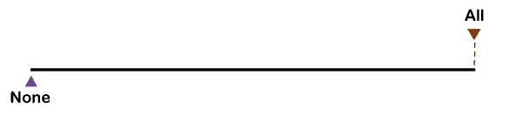

**Negated version of Choice A**: *Not every genuine scientific enterprise has to use scientific methods to examine the questions it raises.*

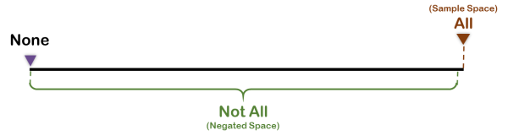

**Rephrase of the negated statement**: *0 - 99 genuine scientific enterprises have to use scientific methods to examine the questions they raise.*  
  
**Impact of the negated statement on the conclusion**: The negated statement offers a range of possibilities. We’ll consider the two extreme ones for a clear understanding. They are:

1. *No genuine scientific enterprises has to use scientific methods to examine the questions it raises. – weakens the conclusion as it indicates that it is probably not a criterion worth considering.*  
  
2. *Almost all genuine scientific enterprises have to use scientific methods to examine the questions they raise. – strengthens the conclusion, as it indicates that it is a criterion worth considering.*

**As you can see, the negated version of choice A does not have a clear impact on the conclusion of the argument - it does not shatter the conclusion. Hence, choice A is not an assumption made by the author.**

**Choice B**

**Choice B**: *Any field of study that employs scientific methods is a genuine scientific enterprise.*

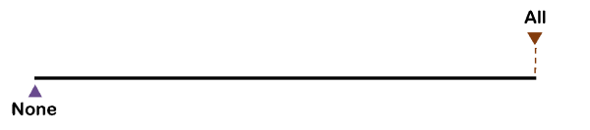

**Negated version of Choice B**: *Not all fields of study that employ scientific methods are genuine scientific enterprises.*

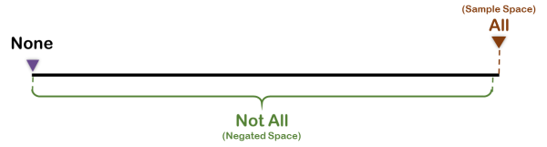

**Rephrase of the negated statement**: *0-99 fields of study that employ scientific methods are genuine scientific enterprises.*  
  
**Meaning of the negated statement**: If you see, the above statement says that out of a 100 that employ scientific methods, only 0-99 are genuine scientific enterprises. This means that there is definitely one possibility that a field employs scientific methods but is still not a genuine scientific enterprise.  
  
**Impact on the conclusion**: The negated version of Choice B completely destroys the basis of the author’s conclusion. The reason the author said that parapsychology is a genuine scientific enterprise was that it uses scientific methods to examine the question it raises, implying that this factor is sufficient. However, **the negated version says that it is not sufficient as there is definitely 1 possibility in which even a field that uses scientific methods is not a genuine scientific enterprise. Hence, the conclusion is falsified. It is indeed the correct answer!**  
  
Even though we have arrived at the correct answer, we will see how the Negation Test helps us reject Choice C that we did consider as a contender in the beginning.

**Choice C**

**Choice C**: *There is no other parameter, besides the use of scientific methods, that can singlehandedly determine whether a field is a genuine scientific enterprise.*  
  
**Negated version of Choice C**: *There are some other parameters, besides the use of scientific methods, that can singlehandedly determine whether a field is a genuine scientific enterprise.*  
  
**Meaning of the negated statement**: *While the use of scientific methods can determine singlehandedly, there are some other methods as well.*  
  
**Impact on the conclusion**: Does this choice have any negative impact on the conclusion? Nope. That’s because **we still haven’t negated the basis of the conclusion**. All that we know is that there are other parameters that TOO can determine what this particular parameter determines. So what? Does that take away from the fact that the use of scientific methods is enough to determine whether parapsychology is a genuine science- Nope! **The conclusion is still valid**.  
  
So you see, the Negation Test helps you arrive at the correct answer with a 100% surety; however, you must use it only after you have narrowed down to two contender choices.  
  
To practice the Negation Test with some more assumption questions, take a CR Ability Quiz [here](https://e-gmat.com/cr-ability-registration/?channel=Negation3_GMATClub&page=CR_Ability). The added bonus is that you get a realistic estimate of your strengths and weaknesses in CR.  
  
Good Luck!