Tutorial 4

CB.EN.U4CSE18502

HRIDHI SETHI

CSE A

4TH YEAR, BTECH CSE

# Activity table

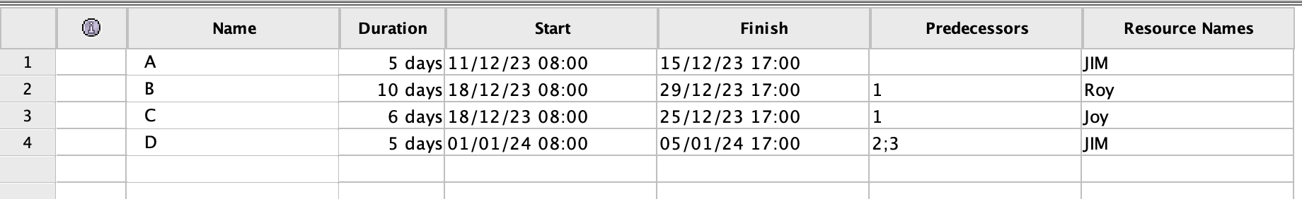

# Resource table



# RBS

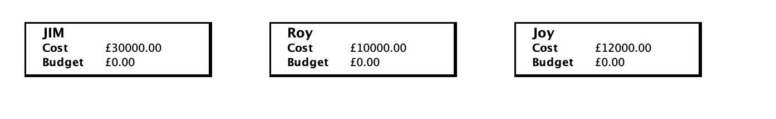

# Resource usage

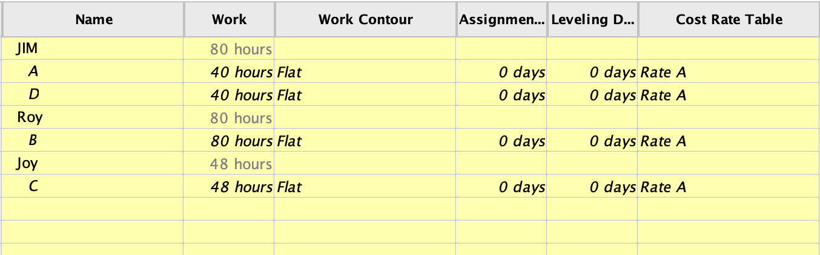

# Gantt chart

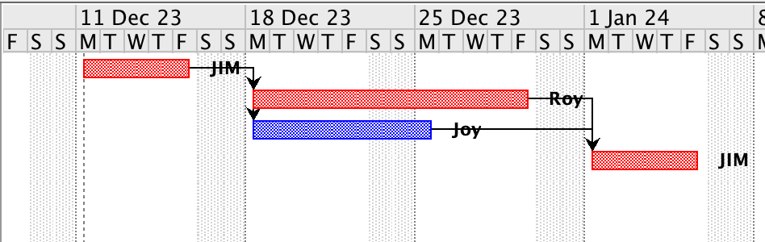

# Network diagram

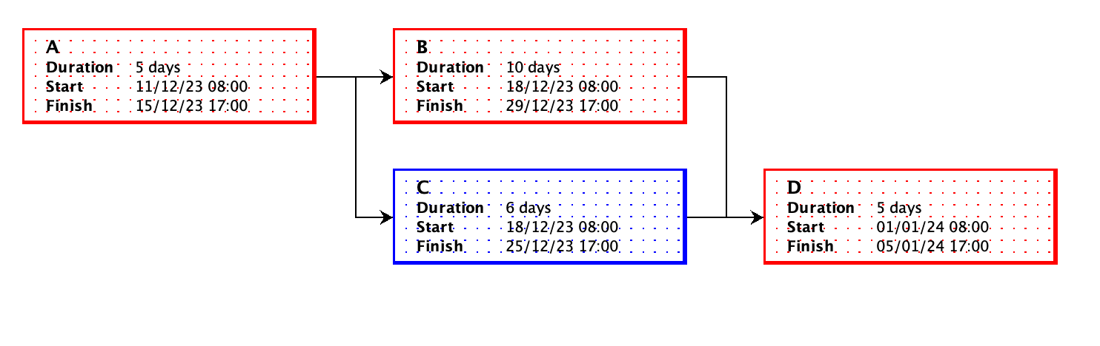

# Part -2

Now activity table becomes

## Resource usage

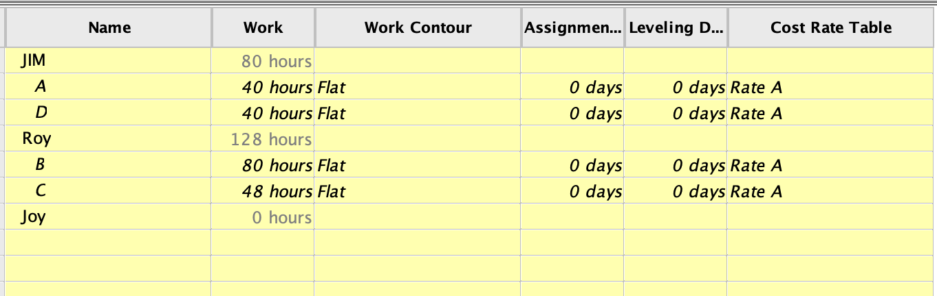

# Cost before roy replaces joy

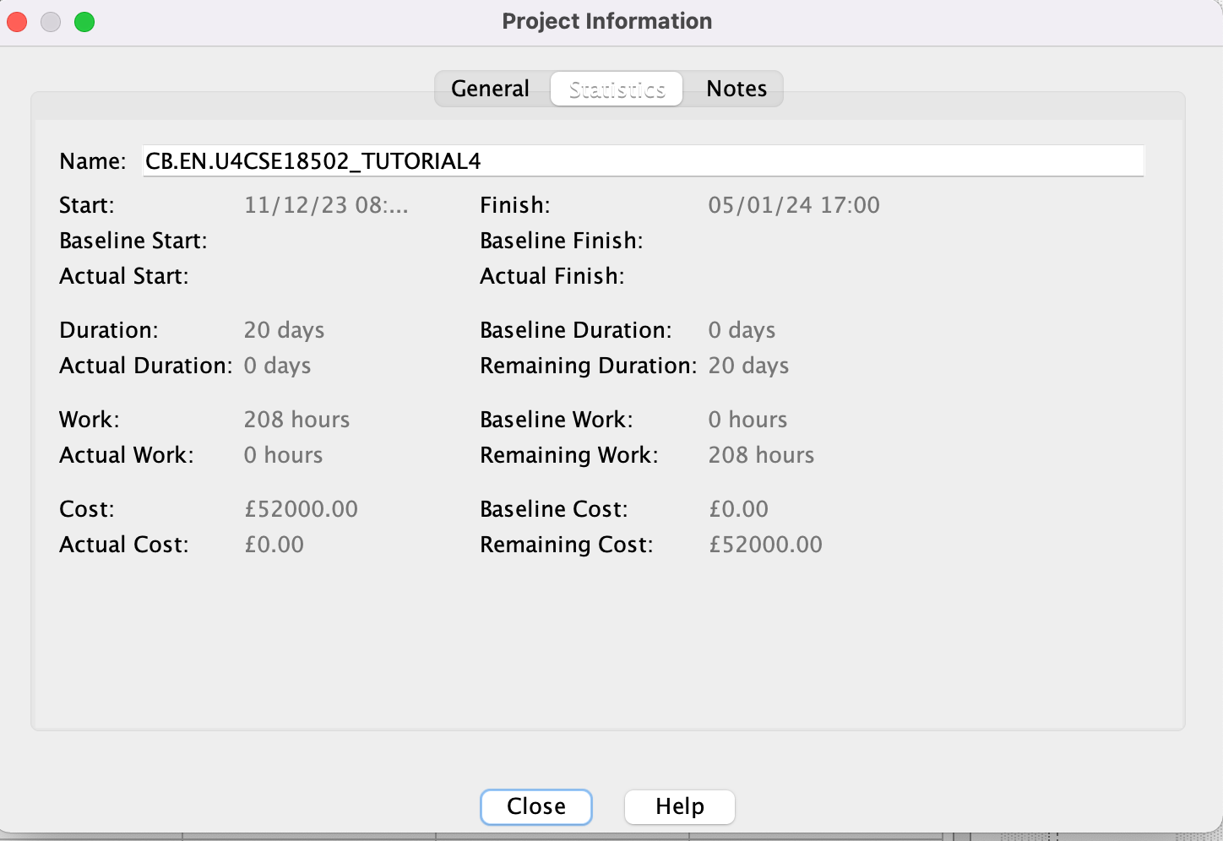

# Cost after roy replaces joy

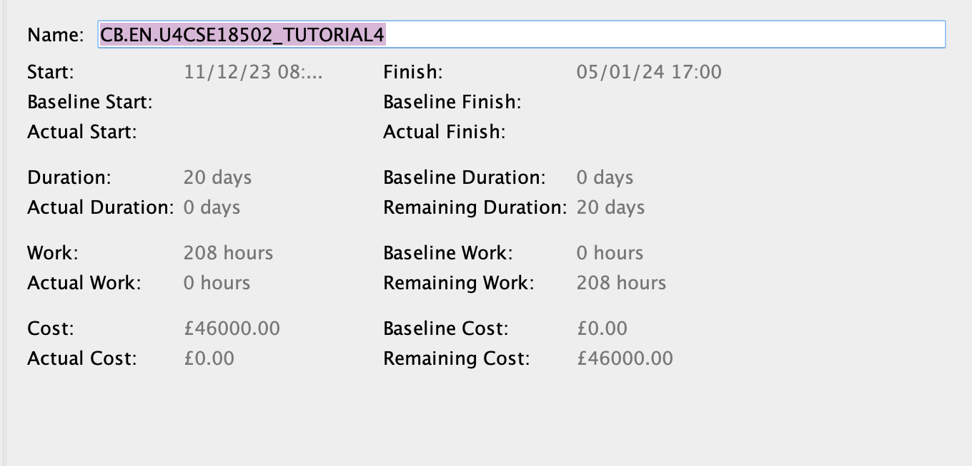

So as you can observe after roy replaces joy the cost of the project has been reduced, work is same

So replacing roy with joy is a better option