**Software Requirements Specification**

**for**

Student paper publication portal

**Prepared by Group:   
Sandeep reddy[CB.EN.U4CSE18007]  
Bandi Kishore Reddy [CB.EN.U4CSE18009]  
Sampath jallipalli [CB.EN.U4CSE18024]  
Kuchipudi kishore [CB.EN.U4CSE18033]  
Hridhi sethi [CB.EN.U4CSE18502]**

**Faculty Incharge:  
Dr.C.Arunkumar**

**Amrita vishwa vidhyappetham**

**3 September 2021**

**Table of Contents**

**Table of Contents ii**

**Revision History ii**

**1. Introduction 1**

1.1 Purpose 1

1.2 Document Conventions 1

1.3 Intended Audience and Reading Suggestions 1

1.4 Project Scope 1

1.5 References 1

**2. Overall Description 2**

2.1 Product Perspective 2

2.2 Product Features 2

2.3 User Classes and Characteristics 2

2.4 Operating Environment 2

2.5 Design and Implementation Constraints 2

2.6 User Documentation 2

2.7 Assumptions and Dependencies 3

**3. System Features 3**

3.1 System Feature 1 3

3.2 System Feature 2 (and so on) 4

**4. External Interface Requirements 4**

4.1 User Interfaces 4

4.2 Hardware Interfaces 4

4.3 Software Interfaces 4

4.4 Communications Interfaces 4

**5. Other Nonfunctional Requirements 5**

5.1 Performance Requirements 5

5.2 Safety Requirements 5

5.3 Security Requirements 5

5.4 Software Quality Attributes 5

**6. Other Requirements 5**

**Appendix A: Glossary 5**

**Appendix B: Analysis Models 6**

**Appendix C: Issues List 6**

**Revision History**

| **Name** | **Date** | **Reason For Changes** | **Version** |
| --- | --- | --- | --- |
|  |  |  |  |
|  |  |  |  |

# **Introduction**

## **Purpose**

*Amrita is a big institution where many publications on various topics happen at various points of time. Tracking these publications is very essential for not only future references for students but also for providing grace marks to them. Hence this portal keeps track of different publications and their details like topics concerned, year, faculty indulged, approval details etc. We are aiming to have a user friendly and dynamic website for a person to find a specific publication. This website intends for students, faculty and admin.*

## **Document Conventions**

*This document is detailed and well explained and does not require any prior knowledge or explanation of any format.*

## **Intended Audience and Reading Suggestions**

*This project student paper publication portal is intended to be within the college premises. This website has been prepared under net centric course and guidance of college professors. This project will be useful for the students and faculty of amrita to get the required details of paper publications.*

## **Project Scope**

*The scope of the project is mainly university level so that the students and the faculty can keep track of different paper publications happening in their university. They can login and view not only their publications but also view publications of others. The users can filter the publications based on date, year , topic etc.. to get their required publications. By getting the necessary details the mentor can also assign grace marks to the respective students.*

## **References**

[*https://www.ijisrt.com/paper-publishing-journals*](https://www.ijisrt.com/paper-publishing-journals)

[*https://www.elsevier.com/authors/submit-your-paper*](https://www.elsevier.com/authors/submit-your-paper)

# **Overall Description**

## **Product Perspective**

*Student paper publication portal is a platform where users can easily track the publications of their university or of a particular user and allot grace marks.*

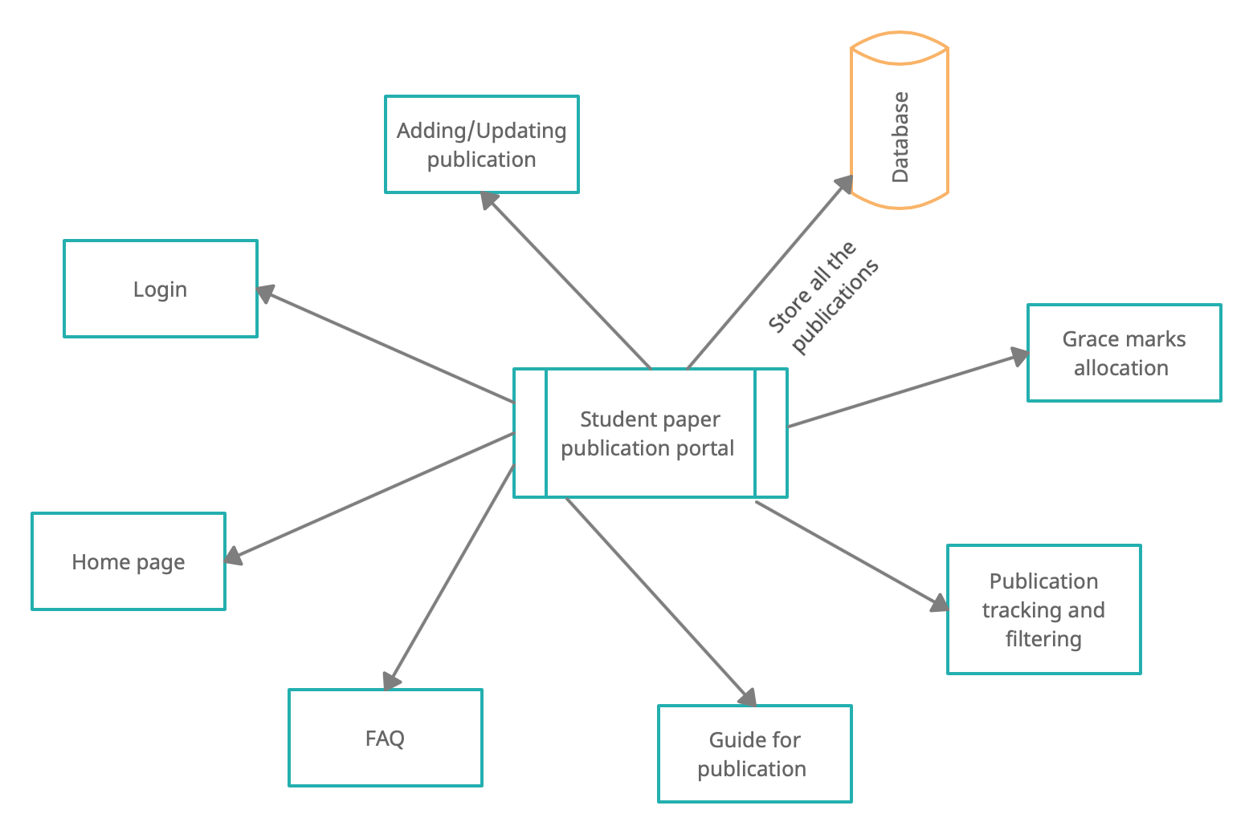

## **Product Features**

*This product proposes to have features like :*

1. *Login page for the users*
2. *Home page to get the information about the website and recent publications*
3. *FAQ page contains the answers for the frequently asked questions*
4. *Feedback page for providing the feedback about the website for further improvement*
5. *Forget password page and password change page for users security purposes*
6. *View publications page for viewing logged in user’s publications*
7. *An informative blog for guiding students to publish their paper in future*
8. *Allocate grace marks for students*

## **User Classes and Characteristics**

1. **College management(Admin)**  
The prime responsibility includes managing the overall database of the portal, updating the Home page, registering new users (Faculty, student), Maintaining the website, Updating frequently asked questions, Keeping track of feedback etc.

2. **Faculty :**  
They can login through their Username and view/update their publications,get a list of students who published papers by filtering to provide them with grace marks, add their recent publications etc.

3. **Student :**They can login through their Username and view their publications, get a list of publications depending on the requirements etc.

## **Operating Environment**

*The operating environment for student paper publication portal is listed below :*

* *Distributed Database*
* *Client/Server system*
* *Operating system: Windows*
* *Database: MongoDB*
* *Platform : Javascript*

## **Design and Implementation Constraints**

*<Describe any items or issues that will limit the options available to the developers. These might include: corporate or regulatory policies; hardware limitations (timing requirements, memory requirements); interfaces to other applications; specific technologies, tools, and databases to be used; parallel operations; language requirements; communications protocols; security considerations; design conventions or programming standards (for example, if the customer’s organization will be responsible for maintaining the delivered software).>*

## **User Documentation**

1. *User manual*
2. *Video tutorial*

## **Assumptions and Dependencies**

1. *Every user must have a username*
2. *The user will have basic English knowledge to access the website.*

# **System Features**

*<This template illustrates organizing the functional requirements for the product by system features, the major services provided by the product. You may prefer to organize this section by use case, mode of operation, user class, object class, functional hierarchy, or combinations of these, whatever makes the most logical sense for your product.>*

***3.1 Home Page***

*3.1.1 Description and Priority*

*Home page is used to showcase the popular content in the portal, which includes the details about the college, recent publications, authentication and access to the FAQ page.*

*Priority: High |*

*3.1.2 Stimulus/Response Sequences*

*Open the website --> Home Page Available*

*3.1.3 Functional Requirements*

*For Home Page to work we need*

*REQ-1: API to access them*

*REQ-2: Database working*

***3.2 Login page***

*3.1.1 Description and Priority*

*The login page is to help users login with the help of their username and password.*

*Priority: High |*

*3.1.2 Stimulus/Response Sequences*

*Open the website --> Home Page -->Login using username*

*3.1.3 Functional Requirements*

*The page requires the credentials of the user to sign in to the portal.*

*REQ-1: login details*

*REQ-2: authentication*

*REQ-3: Forget password / reset password*

***3.3 Sign Up:***

*3.1.1 Description and Priority*

*The admin can sign up for faculty and students.*

*Priority: High |*

*3.1.2 Stimulus/Response Sequences*

*Open the website --> Home Page -->Login Page-->SignUp*

*3.1.3 Functional Requirements*

*REQ-1: Email Address*

*REQ-2: Name and other details*

***3.4 Forget Password:***

*3.1.1 Description and Priority*

*The student can change his password through email verification*

*Priority: Medium |*

*3.1.2 Stimulus/Response Sequences*

*Open the website --> Home Page -->Login Page-->Forgot Password*

*3.1.3 Functional Requirements*

*REQ-1: Email Address*

*REQ-2: API Access.*

***3.5 Blog :***

*3.1.1 Description and Priority*

*The student can get an insights on how to publish their paper and also help them connect to a relatable mentor available*

*Priority: Medium |*

*3.1.2 Stimulus/Response Sequences*

*Open the website --> Home Page -->Blog*

*3.1.3 Functional Requirements*

*REQ-1: Database connectivity*

*REQ-2: API Access.*

***3.6 Student/user paper submission :***

*3.1.1 Description and Priority*

*The student can submit their publications and its related details*

*Priority: High |*

*3.1.2 Stimulus/Response Sequences*

*Open the website --> Home Page -->Login Page-->Submit publication*

*3.1.3 Functional Requirements*

*REQ-1: Database requirements and other details*

*REQ-2: API Access.*

***3.7 Filtering publication :***

*3.1.1 Description and Priority*

*Here an user can filter publications according to year, date, topic, student name, faculty incharge to get better insights on paper publications going on in our university*

*Priority: High |*

*3.1.2 Stimulus/Response Sequences*

*Open the website --> Home Page -->Filtering publication page*

*3.1.3 Functional Requirements*

*REQ-1: Database requirements*

*REQ-2: API Access.*

***3.8 User home page :***

*3.1.1 Description and Priority*

*This page contains the user details and other functionalities that a user can access*

*Priority: Medium |*

*3.1.2 Stimulus/Response Sequences*

*Open the website --> Home Page -->Login Page-->User home page*

*3.1.3 Functional Requirements*

*REQ-1: Database requirements*

*REQ-2: API Access.*

***3.9 FAQ:***

*3.1.1 Description and Priority*

*This page contains questions that are commonly asked by the students.*

*Priority: Low |*

*3.1.2 Stimulus/Response Sequences*

*Open the website → Home page → FAQ page*

*3.1.3 Functional Requirements*

*REQ-1: API to access them*

*REQ-2: Database working*

***3.10 Feedback:***

*3.1.1 Description and Priority*

*This page contains the feedback of the users*

*Priority: Low |*

*3.1.2 Stimulus/Response Sequences*

*Open the website → Home Page → User login → Feedback*

*3.1.3 Functional Requirements*

*REQ-1: User interface with an input field*

*REQ-2: Database working*

# **External Interface Requirements**

## **User Interfaces**

*The product to be designed is a complete web application. The basic interaction between the users and the product is the mouse + keyboard controls, to navigate through various pages.*

## **Hardware Interfaces**

*Hardware interfaces required will be a proper electrical connection to the client-side device and it must follow the IEEE 802.1.1 architecture for networking purposes and must have port 80 open for HTTP connection establishment. Minimal keyboard interactions will be required and hence a 16-pin keyboard socket or USB port for keyboard connection is preferred. The mouse will be the basic means of communication and so an additional USB port will be required. A high-speed Internet connection is also preferred as it is a stateless connection and to prevent data loss or delay due to bandwidth bottleneck from the client to the immediate router in the network.*

*Minimum Ram: 2 GB*

*Minimum Processor: Pentium 3*

## **Software Interfaces**

*Software Interfaces required will be a basic operating system with a workable web browser capable of executing the HTML code. No additional libraries will be necessary in order to set up the work environment.*

## **Communications Interfaces**

*This project supports all types of web browsers. We are using simple HTTPS-based API calls to communicate between the frontend and backend services*

# **Other Nonfunctional Requirements**

## **Performance Requirements**

*The product is completely data-centric so the processing power required in servers is minimal. The product features are targeted for real-time purposes, so the data will be fetched and updated regularly. As the application involves huge database retrieval, the loading speed should be taken into consideration.*

## **Safety Requirements**

*The product being data-centric the database should be highly protected against human and non-human failures. As the Vacancy data is entered manually a backup is stored on a daily basis to handle system failures and external attacks.*

## **Security Requirements**

*The product is to be used by different students so it should be protected using domain credentials, and each API call is to be validated using the user name. The credentials to access to the real-time database should be carefully used*

## **Software Quality Attributes**

***Correctness*** *: The data available about the publications should be accurate and correct*

***Maintainability****: Creators of a particular publication should be able to edit any changes or other details*

***Usability****: The whole product should be easy to use for the user as the product architecture is data-centric in nature.*

# **Other Requirements**

*The software will have a license, so anyone who wishes to reuse or modify the software must provide proper credits to the proprietor and any further patches or updates must be approved by the proprietor.*

**Appendix A: Glossary**

*FAQ- Frequently asked questions*

*API - Application Programming Interface*

*IEEE - Institute of Electrical and Electronics Engineers*

*HTTPS - Hypertext Transfer Protocol Secure*

**Appendix B: Analysis Models**

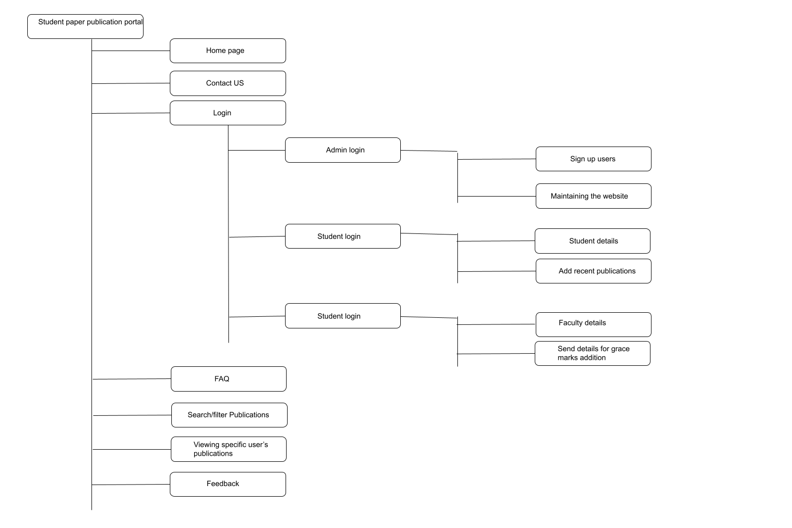

**Appendix C: Issues List**

*Usage of free tier database and backend services may cause availability problems if the network traffic suddenly increases.*