Router Backup/configuration Tool

Functions
  - One can configure this Tool with any router command and can schedule the execution at different time intervals and the Tool executes and stores the results.

  - The Tool is really helpful when you need to execute same command for multiple routers. Ex: sh ip mroute active command for all TSL Locations; or sh startup for all locations' for daily config backup.

  - The Tool helps you to configure multiple routers with same configuration. The configuration is taken from the file you mention.

  - The Results are stored in C:\Backup\<date> Folder, which is created by the Tool. A log File is also created in the same Folder.

  - You can upload the File which contains IPs of locations and the configured command is executed in all IPs given.
About the Tool
  - This Tool is developed Using Tcl/Tk/Expect Language. It requires ActiveStateTclV8.5.7 and openSSH Software installed on your machine.

  - All the mentioned Softwares are Free and based on OpenBSD and part of Source Forge Projects.

Documentation

Login Tab

- You should be login in with a valid, active TCAP ACS Login ID and Password.

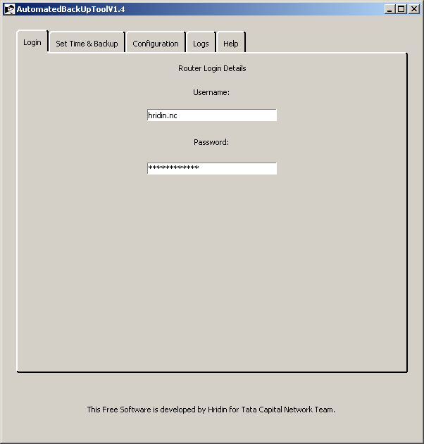

Set time & backup Tab

- You can configure this Tool with any router command and can schedule the execution at different time intervals and the Tool executes and stores the result for you.
- In this Example I have used sh version Command
- We can select the IP file by clicking on Select IP File button.
- You can use Start Button to start the command execution immediately if you don’t want to set the timings
- You should be uploading the IP File which is in txt format and it should be tab delimited. Ex: 10.0.0.75<Tab>Ahura.
- File format should like the following. It should be tab delimited; and no spacing in the name of locations.
- 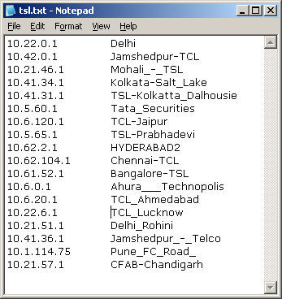
- You should be entering the time intervals in 24HOURS Format.

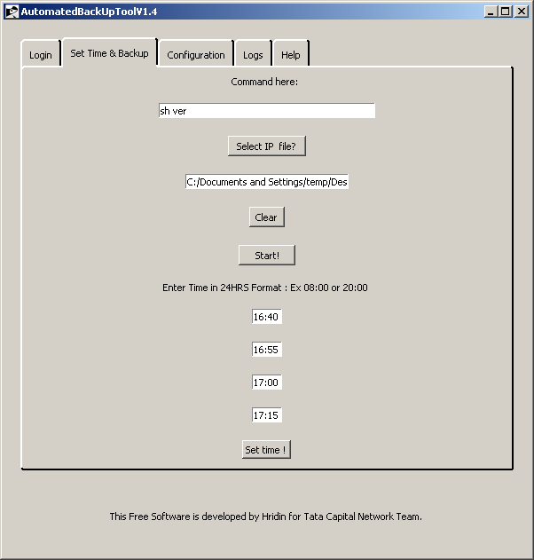

- Click on set time button to save the timings. You can see it on Log tab as follows.
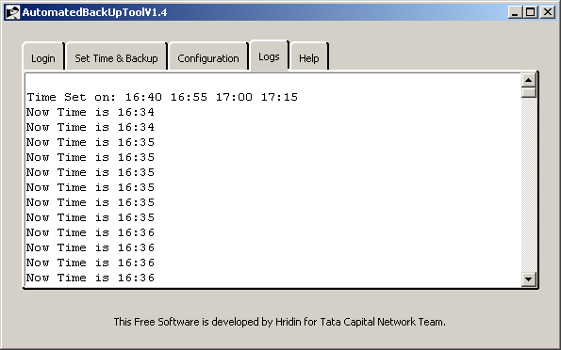

Configuration Tab

- You can use Select Config File to select any common config file
- You can use Select IP File to select file which contains IPs of locations you want to configure.
- File format should like the following. It should be tab delimited; and no spacing in the name of locations.

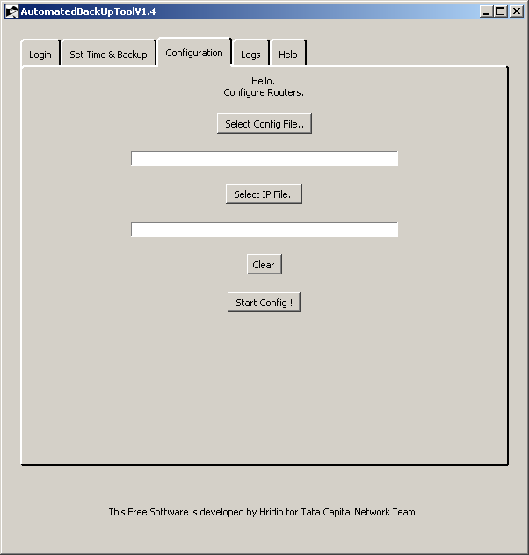

Log tab.

- Activity Logs are displayed on the Log tab.

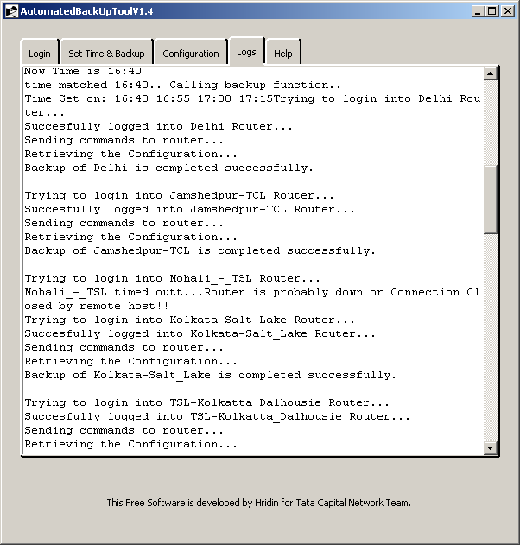

Command Results/Outputs

- Command Results/Outputs are stored in C: /backup/date/time folder automatically.
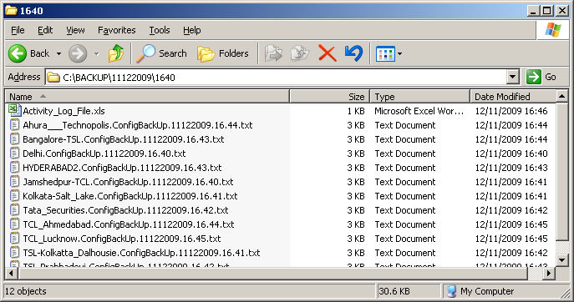

- A log File is also created in the same Folder. It has entries of Username, Router command used, and the timings which are scheduled for command execution.
- It records the Command execution status and the reason if the TELNET/ SSH ing is failed.

