IOT based Intelligent Gas Leakage Detector Using Arduino
Many accidents occur in day to day life like explosion because of LPG leakage. Major harm is caused,
if gas leakage is not detected early. But now we can detect the gas leakage using the MQ5 gas
sensor. In this IOT gas leakage detector, device will get connected to WIFI, the minimum and
maximum parameter can be set accordingly. Such IOT as well as Arduino based gas leakage detector
systems can be installed in homes, hotels LPG gas storage areas. In this LPG gas detector system
senses the LPG gas using MQ5 gas sensor. This device will continuously monitor the level of LPG gas
present in the air. While monitoring, if the value of LPG gas in air is within the set limit then the RGB
LED on the circuit will glow green giving a safe sign. And whenever the gas exceeds above the
predefined limit than the RGB LED will glow red and simultaneously solenoid value will turn off and
update it over IOT. This Arduino and IOT project will help in detecting gas leakage in the surrounding.

Block Diagram:
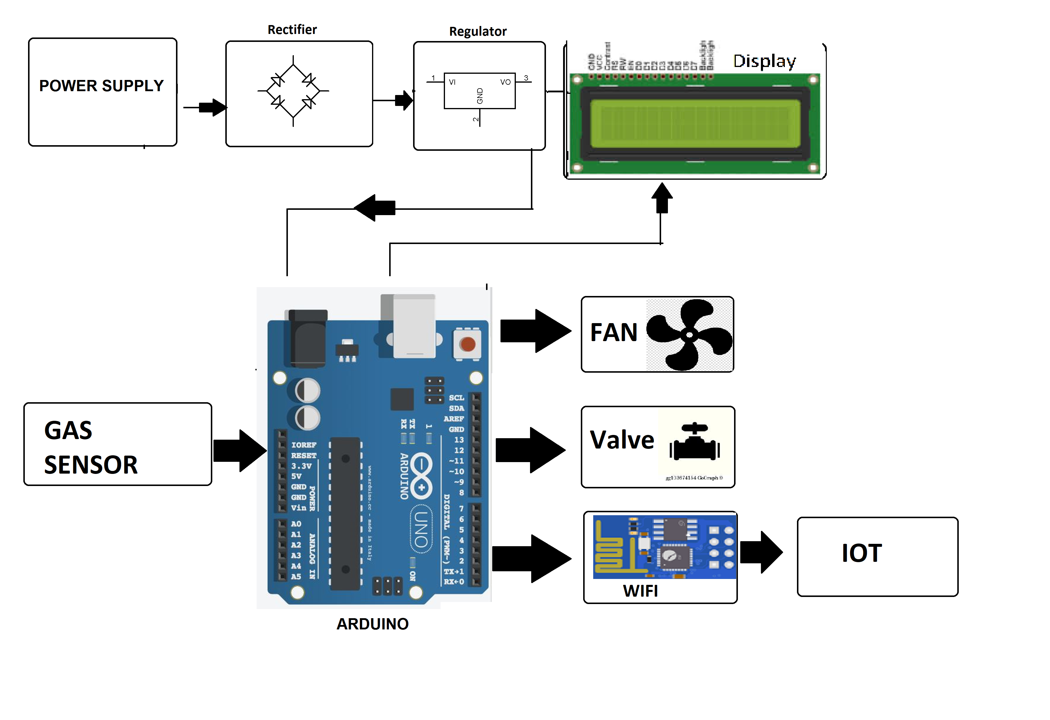

Hardware Specifications

Arduino
LCD
Wi-Fi module
Dc fan
Gas sensor
Buzzer
Regulator
Crystal Oscillator
Resistors
Capacitors
Transistors
Cables and Connectors
Diodes
PCB and Breadboards
LED
Transformer/Adapter
Push Buttons
Switch
IC
IC Sockets

Software Specifications
- Arduino Compiler
- Programming Language: C

