Webhooks and API Endpoints that would be used:

1. <https://developers.welcomesoftware.com/webhooks.html#section/External-Work-Management-events/external_sub_step_started>

This API should be used and from here data[task][links][assets] URL to fetch the assets associated with the task through Welcome Open API. From the example we get this url from the “assets” data: <https://api.welcomesoftware.com/v3/tasks/5f6a0312a5963d0591015e3e/assets>

1. For retrieval and pushing the data of the assets we will use this API: [https://api.welcomesoftware.com/v3/tasks/{id}/assets](https://api.welcomesoftware.com/v3/tasks/%7Bid%7D/assets)

Here, the task id is the id we got from our previous API [5f6a0312a5963d0591015e3e](https://api.welcomesoftware.com/v3/tasks/5f6a0312a5963d0591015e3e/assets)

This GET request will provide us with this example data:

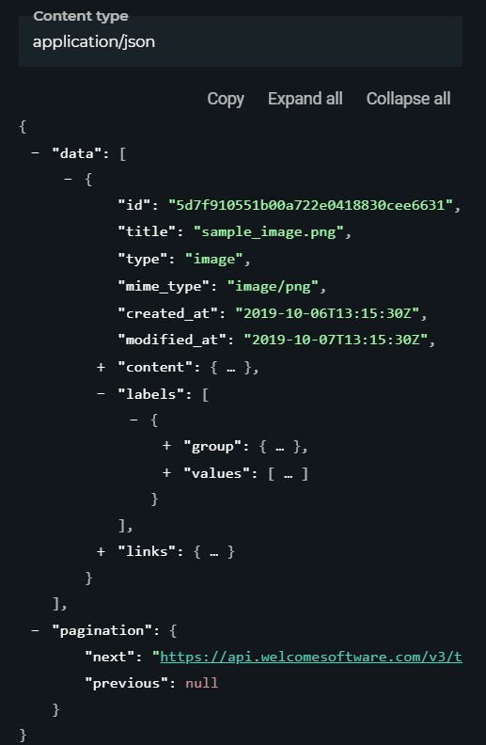

Using the “labels” we will call the API: <https://api.welcomesoftware.com/v3/label-groups> . From here the data can be fetched and pushed to LegALpprove.

1. This API can be used to retrieve and share the custom fields data: [https://api.welcomesoftware.com/v3/tasks/{id}/custom-fields](https://api.welcomesoftware.com/v3/tasks/%7Bid%7D/custom-fields)
2. When external sub step is modified this happens: <https://developers.welcomesoftware.com/webhooks.html?hash=nkbq#section/External-Work-Management-events/external_sub_step_modified>
3. Updating the third step due date will also result in this: <https://developers.welcomesoftware.com/webhooks.html?hash=nkbq#section/External-Work-Management-events/external_sub_step_modified>
4. This API is used to comment each asset and for each task: [https://api.welcomesoftware.com/v3/tasks/{task_id}/assets/{asset_id}/comments](https://api.welcomesoftware.com/v3/tasks/%7Btask_id%7D/assets/%7Basset_id%7D/comments)
5. Uploading a new version using this API: [https://api.welcomesoftware.com/v3/assets/{asset_id}/versions](https://api.welcomesoftware.com/v3/assets/%7Basset_id%7D/versions)
6. This will happen when closing the third step in Welcome: <https://developers.welcomesoftware.com/webhooks.html?hash=nkbq#section/External-Work-Management-events/external_sub_step_completed>

I think from this list I can specify the API Endpoints that can be used. Some of the endpoints are not clear or found in the open API doc. I have assumed it as they were mentioned in the Welcome Webhook.