Supporting Information

Molecular Property Diagnostic Suite for COVID-19 (MPDS^{COVID-19}): An open source disease specific drug discovery portal

Lipsa Priyadarsinee ^{1,2}, Esther Jamir¹, Selvaraman Nagamani ^{1,2}, Hridoy Jyoti Mahanta^{1,2}, Nandan Kumar¹, Lijo John¹, Himakshi Sarma¹, Asheesh Kumar¹, Anamika Singh Gaur³, Rosaleen Sahoo ^{1,2}, S. Vaikundamani¹, N. Arul Murugan⁴, U. Deva Priyakumar⁵, G.P.S. Raghava⁴, Prasad V. Bharatam⁶, Ramakrishnan Parthasarathi^{2,3}, V. Subramanian⁷, G. Madhavi Sastry⁸ and G. Narahari Sastry ^{1, 2}*

¹CSIR–North East Institute of Science and Technology, Jorhat – 785006, India;
²Academy of Scientific and Innovative Research (AcSIR), Ghaziabad – 201002, India;
³CSIR-Indian Institute of Toxicology Research, Uttar Pradesh, Lucknow – 226001,India;
⁴Indraprastha Institute of Information Technology, Delhi – 110020, India;
⁵International Institute of Information Technology, Gachibowli, Hyderabad – 500032, India;
⁶National Institute of Pharmaceutical Education and Research, S.A.S. Nagar (Mohali) – 160 062, India;
⁷Department of Chemistry, Indian Institute of Technology, Chennai – 600036, India;
⁸Schrödinger Inc., Octave, Salarpuria Sattva Knowledge City, 1st Floor, Unit 3A, Hyderabad – 500081, India;

*Correspondence address. G. Narahari Sastry, CSIR-North East Institute of Science and Technology, Jorhat-785006, Assam, India, Email: gnsastry@gmail.com gnsastry@neist.res.in
Figure S1a: Case study 1- Screening of phytochemicals for antiviral activity against SARS-CoV2 targets.
Figure S1b: Case study 2- Drug repurposing for SARS-CoV2 protein NSP5 through virtual screening
Figure S1c: Case study 3-Screening of phytochemicals for natural product likeness properties and docking against SARS-CoV2 protein involved in viral entry
Figure S1d: Case study 4- Phylogenetic tree generation of seven types of Human Coronavirus using the available sequence from the SARS-CoV2 disease library
Figure S1e: Case study 5- Perform QSAR calculation of FDA approved drugs using the available drugs from the SARS-CoV2 disease library
Figure S1f: Case study 6- Investigating Repurposed Drugs' Binding Interactions with SARS-CoV-2 RdRp Using MPDS-COVID Docking
Figure S2. An illustration of various tools available in the Galaxy platform under different categories focused in the field of drug discovery.
Figure S3. An overview of drug repurposing approach for COVID-19 disease which involves identifying existing drugs with potential therapeutic indications against multiple targets. This may include assessing potential novel uses for drugs based on their known mechanisms of action and interactions with druggable targets, as well as screening existing drugs against the targets in the same pathway or targets from multiple pathways. Applying a unique combination of drug repurposing and polypharmacology approach has led to identification of potential leads that can be repurposed for COVID-19 disease.

Table S1. List of publicly available various COVID-19 disease related databases and their description.
Table S2: The list of online databases and sources used for the collection of disease specific information for the SARS-CoV-2 disease library in MPDS^{COVID-19}.
Table S3. List of AI-Powered drug discovery tools along with its URL, brief description and reference.
Table S4. List of available severs and web portals deployed using Galaxy platform.

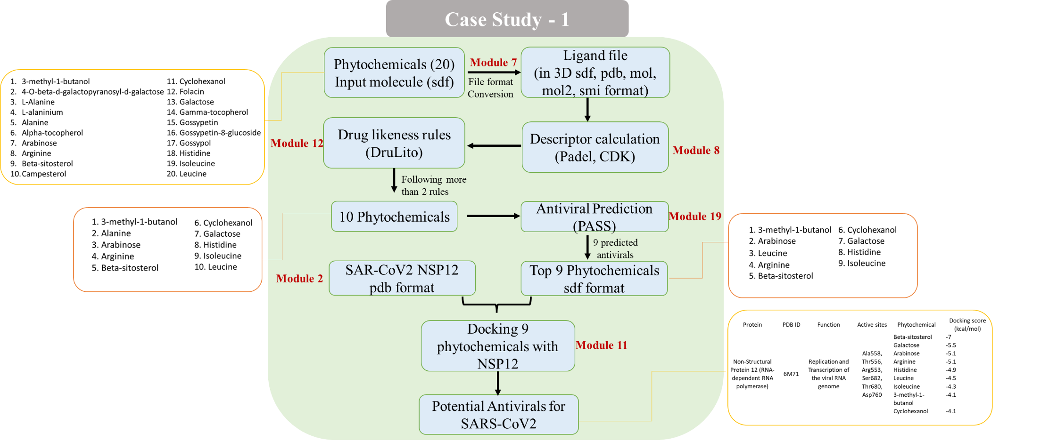

Figure S1a: Screening of phytochemicals for antiviral activity against SARS-CoV2 targets

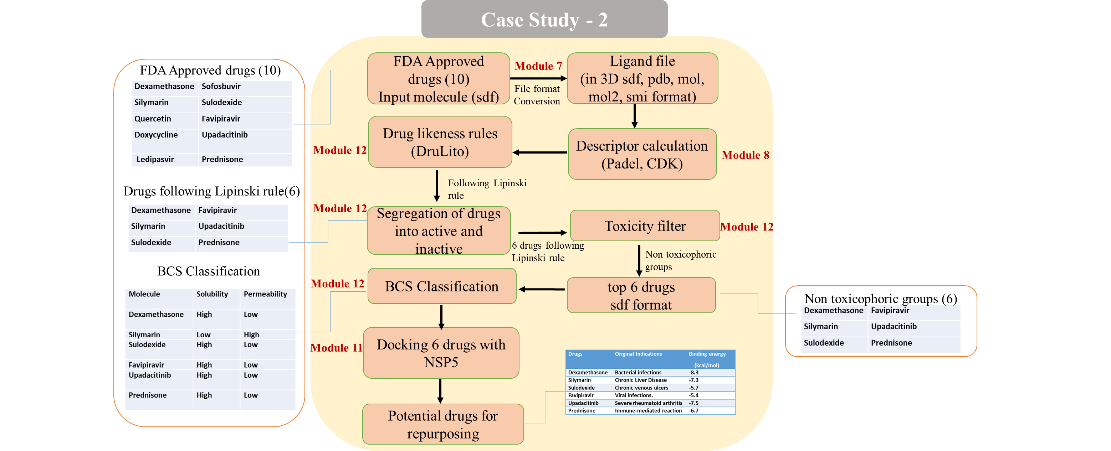

Figure S1b: Drug repurposing for SARS-CoV2 protein NSP5 through virtual screening

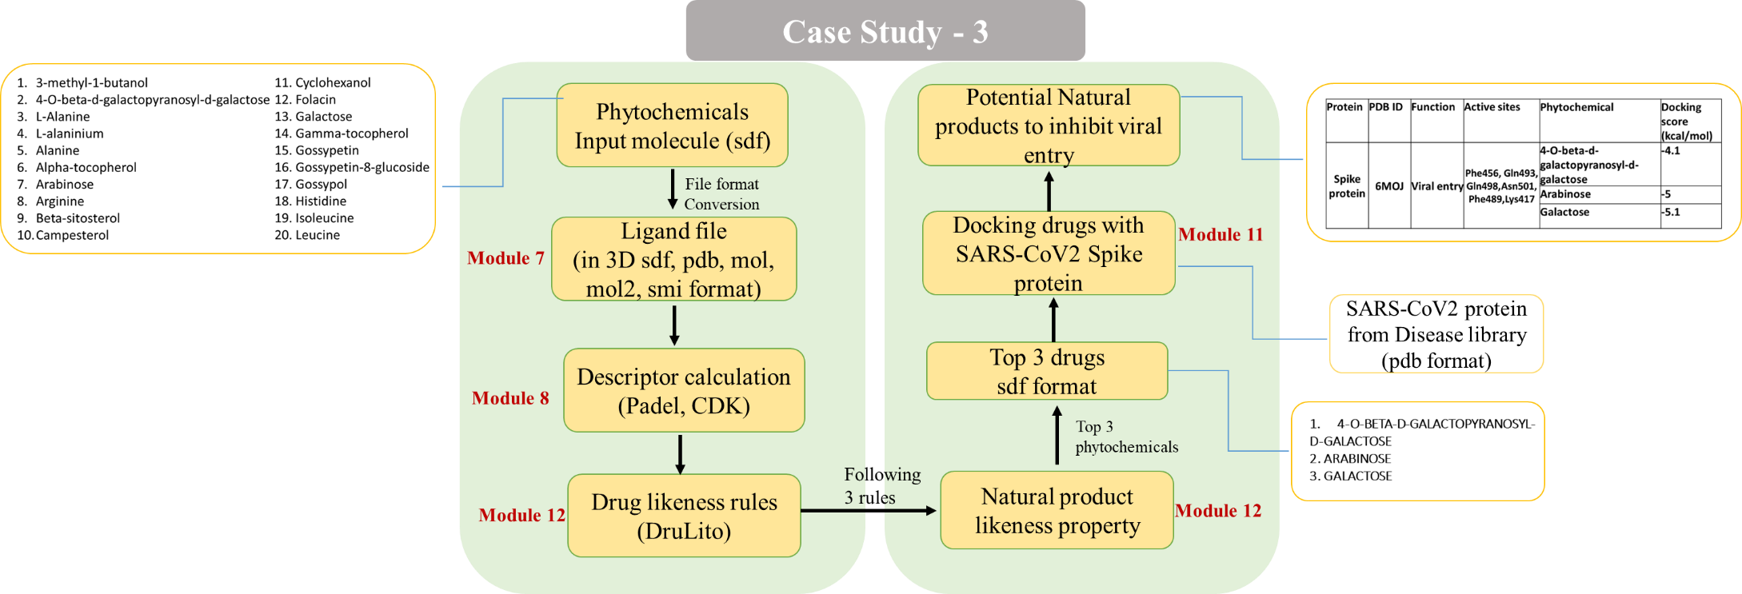

Figure S1c: Screening of phytochemicals for natural product likeness properties and docking against SARS-CoV2 protein involved in viral entry

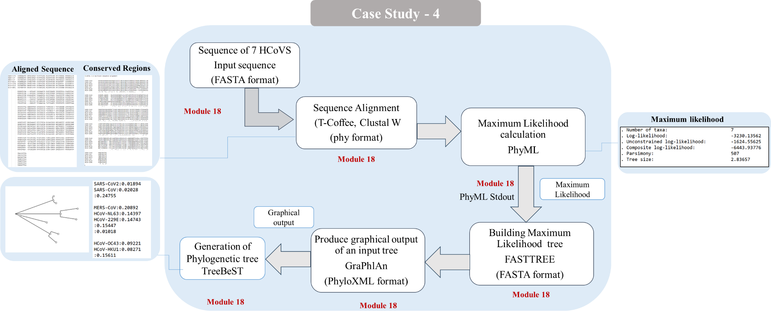

Figure S1d: Phylogenetic tree generation of seven types of Human Coronavirus using the available sequence from the SARS-CoV2 disease library
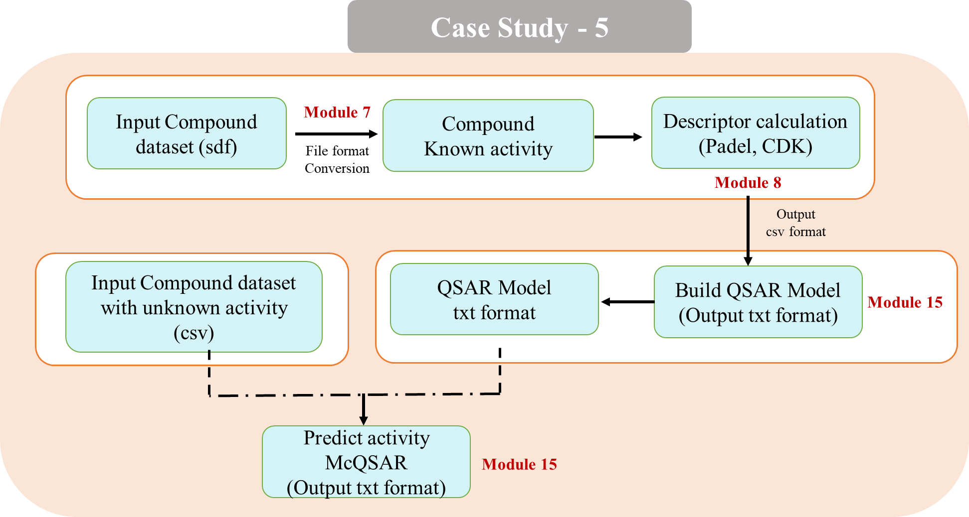

Figure S1e: Perform QSAR calculation of FDA approved drugs using the available drugs from the SARS-CoV2 disease library

Case Study-6
Investigating Repurposed Drugs' Binding Interactions with SARS-CoV-2 RdRp Using MPDS-COVID Docking

This study is to demonstrate the potential of the MPDS-COVID docking module in facilitating the development of multi-targeted therapies against SARS-CoV-2. This study showcases the efficacy of MPDS-COVID docking module in examining how repurposed drugs interact with SARS-CoV-2's RNA-dependent RNA polymerase (RdRp).
Sl. No. | Drug Name | Binding Affinity (kcal/mol) | Interacting Residues
 | Baicalin | -8.7 | LYS17, TYR129, HIS133, SER709, ASP711, LYS780, LYS780, ASN781, SER784
 | Hesperidin | -9.7 | LYS47, ASP135, ALA706, THR710, GLN773, LYS780
 | Bictegravir | -8.7 | THR394, ARG457
 | Eravacycline | -8.5 | SER255, ARG349, THR675
 | Paritaprevir | -10.1 | GLN408, SER501, ASN543

Figure S1f: Binding affinities and interacting residues of repurposed drug molecules with the SARS-CoV-2 RNA-dependent RNA polymerase (PDB ID: 6M71). The MPDS-COVID docking module utilized specific parameters for the docking process.

Figure S2. An illustration of various tools available in the Galaxy platform under different categories focused in the field of drug discovery.

Figure S3. An overview of drug repurposing approach for COVID-19 disease which involves identifying existing drugs with potential therapeutic indications against multiple targets. This may include assessing potential novel uses for drugs based on their known mechanisms of action and interactions with druggable targets, as well as screening existing drugs against the targets in the same pathway or targets from multiple pathways. Applying a unique combination of drug repurposing and polypharmacology approach has led to identification of potential leads that can be repurposed for COVID-19 disease.
Table S1. List of publicly available various COVID-19 disease related databases and their description.
S.  No. | Databases | URL  (Accessed on 10th July 2023) | Description | Ref
1. | COVID-evidence | https://covid-evidence.org/database | A database for a planned, ongoing and completed trials to treat and prevent COVID-19 | 34
2. | OxCOVID19 | https://covid19.oii.ox.ac.uk/database/ | A large, single-centre, multimodal relational database. | 35
3. | LitCOVID | https://www.ncbi.nlm.nih.gov/research/coronavirus/#data-download | A literature hub for tracking up-to-date scientific information. | 36
4. | ClinicalTrials.gov | https://clinicaltrials.gov/ct2/results?cond=COVID-19 | A database of clinical studies. | 37
5. | DockCoV2 | https://dockcov2.org/drugs/ | Experimental information about MERS and SARS-CoV. | 38
6. | Lexicomp Online Drug Database | https://kutuphane.istinye.edu.tr/en/announcements/lexicomp-online-drug-database-covid-19-contents | Drug and clinical information about COVID-19. | 39
7 | COVID-19 Radiography Database | https://www.kaggle.com/datasets/tawsifurrahman/covid19-radiography-database | A database of COVID-19 patients Chest X-ray images and Lung masks. | 40
8 | DrugBank | https://go.drugbank.com/covid-19 | A comprehensive, online database containing information on drugs and drug targets. | 41
9. | SARSCOVIDB | https://sarscovidb.org/ | A database that contains viral strains, hosts, methodologies, genes/proteins with the altered expression. | 42
10 | GISAID | https://gisaid.org/ | An open access genomic data from all influenza viruses and the coronavirus causing COVID-19. | 43
11 | ImmuneCODE™ | https://immunerace.adaptivebiotech.com/data/ | A database for decoding the adaptive immune response to COVID19 along with detailed population view. | 44
12 | CORDITE | https://cordite.mathematik.uni-marburg.de/#/ | A drug interaction database to address viral proteins or human proteins to treat COVID19. | 45
13 | Coronavirus Antiviral & Resistance Database | https://covdb.stanford.edu/ | A database of antiviral & resistance information. | 46
14 | DBatVir | http://www.mgc.ac.cn/DBatVir/ | A database of 3873 sequences from the family coronaviridae. | 47
15. | SARS-CoV-2 Database | https://covid19.sfb.uit.no/ | A knowledge database of SARS-CoV-2 virus research compiled from publicly available resources. | 48
16. | Therapeutic Target Database | http://db.idrblab.net/ttd/ | A collection of anti-coronavirus drugs and their associated targets and pathways. | 49
17. | NCBI Virus | https://www.ncbi.nlm.nih.gov/labs/virus/vssi/#/ | A community portal for viral sequence data from RefSeq, GenBank and other NCBI repositories. | 50
18. | GESS | https://biokeanos.com/source/GESS-db | A database of global evaluation of SARS-CoV-2 sequences. | 51
19 | IDbSV | http://idbsv.medbiotech-lab.ma/ | A largest repository of SARS-CoV-2 variants and the largest analysis of SARS-CoV-2 genomes. | 52
20 | COVID-19 Data Portal | https://www.covid19dataportal.org/ | The European COVID-19 Data Platform for data sharing and analysis to accelerate coronavirus research. | 53
21 | NCATS Open data portal | https://opendata.ncats.nih.gov/covid19/index.html | A collection of datasets by screening a panel of SARS-CoV-2-related assays against all approved drugs. | 54
22 | The COVID-19 Drug and Gene Set Library | https://maayanlab.cloud/covid19/ | A collection of drug and gene sets related to COVID-19 research. | 55
23 | National Institute of Allergy and Infectious Diseases (NIAID) | https://www.niaid.nih.gov/research/accessing-clinical-data | A cloud-based, secure data platform that enables sharing of and access to reports and data sets related to COVID-19. | 56
24 | Nextstrain | https://nextstrain.org/ncov/gisaid/global/6m | An open-source database to empower the wider genomic epidemiology and public health. | 57
25 | SARS-CoV-2 related structures | https://covid19.bioreproducibility.org/ | A database with 2465 SARS-CoV-2 protein structures and 143 additional structures of other corona viruses. | 58
26 | ERACODA | https://www.eracoda.org/ | A European database collecting clinical information of patients on kidney replacement therapy with COVID-19. | 59
27 | Virus-CKB | https://www.cbligand.org/g/virus-ckb | A knowledgebase for COVID-19 and similar viral infection research. | 60
28 | CoronaVR | https://bioinfo.imtech.res.in/manojk/coronavr/ | A database that contains potential epitopes, therapeutics, etc. | 61
29 | Drug Gene Interaction database | https://www.dgidb.org/ | A database of drug-gene interactions and the druggable genome, mined from over thirty trusted sources. | 62
30 | STRING Database | https://string-db.org/ | A database of known and predicted protein-protein interactions. | 63
31 | COVID-19 Genome Sequence Dataset | https://registry.opendata.aws/ncbi-covid-19/ | A centralized sequence repository for all strains of novel corona virus (SARS-CoV-2). | 64
32 | COVID-19 Molecular Structure and Therapeutics Hub | https://covid.molssi.org/ | A community data repository for structure, models, therapeutics, simulations related computations for COVID-19. | 65
33 | COVID19db | http://www.biomedical-web.com/covid19db/home | A comprehensive platform to discover potential drugs and targets of COVID-19 at whole transcriptome scale. | 66
34 | H2V | http://www.zhounan.org/h2v/ | A knowledge base of human genes/proteins that respond to the infection of SARS-CoV-2, SARS-CoV and MERS-CoV. | 67
35 | SARS-CoV-2 Virion and Proteins | https://3dprint.nih.gov/niaid/sars-cov-2 | A database consists of structures released by the Protein Data Bank, as well as additional “Featured” structures curated by NIAID, in 3D-printable formats. | 68
36 | MIDAS | https://midasnetwork.us/covid-19/ | A collection of more than 300 digital resources relevant to COVID modeling. | 69
37 | outbreak.info | https://outbreak.info/situation-reports#voc | A database with 12,742,821 sequences from GISAID. | 70
38 | COVIDium | http://kraza.in/covidium/ | A list of all the relevant databases characterized into 10 broad categories. | 71
39 | SCoV2-MD | https://submission.gpcrmd.org/covid19/home/ | Share, visualize and analyze MD data of SARS-CoV-2 related proteins | 72
40 | Comparative Toxicogenomics Database | http://ctdbase.org/detail.go?type=disease&acc=MESH%3AD000086382 | A database of manually curated information about chemical–gene/protein interactions, chemical–disease and gene–disease relationships. | 73
41 | REACTOME | https://reactome.org | An open-source, open access, manually curated and peer-reviewed pathway database. | 74
42 | ViPR | https://www.viprbrc.org/brc/home.spg?decorator=corona_ncov | A database with latest SARS-CoV-2 Variants and Lineages of Concern. | 75
43 | INSDC | https://ncbiinsights.ncbi.nlm.nih.gov/2020/08/17/insdc-covid-data-sharing/ | A database that capture, organize, preserve and present nucleotide sequence data. | 76
44 | COVID-19 Drug Repurposing Database | https://www.excelra.com/covid-19-drug-repurposing-database/ | An open-access database of ‘Approved’ small molecules and biologics, which can rapidly enter either Phase 2 or 3, or may even be used directly in clinical settings against COVID-19. | 77
45 | NCBI SARS-CoV-2 Resources | https://www.ncbi.nlm.nih.gov/sars-cov-2/ | A comprehensive information from NCBI. | 78
46 | CAS COVID-19 antiviral candidate compounds dataset | https://www.cas.org/covid-19-antiviral-compounds-dataset | An open-source dataset with 50,000 chemical substances includes antiviral drugs and related compounds. | 79
47 | BioExcel-CV19 | https://bioexcel-cv19.bsc.es/#/ | A web-access to atomistic-MD trajectories for macromolecules involved in the COVID-19. | 80
48 | Rfam | https://rfam.org/covid-19 | A database of new and updated Coronavirus families | 81
49 | Malacard | https://www.malacards.org/card/covid_19 | An integrated GeneCards database of human genes. | 82
50 | National Genomics Data Center | https://ngdc.cncb.ac.cn/ | An open access database with big genomics data. | 83
51 | CoV-AbDab | http://opig.stats.ox.ac.uk/webapps/covabdab/ | A database of immune response to SARS-CoV-2 infection and vaccination. | 84
52 | COVIDep | https://covidep.ust.hk/ | A database for B-cell and T-cell epitopes that can serve as potential vaccine targets for COVID-19. | 85
53 | VirHostNet | https://virhostnet.prabi.fr/ | It is a bioinformatics information system dedicated to the bio-curation, data integration, reproducible systems-level analysis and visualization of viral protein-protein networks. | 86
54 | GENCODE | https://www.gencodegenes.org/human/covid19.html | It contains annotation of human protein-coding genes linked to SARS-CoV-2 infection. | 87
55 | RCoV19 | https://ngdc.cncb.ac.cn/ncov/ | A database of comprehensive integration of genomic and proteomic sequences as well as their metadata information from the GISAID, NCBI, NMDC and CNCB/NGDC | 88
56 | COVID-19 UniProtKB | https://covid-19.uniprot.org/uniprotkb?query=* | It has latest available pre-release UniProtKB data for the SARS-CoV-2 coronavirus and other entries relating to the COVID-19 outbreak. | 89
57 | COG-UK-Mutation Explorer | https://sars2.cvr.gla.ac.uk/cog-uk/ | It provides information and structural context on mutations and associated variants in the genes encoding SARS-COV-2 proteins | 90
58 | ViralZone | https://viralzone.expasy.org/ | It provides resources related to beta-coronavirus genome, proteome, interactome, coronavirus life cycle, antiviral drugs and treatment. | 91
59 | CoV-GLUE | https://cov-glue.cvr.gla.ac.uk/ | It has the information of mutations, insertions and deletions which have been observed in GISAID hCoV-19 sequences. | 92
60 | Cellosaurus | https://web.expasy.org/cellosaurus/sars-cov-2.html | A knowledge resource on cell lines for SARS-CoV-2. | 93
61 | Corona OMA Browser | https://corona.omabrowser.org/oma/home/ | A database that encompasses the human SARS viruses, and other viruses. | 94
62 | GlyConnect | https://glyconnect.expasy.org/covid-19 | Provide information on characterizing the molecular components of protein glycosylation for SARS-CoV-2. | 95
63 | neXtProtD | https://www.nextprot.org/ | It includes information about human proteins that bind SARS-CoV-2. | 96
64 | SWISS-MODEL | https://swissmodel.expasy.org/repository/species/2697049 | Provides 3D homology models and links to experimental structures in PDB for SARS-CoV-2 proteins. | 97
65 | Bioinformatics Resources for SARS-CoV-2 | https://www.clinbioinfosspa.es/CovidResources | It provides links to bioinformatics resources useful to track the evolution and progression of the SARS-CoV-2. | 98
66 | CoV2ID | http://covid.portugene.com/cgi-bin/COVid_home.cgi | This database has updated list of oligonucleotides for SARS-CoV-2 | 99
67 | canSAR | https://corona.cansar.icr.ac.uk/ | A COVID-19 drug discovery platform. | 100
68 | C-I-TASSER | https://seq2fun.dcmb.med.umich.edu//COVID-19/ | Provides 3D structural models and function annotation for all proteins encoded by the genome of SARS-CoV-2. | 101
69 | CoVex | https://exbio.wzw.tum.de/covex/ | It integrates virus-human interactions for SARS-CoV-2 and SARS-CoV-1. | 102
70 | DBCOVP | http://covp.immt.res.in/ | Database of coronavirus virulent glycoproteins | 103
71 | SARS-CoV-2 Proteome-3D | https://sars3d.com/ | Annotated S SARS-CoV-2-3D proteome database. | 104
72 | hCoronavirusesDB | http://hcoronaviruses.net/#/ | An integrated bioinformatics resource for human coronaviruses. | 105
73 | COVIDOUTCOME | https://www.covidoutcome.com/ | A database that informs about the severity based on Mutations in the SARS-CoV-2 Genome. | 106
74 | Chemical Checker | https://sbnb.irbbarcelona.org/covid19/ | A database of small molecules with similar chemical and bioactivity features to the reported drugs in a universe of 800 thousand bioactive compounds | 107
75 | Signor | https://signor.uniroma2.it/covid/index.php?beta=3.0 | A database in which every entry point has experimental evidence. With available evidence, it has relevant information for the COVID-19 pathology. | 108
76 | Human Protein Atlas | https://www.proteinatlas.org/humanproteome/sars-cov-2 | A database for knowledge-base of disease and efforts to develop diagnostic tools and therapeutic drugs to combat the pandemic. | 109

Table S2: The list of online databases and sources used for the collection of disease specific information for the SARS-CoV-2 disease library in MPDS^{COVID-19}.
Sl. No | Database/Server | Link (Accessed on 12th July 2023)
1 | PDB | https://www.rcsb.org/
2 | UniProt | https://www.uniprot.org/
3 | NCBI | https://www.ncbi.nlm.nih.gov/
4 | PubMed | https://pubmed.ncbi.nlm.nih.gov/
5 | BindingDB | https://www.bindingdb.org/rwd/bind/index.jsp
6 | KEGG | http://www.kegg.jp/ or http://www.genome.jp/kegg/
7 | ChEMBL | https://www.ebi.ac.uk/chembl/
8 | DrugBank | https://go.drugbank.com/
 | Online Source | Link (Accessed on 12th July 2023)
9 | The New York Times | https://www.nytimes.com/interactive/2020/science/coronavirus-drugs-treatments.html
 | NIH COVID-19 Treatment Guidelines | https://www.covid19treatmentguidelines.nih.gov/
10 | BMJ | https://www.bmj.com/content/370/bmj.m3379
11 | GoodRx | https://www.goodrx.com/conditions/covid-19/coronavirus-treatments-on-the-way
12 | World Health Organization (WHO) | https://www.who.int/activities/tracking-SARS-CoV-2-variants
13 | European Centre for Disease Control and Prevention (ECDC) | https://www.ecdc.europa.eu/en/covid-19/variants-concern
14 | FDA Drugs Emergency Preparedness | https://www.fda.gov/drugs/emergency-preparedness-drugs/coronavirus-covid-19-drugs
15 | FDA Press Announcements | https://www.fda.gov/news-events/press-announcements/coronavirus-covid-19-update-fda-authorizes-new-monoclonal-antibody-treatment-covid-19-retains

Table S3. List of AI-Powered drug discovery tools along with its URL, brief description and reference.

Sl. No | AI-Powered Drug Discovery Tools | URL (Accessed on 10th July 2023) | Description | Reference
1 | AlphaFold | https://alphafold.ebi.ac.uk/ | A DeepMind AI system that predicts 3D structure of protein using the amino acid sequence of protein | 1
2 | DeepChem | https://deepchem.io/ | A python-based DeepChem provides a set of features for using deep learning to solve challenges in drug development and cheminformatics. | 2
3 | ODDT (Open Drug Discovery Toolkit) | https://github.com/oddt/oddt | An open-source tool for computer-aided drug discovery. CADD pipelines are created by ODDT using machine learning scoring methods | 3
4 | Cyclica | https://cyclicarx.com/ | A platform that allows for prioritization of compounds based on their on- and off-target polypharmacology profiles and their ADMET properties | 4
5 | Exscientia | https://www.exscientia.ai/ | An AI-driven pharmaceutical technology firm dedicated to finding, creating, and developing pharmaceuticals in the quickest and most efficient way. | -
6 | ATOM Modeling PipeLine (AMPL) | https://github.com/ATOMconsortium/AMPL | An open-source, modular, extendable software pipeline enabling model development and sharing for advancing drug discovery | 5

Table S4. List of available severs and web portals deployed using Galaxy platform.
Selected servers | URL  (Accessed on 10th July 2023) | References
Bioinformatics, Drug Discovery and Computational Chemistry
Galaxy India | https://galaxyproject.org/use/galaxy-india/ | 6
BIPAA | https://bipaa-galaxy.genouest.org/root/login?redirect=%2F | -
MiRGalaxy | https://hub.docker.com/r/glogobyte/mirgalaxy | 7
BRIDGE | https://galaxyproject.org/use/bridge/ | 8
COVID-19 | https://covid19.galaxyproject.org/
HyPhy HIV NGS Tools | https://galaxyproject.org/use/hyphy/ | 9
FROG | http://frogs.toulouse.inra.fr/ | 10
Anastasia | http://motherbox.chemeng.ntua.gr/anastasia_dev/ | 11
BioBix | http://galaxy.ugent.be/ | 12
BioDivine toolset | https://biodivine-vm.fi.muni.cz/galaxy/ | 13
Graphclust | https://graphclust.usegalaxy.eu/ | 14
MPDS | http://mpds.neist.res.in/ | 15
Chemical ToolBox | https://cheminformatics.usegalaxy.eu/ | 16
GCAC | http://ccbb.jnu.ac.in/gcac | 17
ChemFlow | https://vm-chemflow-francegrille.eu/ | 18
Halogen Bonding | http://134.2.17.68:8081/ | 19
OSDDlinux LiveGalaxy | https://galaxyproject.org/use/osddlinux-livegalaxy/ | 20
Proteogenomics Gateway | https://galaxyproject.org/use/proteogenomics-gateway/ | 21
ProteoRE | https://proteore.org/ | 22
Protologger | http://www.protologger.de/tours/core.galaxy_ui | 23
Advanced Data Science Tools
Machine Learning Workbench | https://galaxyproject.org/use/ml-workbench/ | 24
Galactic Circos | https://github.com/galaxyproject/tools-iuc/tree/master/tools/circos | 25
Interactive environments  (RStudio, Jupyter) | https://training.galaxyproject.org/training-material/topics/galaxy-interface/tutorials/rstudio/tutorial.html  https://training.galaxyproject.org/training-material/topics/galaxy-interface/tutorials/galaxy-intro-jupyter/tutorial.html | 26
Image analysis | https://training.galaxyproject.org/trainingmaterial/topics/imaging/tutorials/imaging-introduction/tutorial.html | 27
IWC | https://dockstore.org/organizations/iwc | -
MCMICRO | https://spatialomics.usegalaxy.eu/ | 28
immuneML | https://galaxy.immuneml.uiocloud.no/ | 29
Galaxy commercial clouds
Globus Genomics | https://galaxyproject.org/use/globus-genomics/ | 30
AnVIL | https://galaxyproject.org/use/anvil/ | 31
PhenoMeNal | https://github.com/phnmnl/container-galaxy-k8s-runtime | 32
Terra | https://galaxyproject.org/use/terra/ | 33

References
- Varadi, M.; Anyango S.; Deshpande M. et al. AlphaFold Protein Structure Database: massively expanding the structural coverage of protein-sequence space with high-accuracy models. Nucleic Acids Res. 2022, 50(D1):D439-D444.
- DeepChem GitHub Repository. Accessed July 14, 2023. https://github.com/deepchem/deepchem.
- Wójcikowski, M.; Zielenkiewicz, P.; Siedlecki, P. Open Drug Discovery Toolkit (ODDT): a new open-source player in the drug discovery field. J Cheminform. 2015, 7:26.
- Cyclicarx. Accessed July 14, 2023. https://cyclicarx.com/press-releases/whitepaper-evolved-business/
- Minnich, A.J.; McLoughlin, K.; Tse, M.; Deng, J. AMPL: A Data-Driven Modeling Pipeline for Drug Discovery. J Chem Inf Model. 2020, 60(4):1955-1968.
- Galaxy Community. The Galaxy platform for accessible, reproducible and collaborative biomedical analyses: 2022 update. Nucleic Acids Res. 2022, 50(W1):W345–5.
- Glogovitis, I.; Yahubyan, G.; Würdinger, T.; Koppers-Lalic, D.; Baev, V. MiRGalaxy: Galaxy-Based Framework for Interactive Analysis of MicroRNA and IsomiR Sequencing Data. Cancers. 2021, 13(22), 5663.
- Senapathi, T.; Suruzhon, M.; Barnett, C. B.; Essex, J.; Naidoo, K. J. BRIDGE: An Open Platform for Reproducible High-Throughput Free Energy Simulations. J. Chem. Inf. Model. 2020, 60(11), 5290-5295.
- Kosakovsky Pond, S. L.; Poon, A. F.; Velazquez, R.; Weaver, S.; Hepler, N. L.; Murrell, B.; et al. HyPhy 2.5—a customizable platform for evolutionary hypothesis testing using phylogenies. Mol. Biol. Evol. 2020, 37(1), 295-299
- Escudié, F.; Auer, L.; Bernard, M.; Mariadassou, M.; Cauquil, L.; Vidal, K.; FROGS: find, rapidly, OTUs with galaxy solution. Bioinform. 2018, 34(8), 1287-1294.
- Koutsandreas, T.; Ladoukakis, E.; Pilalis, E.; Zarafeta, D.; Kolisis, F. N.; Skretas, G.; Chatziioannou, A. A. ANASTASIA: an automated metagenomic analysis pipeline for novel enzyme discovery exploiting next generation sequencing data. Front. Genet. 2019, 469.
- Verbruggen, S.; Ndah, E.; Van Criekinge, W.; Gessulat, S.; Kuster, B.; Wilhelm, M.; Van Damme, P.; Menschaert, G. PROTEOFORMER 2.0: Further Developments in the Ribosome Profiling-assisted Proteogenomic Hunt for New Proteoforms. Mol. Cell Proteomics. 2019, 18 (8 suppl 1), S126–S140.
- Barnat, J.; Brim, L.; Černá, I.; Dražan, S.; Fabriková, J.; Láník, J. et al. Biodivine: A framework for parallel analysis of biological models. arXiv preprint. 2009, arXiv:0910. 0928.
- Miladi, M.; Sokhoyan, E.; Houwaart, T.; Heyne, S.; Costa, F.; Grüning, B.; Backofen, R. GraphClust2: annotation and discovery of structured RNAs with scalable and accessible integrative clustering. GIGAS. 2019, 8(12), giz150.
- Gaur, A.S.; Bhardwaj, A.; Sharma, A.; John, L.; Vivek, M.R.; Tripathi, N.; Bharatam, P. V.; Kumar, R.; Janardhan, S.; Mori, A.; et al. Assessing Therapeutic Potential of Molecules: Molecular Property Diagnostic Suite for Tuberculosis (MPDSTB). J. Chem. Sci. 2017, 129, 515–531.
- Bray, S. A.; Lucas, X.; Kumar, A.; Grüning, B. A. The ChemicalToolbox: reproducible, user-friendly cheminformatics analysis on the Galaxy platform. J. Cheminform. 2020, 12(1), 1-7.
- Bharti, D. R.; Hemrom, A. J.; Lynn, A. M. GCAC: galaxy workflow system for predictive model building for virtual screening. BMC Bioinform. 2019, 19(13), 199-206.
- Barreto Gomes, D. E.; Galentino, K.; Sisquellas, M.; Monari, L.; Bouysset, C.; Cecchini, M. ChemFlow─ From 2D Chemical Libraries to Protein–Ligand Binding Free Energies. J. Chem. Inf. Model. 2023, 63(3), 407-411.
- Heidrich, J; Exner, T. E.; Boeckler, F. M. Predicting the magnitude of σ-holes using VmaxPred, a fast and efficient tool supporting the application of halogen bonds in drug discovery. J. Chem. Inf. Model. 2018, 59(2), 636-643.
- Chauhan, J. S.; Dhanda, S. K.; Singla, D.; Agarwal, S. M.;Raghava, G. P. Open Source Drug Discovery Consortium: QSAR-based models for designing quinazoline/imidazothiazoles/pyrazolopyrimidines based inhibitors against wild and mutant EGFR. PloS one. 2014, 9(7), e101079.
- Chambers, M. C.; Jagtap, P. D.; Johnson, J. E.; McGowan, T.; Kumar, P.; Onsongo, G. et al. An accessible proteogenomics informatics resource for cancer researchers. Cancer Res. 2017, 77(21), e43-e46.
- Combes, F.; Loux, V.; Vandenbrouck, Y. GO enrichment analysis for differential proteomics using ProteoRE. Proteomics Data Analysis. 2021, 179-196.
- Hitch, T. C.; Riedel, T.; Oren, A.; Overmann, J.; Lawley, T. D.;Clavel, T. Automated analysis of genomic sequences facilitates high-throughput and comprehensive description of bacteria. ISME Commun. 2021, 1(1), 16.
- Gu, Q;, Kumar, A.; Bray, S.; Creason, A.; Khanteymoori, A.; Jalili, V.; et al., Galaxy-ML: An accessible, reproducible, and scalable machine learning toolkit for biomedicine. PLoS Comput. Biol. 2021, 17(6), e1009014.
- Rasche, H.; Hiltemann, S. Galactic Circos: User-friendly Circos plots within the Galaxy platform. GigaScience, 2020, 9(6), giaa065.
- Mendez, K. M.; Pritchard, L.; Reinke, S. N.; Broadhurst, D. I. Toward collaborative open data science in metabolomics using Jupyter Notebooks and cloud computing. Metabolomics. 2019, 15, 1-16.
- Afgan, E.; Baker, D.; Batut, B.; Van Den Beek, M.; Bouvier, D.; Čech, M.; et al. The Galaxy platform for accessible, reproducible and collaborative biomedical analyses: 2018 update. Nucleic Acids Res. 2018, 46(W1), W537-W544.
- Schapiro, D.; Sokolov, A.; Yapp, C.; Chen, Y. A.; Muhlich, J. L.; Hess, J.; et al. MCMICRO: a scalable, modular image-processing pipeline for multiplexed tissue imaging. Nat. Methods. 2022, 19(3), 311-315.
- Pavlović, M.; Scheffer, L.; Motwani, K.; Kanduri, C.; Kompova, R.; Vazov, N.; et al. The immuneML ecosystem for machine learning analysis of adaptive immune receptor repertoires. Nat. Mach. Intell. 2021, 3(11), 936-944.
- Madduri, R. K.; Sulakhe, D.; Lacinski, L.; Liu, B.; Rodriguez, A.; Chard, K. Experiences building Globus Genomics: a next‐generation sequencing analysis service using Galaxy, Globus, and Amazon Web Services. Concurr Comput. 2014, 26(13), 2266-2279.
- Schatz, M. C.; Philippakis, A. A.; Afgan, E.; Banks, E.; Carey, V. J.; Carroll, R. J. Inverting the model of genomics data sharing with the NHGRI Genomic Data Science Analysis, Visualization, and Informatics Lab-space. Cell Genomics. 2022, 2(1), 100085.
- Goecks, J.; Nekrutenko, A.; Taylor, J. Galaxy: a comprehensive approach for supporting accessible, reproducible, and transparent computational research in the life sciences. Genome Biol., 2010, 11(8), 1.
- Peters, K.; Bradbury, J.; Bergmann, S.; Capuccini, M.; Cascante, M.; de Atauri, P. et al. PhenoMeNal: processing and analysis of metabolomics data in the cloud. Gigascience, 2019, 8(2), giy149.
- Julian Hirt, J.; Rasadurai, A.; Briel, M.; Düblin, P.; Janiaud, P.; Hemkens, L.G. Clinical trial research on COVID-19 in Germany – a systematic analysis [version 1; peer review: 1 approved]. F1000Research. 2021, 10, 1-20.
- Mahdi, A., Błaszczyk, P., Dłotko, P. et al. OxCOVID19 Database, a multimodal data repository for better understanding the global impact of COVID‑19. Sci. Rep. 2021, 11, 1-11.
- Chen, Q.; Allot, A.; Lu, Z.; LitCovid: an open database of COVID-19 literature. Nucleic Acids Res. 2021, 49, D1534–D1540.
- Wang, Y.; Li, F.; Zhang, Y.; Zhou, Y.; Tan, Y.; Chen, Y.; Zhu, F. Databases for the targeted COVID-19 therapeutics. Br J Pharmacol. 2020, 177, 4999–5001.
- Chen, T. F.; Chang, Y. C.; Hsiao, Y.; Lee, K. H.; Hsiao, Y. C; Lin, Y. H.; Tu, Y. E.; Huang, H. C.; Chen, C. Y.; Juan, H. F. DockCoV2: a drug database against SARS-CoV-2. Nucleic Acids Res. 2021, 49, D1152–D1159.
- Manjhi, P.K.; Kumar, R.; Priya, A.; Rab, I. Drug-Drug Interactions in Patients with COVID-19: A Retrospective Study at a Tertiary Care Hospital in Eastern India. Maedica (Bucur). 2021, 16, 163-169.
- Pham, T.D. Classification of COVID-19 chest X-rays with deep learning: new models or fine tuning? Health Inf Sci Syst. 2020, 9, 1-11.
- Wishart, D. S.; Feunang, Y. D.; Guo, A. C.; Lo, E. J.; Marcu, A.; Grant, J. R. et al. DrugBank 5.0: a major update to the DrugBank database for 2018. Nucleic Acids Res. 2018, 46, D1074–D1082.
- da Rosa, R. L.; Yang, T. S.; Tureta, E. F.; de Oliveira, L. R. S.; Moraes, A. N. S. et al. SARSCOVIDB-A New Platform for the Analysis of the Molecular Impact of SARS-CoV-2 Viral Infection. ACS Omega. 2021, 6, 3238−3243.
- Khare, S.; Gurry, C.; Freitas, L.; Schultz, M. B.; Bach, G.; Diallo, A.; Akite, N.; Ho, J.; Lee, R. T.; Yeo, W.; Curation Team, G. C.; Maurer-Stroh, S. GISAID's Role in Pandemic Response. China CDC Wkly. 2021, 49, 1049-1051.
- Nolan, S.; Vignali, M.; Klinger, M.; et al. A large-scale database of T-cell receptor beta (TCRβ) sequences and binding associations from natural and synthetic exposure to SARS-CoV-2. Res Sq. 2020, 3, 1-28.
- Martin, R.; Löchel, H.F.; Welzel, M.; Hattab, G.; Hauschild, A. C.; Heider, D. CORDITE: The Curated CORona Drug InTERactions Database for SARS-CoV-2. iScience. 2020, 23, 1-6.
- Tzou, P. L.; Tao, K.; Nouhin, J.; Rhee, S. Y.; Hu, B. D.; Pai, S; Parkin, N.; Shafer, R. W. Coronavirus Antiviral Research Database (CoV-RDB): An Online Database Designed to Facilitate Comparisons between Candidate Anti-Coronavirus Compounds. 2020, Viruses, 12(9), 1006.
- Zhou, S.; Liu, B.; Han, Y.; Wang, Y.; Lihong Chen, L.; Wu, Z; and Jian Yang, J. ZOVER: the database of zoonotic and vector-borne viruses. Nucleic Acids Res. 2022, 50, D943–D949.
- Ogata, Y.; Kitayama, R. A database for retrieving information on SARS-CoV-2 S protein mutations based on correlation network analysis. BMC Genom Data. 2022, 23, 1-9.
- Wang, S.; Zhang, F.; Li, Y.; et al., Therapeutic target database 2020: enriched resource for facilitating research and early development of targeted therapeutics, Nucleic Acids Res. 2020, 48, D1031–D1041.
- Lefkowitz, E. J.; Odom, M. R.; Upton, C. Virus Databases. Encyclopedia of Virology. 2008, 348-364.
- Fang, S.; Li, K.; Shen, J; Liu, S.; Liu, J.; Yang, L.; Hu, C.D; Wan, J. GESS: a database of global evaluation of SARS-CoV-2/hCoV-19 sequences. Nucleic Acids Res. 2021, 49, D706-D714.
- Essabbar, A.; Kartti, S.; Alouane, T.; Hakmi, M.; Belyamani, L. and Ibrahimi, A. IDbSV: An Open-Access Repository for Monitoring SARS-CoV-2 Variations and Evolution. Front. Med. 2021, 8, 1-8.
- Harrison, P.W.; Lopez, R.; Rahman, N. et al. The COVID-19 Data Portal: accelerating SARS-CoV-2 and COVID-19 research through rapid open access data sharing. Nucleic Acids Res. 2021, 49, W619-W623.
- Siramshetty, V.B.; Grishagin, I.; Nguyễn, Ð.T. et al. NCATS Inxight Drugs: a comprehensive and curated portal for translational research. Nucleic Acids Res., 2022, 50, D1307-D1316.
- Kuleshov, M. V.; Stein, D. J.; Clarke, D. J. B.; et al. The COVID-19 Gene and Drug Set Library. Patterns. 2020, 1, 1-10.
- Kalil, A. C.; Patterson, T.F.; Mehta, A.K.; Tomashek, K.M.; Wolfe, C.R.; et al. Baricitinib plus Remdesivir for Hospitalized Adults with Covid-19. N Engl J Med. 2021, 384, 795-807.
- Saxena, S. K.; Kumar, S.; Ansari, S.; Paweska, J. T.; Maurya, V. K.; Tripathi, A. K.; Abdel Moneim, A. S. Transmission dynamics and mutational prevalence of the novel Severe acute respiratory syndrome coronavirus 2Omicron Variant of Concern. J Med Virol. 2022, 94, 2160–2166.
- Wlodawer, A.; Dauter, Z.; Shabalin, I. G. Ligand-centered assessment of SARS-CoV-2 drug target models in the Protein Data Bank. FEBS J. 2020, 287, 3703–3718.
- Goffin, E.; Candellier, A.; Vart, P. COVID-19-related mortality in kidney transplant and haemodialysis patients: a comparative, prospective registry-based study. Nephrol Dial Transplant. 2021, 36, 2094–2105.
- Feng, Z.; Chen, M.; Liang, T.; Shen, M.; Chen, H. and Xie, X.Q. Virus-CKB: an integrated bioinformatics platform and analysis resource for COVID-19 research. Brief. Bioinformatics. 2021, 22, 882–895.
- Gupta, A. K.; Khan, M. S.; Choudhury, S.; et al. CoronaVR: a computational resource and analysis of epitopes and therapeutics for severe acute respiratory syndrome coronavirus-2. Front. Microbiol., Sec. Virology. 2020, 11, 1-21
- Freshour, S. L.; Kiwala, S.; Cotto, K. C.; Coffman, A. C.; McMichael, J. F., Song, J. J.; Griffith, M.; Griffith, O.L.; Wagner, A.H. Integration of the Drug-Gene Interaction Database (DGIdb 4.0) with open crowdsource efforts. Nucleic Acids Res. 2021, 49, D1144-D1151.
- Subbarayan, K.; Ulagappan, K.; Wickenhauser, C.; Bachmann, M.; Seliger, B. Immune Interaction Map of Human SARS-CoV-2 Target Genes: Implications for Therapeutic Avenues. Front Immunol. 2021, 12, 1-14.
- Grzesik, P.; Augustyn, D. R.; Wyciślik, L.; Mrozek, D.; Serverless computing in omics data analysis and integration. Brief. Bioinformatics. 2022, 23, bbab349.
- Muratova, E. N.; Amaro, R.; Andrade., C. H.; A critical overview of computational approaches employed for COVID-19 drug discovery. Chem. Soc. Rev. 2021, 50, 9121-9151.
- Zhang, W.; Zhang, Y.; Min, Z.; Mo, J.; Ju, Z.; Guan, W.; Zeng, B.; Liu, Y.; Chen, J.; Zhang, Q.; Li, H.; Zeng, C.; Wei, Y.; Chan, G.C. COVID19db: a comprehensive database platform to discover potential drugs and targets of COVID-19 at whole transcriptomic scale. Nucleic Acids Res. 2022, 50, D747-D757.
- Zhou, N.; Bao, J.; and Ning, Y. H2V: a database of human genes and proteins that respond to SARS‑CoV‑2, SARS‑CoV, and MERS‑CoV infection. BMC Bioinform. 2021, 22, 1-10.
- Grifoni, A.; Sidney, J.; Zhang, Y.; Scheuermann, R.H.; Peters, B.; and Sette, A.; A Sequence Homology and Bioinformatic ApproachCan Predict Candidate Targets for Immune Responses to SARS-CoV-2. Cell Host & Microbe. 2020, 27, 671–680.
- Costa, J.P., Grobelnik, M., Fuart, F., et al. Meaningful big data integration for a global COVID-19 strategy. IEEE Comput. Intell. Mag. 2020, 15, 51-61.
- Tsueng, G.; Mullen, J.; Alkuzweny, M.; et al. Outbreak.info: A standardized, searchable platform to discover and explore COVID-19 resources and data. bioRxiv. 2022, 1, 1-19.
- Satyam, R.; Yousef, M.; Qazi, S.; Bhat, A. M.; and Raza, K. COVIDium: a COVID-19 resource compendium. 2021. Database. 2021, 1–9.
- Torrens-Fontanals, M.; Peralta-García, A.; Talarico, C.; Guixà-González, R.; Giorgino, T.; Selent, J. SCoV2-MD: a database for the dynamics of the SARS-CoV-2 proteome and variant impact predictions. Nucleic Acids Res. 2022, 50, D858–D866.
- Davis, A. P.; Grondin, C. J.; Johnson, R. J.; et al. Comparative Toxicogenomics Database (CTD): update 2021. Nucleic Acids Res. 2021, 49, D1138–D1143.
- Gillespie, M.; Jassal, B.; Stephan, R.; et al. The reactome pathway knowledgebase 2022. Nucleic Acids Res. 2022, 50, D687-D692.
- Pickett, B.E.; Sadat, E.L.; Zhang, Y.; et al. ViPR: an open bioinformatics database and analysis resource for virology research. Nucleic Acids Res. 2012, 40, D593–D598.
- Schriml, L. M.; Chuvochina, M.; Davies, N.; et al. COVID-19 pandemic reveals the peril of ignoring metadata standards. Sci. Data. 2020, 7, 1-4.
- Velu, P.; Rathinavel, T.; Kumarasamy, S.; Iqbal, M. N.; Noor, H.; Ikram, A.; Rajamanickam, K. and Shanmugam, G. Whole genome analysis and homology modeling of SARS-CoV-2 Indian isolate reveals potent FDA approved drug choice for treating COVID-19. J Biomol Struct Dyn. 2022, 1-17.
- Jeong, H., Lee, S., Ko, J. et al. Identification of conserved regions from 230,163 SARS-CoV-2 genomes and their use in diagnostic PCR primer design. Genes Genom. 2022, 44, 899–912.
- Feng, Z.; Chen, M.; Xue, Y.; Liang, T.; Chen, H.; Zhou, Y.; Nolin, T.D.; Smith, R. B. and Xie, X. Q., MCCS: a novel recognition pattern-based method for fast track discovery of anti-SARS-CoV-2 drugs. Brief. Bioinformatics. 2021, 22, 946-962.
- Wieczór, M.; Genna, V.; Aranda, J.; et al. Pre-exascale HPC approaches for molecular dynamics simulations. Covid-19 research: A use case. WIREs Comput Mol Sci. 2022, e1622, 1-25.
- Kalvari, I.; Nawrocki, E.P.; Ontiveros-Palacios, N.; Argasinska, J.; et al. Rfam 14: expanded coverage of metagenomic, viral and microRNA families. Nucleic Acids Res. 2021, 49, D192-D200.
- Quincozes-Santos, A.; Rosa, R. L.; Tureta, E. F.; Bobermin, L. D.; Berger, M.; Guimarães, J. A.; Santi, L. and Beys-da-Silva, W. O. COVID-19 impacts the expression of molecular markers associated with neuropsychiatric disorders. Brain, Behavior, and Immunity - Health (BBI - Health). 2021, 11, 1-5.
- Alkady, W.; El Bahnasy, K.; Leivac, V.; Gad, W. Classifying COVID-19 based on amino acids encoding with machine learning algorithms. Chemom. Intell. Lab. Syst. 2022, 224, 1-11.
- Reincke, S. M.; Yuan, M.; Kornau, H-C.; Corman, V.M. et al. SARS-CoV-2 Beta variant infection elicits potent lineage-specific and cross-reactive antibodies. SCIENCE. 2022, 375, 782-787
- Ahmed, S. F.; Quadeer, A. A. & McKay, M. R. COVIDep: a web-based platform for real-time reporting of vaccine target recommendations for SARS-CoV-2. Nat Protoc. 2020, 15, 2141–2142.
- Guirimand, T.; Delmotte, S.; Navratil, Vincent. VirHostNet 2.0: surfing on the web of virus/host molecular interactions data. Nucleic Acids Research. 2015, 43, D583–D587.
- Frankish, A.; Diekhans, M.; Jungreis, I.; et al. GENCODE 2021. Nucleic Acids Research. 2021, 49, D916-D923.
- Ma, W.; Yang, J.; Fu, H.; Su, C.; et al. Genomic Perspectives on the Emerging SARS-CoV-2 Omicron Variant. Genom. Proteom. Bioinform. 2022, 1, 1-10.
- Tuerkova, A., Zdrazil, B. A ligand-based computational drug repurposing pipeline using KNIME and Programmatic Data Access: case studies for rare diseases and COVID-19. J Cheminform. 2020, 12, 1-20.
- Wright, D. W.; Harvey, W. T.; Hughes, J. et al. Tracking SARS-CoV-2 mutations and variants through the COG-UK-Mutation Explorer. Virus Evol. 2022, 8, 1-14.
- Hulo, C.; de Castro, E.; Masson, P.; Bougueleret, L.; Bairoch, A.; Xenarios, I.; Le Mercier, P. ViralZone: a knowledge resource to understand virus diversity. Nucleic Acids Res. 2011, 39, D576-82.
- MacLean, O. A.; Orton, R. J.; Singer, J. B.; Robertson, D. L. No evidence for distinct types in the evolution of SARS-CoV-2. Virus Evol. 2020, 6, 1-6.
- Bairoch A. The Cellosaurus, a Cell-Line Knowledge Resource. J. Biomol Tech. 2018, 29, 25-38.
- Altenhoff, A. M.; Train, C. M.; Gilbert, K. J.; Mediratta, I. OMA orthology in 2021: website overhaul, conserved isoforms, ancestral gene order and more. Nucleic Acids Res. 2021, 49, D373–D379.
- Omenn, G. S.; Lane, L.; Overall, C. M. Progress Identifying and Analyzing the Human Proteome: 2021 Metrics from the HUPO Human Proteome Project. J. Proteome Res. 2021, 20, 5227−5240.
- Zahn-Zabal, M.; Michel, P-A.; Gateau, A.; et al. The neXtProt knowledgebase in 2020: data, tools and usability improvements. Nucleic Acids Res. 2020, 48, D328–D334.
- Waterhouse, A.; Bertoni, M.; Bienert, S.; Studer, G. et al. SWISS-MODEL: homology modelling of protein structures and complexes. Nucleic Acids Res. 2018, 46, W296–W303.
- Hu, T; Li, J.; Zhou, H.; Li, C.; Holmes, E. C. & Shi, W. Bioinformatics resources for SARS-CoV-2 discovery and surveillance. Brief. Bioinformatics. 2021, 22, 631-641.
- Carneiro, J.; Gomes, C.; Couto, C.; Pereira, F. CoV2ID: Detection and Therapeutics Oligo Database for SARS-CoV-2. bioRxiv. 2020, 1-10.
- Mitsopoulos, C.; Di Micco, P.; Fernandez, E.V.; Dolciami, D.; Holt, E.; et al. canSAR: update to the cancer translational research and drug discovery knowledgebase. Nucleic Acids Res. 2021, 49, D1074-D1082.
- Wei Zheng, W.; Zhang, C.; Li, Y.; Pearce, R.; Bell, E.W.; and Yang Zhang, Y. Folding non-homologous proteins by coupling deep-learning contact maps with I-TASSER assembly simulations. Cell Reports Methods. 2021, 1, 1-e10.
- Sadegh, S.; Matschinske, J.; Blumenthal, D. B. et al. Exploring the SARS-CoV-2 virus-host-drug interactome for drug repurposing. Nat. Commun. 2020, 11, 1-9.
- Sahoo, S.; Mahapatra, S.R.; Parida, B.K.; Rath, S.; Dehury, B.; Raina, V.; Mohakud, N.K.; Misra, N.; Suar, M. DBCOVP: A database of coronavirus virulent glycoproteins. ComputBiol Med. 2021, 129, 1-10.
- Alsulami, A.F.; Thomas, S. E.; Jamasb, A.R.; Beaudoin, C.A. SARS-CoV-2 3D database: understanding the coronavirus proteome and evaluating possible drug targets. Brief. Bioinformatics. 2021, 22, 769-780.
- Almansour, I.; Boudellioua, I. hCoronavirusesDB: an integrated bioinformatics resource for human coronaviruses. Database. 2022, baac017, 1-7.
- Nagy, Á.; Ligeti, B.; Szebeni, J.; Pongor, S.; Gyrffy, B. COVIDOUTCOME-estimating COVID severity based on mutation signatures in the SARS-CoV-2 genome. Database (Oxford). 2021, baab020.
- Duran-Frigola, M.; Pauls, E.; Guitart-Pla, O. et al. Extending the small-molecule similarity principle to all levels of biology with the Chemical Checker. Nat Biotechnol. 2020, 38, 1087-1096.
- Licata, L. et al. SIGNOR 2.0, the SIGnaling Network Open Resource 2.0: 2019 update. Nucleic Acids Res. 2020, 48, D504-D510.
- Tang, H.; Lu, X.; Qie, S. and Xi, J. Thoughts on detecting tissue distribution of potential COVID-19 receptors. Future Virol. 2020, 15, 489-496.

