**Table of content**

**…………………………………………………………………**

I. Introduction 3

II. Developer ………………………………………………….....3

III. Needs/Problems 3

IV. Objectives 3

**V. Technical Approach……………………………………….4**

VI. Procedures/Scope of Work 4-5

VII. RESOURCE 6

VIII. Budget 6

IX. Evaluation 7

X. Future works 8

1. Introduction:

Now a days we use emoticon in chatting, status sharing, and various activities on social media. It describes our mood in different situation. Moreover we know **music elevates our mood.** So we would like to build an android app that can swing and thrill up our regular mood. Then we decided to develop an app named “Mood Swing”. This app is made for people of all ages. There is no restriction using this app among child to old-age person.

* We can use this app for swing people's mood and change it in a while.
* This app is able to recharge one’s mind with musical vibe.

1. Developer:

|  |  |  |
| --- | --- | --- |
| **No.** | **ID** | **Name** |
| **1** | 15162103130 | Raisul Islam |
| **2** | 15162103104 | Yakub Ali |
| **3** | 15162103117 | Md. Parves Alam |

3. Needs:

Basically we targeted the people of every stage to swing their mood using this app. Sometimes a person needs the perfect mental meditation when depressed with something personal. Then it’s a perfect app that enables to recognize current mood through different emoticon.

1. Objective:

* This software provide to perfect mood detection emoticon .
* Several options that choose peoples mood.
* Each emoticon activity expresses Play, Pause, Next, and Stop option.

5. Technical Approach:

* Ram 4gb (minimum) .
* Android Studio.
* Processor: core i3,i5,i7.
* Windows 7 version requirement.

6. Scope of Work:

* Diagram:
* Use case.
* Data flow.
* E-R diagram.
* Front-End Coding. (xml)
* Back-End Coding. (java)

7. Diagram

1. Use case:

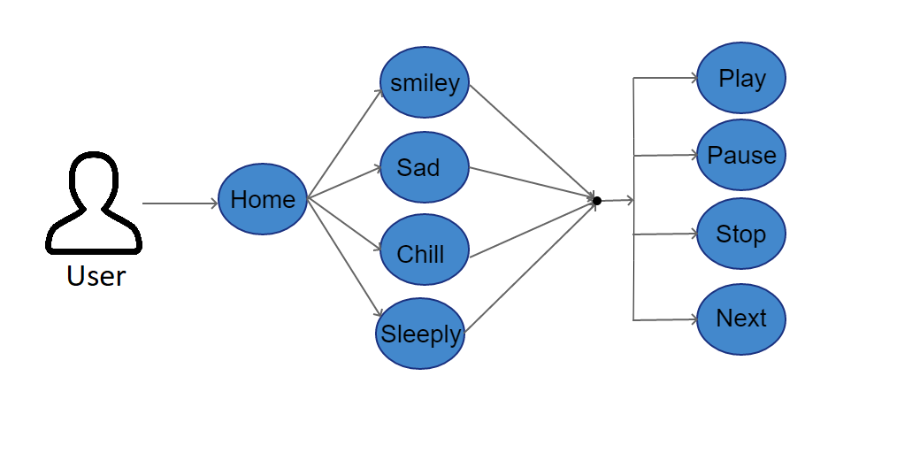

1. Data flow:

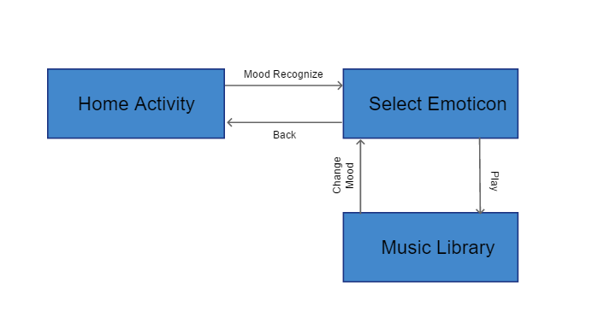

1. E-R diagram:

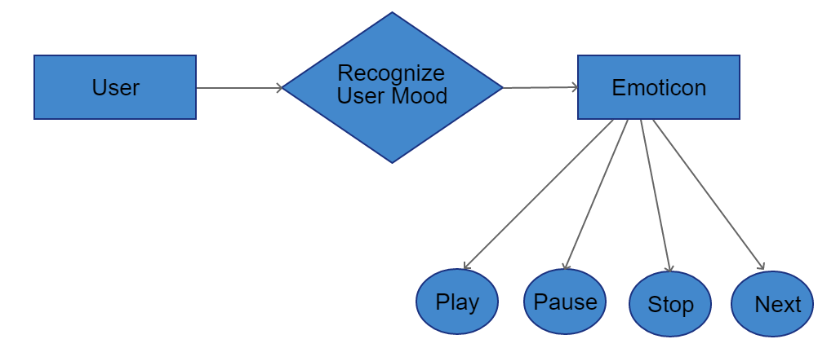

8. Resources:

* <https://www.edx.org/learn/android-development?g_acctid=926-195-8061&g_campaign=gs-nonbrand-topic-android&g_campaignid=1536179997&g_adgroupid=60153958778&g_adid=291587752236&g_keyword=android%20development%20online%20courses&g_keywordid=kwd-296070818774&g_network=g?utm_source=adwords&utm_campaign=1536179997&utm_medium=60153958778&utm_term=android%20development%20online%20courses&gclid=CjwKCAjw9dboBRBUEiwA7VrrzZX2i0jxYt3g-BHqriKtr2hed7fh0VI6l6xGvKYTusY8VCbhb2rsSxoCq0AQAvD_BwE> <https://www.webmd.com/bipolar-disorder/are-my-mood-swings-normal#1>
* <https://developer.android.com/courses/>
* <https://www.androidauthority.com/10-resources-learning-android-app-development-687441/>
* <https://www.udemy.com/android-material-design/>

9. Budget:

* High level computer(1)
* Processor:- core i5 or core i7.
* Windows 10 pro.
* Normal computer(2)
* Processor:- core i3.
* Windows 8+ version requirement.
* Software.
* Pen-drive.
* USB Cable
* Internet.
* Paper.
* File.

10. Evaluation:

Few Screenshots of developed “Mood Swing” android app.



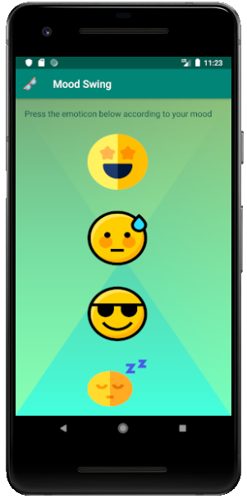

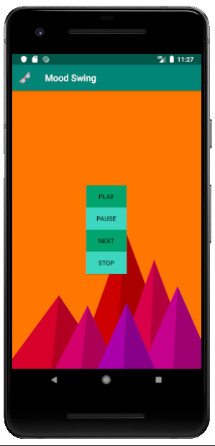

10. Future works:

Though this project is literally completed with our effort and planning but we also have future goal about the theme of the project.

Firstly,

We would like to update this app with online huge amount of audio resources.

Secondly,

We would like to detect face expression with this app and thus it suggest music from those online audio libraries.

Thirdly,

3D animated face-emoji will be added.

Forthly,

Quote suggestion according to face expression will be applied.