1. Download the file [web_scraper.sh](https://hs2solutions-my.sharepoint.com/:u:/g/personal/sharath_ram_bounteous_com/EVjtybZVxKRHjRNAwDkxVIYB_IKgcXaEGaAEjgcYAnTC1Q?e=MwOOxC) . Make the file executable. The file takes any  wikipedia webpage as an argument. Run the process on multiple sites like [Wikipedia:Stub - Wikipedia](https://en.wikipedia.org/wiki/Wikipedia:Stub) , [India - Wikipedia](https://en.wikipedia.org/wiki/India) at the same time and
2. Find all the processes running on the system.
3. Find the first 5 processes with the highest memory usage.

1. **Print the HTTP response code obtained from google.com.**

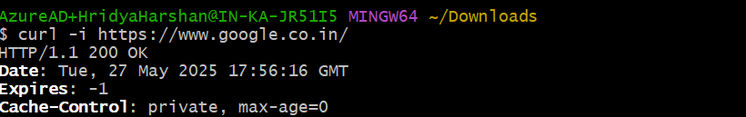



1. **Find the top 3 running processes which consume the most processing power.**

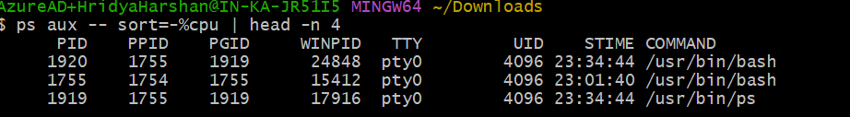

1. **Write a script that finds all files larger than 100MB in a directory and lists them.**

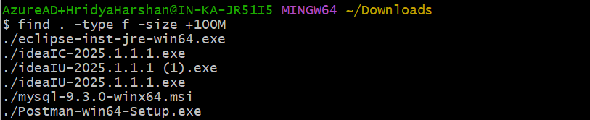

1. Find which version of Python is installed on the system.



1. **Get the current time zone of your system.**

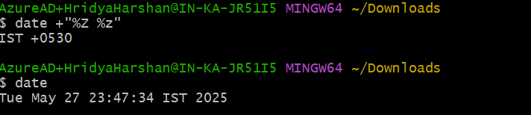

1. Get the current time in New York, London, and Sydney.
2. Check for how long the system is up.

1. Given a log file:
2. **Find all the errors in the log and dump them to a new file.**

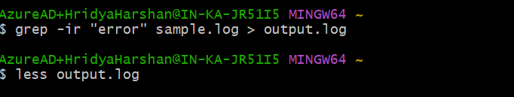

1. What events occurred between 09:10 and 09:19?

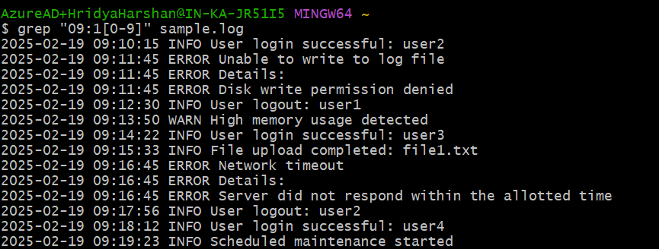

1. How many INFO messages are in the log file?

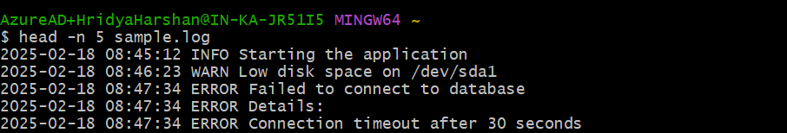

1. Print the first 5 lines of the file.

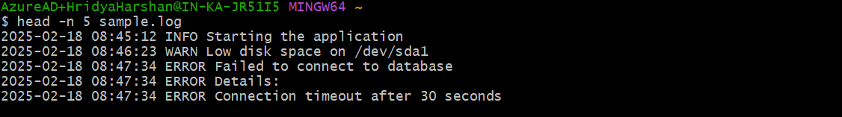

1. Print the last 5 lines of the file.



1. Print lines if the lines contain error, fail, or warning.

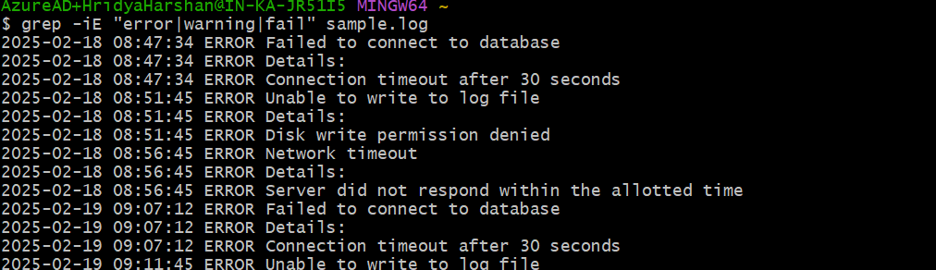

1. Rename the file to new_log.txt.



1. Edit the log file and add the string "hello, world!" at the beginning of the file.
2. Delete the old log file.



1. Filter entries containing the "INFO" string for a particular date for a given   log file, you can use the sample log file given below.

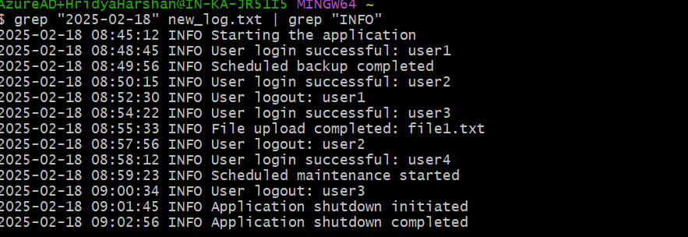

1. Write a command to continuously monitor what is being appended to the file and output if you find the string "Error".
2. Connect to google.com and copy the output to a text file.

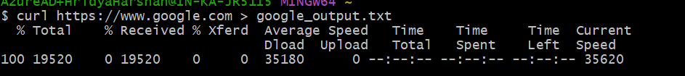

1. Create a file called example.txt. Write a script to make it read-only for all users.

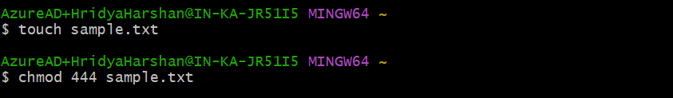

1. Write a script that changes the permissions of a script named myscript.sh to make it executable by the owner, group, and others.
2. Recursively make all the files readable in a directory.
3. List out all the files that end with ".log" in a directory.

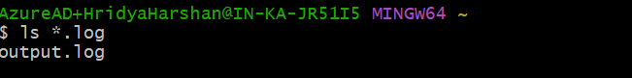

1. Write a command to get the kernel version.



1. Find the IP address of the system.

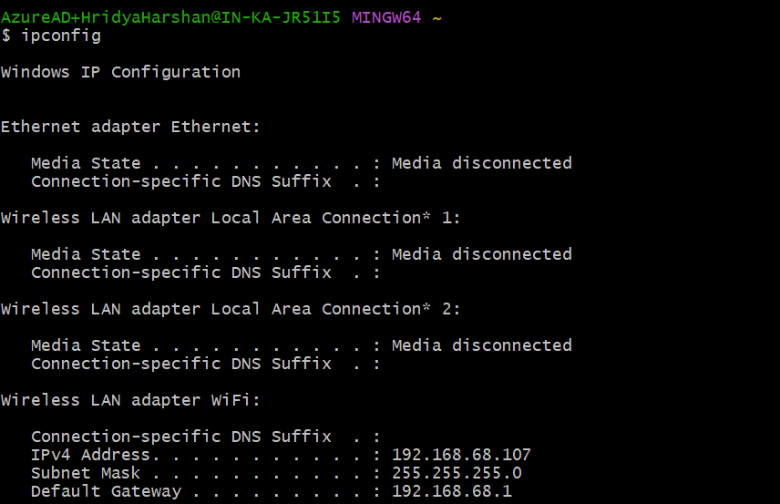

1. Write a script to list all files and directories in the current directory, sorted by size.

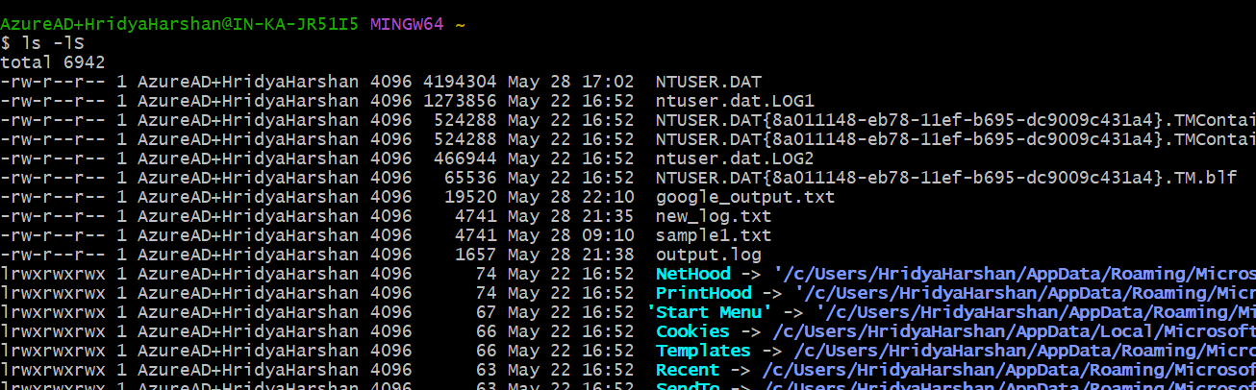

1. List all files and directories in the current directory with sizes in human-readable format.

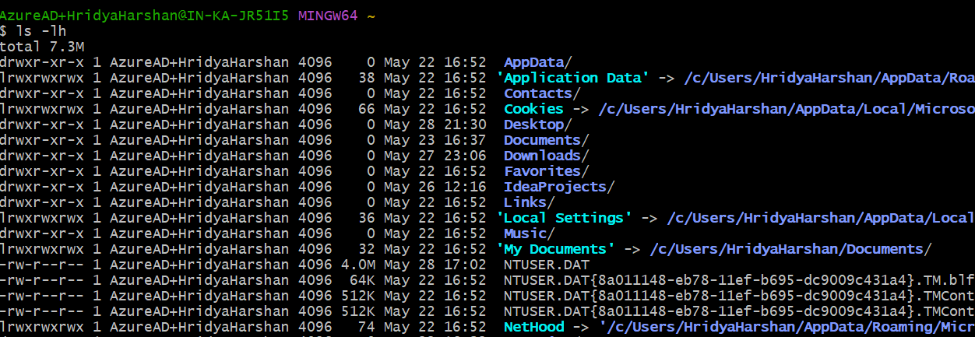

1. Print the hostname a computer.



1. Command to Kill a particular process running in your system.



1. Create two files test1.txt and test2.txt with some content and merge it to a single file test.text



1. Create a shell script test.sh with the content given at the bottom and execute it.

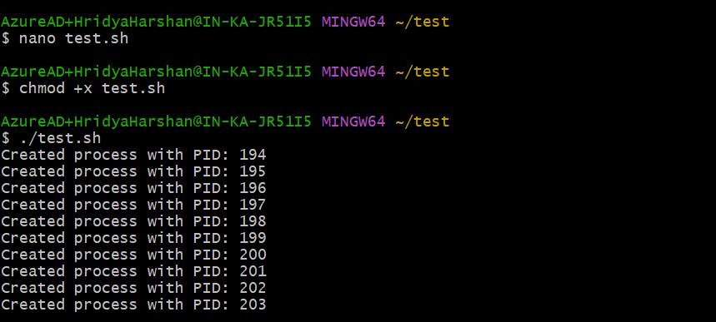

1. Tes.sh creates mutiple process , wrtie command to kill some specific process with given pid.
2. Write a shell script which take your name as input and it will dispaly Hello your name.

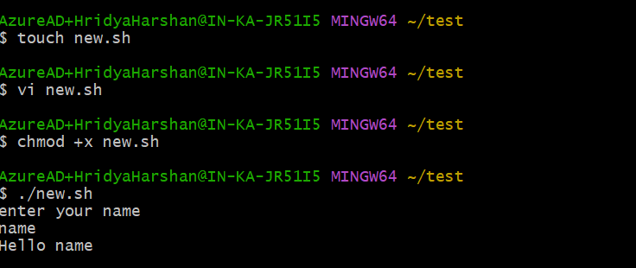

1. Write a command to download file.zip from  <https://github.com/github/gitignore/archive/refs/heads/main.zip>

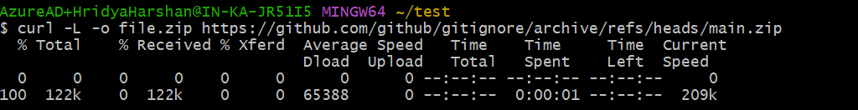

1. Write a command to zip test.txt to test.zip and unzip it.

Sample log file:

2025-02-18 08:45:12 INFO Starting the application   
2025-02-18 08:46:23 WARN Low disk space on /dev/sda1   
2025-02-18 08:47:34 ERROR Failed to connect to database   
2025-02-18 08:47:34 ERROR Details:   
2025-02-18 08:47:34 ERROR Connection timeout after 30 seconds   
2025-02-18 08:48:45 INFO User login successful: user1   
2025-02-18 08:49:56 INFO Scheduled backup completed   
2025-02-18 08:50:15 INFO User login successful: user2   
2025-02-18 08:51:45 ERROR Unable to write to log file   
2025-02-18 08:51:45 ERROR Details:   
2025-02-18 08:51:45 ERROR Disk write permission denied   
2025-02-18 08:52:30 INFO User logout: user1   
2025-02-18 08:53:50 WARN High memory usage detected   
2025-02-18 08:54:22 INFO User login successful: user3   
2025-02-18 08:55:33 INFO File upload completed: file1.txt   
2025-02-18 08:56:45 ERROR Network timeout   
2025-02-18 08:56:45 ERROR Details:   
2025-02-18 08:56:45 ERROR Server did not respond within the allotted time   
2025-02-18 08:57:56 INFO User logout: user2   
2025-02-18 08:58:12 INFO User login successful: user4   
2025-02-18 08:59:23 INFO Scheduled maintenance started   
2025-02-18 09:00:34 INFO User logout: user3   
2025-02-18 09:01:45 INFO Application shutdown initiated   
2025-02-18 09:02:56 INFO Application shutdown completed   
   
2025-02-19 09:05:23 INFO Starting the application   
2025-02-19 09:06:45 WARN Low disk space on /dev/sda1   
2025-02-19 09:07:12 ERROR Failed to connect to database   
2025-02-19 09:07:12 ERROR Details:   
2025-02-19 09:07:12 ERROR Connection timeout after 30 seconds   
2025-02-19 09:08:34 INFO User login successful: user1   
2025-02-19 09:09:56 INFO Scheduled backup completed   
2025-02-19 09:10:15 INFO User login successful: user2   
2025-02-19 09:11:45 ERROR Unable to write to log file   
2025-02-19 09:11:45 ERROR Details:   
2025-02-19 09:11:45 ERROR Disk write permission denied   
2025-02-19 09:12:30 INFO User logout: user1   
2025-02-19 09:13:50 WARN High memory usage detected   
2025-02-19 09:14:22 INFO User login successful: user3   
2025-02-19 09:15:33 INFO File upload completed: file1.txt   
2025-02-19 09:16:45 ERROR Network timeout   
2025-02-19 09:16:45 ERROR Details:   
2025-02-19 09:16:45 ERROR Server did not respond within the allotted time   
2025-02-19 09:17:56 INFO User logout: user2   
2025-02-19 09:18:12 INFO User login successful: user4   
2025-02-19 09:19:23 INFO Scheduled maintenance started   
2025-02-19 09:20:34 INFO User logout: user3   
2025-02-19 09:21:45 INFO Application shutdown initiated   
2025-02-19 09:22:56 INFO Application shutdown completed   
2025-02-19 09:23:45 INFO System reboot initiated   
2025-02-19 09:24:56 INFO System reboot completed   
2025-02-19 09:25:34 INFO User login successful: admin   
2025-02-19 09:26:45 WARN CPU temperature high   
2025-02-19 09:27:56 INFO User logout: admin   
2025-02-19 09:28:34 INFO User login successful: user5   
2025-02-19 09:29:45 ERROR Application crash   
2025-02-19 09:29:45 ERROR Details:   
2025-02-19 09:29:45 ERROR Null pointer exception in module X   
2025-02-19 09:30:56 INFO User logout: user5   
   
2025-02-20 10:05:23 INFO Starting the application   
2025-02-20 10:06:45 WARN Low disk space on /dev/sda1   
2025-02-20 10:07:12 ERROR Failed to connect to database   
2025-02-20 10:07:12 ERROR Details:   
2025-02-20 10:07:12 ERROR Connection timeout after 30 seconds   
2025-02-20 10:08:34 INFO User login successful: user1   
2025-02-20 10:09:56 INFO Scheduled backup completed   
2025-02-20 10:10:15 INFO User login successful: user2   
2025-02-20 10:11:45 ERROR Unable to write to log file   
2025-02-20 10:11:45 ERROR Details:   
2025-02-20 10:11:45 ERROR Disk write permission denied   
2025-02-20 10:12:30 INFO User logout: user1   
2025-02-20 10:13:50 WARN High memory usage detected   
2025-02-20 10:14:22 INFO User login successful: user3   
2025-02-20 10:15:33 INFO File upload completed: file1.txt   
2025-02-20 10:16:45 ERROR Network timeout   
2025-02-20 10:16:45 ERROR Details:   
2025-02-20 10:16:45 ERROR Server did not respond within the allotted time   
2025-02-20 10:17:56 INFO User logout: user2   
2025-02-20 10:18:12 INFO User login successful: user4   
2025-02-20 10:19:23 INFO Scheduled maintenance started   
2025-02-20 10:20:34 INFO User logout: user3   
2025-02-20 10:21:45 INFO Application shutdown initiated   
2025-02-20 10:22:56 INFO Application shutdown completed   
2025-02-20 10:23:45 INFO System reboot initiated   
2025-02-20 10:24:56 INFO System reboot completed   
2025-02-20 10:25:34 INFO User login successful: admin   
2025-02-20 10:26:45 WARN CPU temperature high   
2025-02-20 10:27:56 INFO User logout: admin   
2025-02-20 10:28:34 INFO User login successful: user5   
2025-02-20 10:29:45 ERROR Application crash   
2025-02-20 10:29:45 ERROR Details:   
2025-02-20 10:29:45 ERROR Null pointer exception in module X   
2025-02-20 10:30:56 INFO User logout: user5

-----------------------------------------------------------------------------------------------------------------

Test.sh

num_processes=10

for ((i=1; i<=num_processes; i++))

do

    # Forking a child process

       (sleep 60) &

           echo "Created process with PID: $!"

           done 

------------------------------------------------------------------