**Exercise 1: Setting Up Junit**

**Dependecies used**

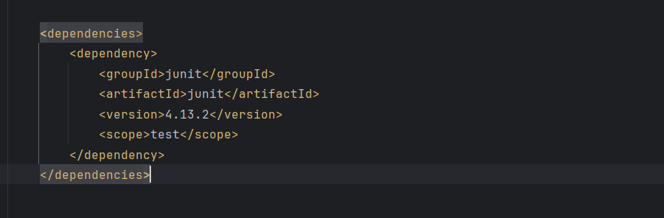

**Main class**

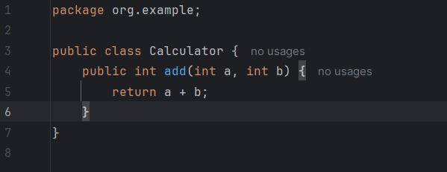

**Tester class**

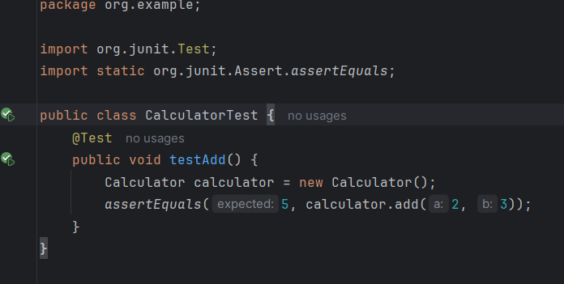

**Output of Exercise 1:**

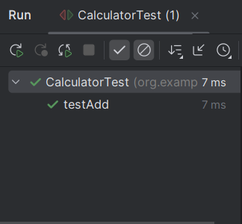

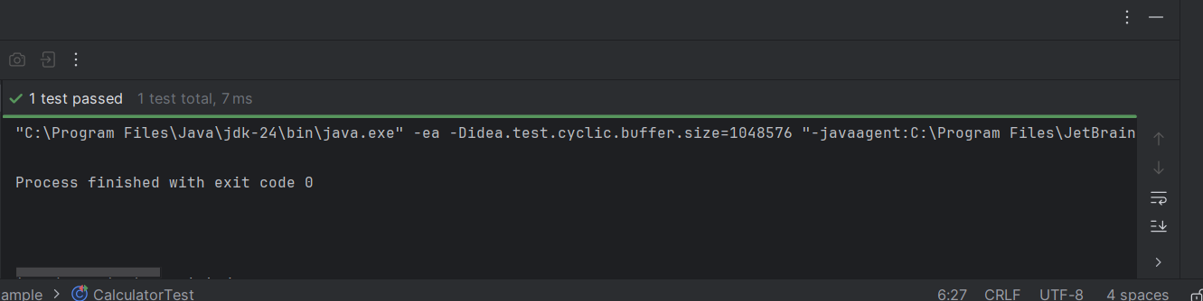

**Exercise 3: Assertions in Junit**

**Dependencies used**



**Tester class used**

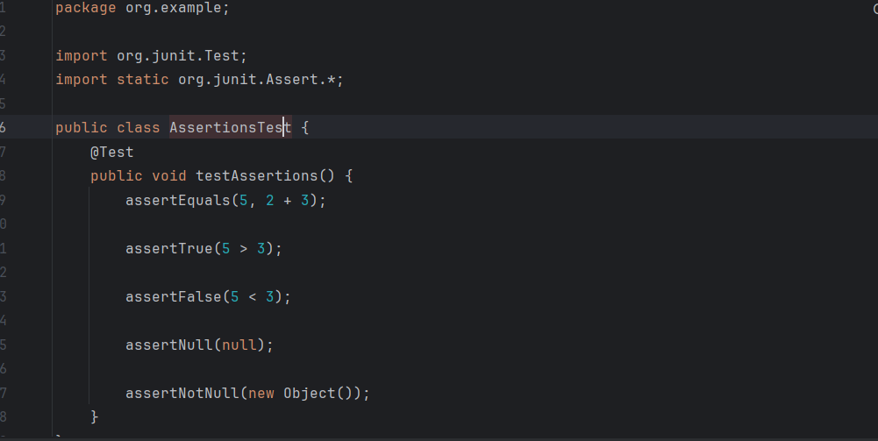

**Output of Exercise 3:**

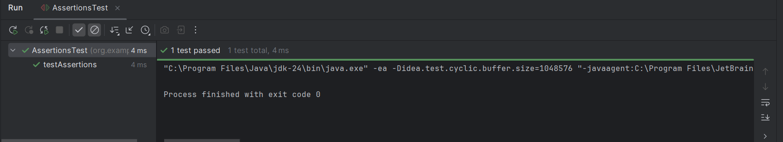

**Exercise 4: Arrange-Act-Assert (AAA) Pattern, Test Fixtures, Setup and Teardown Methods in Junit**

**Dependencies used**



**Main class used**

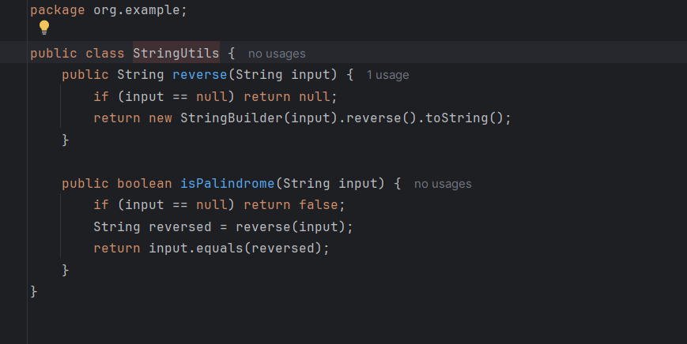

**Tester class used**

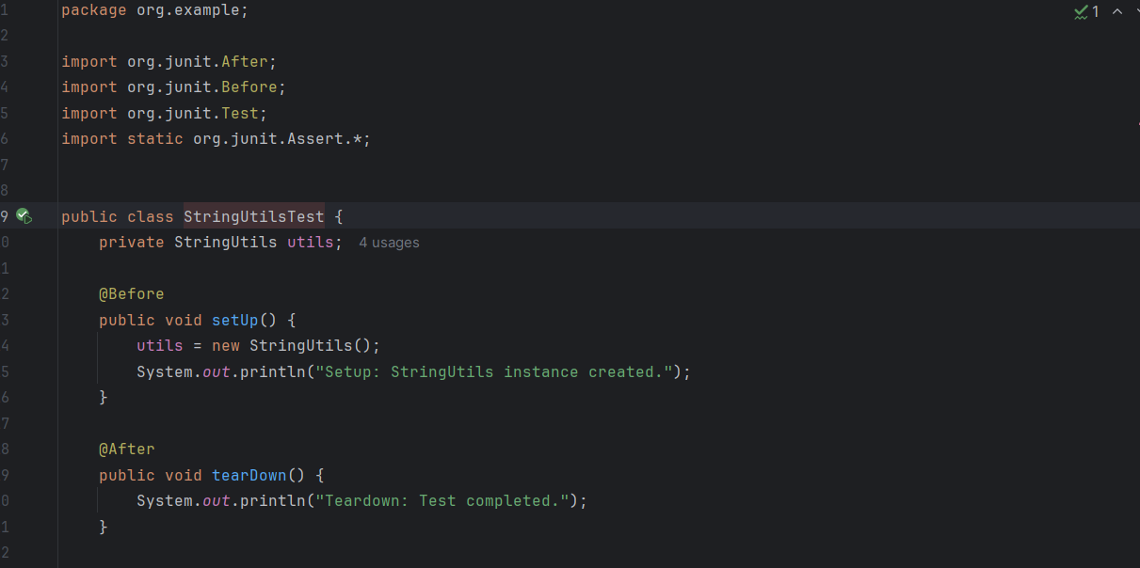

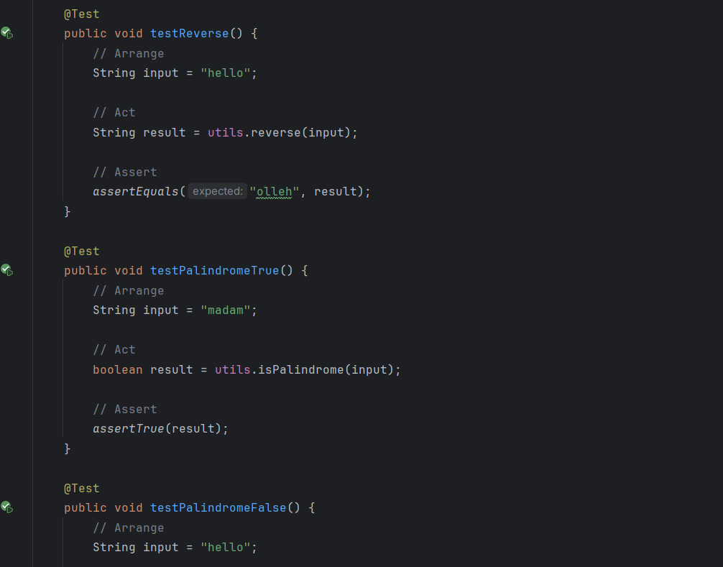

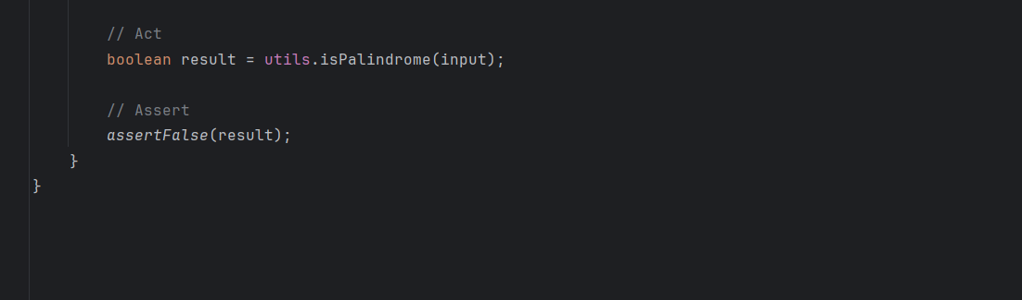

**Output of Exercise 4**

