**Exercise 1: Mocking and Stubbing**

**Dependencies used**

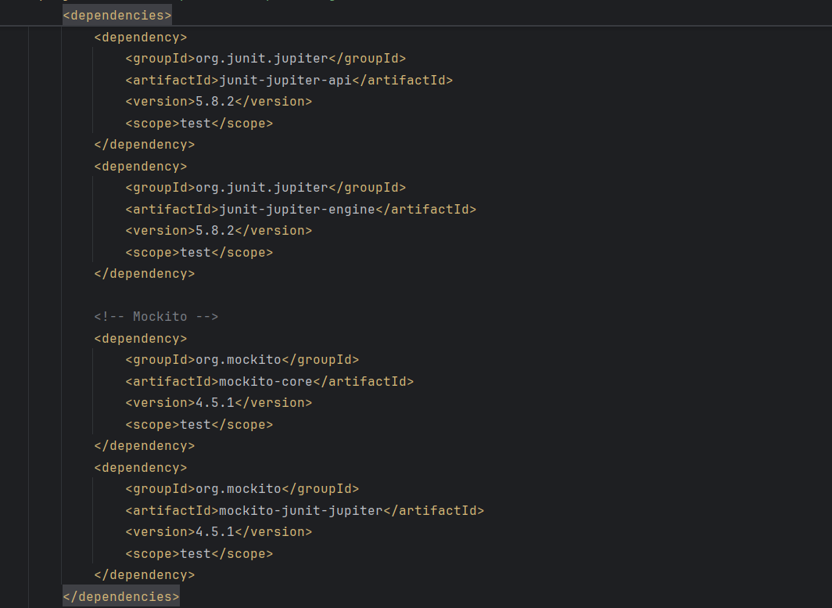

**Interface used**

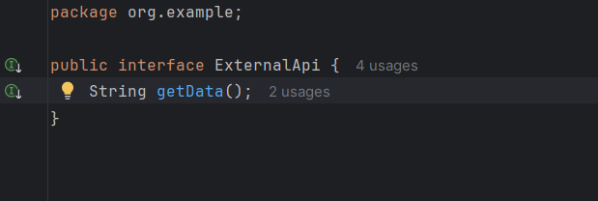

**Main class used**

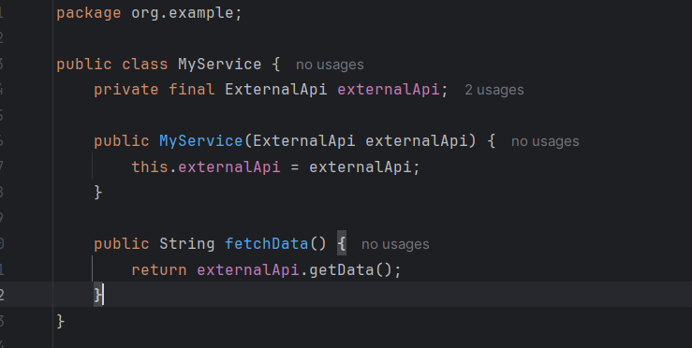

**Tester class used**

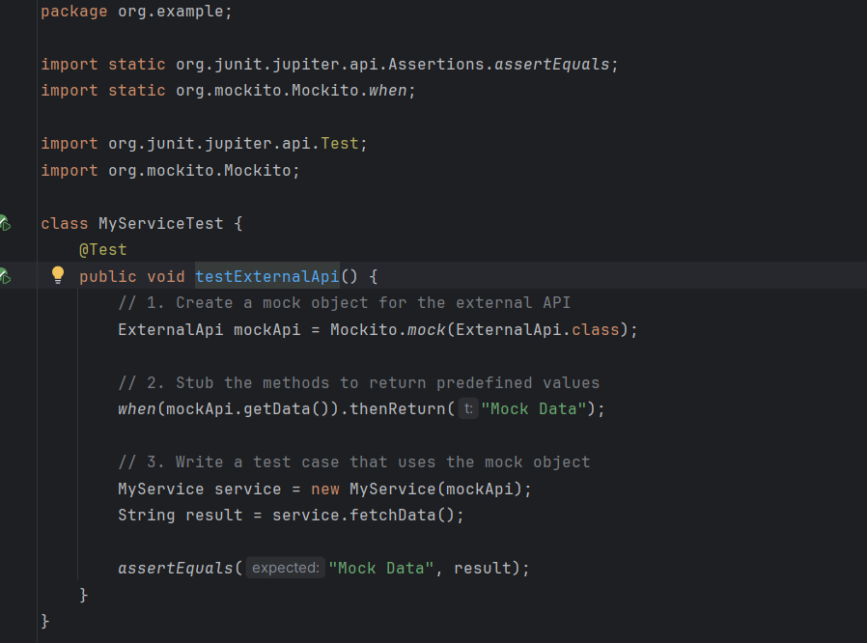

**Output of Exercise 1:**

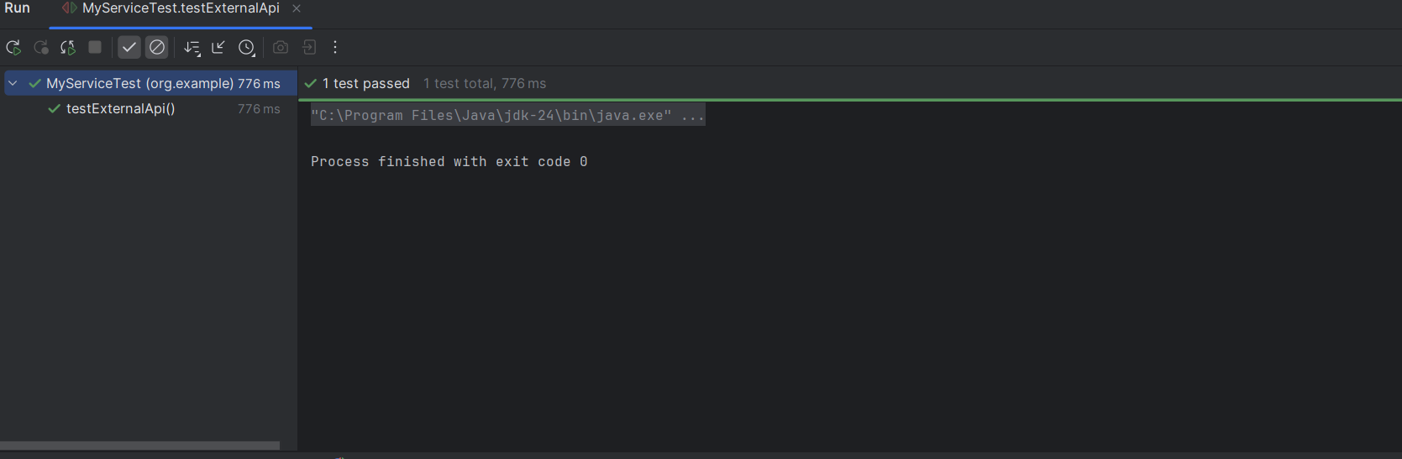

**Exercise 2: Verifying Interactions**

**Dependencies used**



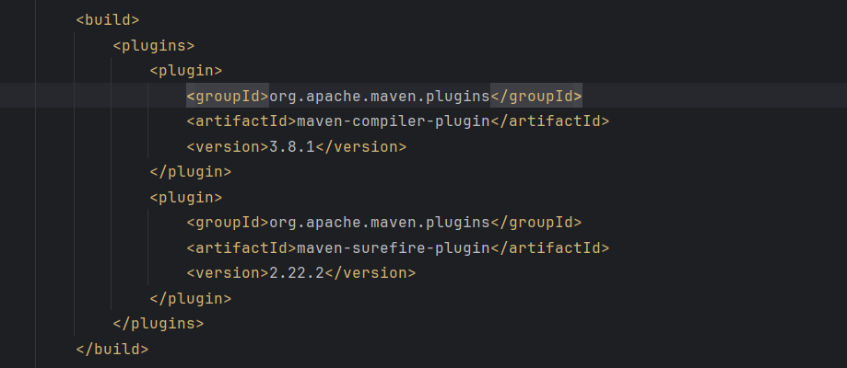

**Interface Used**

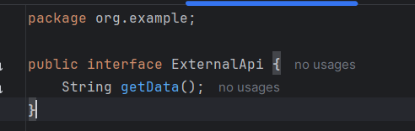

**Main class used**

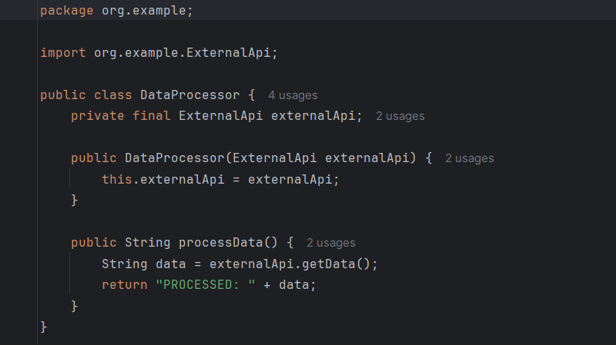

**Tester class used**

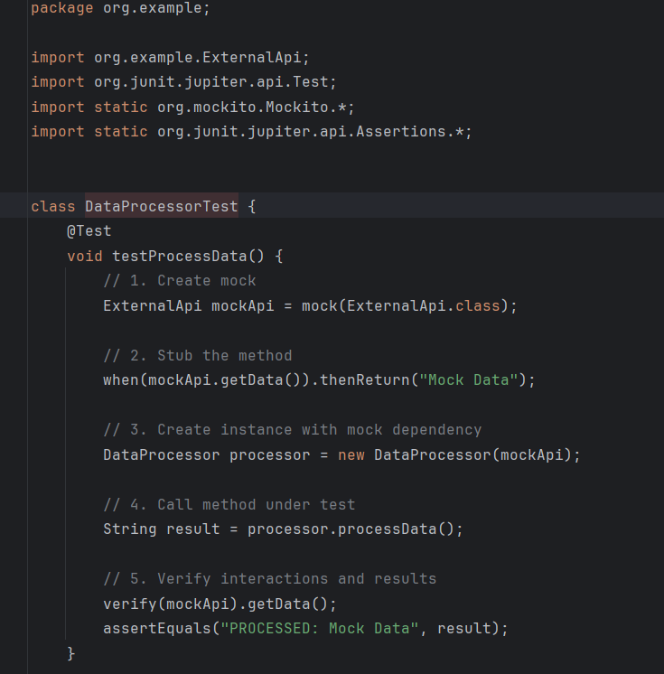

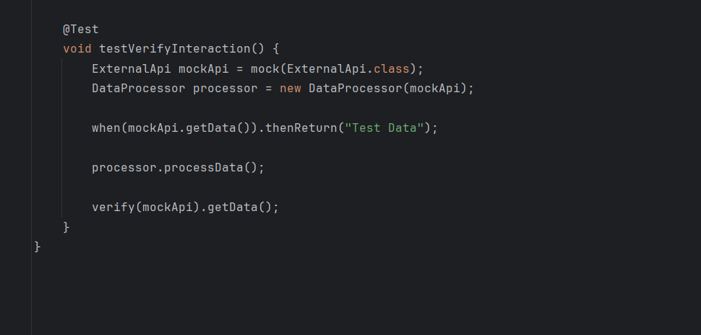

**Output of Exercise 2:**

