**Exercise 1: Logging Error Messages and Warning Levels**

**Dependencies used**

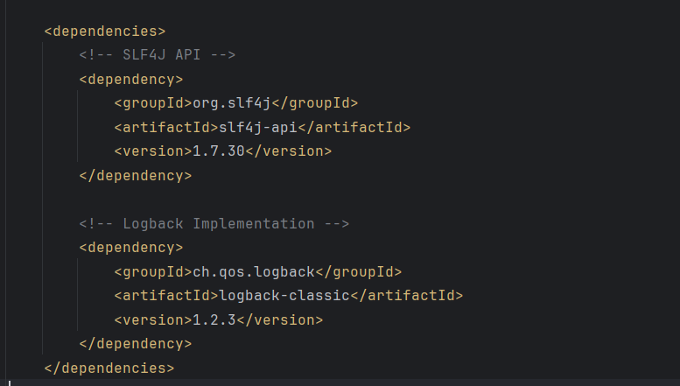

**Logback XML file used**

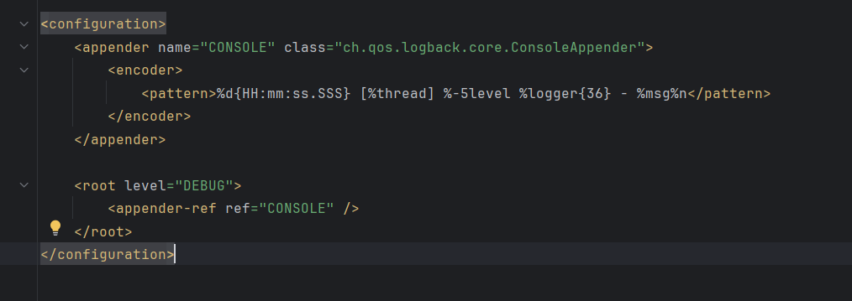

**Main class used**

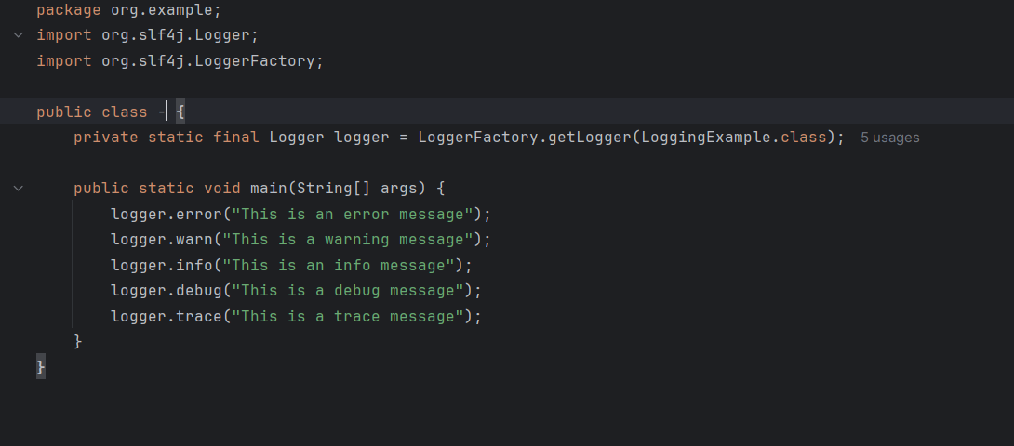

**Output of Exercise 1:**

