WEEK 2: PL/SQL Exercises (Solutions with queries)

Exercise 1: Control Structures

Scenario 1: The bank wants to apply a discount to loan interest rates for customers above 60 years old.
  - Question: Write a PL/SQL block that loops through all customers, checks their age, and if they are above 60, apply a 1% discount to their current loan interest rates.
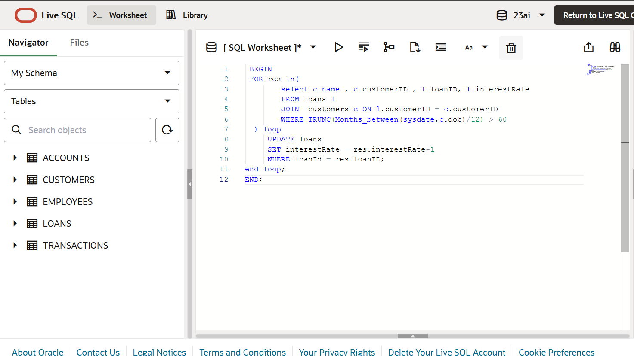
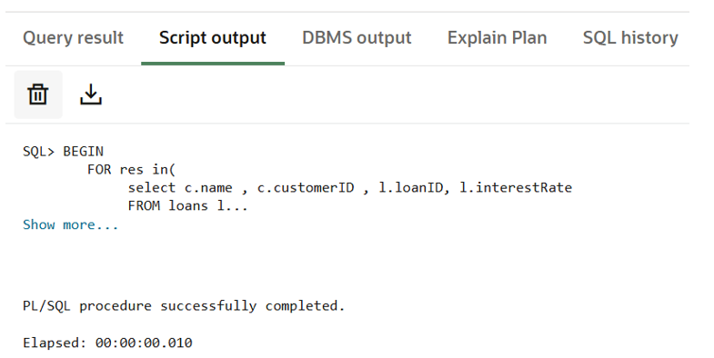
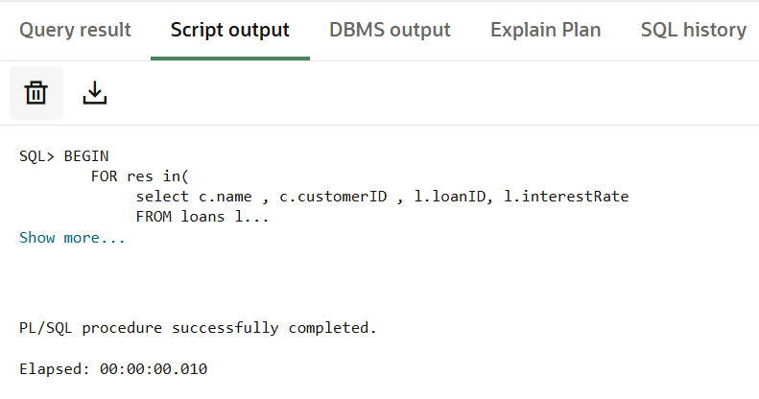

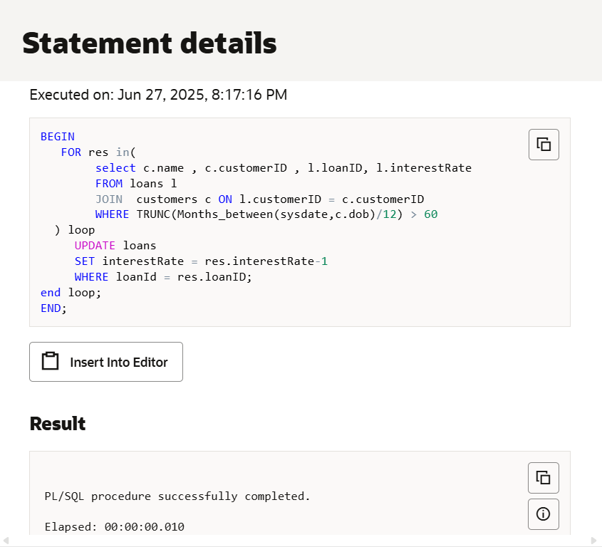

Scenario 2: A customer can be promoted to VIP status based on their balance.
  - Question: Write a PL/SQL block that iterates through all customers and sets a flag IsVIP to TRUE for those with a balance over $10,000.

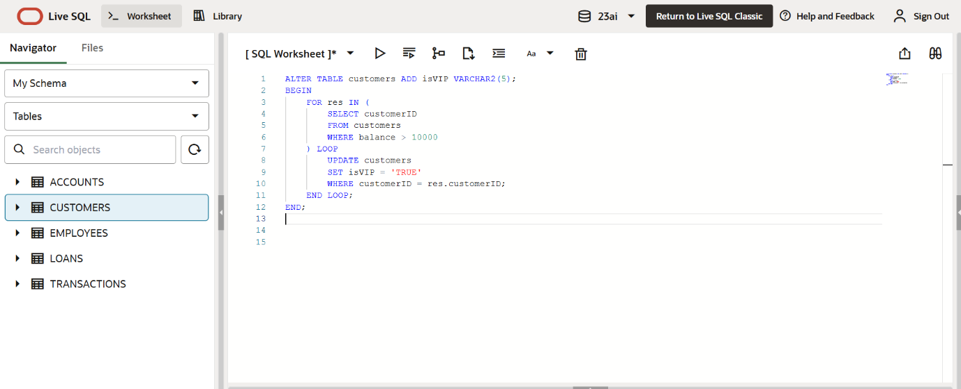

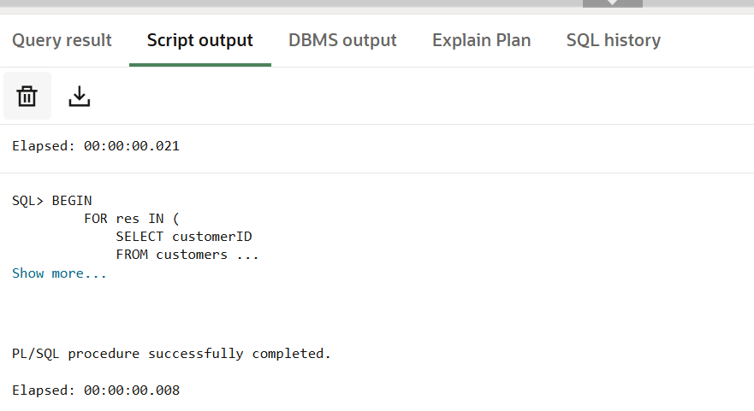

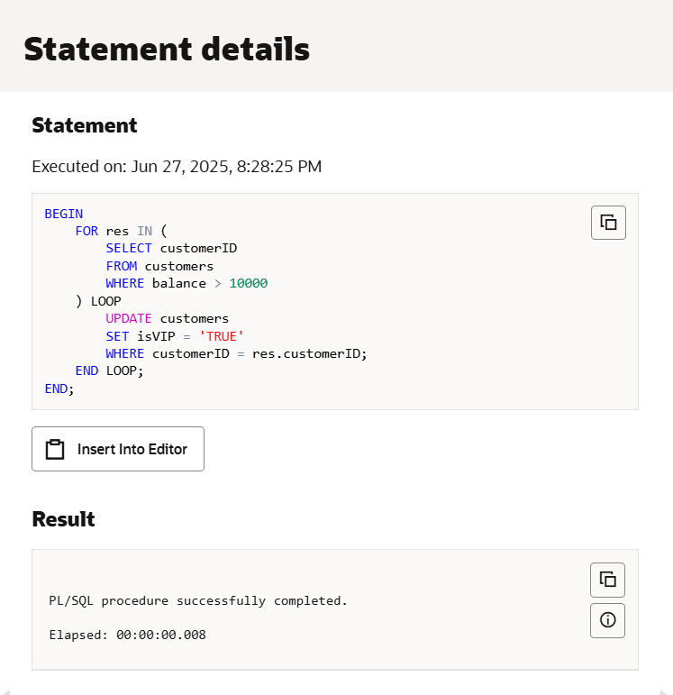

Scenario 3: The bank wants to send reminders to customers whose loans are due within the next 30 days.
  - Question: Write a PL/SQL block that fetches all loans due in the next 30 days and prints a reminder message for each customer.

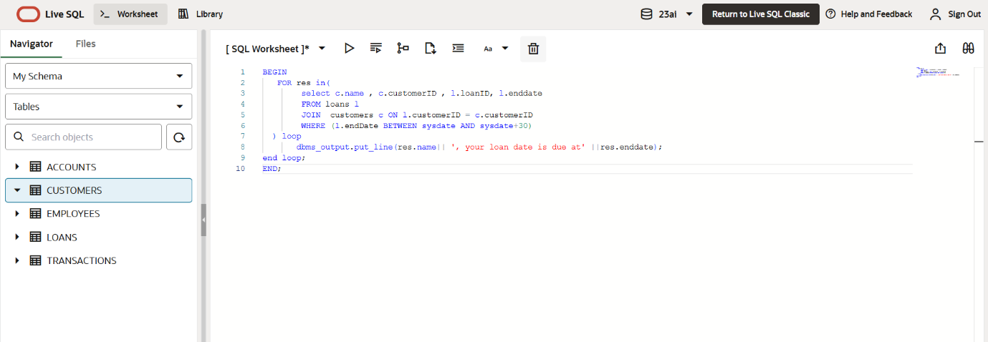

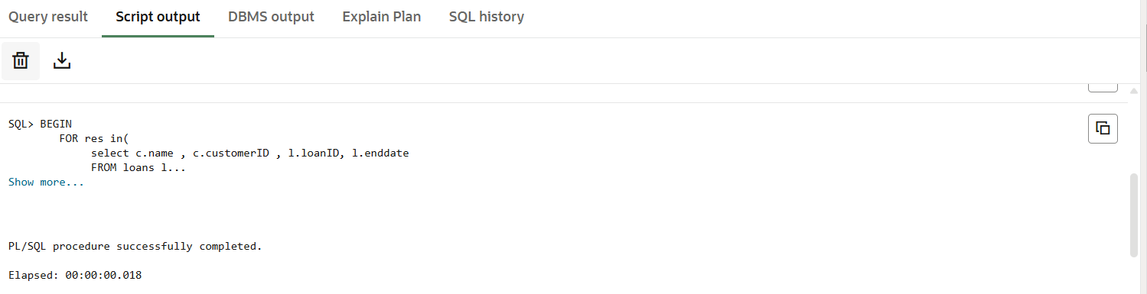

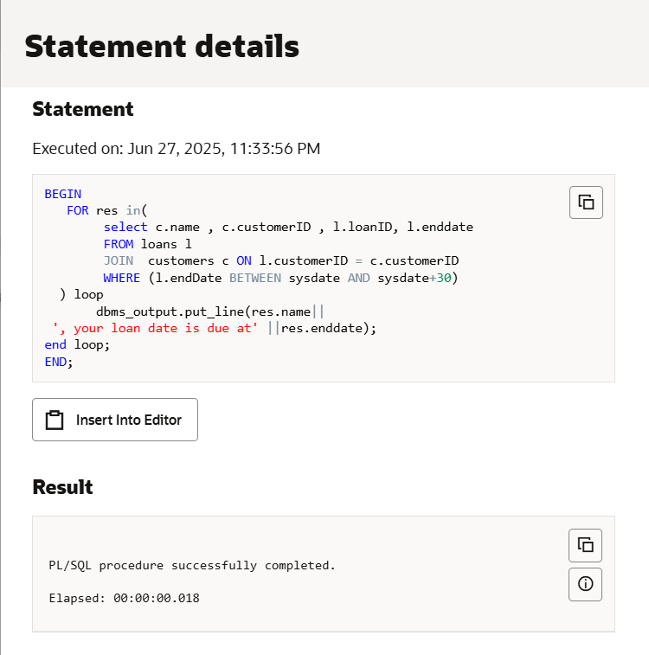

Exercise 3: Stored Procedures
Scenario 1: The bank needs to process monthly interest for all savings accounts.
  - Question: Write a stored procedure ProcessMonthlyInterest that calculates and updates the balance of all savings accounts by applying an interest rate of 1% to the current balance.

Stored Procedure:
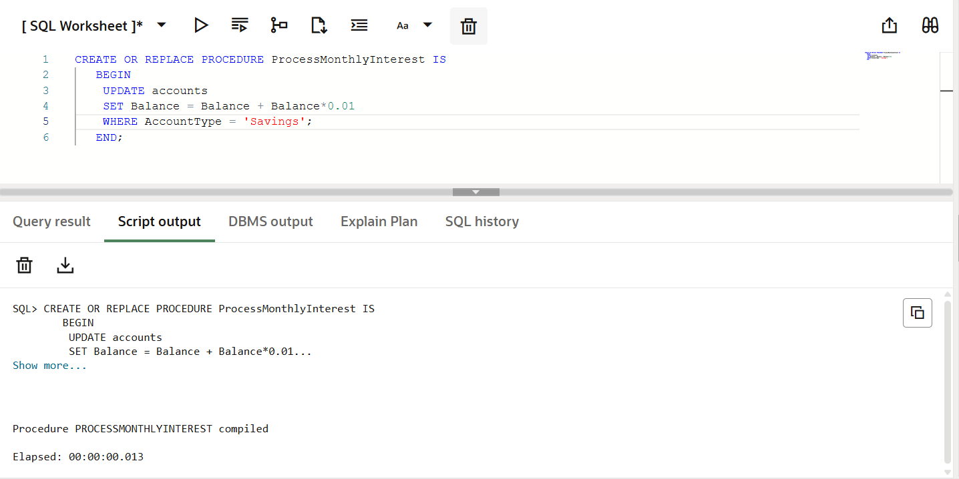

Executing the stored procedure:
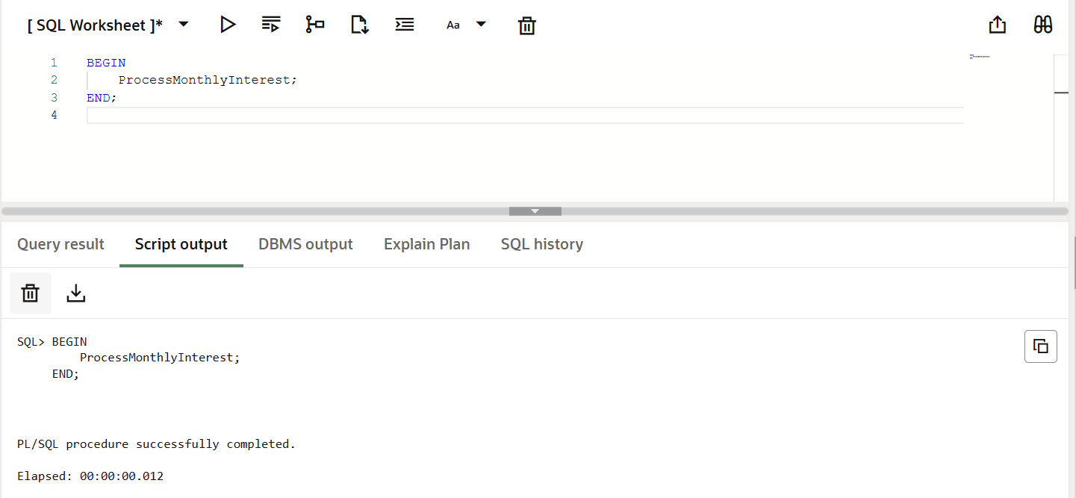

Scenario 2: The bank wants to implement a bonus scheme for employees based on their performance.
  - Question: Write a stored procedure UpdateEmployeeBonus that updates the salary of employees in a given department by adding a bonus percentage passed as a parameter.

Stored Procedure:
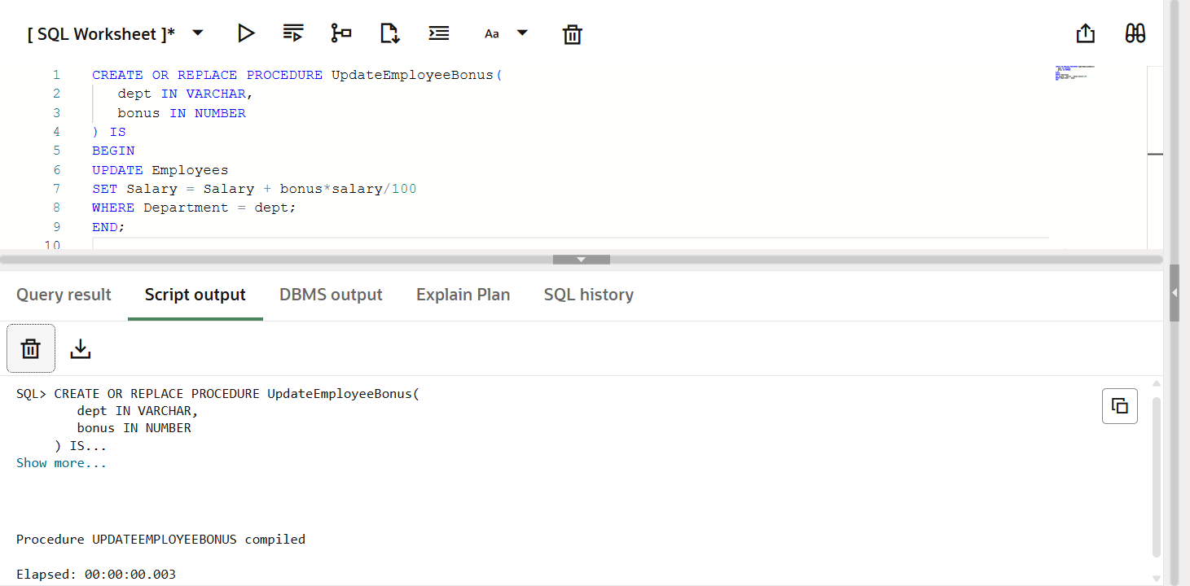

Executing the stored procedure:
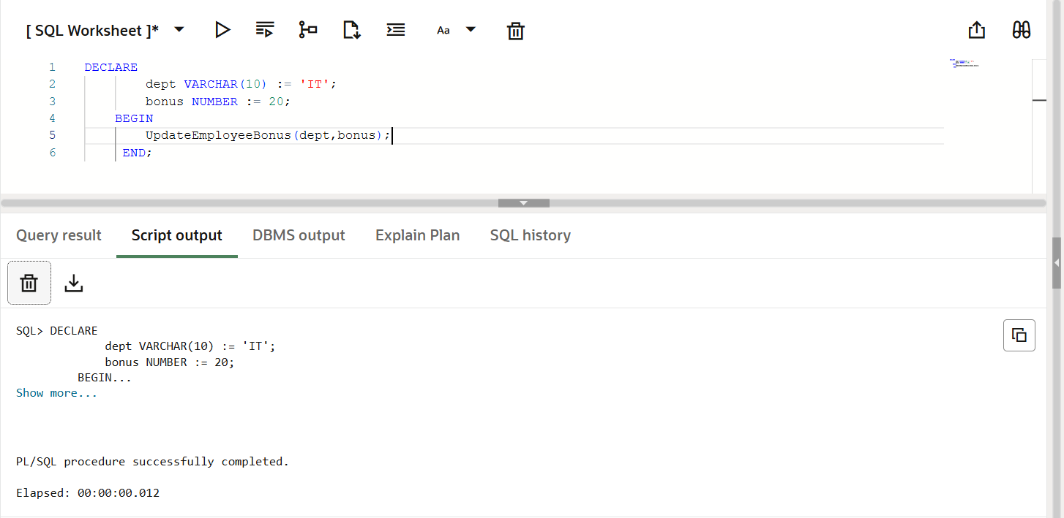

Scenario 3: Customers should be able to transfer funds between their accounts.
Question: Write a stored procedure TransferFunds that transfers a specified amount from one account to another, checking that the source account has sufficient balance before making the transfer.

Stored Procedure:

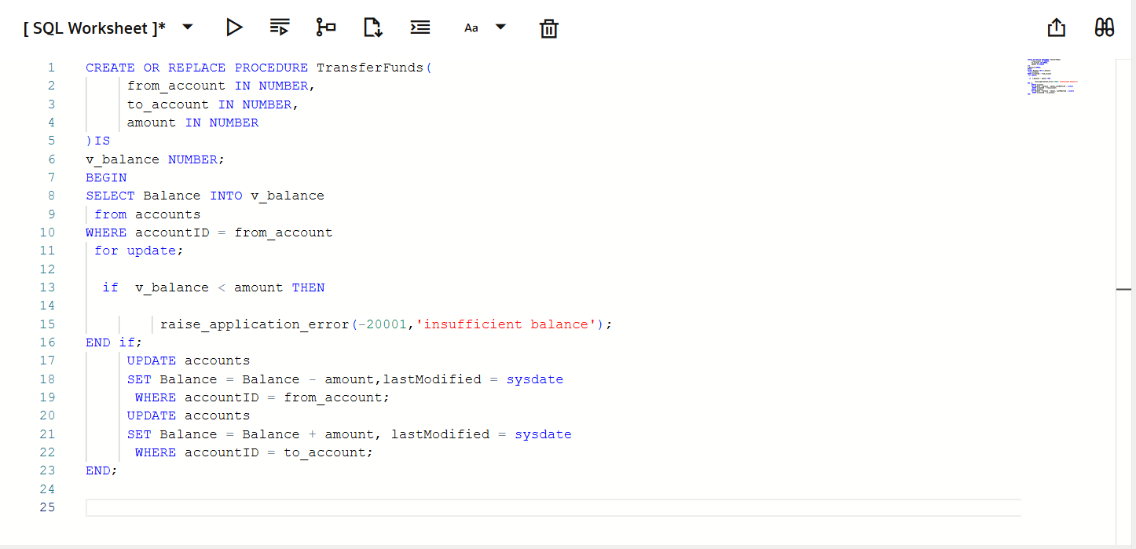

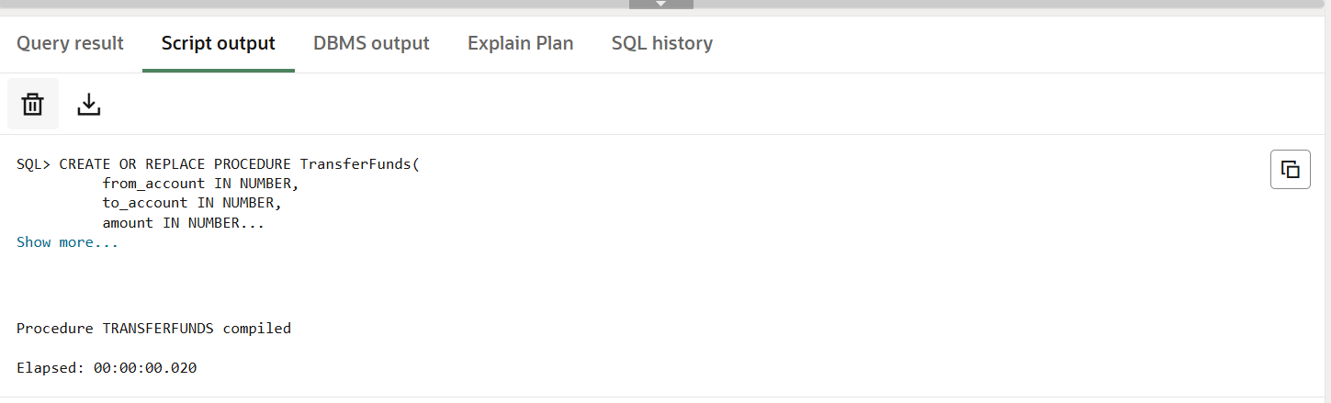

Executing the stored procedure:
