|  |
| --- |
| Questions |
| i)Create a Html form Named as Employee Form as a header with fields : Name - TextBox, Email id - TextBox , Mobile - Number , D.O.B - Datepicker, Country - Dropdown , State - Dropdown, City - Dropdown, Address - Multiline Text , Submit and Cancel button. |
| ii)On Submit button validate all the fields using jquery and javascript |
| iii)On selection of Country Dropdown , Bind State list drop down in State field , respectively on selection of state field bind city list in city field ex - India - Karnataka - Bangalore |
| Create a table using html and add one addition button in last column , On click of addition button , add one row below in the the table dynamically and on remove delete current row from table using jquery and javascript |
| Create an array with Employee Details as Name , Email id , Mobile , D.O.B , Country, State , City , Address in javascript and bind it to a table using looping which should contain features like searching , sorting , exporting option |

Answer 1,2 and 3

<form>

    <table>

        <tr>

            <td>

                <label *for*="uname">Name</label>

            </td>

            <td>

                <input *type*="text" *id*="uname" *name*="username">

            </td>

        </tr>

        <tr>

            <td>

                <label *for*="uemail">Email ID</label>

            </td>

            <td>

                <input *type*="text" *id*="uemail" *name*="usermail">

            </td>

        </tr>

        <tr>

            <td>

                <label *for*="age">Mobile</label>

            </td>

            <td>

                <input *type*="text" *name*="usermobile" *id*="mobile" *size*="10" *maxlength*="10">

            </td>

        </tr>

        <tr>

            <td>

                <label>DOB</label>

            </td>

            <td>

                <input *type*="datetime-local" *id*="Test_DatetimeLocal">

            </td>

        </tr>

        <tr>

            <td>

                    <label *for*="pass">Country</label>

            </td>

            <td>

                <select *id*="Country" *name*="Country">

                    <option *disabled* *selected*>--Choose Country--</option>

                            <option>india</option>

                            <option>USA</option>

                            <option>england</option>

                            <option>sri lanka</option>

                            <option>japan</option>

                            <option>china</option>

                            <option>nepal</option>

                            <option>bhutan</option>

                </select>

        </td>

        <tr>

            <td>

                <label *for*="pass">State</label>

            </td>

            <td>

                <select *id*="state" *name*="state">

                    <option *disabled* *selected*>--Choose state--</option>

                            <option>goa</option>

                            <option>uttar pradesh</option>

                            <option>kerala</option>

                            <option>J&K</option>

                            <option>punjab</option>

                            <option>Arunachal Pradesh</option>

                            <option>bihar</option>

                            <option>assam</option>

                </select>

        </td>

        <tr>

            <td>

                    <label *for*="city">City</label>

            </td>

            <td>

                    <select *id*="city" *name*="city">

                        <option *disabled* *selected*>--Choose City--</option>

                                <option>New Delhi</option>

                                <option>Mumbai</option>

                                <option>Channai</option>

                                <option>Kolkata</option>

                                <option>Noida</option>

                                <option>Gurgram</option>

                                <option>Faridabad</option>

                                <option>Gaziabad</option>

                    </select>

            </td>

        </tr>

        <tr>

            <td>

                <label>Address</label>

            </td>

            <td>

                <textarea *rows*="4" *cols*="40"></textarea>

            </td>

        </tr>

        <tr>

            <td></td>

            <td>

                <input *type*="submit" *value*="Submit">

                <input *type*="reset">

                <h1>FORM CREATED BY Hrishabh sharma</h1>

            </td>

        </tr>

    </table>

</form>

**Output**

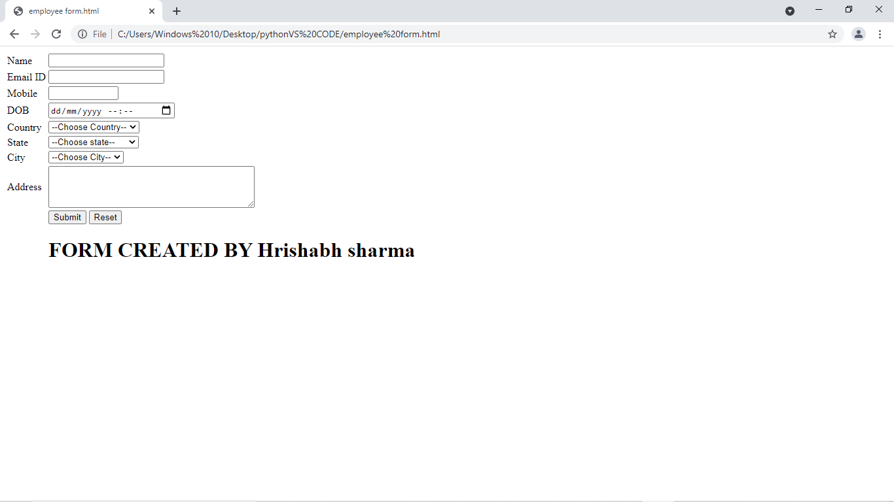

**Answer 4**

<HTML>

    <HEAD>

         <TITLE> Add/Remove dynamic rows in HTML table </TITLE>

         <SCRIPT *language*="javascript">

              function **addRow**(tableID) {

       var table = document.**getElementById**(tableID);

       var rowCount = table.rows.length;

       var row = table.**insertRow**(rowCount);

*//Column 1*

       var cell1 = row.**insertCell**(0);

       var element1 = document.**createElement**("input");

       element1.type = "button";

       var btnName = "button" + (rowCount + 1);

       element1.name = btnName;

       element1.**setAttribute**('value', 'Delete'); *// or element1.value = "button";*

       element1.**onclick** = function () { **removeRow**(btnName); }

       cell1.**appendChild**(element1);

*//Column 2*

       var cell2 = row.**insertCell**(1);

       cell2.innerHTML = rowCount + 1;

*//Column 3*

       var cell3 = row.**insertCell**(2);

       var element3 = document.**createElement**("input");

       element3.type = "text";

       cell3.**appendChild**(element3);

   }

   function **removeRow**(btnName) {

       try {

           var table = document.**getElementById**('dataTable');

           var rowCount = table.rows.length;

           for (var i = 0; i < rowCount; i++) {

               var row = table.rows[i];

               var rowrowObj = row.cells[0].childNodes[0];

               if (rowObj.name == btnName) {

                   table.**deleteRow**(i);

                   rowCount--;

               }

           }

       }

       catch (e) {

**alert**(e);

       }

   }

</SCRIPT>

    </HEAD>

    <H3>Add/Remove dynamic rows in HTML table</H3>

    <BODY>

         <INPUT *type*="button" *value*="Add Row" *onclick*="**addRow**('dataTable')" />

         <TABLE *id*="dataTable" *width*="350px" border="1">

              <TR>

                   <TD><input *type*="button" *name*="button1" *value*="Delete" *onclick*="**removeRow**('button1')"></TD>

                   <TD>1</TD>

                   <TD><input *type*="text" *value*="" *name*="nameTxt"></TD>

              </TR>

         </TABLE>

    </BODY>

</HTML>

**Output**

