**Filename:-Design principles & Patterns**

**Exercise 1: Implementing the Singleton Pattern**

**Code:-**

**Logger.java**

public class Logger {

    private static Logger instance;

    private Logger() {

        System.out.println("Logger Initialized");

    }

    public static Logger getInstance() {

        if (instance == null) {

            instance = new Logger();

        }

        return instance;

    }

    public void log(String message) {

        System.out.println("Log: " + message);

    }

}

**Main.java**

**public class Main {**

**public static void main(String[] args) {**

**Logger log1 = Logger.getInstance();**

**Logger log2 = Logger.getInstance();**

**log1.log("First message");**

**log2.log("Second message");**

**System.out.println(log1 == log2);**

**}**

**}**

**OUTPUT:-**

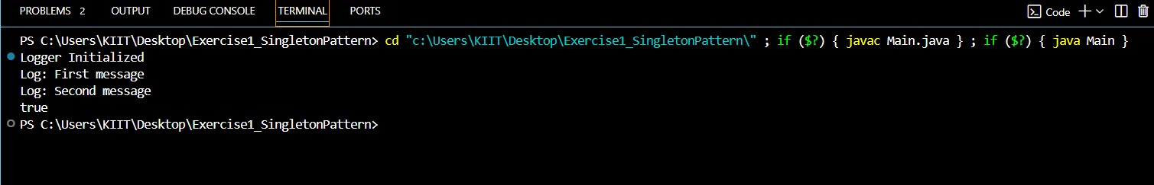

**Exercise 2: Implementing the Factory Method Pattern**

**Code:-**

**Document.java**

public interface Document {

    void open();

}

**DocumentFactorty.java**

public abstract class DocumentFactory {

    public abstract Document createDocument();

}

**ExcelFactory.java**

public class ExcelFactory extends DocumentFactory {

    public Document createDocument() {

        return new ExcelDocument();

    }

}

**PdfDocument.java**

public class PdfDocument implements Document {

    public void open() {

        System.out.println("Opening PDF document...");

    }

}

**PdfFactory.java**

public class PdfFactory extends DocumentFactory {

    public Document createDocument() {

        return new PdfDocument();

    }

}

**WordDocument.java**

public class WordFactory extends DocumentFactory {

   public WordFactory() {

   }

   public Document createDocument() {

      return new WordDocument();

   }

}

**WordFactory.java**

public class WordFactory extends DocumentFactory {

    public Document createDocument() {

        return new WordDocument();

    }

}

**Main.java**

public class Main {

    public static void main(String[] args) {

        DocumentFactory factory = new WordFactory();

        Document doc = factory.createDocument();

        doc.open();

        factory = new PdfFactory();

        doc = factory.createDocument();

        doc.open();

    }

}

**OUTPUT:-**

