Part 2 — Product Understanding
AbleSpace — Caseload → Take Data Workflow

1. Overview
This document walks through the student data-collection workflow in AbleSpace, AbleSpace's caseload management tool for special-education professionals (SLPs, PTs, OTs, and special-ed teachers). I explored the Caseload tab for a demo caseload of two students and used the "Take Data" screen to understand how a clinician logs progress against a student's IEP goals during a live session. Screenshots below are from my own exploration using the AbleSpace demo account.

2. Starting point: the Caseload tab
The Caseload tab (left-hand navigation) lists every student assigned to the logged-in clinician. Selecting a student opens a detail panel with a tabbed layout: Profile, Goals, Worksheets, Notes, Service Time, Accommodation, Attachments, Daily Logs, Progress, and Strength/Need.
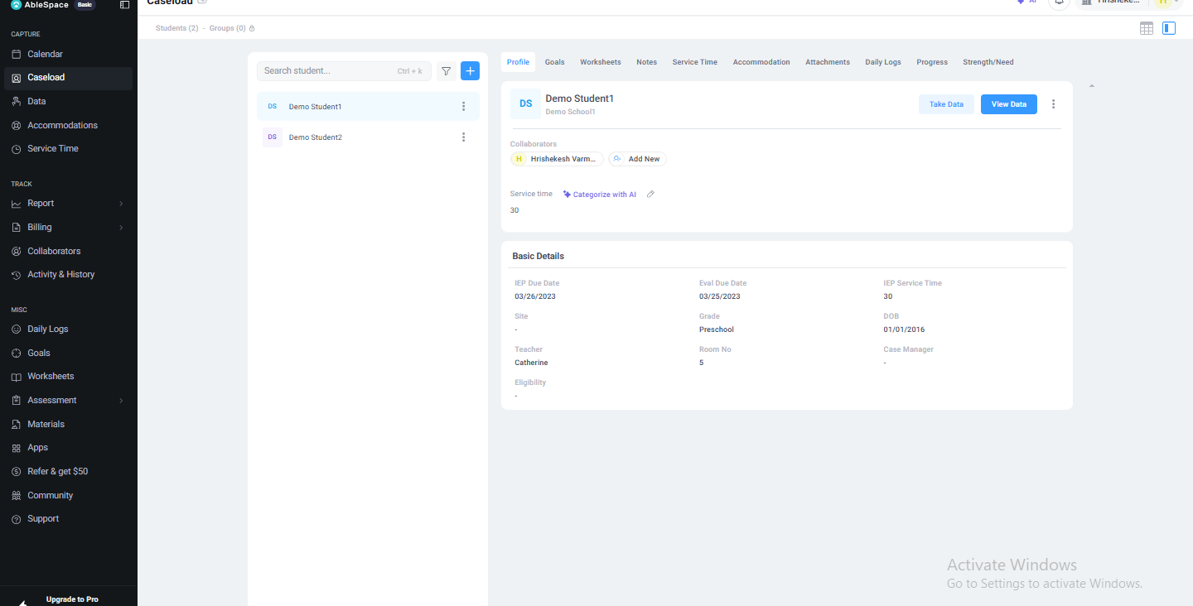
Fig. 1 — Student Profile tab: basic details, IEP due date, service time, and collaborators.
The Profile tab (Fig. 1) is the student's home screen inside the caseload: basic details (IEP due date, evaluation due date, grade, teacher, DOB), assigned collaborators, and total IEP service minutes. From here, two buttons stand out at the top right of the card: "Take Data" and "View Data." This is the clinician's two main actions for any student — either start actively logging new data, or review data that's already been collected.

3. Goals tab — what data collection is measured against
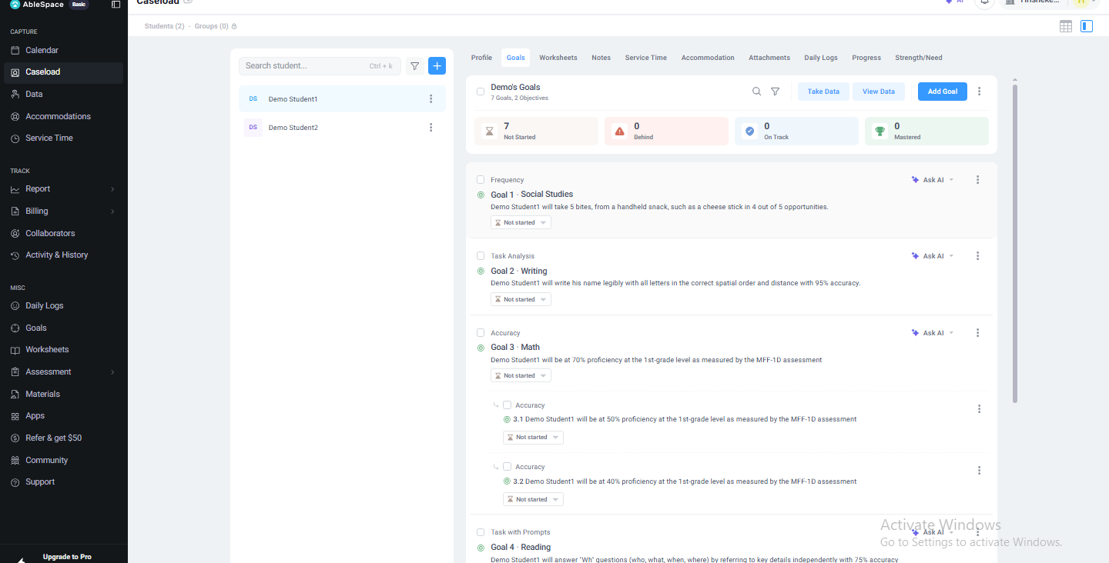
Fig. 2 — Goals tab: 7 IEP goals with categories, status, and nested sub-objectives.
Before looking at data entry itself, the Goals tab (Fig. 2) shows what is actually being tracked. This student has 7 goals spanning Social Studies, Writing, Math, and Reading, each written as a measurable objective (e.g. "will take 5 bites from a handheld snack... in 4 out of 5 opportunities"). Each goal is tagged with a data-collection method (Frequency, Task Analysis, Accuracy, Task with Prompts) and a status pill (Not Started / Behind / On Track / Mastered — summarized in the counter row at the top: 7 / 0 / 0 / 0). Some goals (e.g. Goal 3 · Math) expand into numbered sub-objectives with their own independent progress tracking. An "Ask AI" shortcut sits next to every goal, suggesting AI-assisted goal drafting or analysis is a first-class feature, not an add-on.

4. Notes tab — the running clinical log
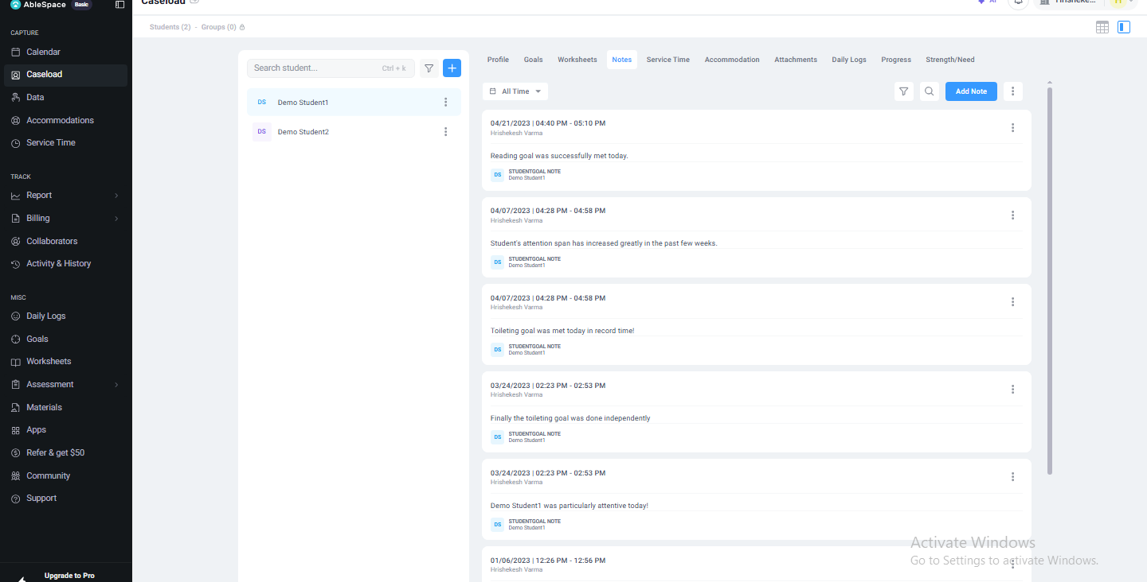
Fig. 3 — Notes tab: a chronological log of session notes tied to specific goals.
The Notes tab (Fig. 3) is a reverse-chronological feed of free-text notes, each timestamped, attributed to a clinician, and tagged to a specific goal ("STUDENTGOAL NOTE"). This is where qualitative context lives alongside the quantitative goal data — e.g. "Toileting goal was met today in record time!" This tab is clearly meant to be read alongside Goals and Take Data, not in isolation.

5. Service Time tab — session accounting
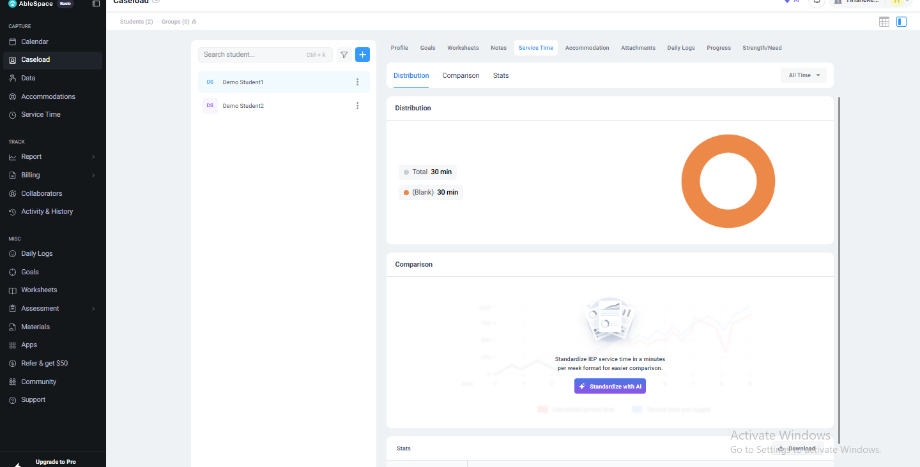
Fig. 4 — Service Time tab: distribution chart, comparison graph, and a stats table.
Service Time (Fig. 4) rolls up how many minutes of service have been logged, shown as a donut chart ("Distribution"), a time-series comparison graph, and a stats table (Session / Providers / Attendance / Service Time / Notes / Total). In this demo account the data is mostly unlabeled ("(Blank)", 30 min total) and the comparison graph is empty with a prompt to "Standardize IEP service time in a minutes-per-week format" via an AI action — this looks like a feature that only becomes useful once a caseload has real session history behind it.

6. The Take Data screen — the core workflow
Clicking "Take Data" from the Profile tab opens a dedicated session view (its own URL, /session/..., rather than staying inside the Caseload tab) with a live session timer already running ("08:36 AM – 09:06 AM" in Fig. 5). This is the screen the assignment specifically asks about, so I'll walk through it in detail.
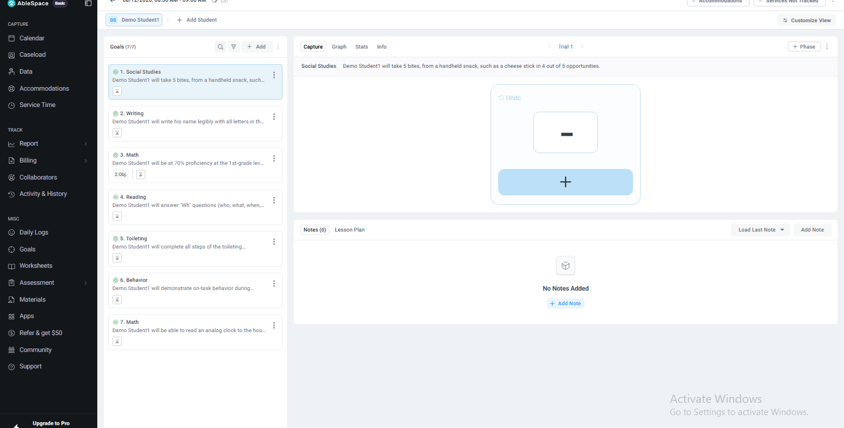
Fig. 5 — Take Data: live session view with goal list, trial capture widget, and notes.

6.1 Layout
- Left panel — "Goals (7/7)": every goal for the student, each shown as a compact card (icon, category, truncated goal text, objective count for goals with sub-objectives). This list is how the clinician switches which goal they're currently collecting data for.
- Top bar — session metadata: date/time range, an "Accommodations" shortcut, a "Services Not Tracked" warning badge, and "Customize View." "+ Add Student" lets one session cover multiple students at once, which matches how group therapy sessions actually run.
- Right panel — the active capture area for whichever goal is selected, with four tabs: Capture, Graph, Stats, and Info.

6.2 Capturing a data point
With "Social Studies" selected on the left, the Capture tab shows the goal's full text, a "Trial 1" indicator with prev/next navigation, and a compact capture widget: a result field (currently a dash, meaning no result logged yet for this trial) and a large blue "+" button beneath it, with "Undo" available above. The interaction model appears to be trial-by-trial: the clinician runs a trial with the student in real life, then taps + (or an equivalent control that likely changes per data-collection method — Frequency vs. Task Analysis vs. Accuracy would each need a different input, e.g. a tally counter vs. a percentage vs. a pass/fail toggle) to log the outcome, then the screen advances to the next trial. A "+ Phase" button suggests the clinician can also mark a change in intervention phase (e.g. baseline → intervention) without leaving this screen.
Underneath the capture widget, a Notes (0) section lets the clinician attach a note to this specific data-capture session ("Add Note", or "Load Last Note" to reuse a previous one), plus a separate "Lesson Plan" tab alongside it.

6.3 Why this design makes sense for the use case
This is designed to be used one-handed, in the moment, while a clinician is actively working with a student — not at a desk afterward. The goal text stays visible at all times so there's no need to memorize the exact wording of the objective mid-session, the capture control is a single large touch target (good for tablet/phone use, which the marketing materials confirm is a primary use case), and switching goals is a single tap on the left list rather than a page navigation, so a clinician working on multiple goals in one session doesn't lose their place.

7. UX / UI observations and suggested improvements
A few things stood out as friction points or opportunities, based on this exploration:

7.1 The capture control's input type isn't self-evident
The dash-and-plus widget for "Social Studies" (a Frequency-type goal) doesn't make it obvious at a glance what tapping "+" actually records — is it a tally count, a binary correct/incorrect, or something else? A first-time user has to infer this from context. A short inline label (e.g. "Tap + for each successful attempt") the first time a goal type is used would remove that ambiguity without adding permanent clutter.

7.2 "Services Not Tracked" is a passive warning with no clear next step
The top bar shows a "Services Not Tracked" badge, but it isn't clear from the screen what to do about it — is service time meant to be logged automatically as the session runs, or does the clinician need to do something manually before or after? Given that Service Time is a whole separate reporting tab (Fig. 4) that this session presumably feeds into, connecting the two more explicitly — e.g. a one-tap "Start tracking service time" action right in this badge — would close a real gap between data collection and the billing/reporting side of the product.

7.3 Empty/low-data states could do more to guide next steps
In Service Time (Fig. 4), the Comparison chart is empty and just prompts the clinician toward an AI "standardize" action, but doesn't explain what having comparison data would actually let them do or why it matters — for a busy clinician deciding whether it's worth their time, a one-line benefit statement ("See if service minutes are trending up or down week over week") would make that call-to-action more compelling than the icon-and-button alone.

7.4 No visible indicator of session progress across goals
With 7 goals in the session and a per-goal Trial counter, there's no summary indicator (e.g. "3 of 7 goals have data logged this session") visible anywhere on the Take Data screen itself — a clinician has to click through each goal card individually to check whether they've already collected data for it during this session, which is exactly the kind of state-tracking a live-in-session tool should be doing for the user rather than asking them to hold it in their head or re-check manually.

7.5 Goal card truncation loses distinguishing detail
In both the Goals tab (Fig. 2) and the Take Data left panel (Fig. 5), longer goal descriptions are truncated with "..." and no way to preview the full text without navigating into the goal. For goals in the same category with similar wording (this caseload has two goals labeled "Math"), the truncated text alone may not be enough to tell them apart quickly during a fast-paced session — a hover tooltip or expand-on-tap for the truncated text would help a clinician confirm they've selected the right goal before logging data against it.

8. Summary
The Take Data screen is clearly built around the real constraint of special-education service delivery: a clinician working directly with a student, needing to log structured progress data quickly, without breaking their attention away from the session itself. The core interaction (persistent goal list, large single-tap capture control, trial-by-trial progression) supports that well. The improvement opportunities above are mostly about closing small gaps between related parts of the product — data capture, service-time tracking, and goal detail — that currently require the clinician to piece things together across tabs rather than being surfaced in the moment they're needed.

