Big Data Analytics Project

Crop recommendation using weather data analysis

-Hrishikesh Kalola (21BCP346)

-Vinit Prajapati (21BCP339)

-Rudra Shah (21BCP340)

**Introduction**

Agriculture stands as a cornerstone of human civilization, yet its challenges persist amidst evolving environmental dynamics. With the advent of big data analytics, there arises an unprecedented opportunity to revolutionize crop planning and optimization. This project endeavors to harness the power of data-driven insights to recommend crops based on temperature and rainfall patterns in diverse metro cities. By integrating climate data with agricultural knowledge, we aim to empower farmers with actionable recommendations, fostering sustainable farming practices and enhancing food security.

**Objectives**

1. Utilize big data analytics to analyze temperature and rainfall data in metro cities.
2. Develop a predictive model to recommend crops based on environmental conditions.
3. Provide tailored crop recommendations for different regions within metro areas.
4. Evaluate the economic and environmental impact of the recommended crop selections.

**Data Analysis**

Dataset: The weather dataset from OpenCity.

Technologies Used: Python libraries including pandas, numpy, scikit-learn, seaborn, and matplotlib for data processing, analysis, and visualization.

Key Columns:

a. ID: Used for identification and categorization of weather records.

b. Date: Indicates the date of the weather observation.

c. Rain: Represents the amount of rainfall on a given date.

d. Temp_Max: Indicates the maximum temperature recorded on a specific date.

e. Temp_Min: Specifies the minimum temperature recorded on a specific date.

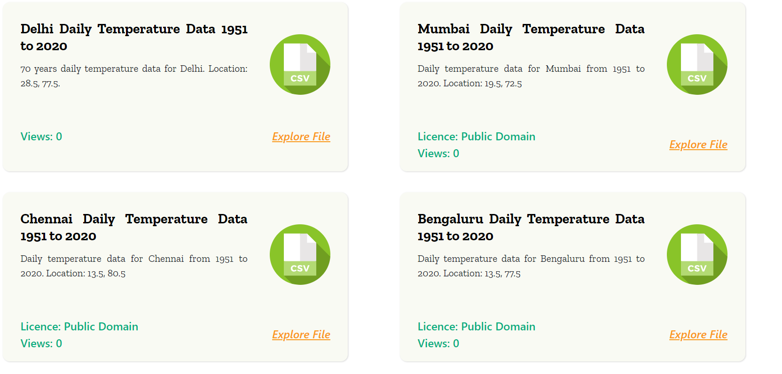

**Literature Review**

Previous research has underscored the significance of climate variables in determining crop suitability and yield. Studies have explored various methodologies for recommending crops based on environmental factors, ranging from rule-based systems to sophisticated machine learning models. Furthermore, research on urban agriculture has highlighted the unique challenges and opportunities in metro areas, necessitating localized recommendations tailored to specific microclimates. By synthesizing insights from existing literature, this project aims to build upon prior research and contribute novel approaches to crop recommendation in urban environments.

**Problems Addressed**

Lack of localized crop recommendations for metro areas, leading to suboptimal crop selection and reduced agricultural productivity.

Limited access to comprehensive climate data and analytical tools for small-scale farmers in urban settings.

Inefficient resource allocation and environmental degradation resulting from mismatches between crops and local climatic conditions.

**Valuable Insights that can be derived:**

Data-driven crop recommendations can optimize agricultural productivity and mitigate the impact of climate variability on crop yields.

Tailored recommendations based on localized climate data empower farmers with actionable insights for sustainable crop management.

Integrating big data analytics with agricultural decision-making processes enhances the resilience and adaptability of farming systems in urban areas.

**Citations:**

Weather Dataset - <https://data.opencity.in/dataset/daily-temperature-70-years-data-for-major-indian-cities>

Crop dataset - <https://www.kaggle.com/datasets/atharvaingle/crop-recommendation-dataset>

Comparative study - <https://iopscience.iop.org/article/10.1088/1742-6596/2161/1/012033/pdf>

Crop-Weather relation - <https://krishi.icar.gov.in/jspui/bitstream/123456789/32973/1/Crop-weather%20relationships.%20Cropping%20system%20management.pdf>

Recommendations using GNB (Gaussian Naïve Bayes) - <https://www.researchgate.net/publication/370056714_Crop_Recommendation_System>

Recommendation using GCN (graph convolution network) - <https://www.mdpi.com/2673-4591/58/1/97>

Crop prediction using different features - <https://www.researchgate.net/publication/346627389_Crop_Recommendation_System>