Project 1 — SafeLine Web Application Firewall (WAF)
Abstract: This project focuses on web application security using DVWA (Damn Vulnerable Web Application) and the SafeLine Web Application Firewall (WAF). DVWA, an intentionally vulnerable website, is deployed with Docker on an Ubuntu virtual machine and attacked with SQL injection to show how such attacks work. SafeLine WAF is then configured to protect the site, so the same attack is detected and blocked. Rate limiting is also configured to protect the application from abnormal request volumes from individual clients. The project teaches how web attacks work, how a WAF protects applications, and how security logs are used to monitor and analyze malicious activity.
Requirements:
Software | VirtualBox (free) + Ubuntu 22.04 ISO (free) + Docker (free)
RAM | At least 4 GB allocated to the Ubuntu VM
Disk Space | 20 GB free on your computer
Network | Set VM network to 'Host-Only Adapter' in VirtualBox settings

Step-by-Step Instructions
Phase 1 — Set Up Your Ubuntu Virtual Machine
Step 1: Download VirtualBox — Go to virtualbox.org and download the installer for your operating system. Install it like any normal program.

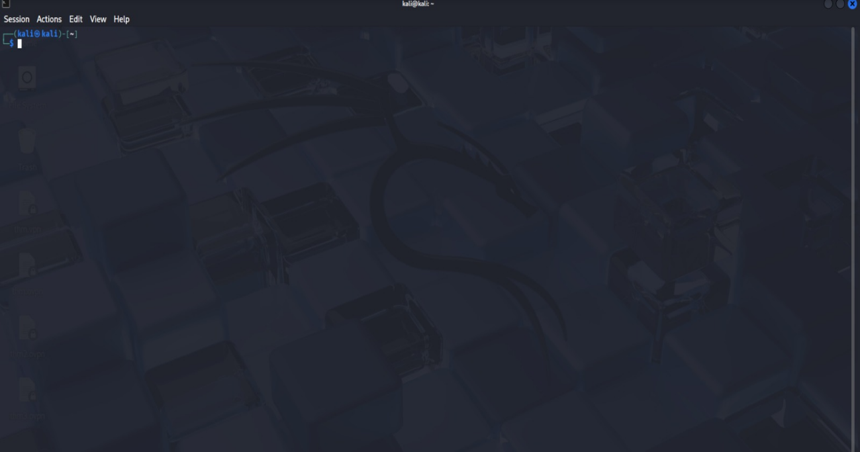

Step 2: Download Ubuntu — Go to ubuntu.com/download/desktop and download Ubuntu 22.04 LTS (the file is about 4–5 GB).

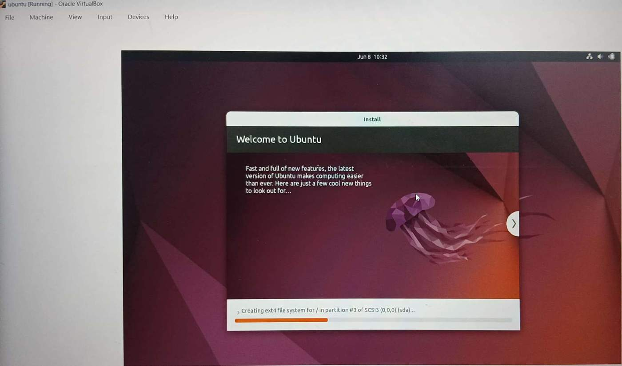

Step 3: Create a new VM — Open VirtualBox, click 'New', and name the VM 'WAF-Lab'. Set the type to Linux and the version to Ubuntu (64-bit). Allocate 4096 MB of RAM and create a 20 GB virtual hard disk.

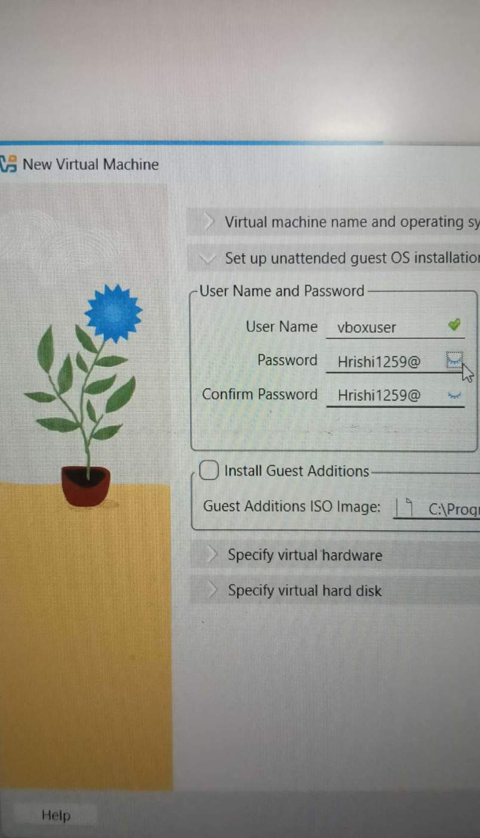

Step 4: Attach the Ubuntu ISO — In the VM's Settings > Storage, click the empty disc icon and attach the Ubuntu ISO you downloaded. Start the VM and follow the Ubuntu installation wizard.

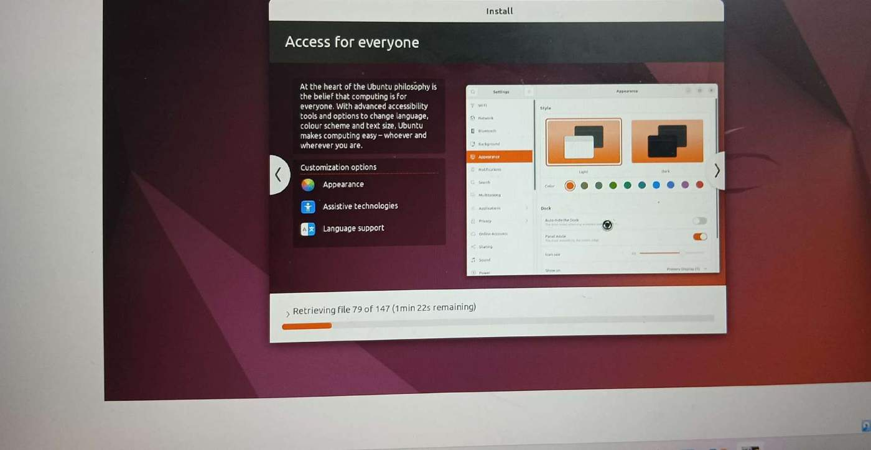

Step 5: Configure the network — In VirtualBox Settings > Network, set Adapter 1 to 'Host-Only Adapter'. This keeps your lab isolated from your home network.
Phase 2 — Install Docker
Docker is a tool that lets you run applications in containers — small, self-contained environments. DVWA and SafeLine both run as Docker containers.
In the Ubuntu terminal, type these commands one at a time, pressing Enter after each:
sudo apt update
sudo apt install -y docker.io docker-compose
sudo systemctl enable docker
sudo systemctl start docker

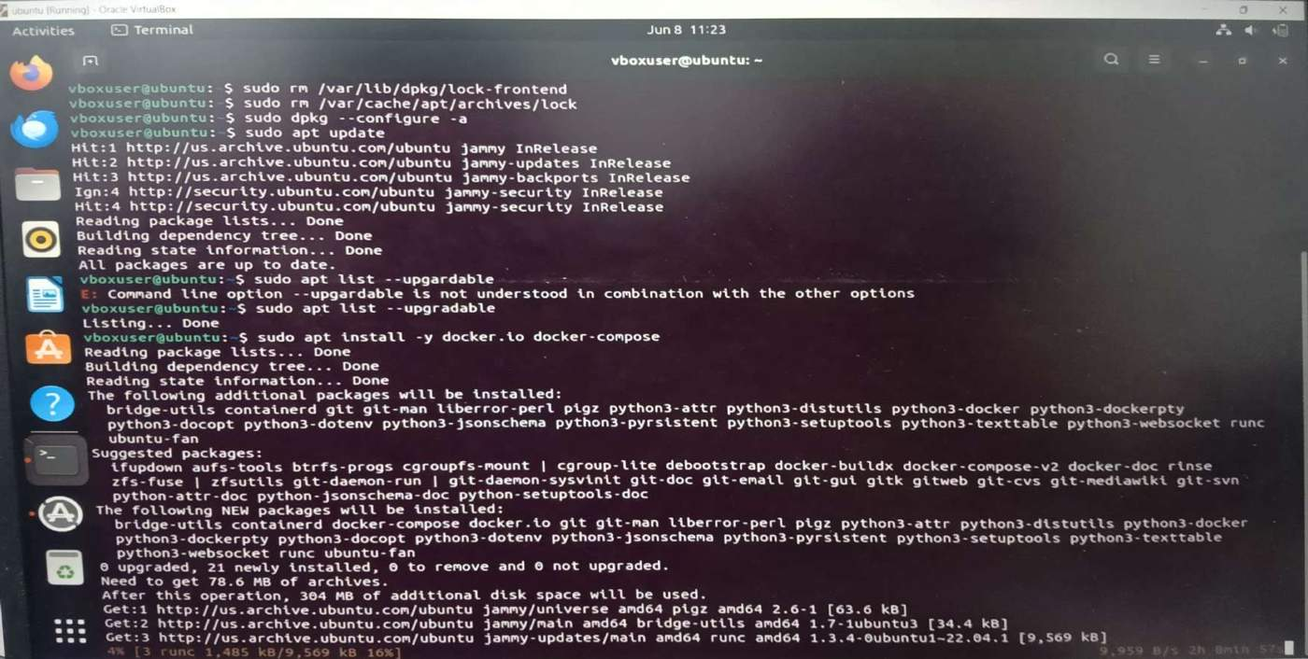

Phase 3 — Install DVWA (The Vulnerable Website)
Step 6: Create a folder — In the terminal, type: mkdir dvwa-lab && cd dvwa-lab

Quick option — start DVWA directly with one command (or follow Steps 7 and 8 to use docker-compose instead):
sudo docker run -d -p 80:80 vulnerables/web-dvwa
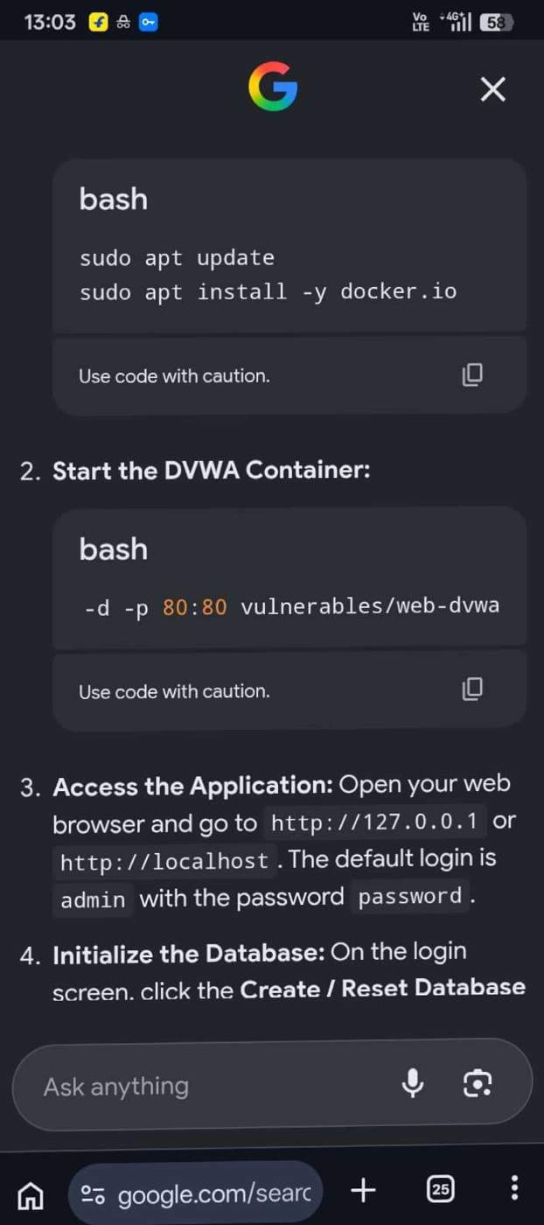

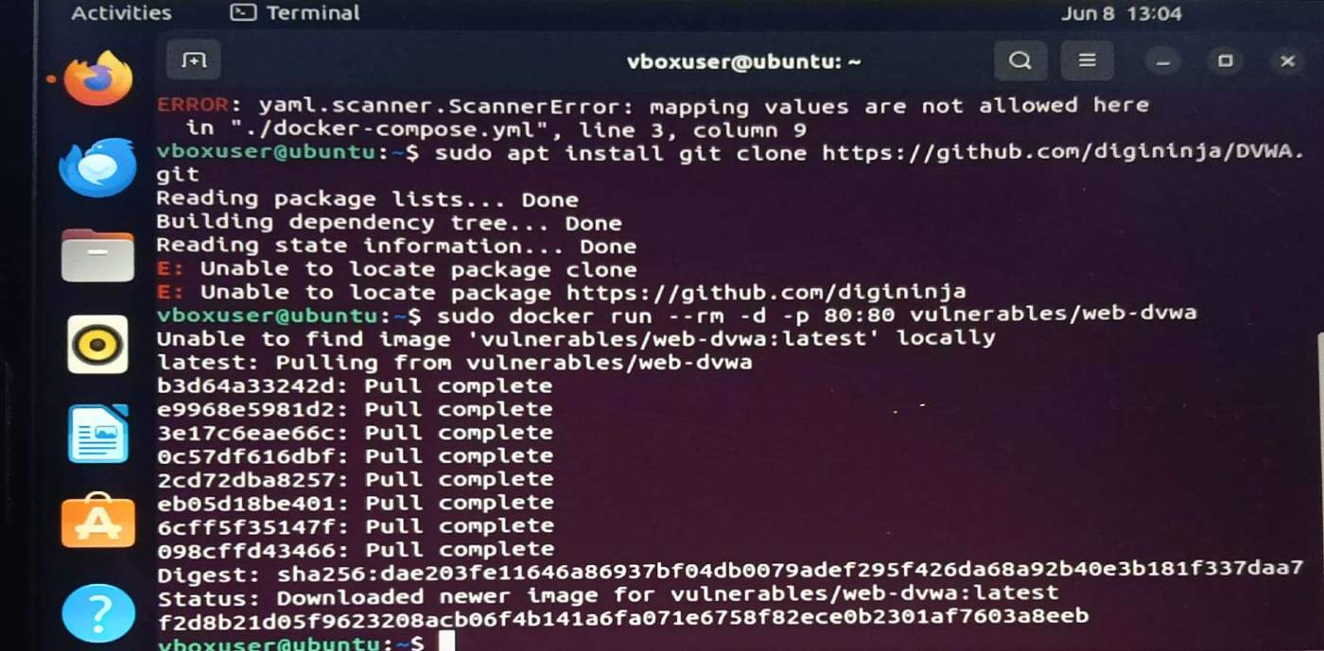

Step 7: Create the docker-compose file — Type: nano docker-compose.yml — then paste in the DVWA Docker configuration (available at github.com/digininja/DVWA). Press Ctrl+X, then Y, then Enter to save.
Step 8: Start DVWA — Type: sudo docker-compose up -d

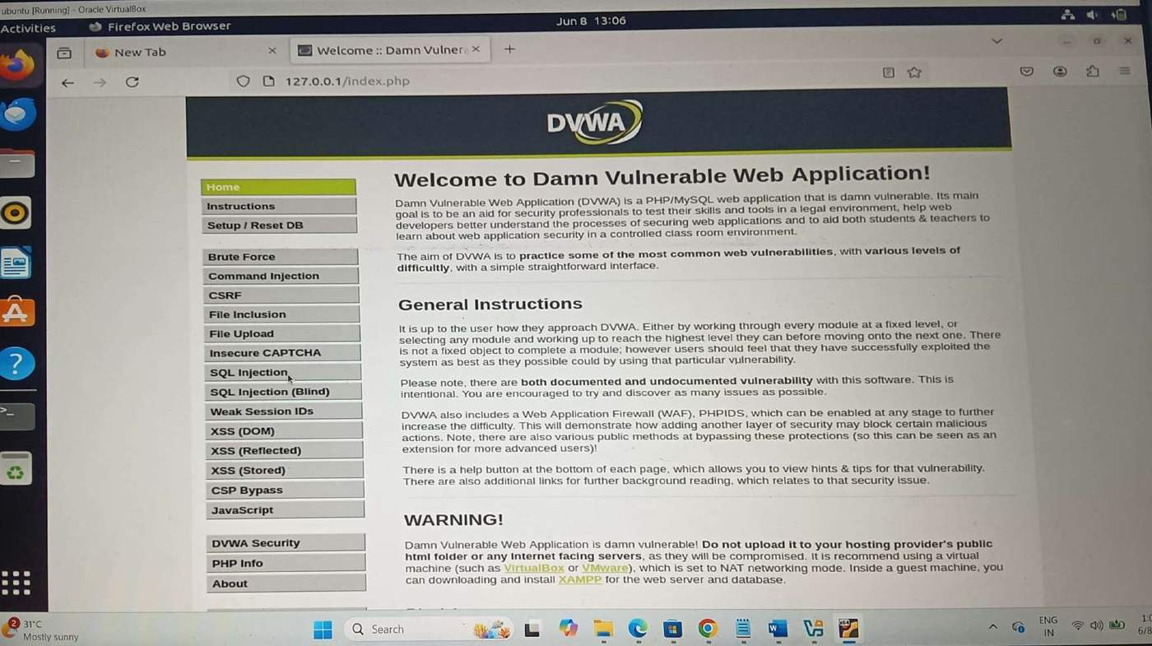

Step 9: Access DVWA — Open the Firefox browser in Ubuntu and go to http://localhost:80. You should see the DVWA login page.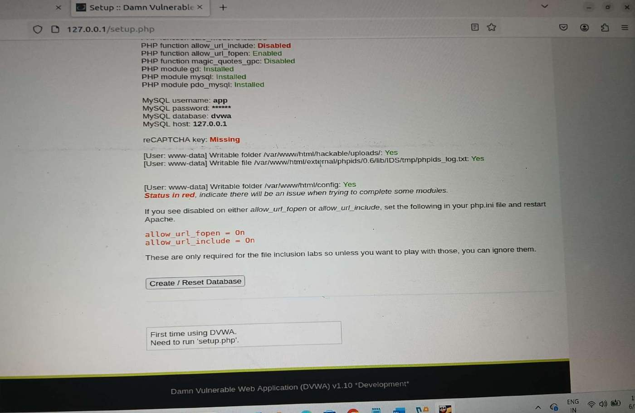

Step 10: Log in — Username: admin | Password: password. Click 'Create / Reset Database' on the setup page.

Phase 4 — Perform an SQL Injection Attack (Test)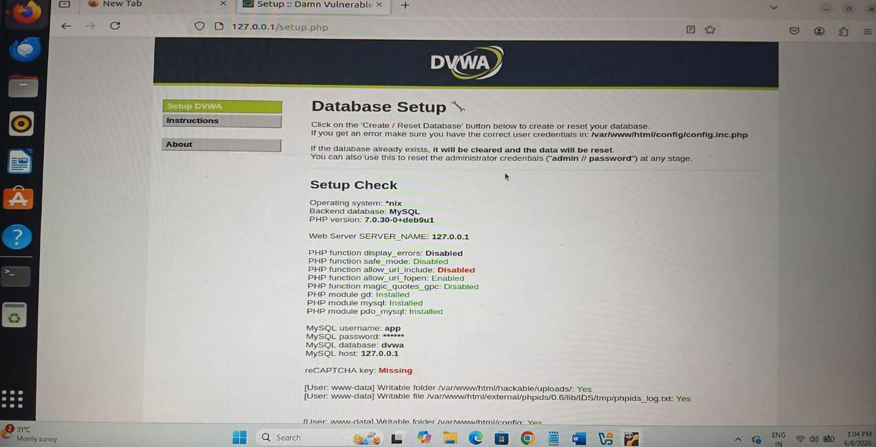
This step simulates what an attacker does. We do this so you can see the attack in the logs — and then block it.

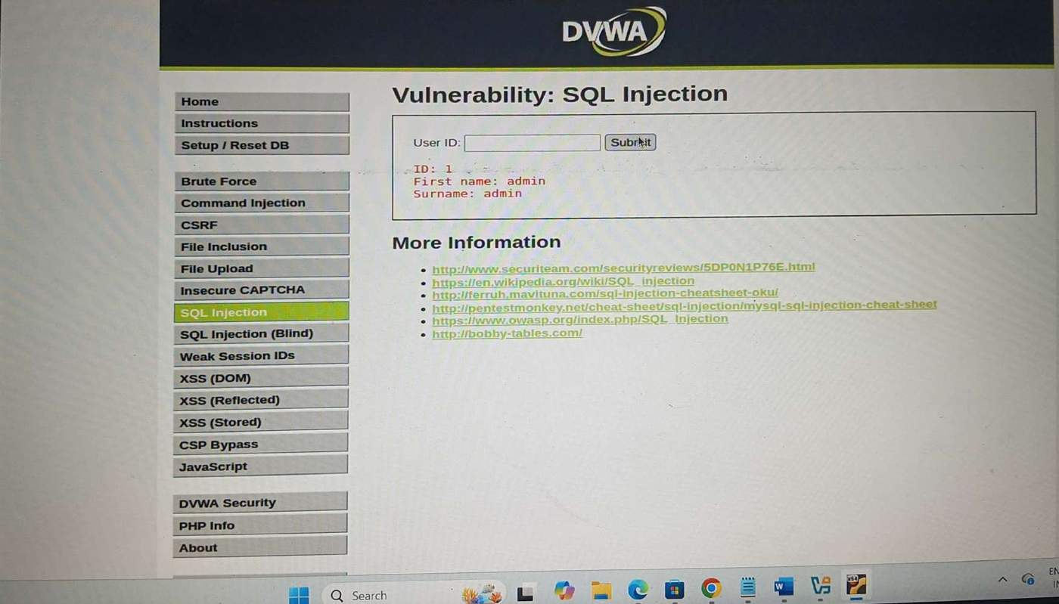

Step 11: Enter a normal input — In the User ID box, type 1 and click Submit. You should see the user's details displayed.

Step 12: Enter a malicious input — Now type the following into the User ID box and click Submit:
1' OR '1'='1

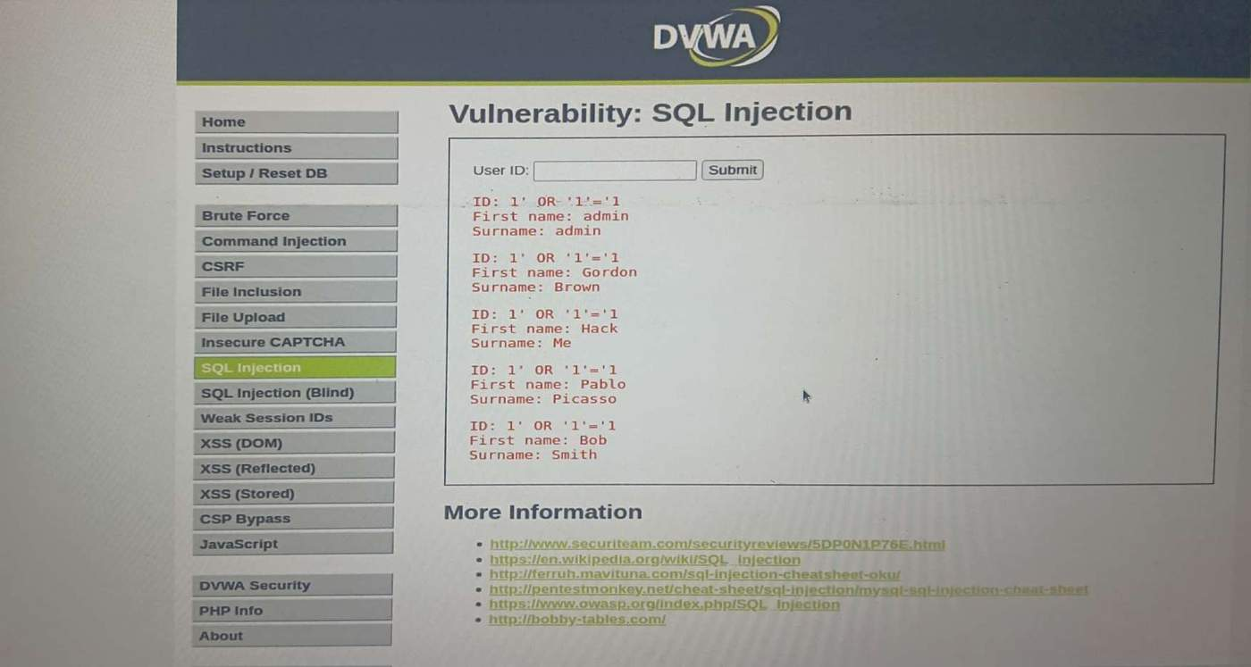

Phase 5 — Install SafeLine WAF
Step 13: Install SafeLine — In the terminal, run:
bash -c "$(curl -fsSLk https://waf.chaitin.com/release/latest/setup.sh)"

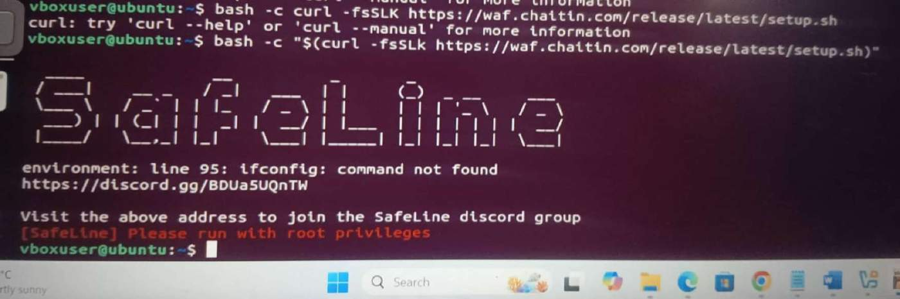

Step 14: Follow the prompts — The installer will guide you through the setup. Accept all defaults for a beginner setup.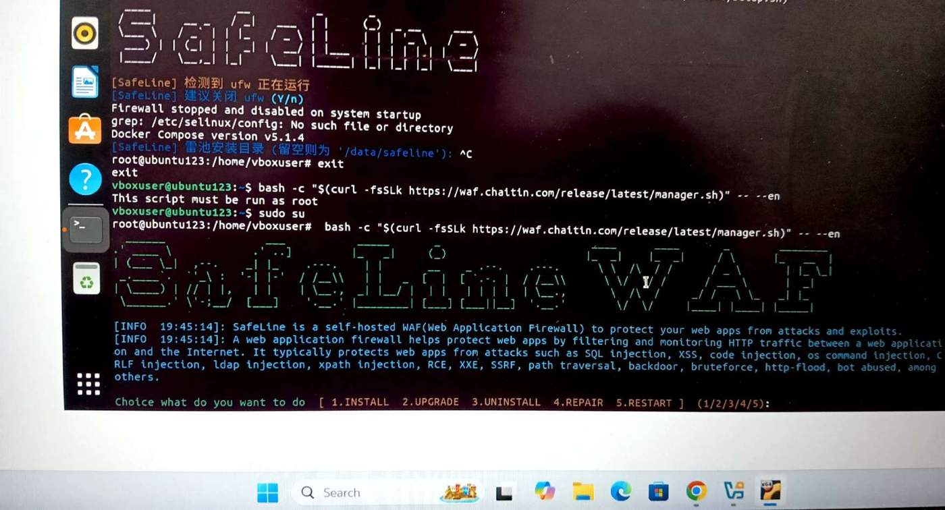

Step 15: Add your site — In the SafeLine dashboard, click 'Add Site' and configure it to protect your DVWA site running on port 80.

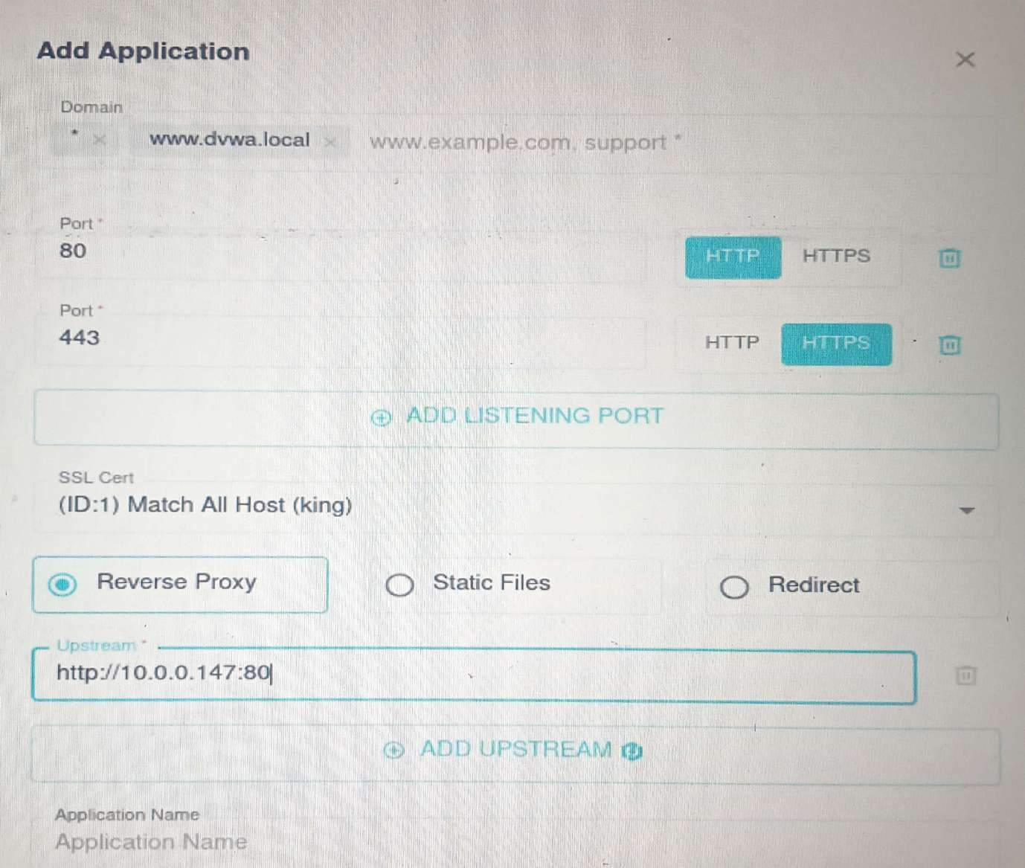

Step 16: Test the WAF — Try the SQL injection from Phase 4 again. This time, SafeLine should block it and you will see a block page instead of results.

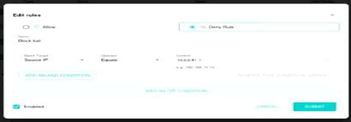

Phase 6 — Configure Rate Limiting
Step 17: Open the Rate Limiting settings — In the SafeLine dashboard, go to the 'Rate Limiting' or 'Anti-Bot' settings.
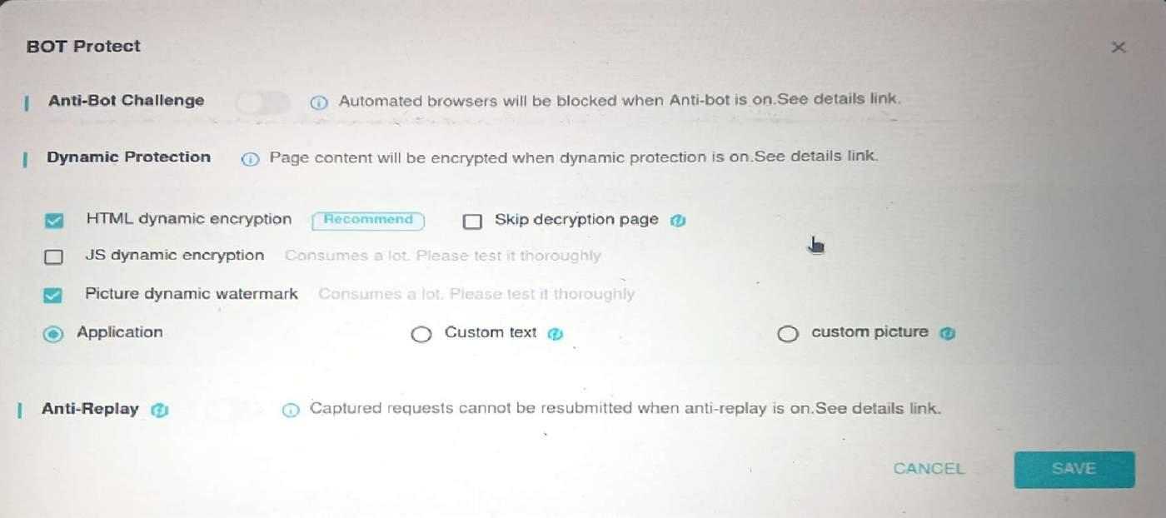

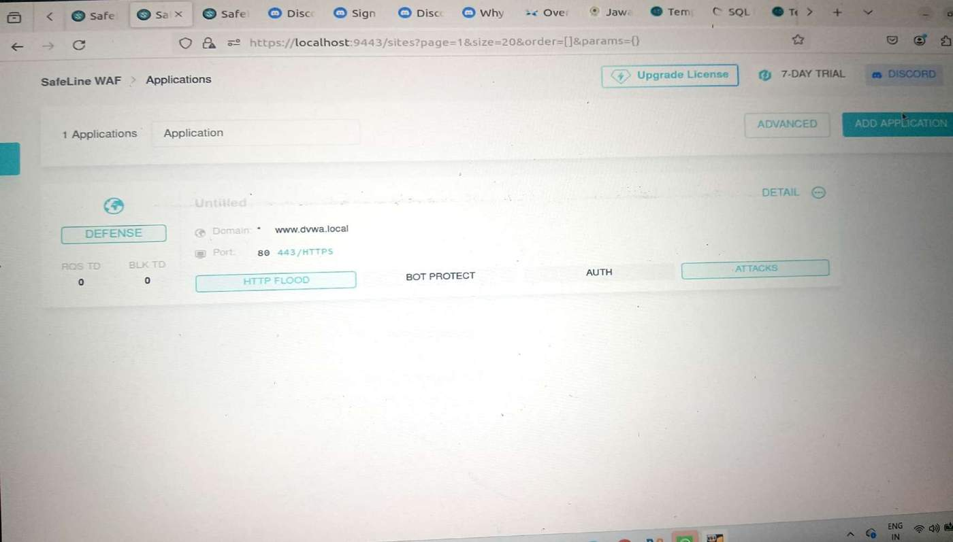

Step 18: Set a limit — Configure a rule that allows no more than 20 requests per second from a single IP address.

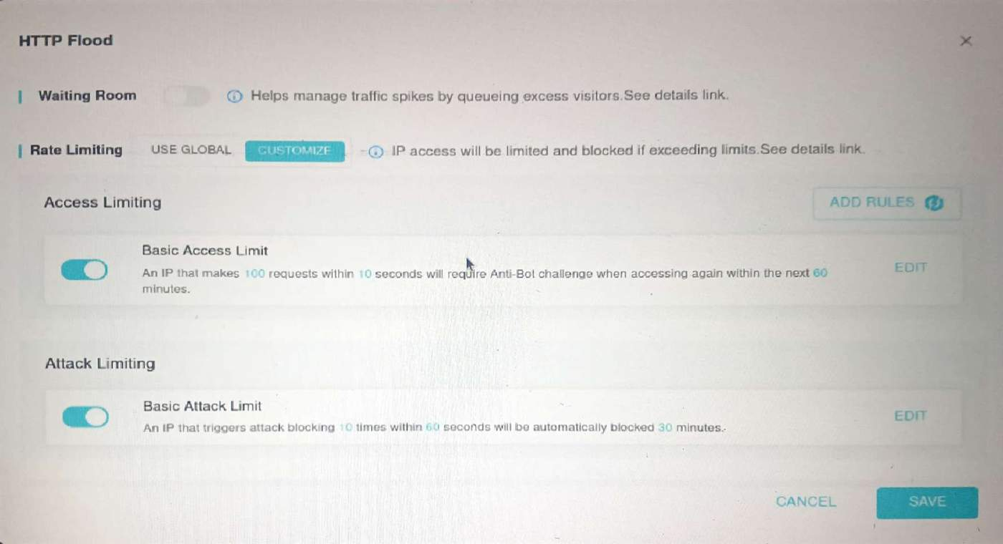

Step 19: Test it — You can simulate rapid requests by refreshing the DVWA page many times quickly, or by using a basic loop command in the terminal.

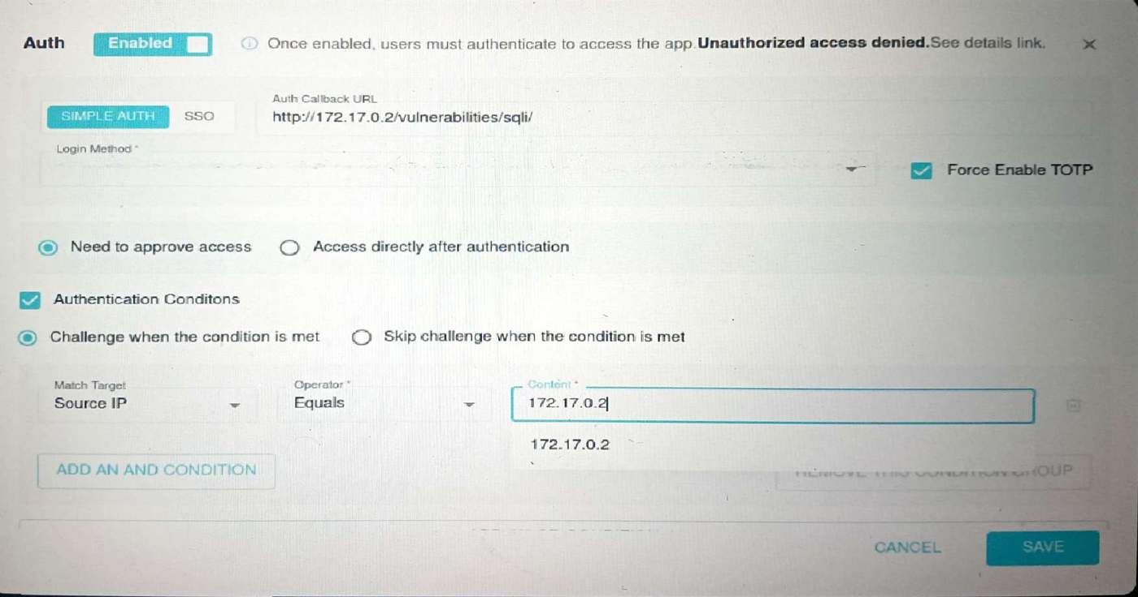

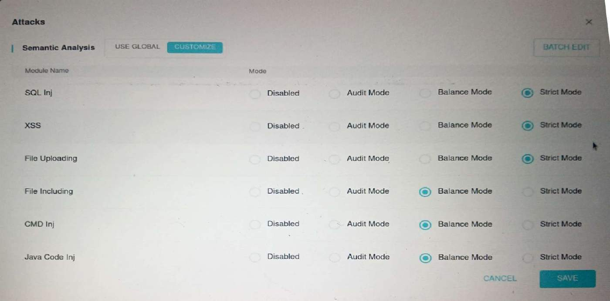

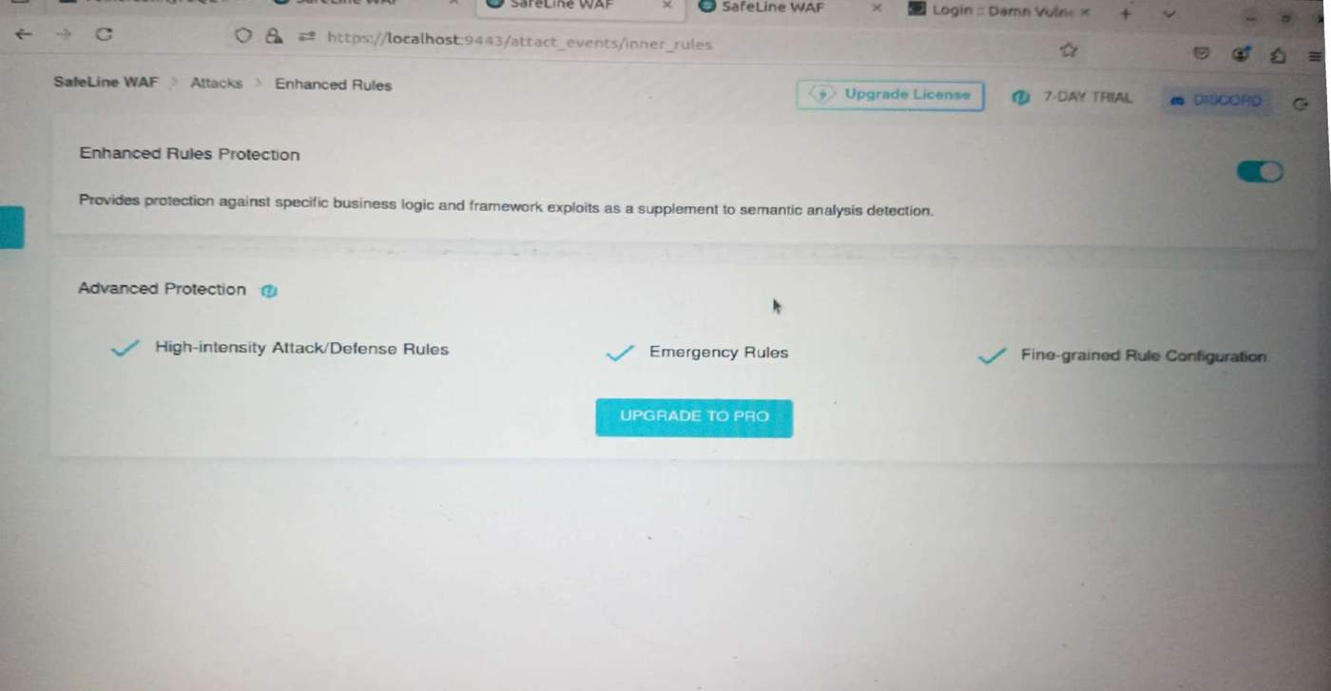

How to Read the WAF Logs
In the SafeLine dashboard, navigate to the 'Events' or 'Logs' section. You will see entries showing:
• The IP address of the attacker
• The time of the attack
• What type of attack was detected (e.g., SQL Injection)
• Whether it was blocked or allowed
What Success Looks Like
• DVWA loads and you can log in
• SQL injection works when the WAF is NOT enabled (it returns all users)
• SQL injection is BLOCKED when the WAF IS enabled (an error or block page is shown)
• The block event appears in SafeLine logs

Conclusion:

This project demonstrates how SQL injection can be used to attack a website and how SafeLine WAF can prevent such attacks. First, a vulnerable website (DVWA) was deployed and tested with an SQL injection attack. SafeLine WAF was then installed and configured to protect the site. After the WAF was enabled, the attack was detected and blocked. This exercise provided practical knowledge of network security, common cyberattacks, and the importance of using WAFs to protect web applications.

