Artificial and Computational Intelligence
Assignment 2
Gaming with Min-Max Algorithm

HRISHIKESH MALAKAR-2023AC05058 Contribution: 100%
SUPRATIM MITRA-2023AC05777 Contribution: 100%
SOMDATTA CHAKRAVARTY-2023AC05746 Contribution: 100%
SARATH S-2023AC05774 Contribution: 100%

PEAS -Gaming with Min-Max Algorithm
Performance | Environment | Actuators | Sensors
Winning: The primary goal of the agent is to connect four pieces of the same color in a row, either horizontally, vertically, or diagonally.  Blocking: The agent must prevent the opponent from connecting four pieces.  Efficiency: The agent should aim to win in as few moves as possible by strategically placing pieces.  Avoiding a Draw: If the board fills up without either player winning, the game ends in a draw, which is a less desirable outcome compared to winning. | Game Board: A 7x6 grid where the agent can drop discs into any of the seven columns.  Opponent: The agent plays against a human player or another AI opponent.  Game Rules: Pieces must be dropped into a column, and they fall into the lowest available space in that column. The goal is to form a line of four consecutive pieces.  Turns: Players alternate turns, and only one piece is dropped per turn.  Terminal States: The game ends when one player connects four pieces or the board is completely filled (draw). | Dropping a Disc: The agent can drop a disc into any valid column (where there's space available). This is the primary action of the agent to influence the game.  Choosing a Column: The agent selects one of the seven columns to place its piece, aiming for an optimal position. | Current Board State: The agent can observe the current positions of all pieces (both its own and the opponent's) on the 7x6 grid.  Valid Moves: The agent observes which columns are valid for placing a piece (i.e., columns that are not yet full).  Opponent’s Last Move: The agent observes where the opponent placed their last piece, which influences the agent's strategy (e.g., blocking a winning move or setting up its own win).  Board Evaluation: The agent evaluates the board to determine potential winning opportunities, blocking opportunities, and the overall state of the game (win/loss/draw).

TASK Environment
Task Environment | Fully VS Partially Observable | Single VS Multi-Agent | Deterministic VS Stochastic | Episodic VS Sequential | Static VS Dynamic | Discrete VS Continuous | Known  VS  Unknown
Gaming with Min-Max Algorithm | Partially | Multi-Agent | Deterministic | Sequential | Static | Discrete | Known
Game Execution (Full board state is there in the ipynb file)
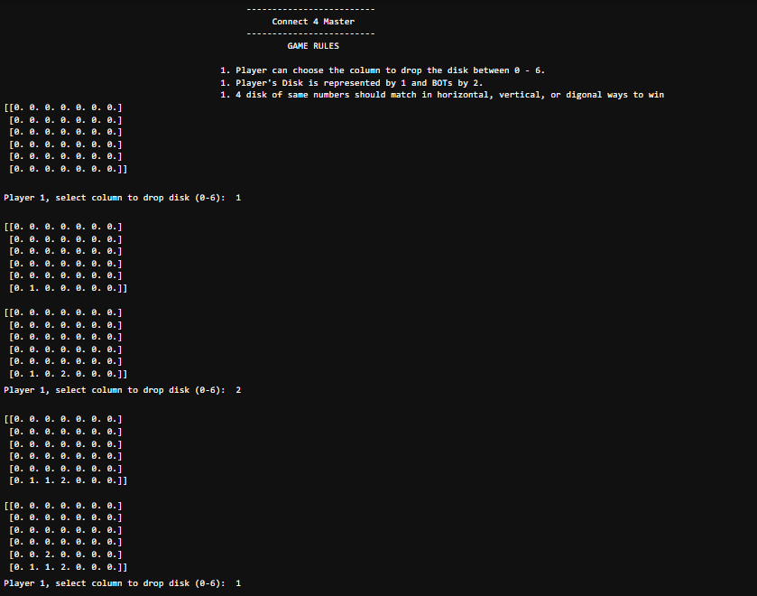
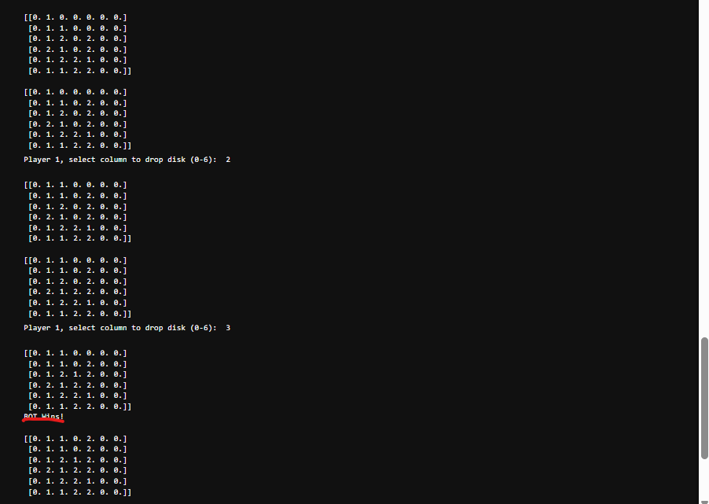

Explanation of Problem number 2

For Problem Statement 2 related to the Pragyan Rover from Chandrayan 3, we need to:

- Create Prolog rules from the provided decision tree to predict whether the rover should measure parameter c0 or c1.
- Take user inputs for the attributes (a0 to a9), and based on the decision tree, dynamically predict and display the result (c0 or c1).

Solution Approach:

We have attached a Prolog solution(decision_tree.pl) based on the provided decision tree and the assignment guidelines. We can implement the rules and interactively take input from the user to predict the class (parameter c0 or c1).

Code Snippet

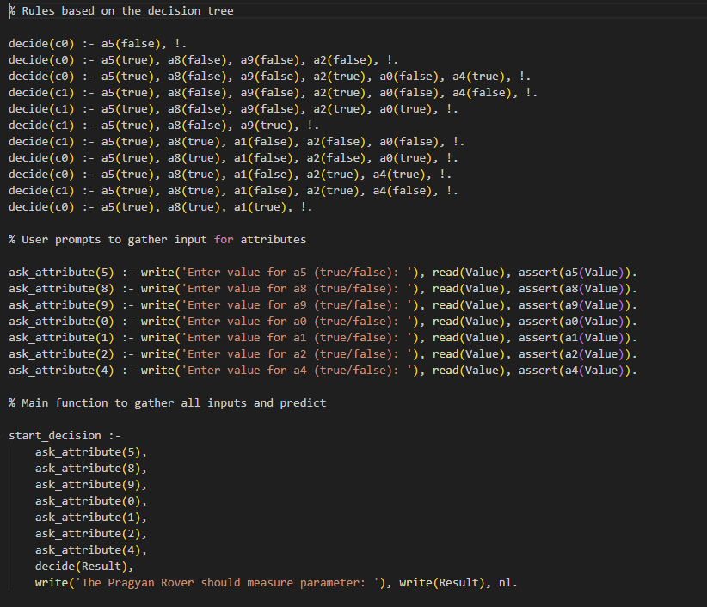

How the Code Works:

Rules:

The decide/1 predicate defines the decision rules based on the decision tree provided in the guideline document. It processes the attributes (like a5, a8, a9, etc.) to predict the parameter (c0 or c1).

User Input:

The ask_attribute/1 predicate prompts the user for input values (true/false) for each attribute.
The user enters either true or false, and Prolog asserts this as a fact in the knowledge base.

Prediction:

The start_decision/0 predicate gathers input for all relevant attributes and makes the decision based on the decision tree.

Steps to Implement and Test:

- Install SWI-Prolog if you haven't already, from SWI-Prolog.

- Save the code as a Prolog file (decision_tree.pl).

- Load the file in SWI-Prolog by running:

?- ['decision_tree.pl'].

Run the decision-making process:

?- start_decision.

Sample Output:
