**Artificial and Computational Intelligence**

**Assignment 1**

**Blood Supply Vehicle Agent**

**HRISHIKESH MALAKAR-2023AC05058 Contribution: 100%**

**SUPRATIM MITRA-2023AC05777 Contribution: 100%**

**SOMDATTA CHAKRAVARTY-2023AC05746 Contribution: 100%**

**SARATH S-2023AC05774 Contribution: 100%**

**PEAS -Blood Supply Vehicle Agent**

|  |  |  |  |
| --- | --- | --- | --- |
| **Performance** | **Environment** | **Actuators** | **Sensors** |
| Minimize the total travel distance while visiting all blood bank only once.  Minimize the time taken to compute the optimal path and the number of nodes explored during the search process. | Blood Banks  Hospital  Edges represent the paths between them with associated travel cost. | Movement of agent from one node to another along the edges.  The movement is deterministic and follows the path with the least cost(distance). | Detection of current location within the graph.  Detection of immediate neighbouring nodes.  The cost associated with moving to each.  Availability of blood at other banks. |

**TASK Environment**

|  |  |  |  |  |  |  |  |
| --- | --- | --- | --- | --- | --- | --- | --- |
| **Task Environment** | **Fully VS Partially Observable** | **Single VS Multi-Agent** | **Deterministic VS Stochastic** | **Episodic VS Sequential** | **Static VS Dynamic** | **Discrete VS Continuous** | **Known**  **VS**  **Unknown** |
| **Blood Supply Vehicle Agent** | Partially | Single | Deterministic | Sequential | Static | Discrete | Known |

**Screenshots of code execution**

1. Setting initial state

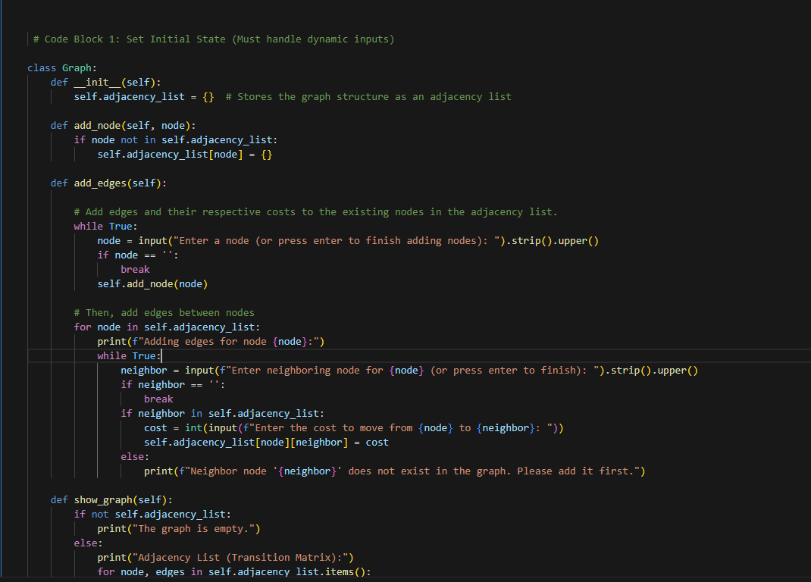

1. **Setting the matrix/list with edges weights**

1. **Transition state and goal node**

1. **BFS definition**

**3. IDA* definition**

1. **Dynamic input**

**6.Calling BFS**

**7 Calling IDA\***

**8.Comparative analysis**

