Assignment 11: Ethernet and Arp

210010020

1. What is the 48-bit Ethernet address of your computer?

A] c4:41:1e:75:b1:52

2. What is the 48-bit destination address in the Ethernet frame? Is this the Ethernet address of gaia.cs.umass.edu? What device has this as its Ethernet address?

A] 00:1e:c1:7e:d9:01. This is address of next hop router, to which the device is connected.

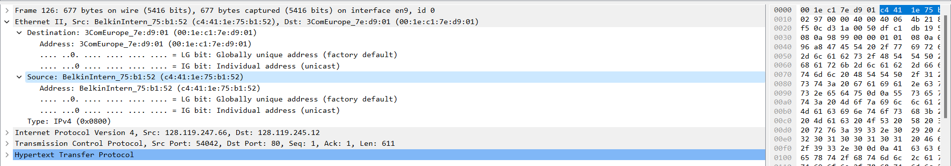

3. What is the hexadecimal value for the two-byte Frame type field in the Ethernet frame carrying the HTTP GET request? What upper layer protocol does this correspond to?

A] Type 0x800, Upper layer protocol: IPv4

4. How many bytes from the very start of the Ethernet frame does the ASCII “G” in “GET” appear?

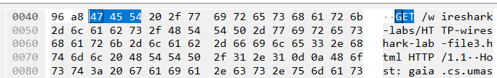

Initializing from 0 ‘G’ appears in address 66 bytes.

5. What is the value of the Ethernet source address? Is this the address of your computer, or gaia.cs.umass.edu? What device has this as its Ethernet address?

A] 00:1e:c1:7e:d9:01. No not of computer / gaia.cs.umass.edu but of router.

6. What is the destination address in the Ethernet frame? Is this the Ethernet address of your computer?

A] c4:41:1e:75:b1:52 . Yes of computer capturing the wireshark trace.

7. Give the hexadecimal value for the two-byte Frame type field. What upper layer protocol does this correspond to?

A] 0x800. Upper layer Protocol: IPv4

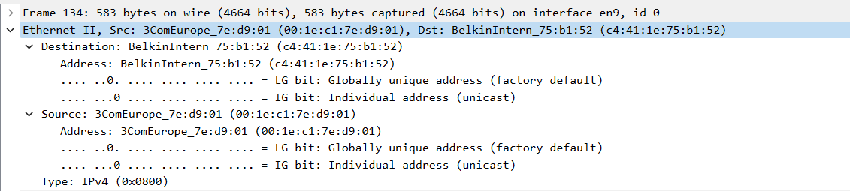

8. How many bytes from the very start of the Ethernet frame does the ASCII “O” in “OK” appear? After how many bytes in the HTTP does the “O” in “OK” appear?

A] 13 bytes initializing from 0 from start of the HTTP.

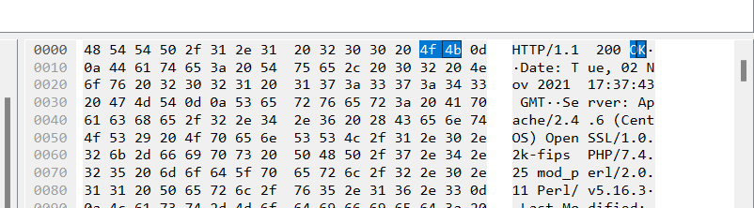

After 79 bytes , O appears in the Ethernet frame.  
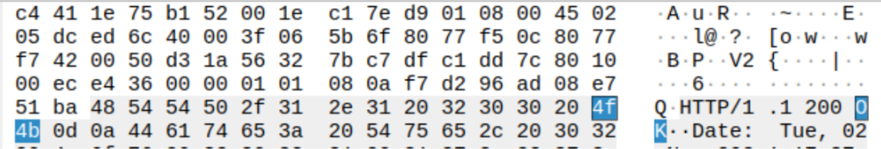

9. How many Ethernet frames (each containing an IP datagram, each containing a TCP segment) carry data that is part of the complete HTTP “OK 200 ...” reply message?

A] 4 Ethernet frames as seen in the reassembled TCP segment.

**Part-2: The Address Resolution Protocol:**

A1]

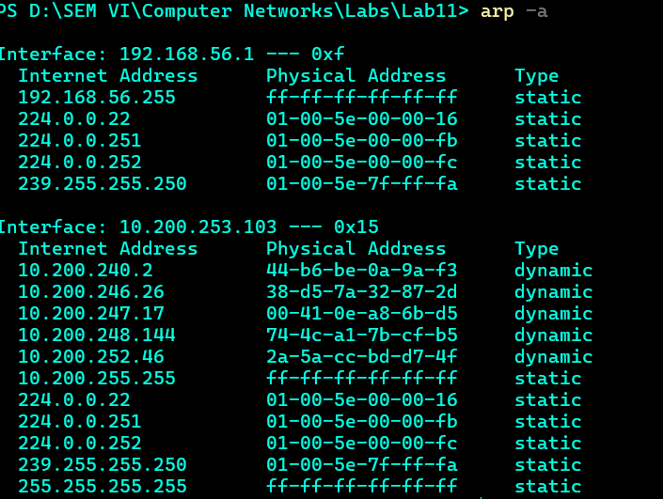

16 entries stored in the arp cache.

A2] Each entry consists of IP to physical address mapping along with the Type.



A3] Source address: c4:41:1e:75b:b1:52. This corresponds to address of my system. This is address of client.

A4] The hexadecimal value of the destination address in an Ethernet frame containing the first ARP request is typically ff:ff:ff:ff:ff:ff. [This address is known as the broadcast address, which means that the ARP request is sent to all devices on the local network segment](https://edisciplinas.usp.br/pluginfile.php/3548487/mod_resource/content/0/EP2%20-%20Gabarito%20-%20Ethernet%20e%20ARP.pdf).

A5] Hexadecimal value is 0x0806 and upper layer protocol is ARP.



A6] Begins after 20byte from beginning of ethernet frame.

A7] The value of the opcode field within the ARP request message sent by computer is 1.

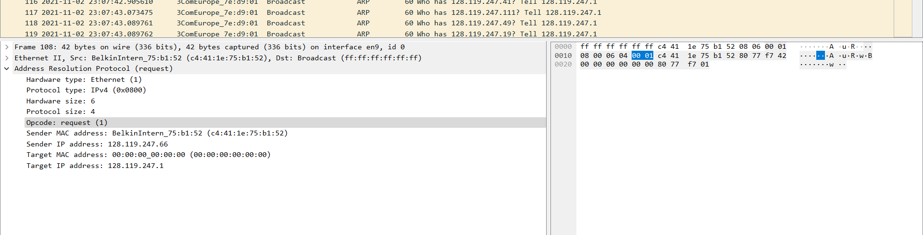

A8] Yes . contains sender IP address = 128.119.247.1

A9] Sender IP address as above.

A10] Opcode field reply =2

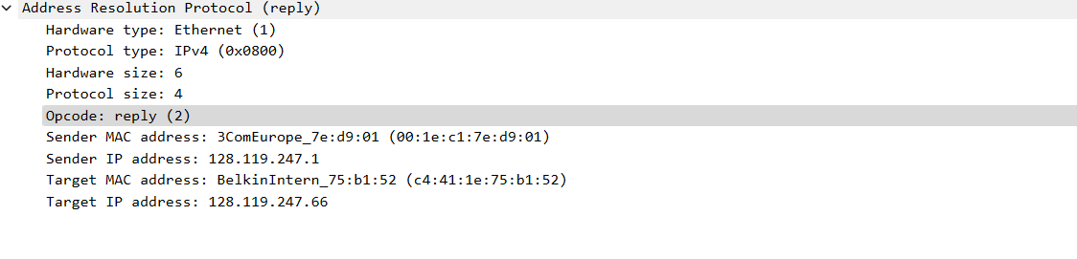

A11] Ethernet address corresponding to the IP address that was specified in the ARP request message sent by computer is  00:1e:c1:7e:d9:01

Screenshot as above.

A12] We cannot find reply messages in the trace since they were broadcasted . However, the reply will only be sent to the device that requested it. As a result, this trace does not include all of the answers.