# Assignment 3: HTTP

# Name: Hrishikesh Ravindra karande

# Roll no: 210010020

Part1:

1. Browser is running HTTP version 1.1 and server is also running on version 1.1.
2. Language Accepted en-US,en.
3. IP Address of Computer: 10.196.106.44

IP Address of server : 128.119.245.12

1. Status code returned from server to browser is 200.
2. Last Modified: Tue, 16 Jan 2024 06:59:02 GMT
3. The entire packet length is = 540 but the content length = Content-Length: 128.
4. No, all the headers can be found in raw data.

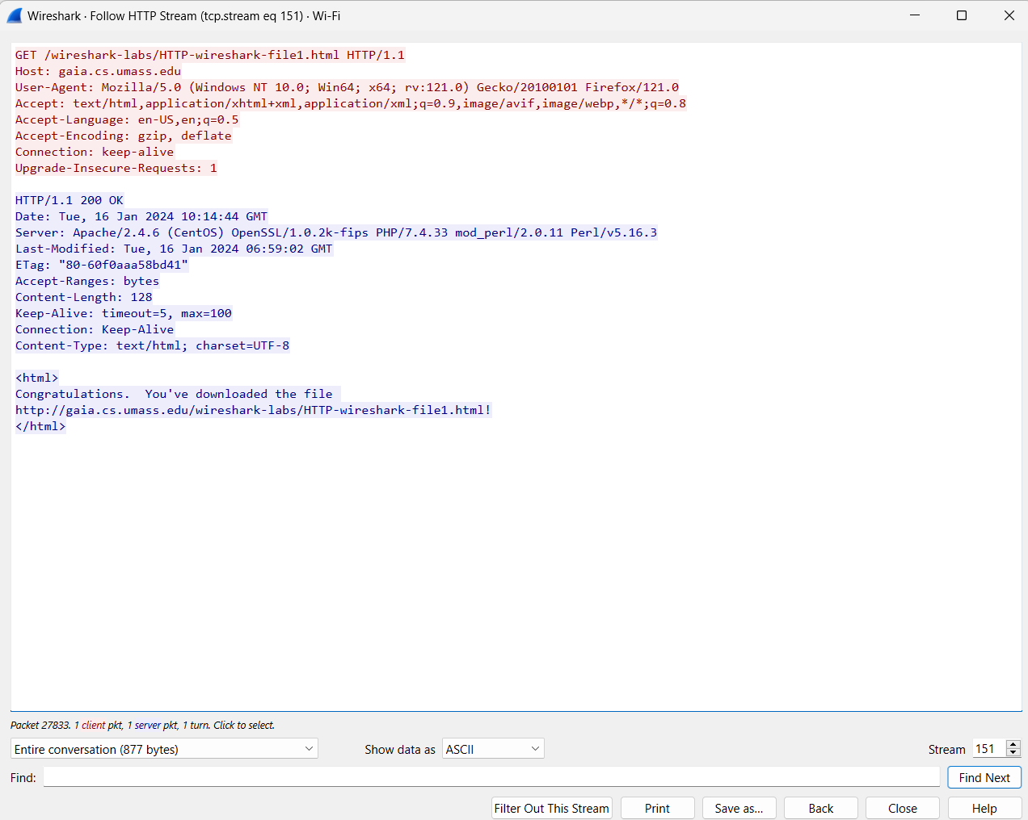

Part 2

1. Yes **IF-MODIFIED-SINCE** field can be seen.

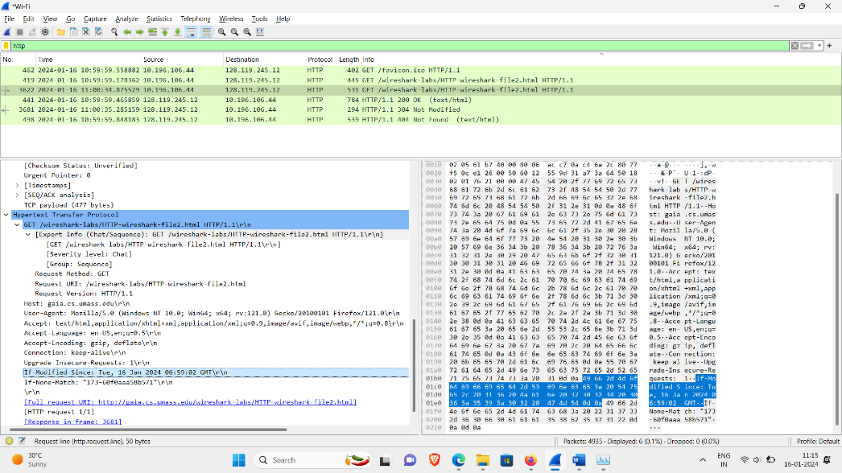

1. Yes, the server explicitly returns the contents of the file.

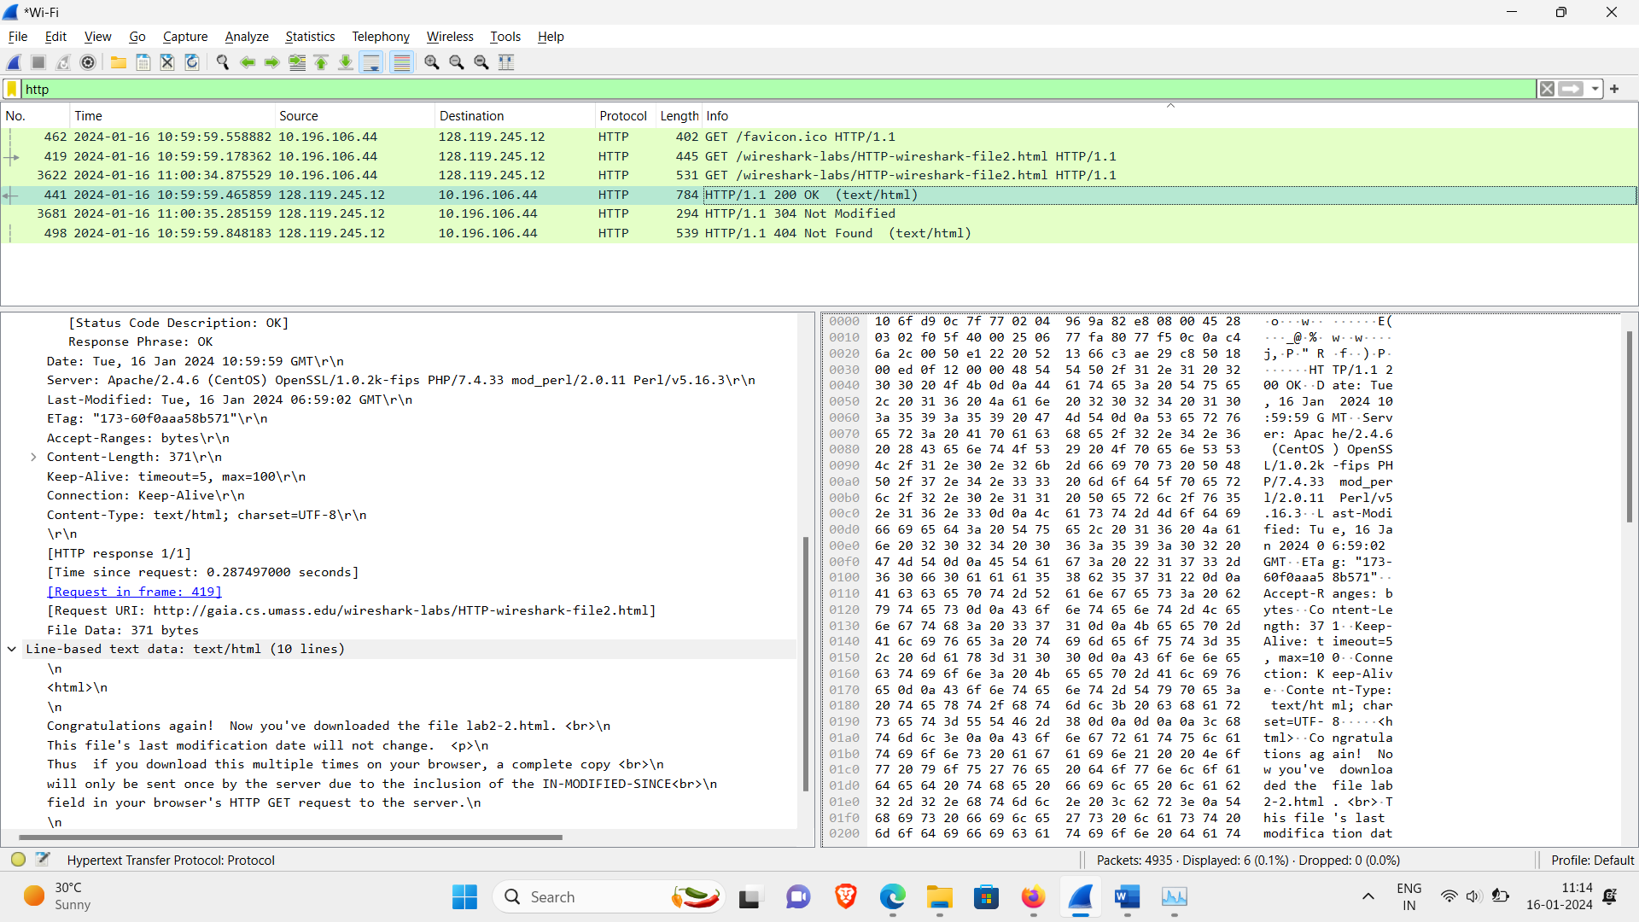

1. Yes we get a **IF-MODIFIED-SINCE** after accessing it for second time**.** This is header field which represents whether the source is modified by the server after the last time it was accessed by our machine. Since we are accessing the same resource twice (by refreshing) and in that interval there was no change in the the website the IF-MODIFIED-SINCE header is not displayed.
2. The status code returned was 304 by the server and this time the content was not explicitly returned. The **HTTP status code 304** means **Not Modified** – the web page you requested hasn’t changed since the last time you accessed it.

The file has not been modified! So the text of the file is NOT returned in the HTTP message.

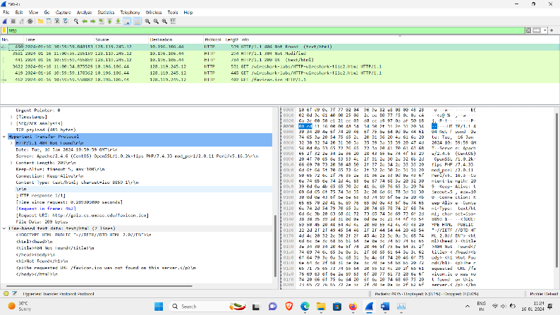

**Part 3:**

1. There is 1 GET Message in the packet listing window. Packet No. with the GET request 214.
2. Response code is 200 and Packet No. is 217.
3. In Response Status code is 200 and phrase is OK.
4. Total 4 TCP segments were required to carry the HTTPS request. The segment count is displayed here.

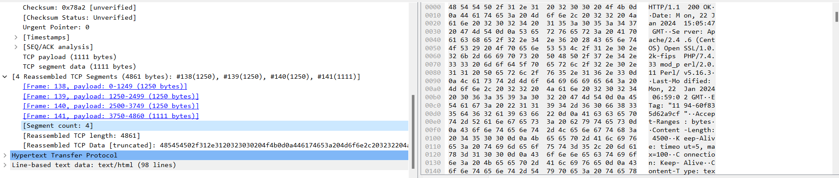

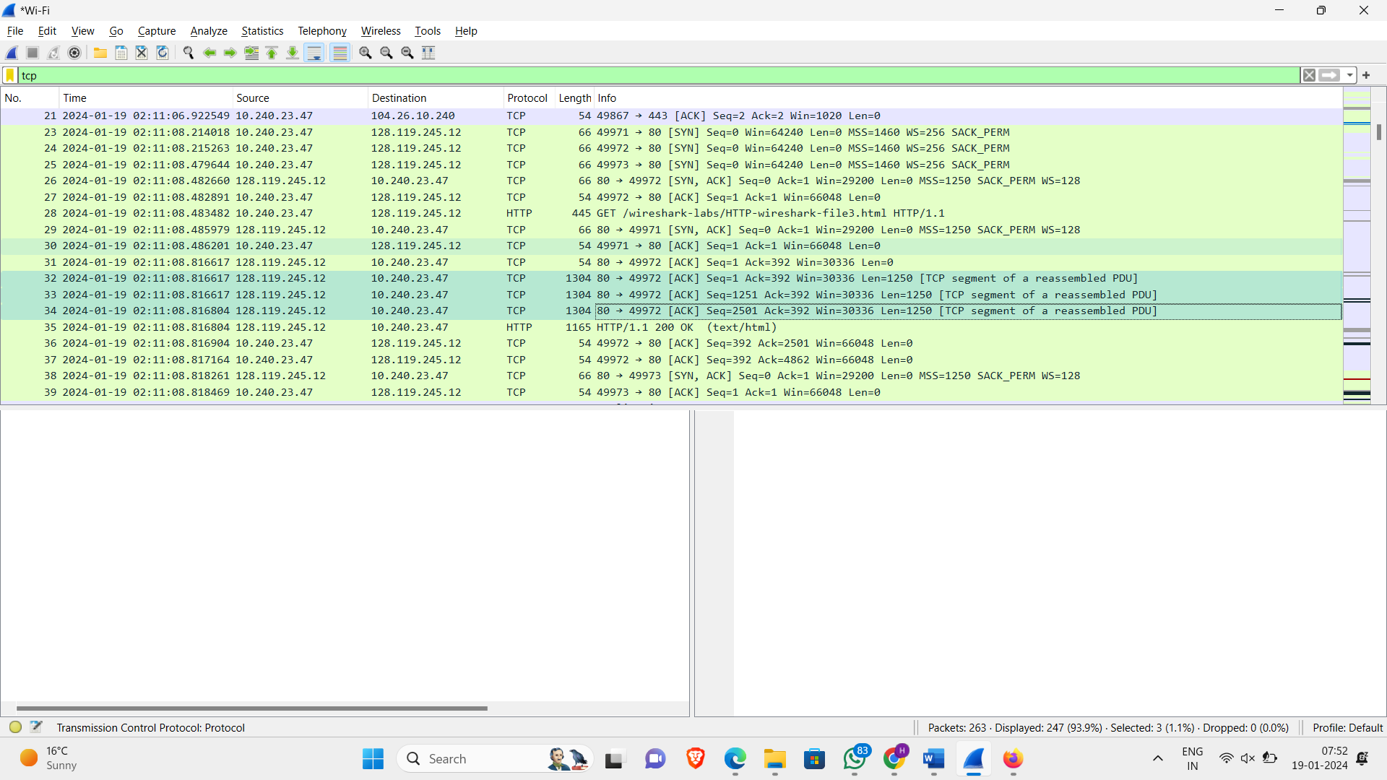

Part4:

1. There were 3 HTTP Get messages sent two at the same IP address and 1 at different by packet numbered 10,34,86 respectively. Packet 10,34 was sent at Destination IP of 128.119.245.12(Address of Page & pearson.png) whereas packet 86 was sent at 178.79.137.164(8E_cover_small.png).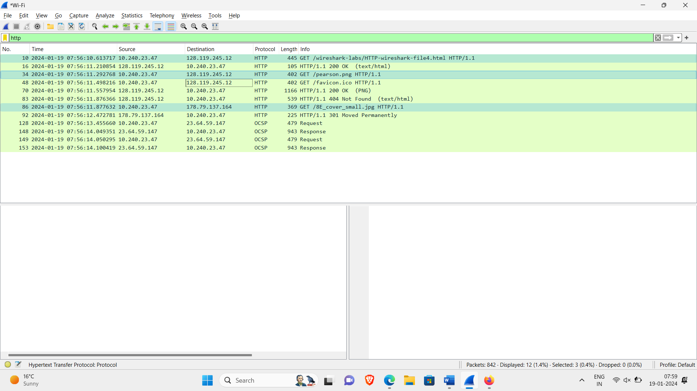
2. The two images were serially downloaded this can be seen from the screenshot attached above where unless the first one returned an OK the request for the next image was not sent. We can cross verify this by the time stamps also.

Part 5:

1. There are two http get messages one at 488 and other at 1517. The first (488) is entered without authorization whereas the second is after entering the given username and passwords. The response code for first request is in packet 518 with status code 401 and phrase as Unauthorized.
2. When two packets were compared there was an authorization field in the second packet to which we had entered the username and password, whereas it wasn’t present for the first one. This can be seen in the screenshot attached below the right side is second packet and left side is of first packet.

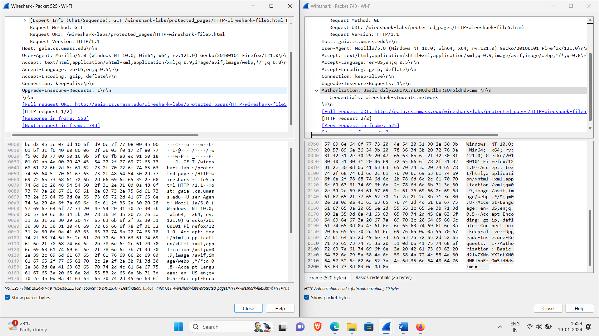

Notes:

Part 4: What does moved permanently signify?

A **301 Moved Permanently** is an [HTTP response status code](https://developer.mozilla.org/en-US/docs/Web/HTTP/Status) indicating that the requested resource has been permanently moved to a new URL provided by the Location response header. The 3xx category of response codes are used to indicate redirection messages to the client, such that the client will become aware that a redirection to a different resource or URL should take place.