# Assignment 5: TCP

# Hrishikesh Ravindra Karande

Part1

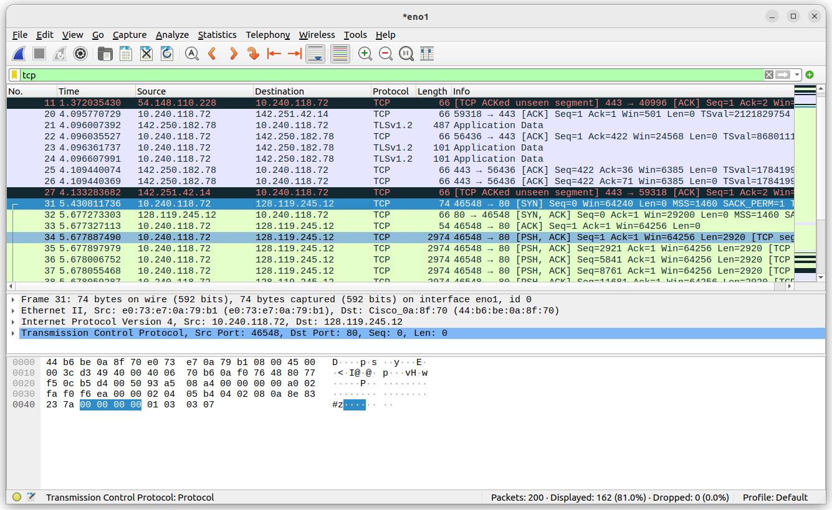

Part2

1. Client IP Address:10.240.118.72 Port: 46548

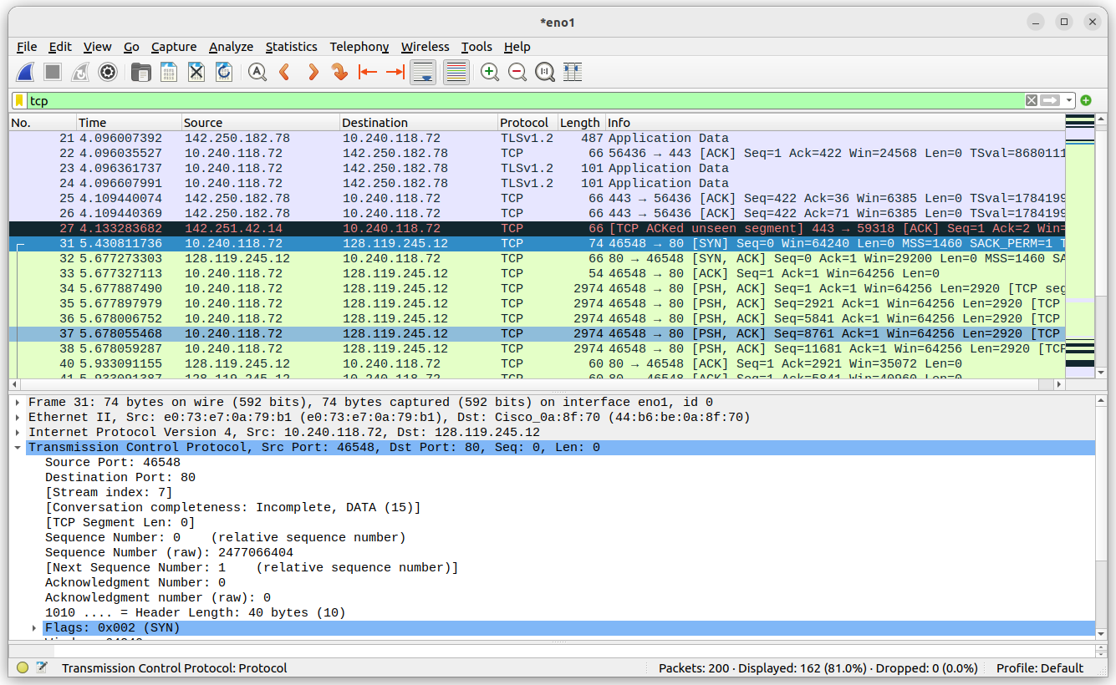

2)IP Address of gaia.cs.umass.edu: *128.119.245.12*, port number is *80.* This can also be seen in the screenshot of above question.

Part3:

Q1) Sequence number = 0. The Flags in this segment help to identify it is SYN packet.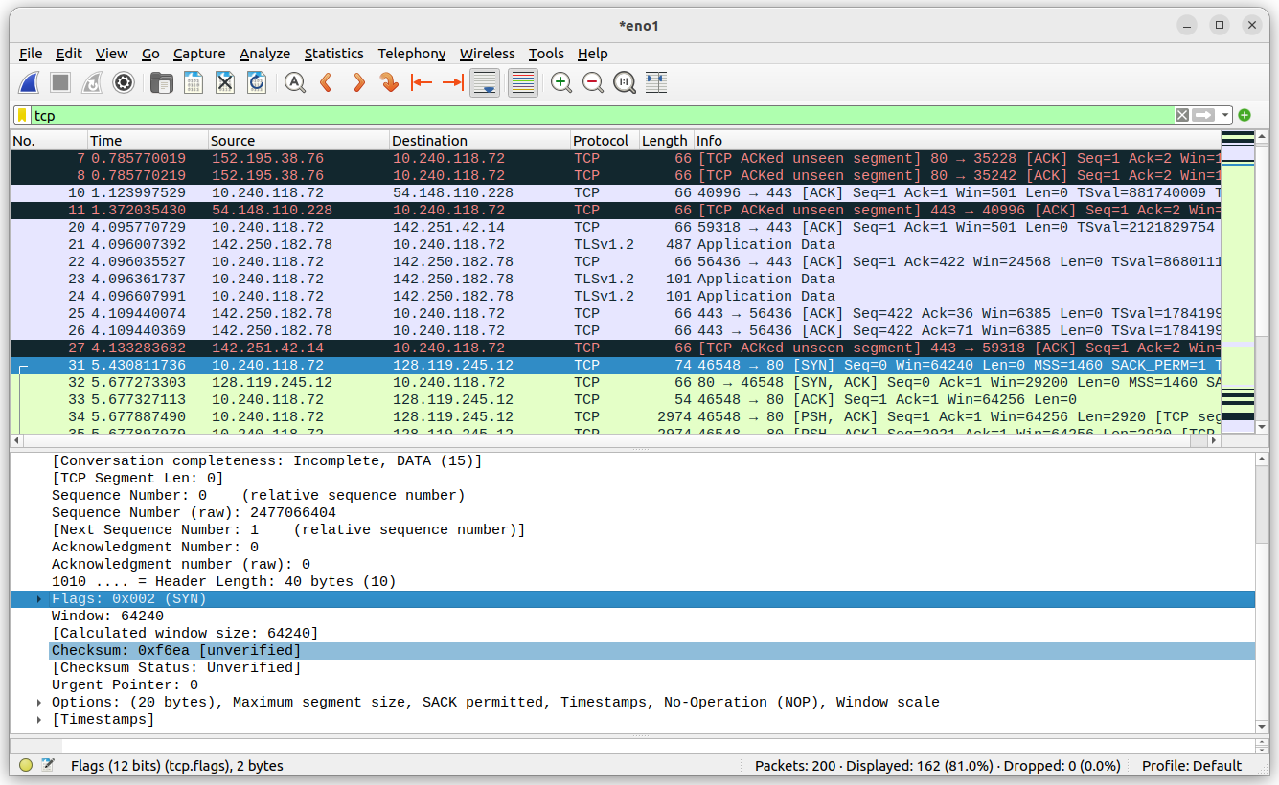

Q2) Sequence Number of SYN ACK segment = 0

The value of Ack field is determined by gaia.cs.umass.edu by adding 1 to the previous SYN Segment from client computer. The packet is identified as SYN-ACK by the value of SYN and ACK flags which is

set to 1 .

Q3) The sequence number of the TCP segment containing the header of the HTTP POST command is 1. The Payload field of request contains 1250 bytes of data. All the data from Alice.txt is not transferred in a single request.

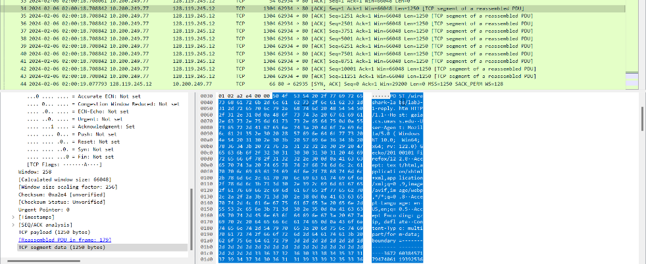

Q4) i) The first segment containing the HTTP Post was sent at this time: 02:00:18.708842.

ii)The first ack was received at Time : 02:00:19.077793

iii) The RTT for the first Data containing segment is: 0.368951000s

iv) The RTT for the second Data containing segment is: 0.368951000s

Q5) First 5 TCP segments have payload = 1250bytes + headers = 20bytes so total length of 1270bytes.

Q6) The minimum window size ranges from 5840 to 6870 bytes of data. The receiver window grows from min to mac in buffer. The sender is never throttled due to lacking of receiver buffer space by inspecting this trace. If there is retransmission then it should display In info window and also plot the packet numbers. Also the packet number are monotonically increasing order.

Q7) There are no retransmitted segments in the trace file, this can be concluded after analyzing from the TimeSequence Graph found using **Statistics > TCP StreamGraph > Time-Sequence Graph (tcptrace)**. We can observe that the packet number continuously increases , if there was any retransmission of packet trend could not be observed.

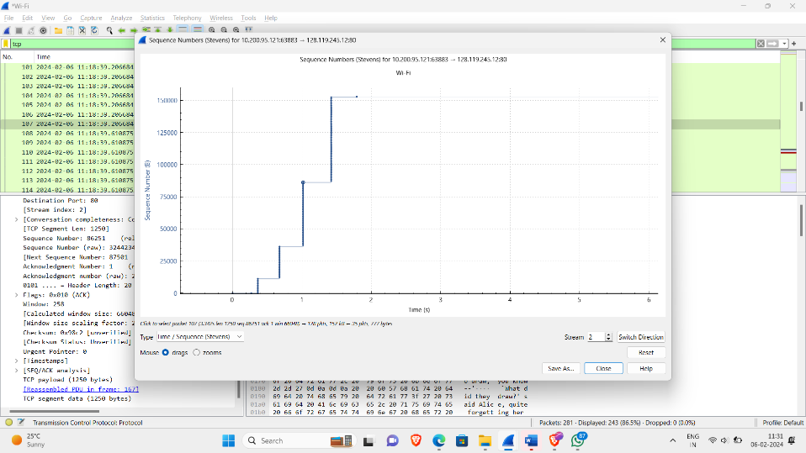

Q8) The data acknowledge can be obtained by difference in the Ack numbers.

I have received total of 123 segments from 26 to 167, therefore data transferred equal to 3750 bytes. In my case the receiver is acking every other segment. The difference in consecutives acks send by receiver is different.

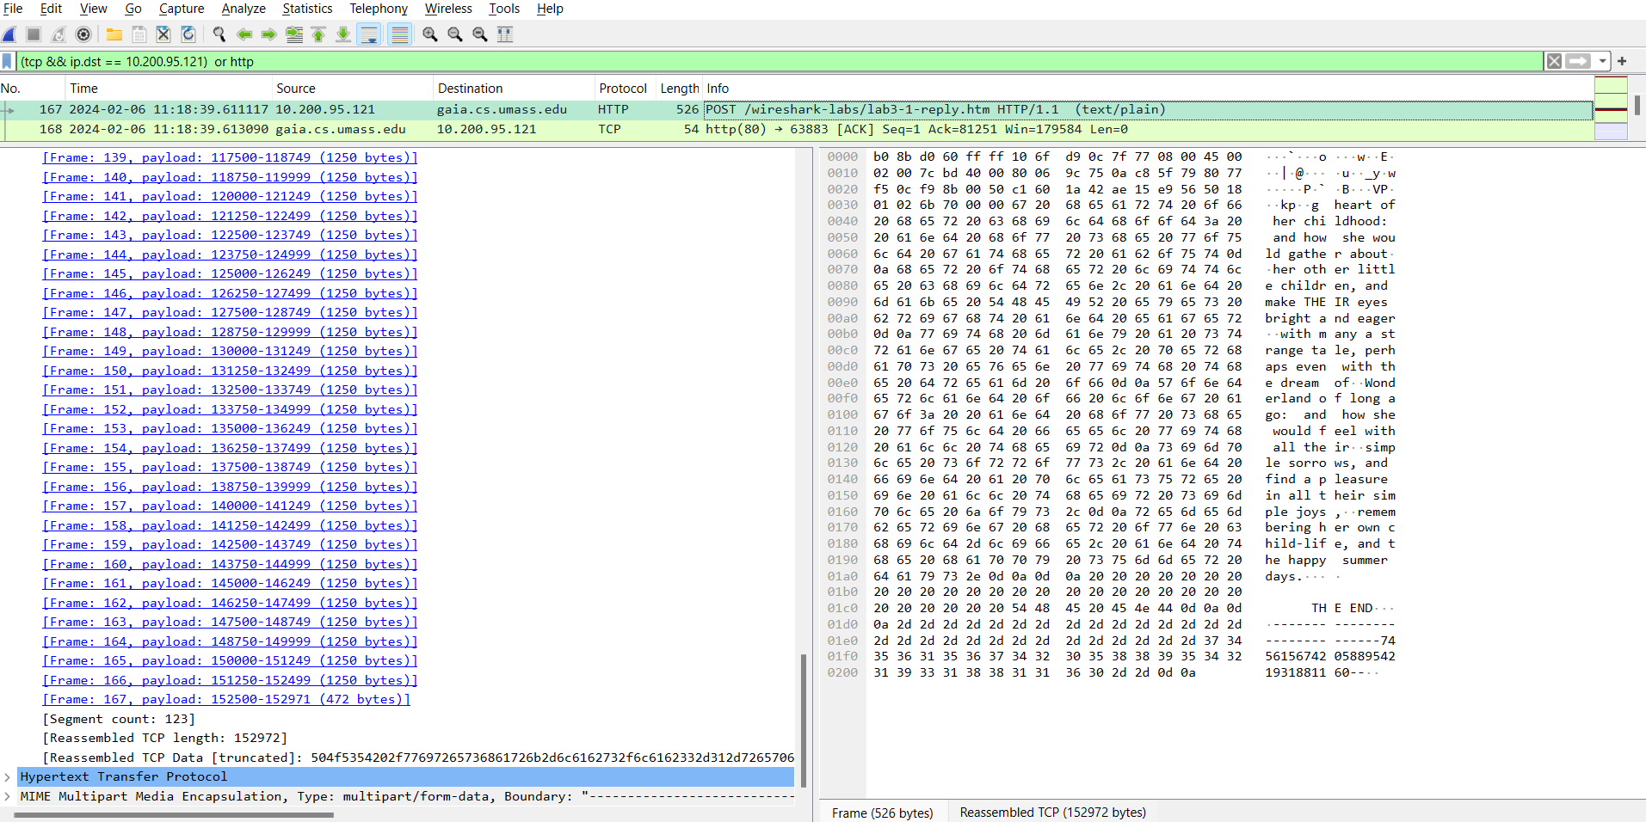

Q9) Average throughput is the total payload over the entire session divided by the total time.  Total time is calculated by taking the difference in timestamps between the first and last packet.

Apply http filter select follow TCP stream then find the first packet which includes the POST. To find the last packet search in trace for [ACK,FIN] after OK is received get the sequence number and time of last packet

First TCP Segment Ack number = 1

First TCP Segment Time = 11:18:38.460210

Last TCP Segment Ack number = 152974

Last TCP Segment Time = 11:18:44.932829

Throughput = (152974-1)bytes/( 6.784199)seconds = 23.66 KBytes/sec

Part4

1. The slow start is in the beginning of the packet transfer until 2.69s then as the packets are received successfully at the other end the window size increases exponentially. It should increase until congestion but there is no congestion observed here. Therefore it end phase is when all the data is completely transmitted.

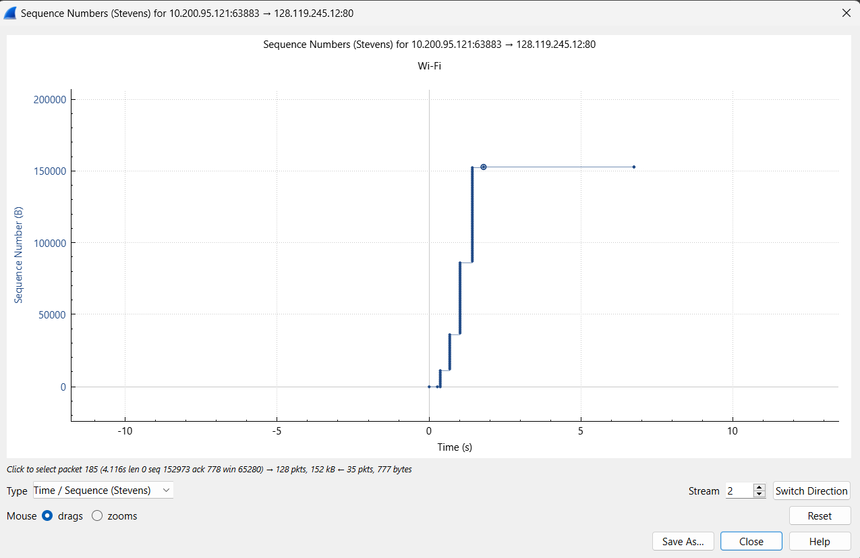

Notes:

1. calculated Window size = Window size * Scaling Factor
2. Next Sequence Number = Prev Sequence num + len

In case of Packet Loss the next sequence number calculated is not same as next sequence number observed.

1. To add a new column in wireshark window select the field in packet listing window(bottom right ) then select Apply as column.