## Assignment 6: UDP and Socket Programming

## Hrishikesh Ravindra Karande 210010020

Part1:

Q1] Select the first UDP segment in your trace. What is the packet number of this segment in the trace file? What type of application-layer protocol message is being carried in this UDP segment? Look at the details of this packet in Wireshark. How many fields are there in the UDP header? What are the names of these fields?

A] Packet Number or Frame Number of first UDP Segment is 27.

The Destination Port number is 53, this indicates that it is carrying DNS Protocol.

There are 4 Fields in UDP Header Source Port, Destination Port, Length and Checksum.

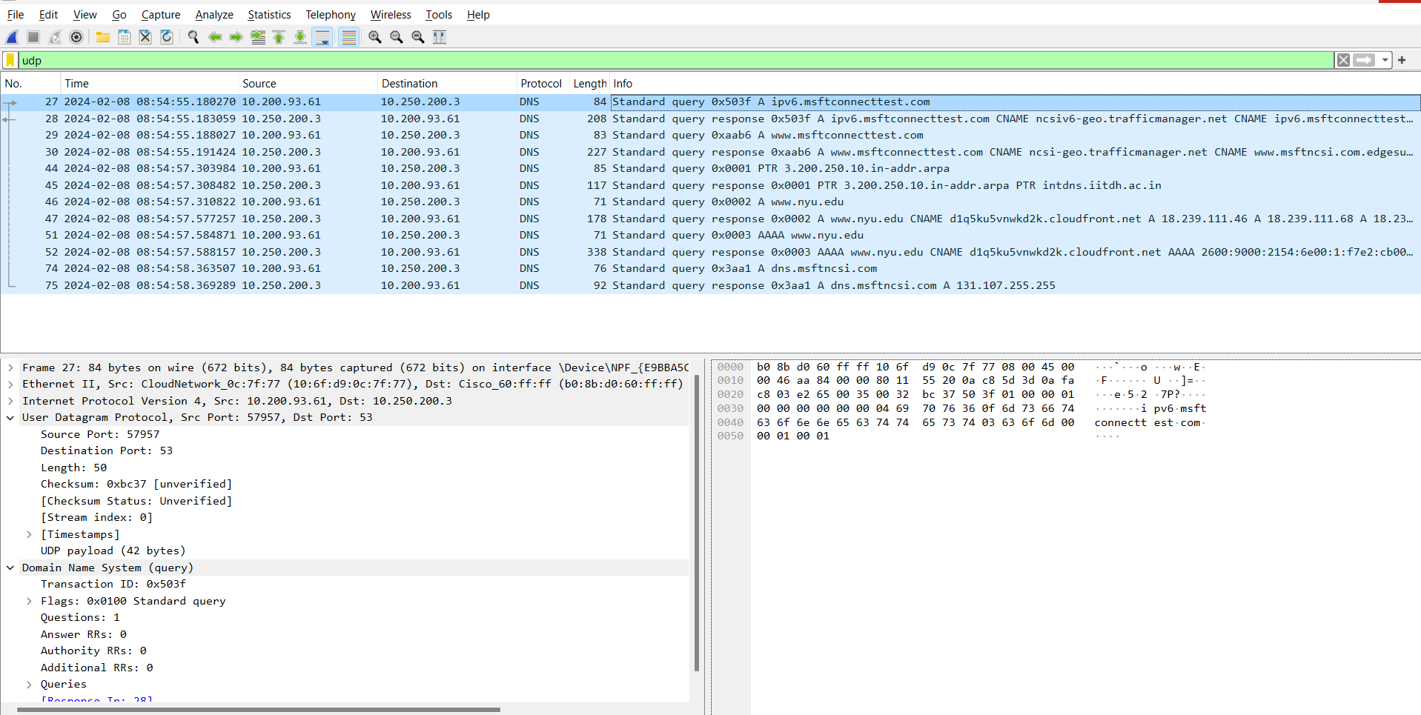

Q2] By consulting the displayed information in Wireshark’s packet content field for this packet, what is the length (in bytes) of each of the UDP header fields?

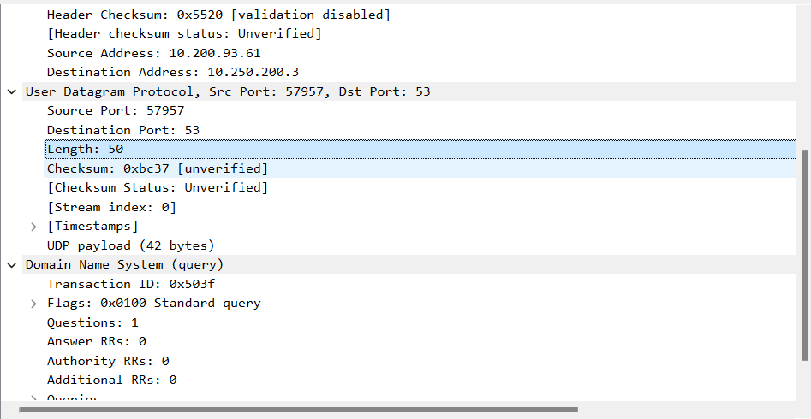

A] The UDP contains 4 headers of total length = 8 bytes therefore each will be of length = 2 bytes. This is always fixed.

Q3] The value in the Length field is the length of what? Verify your claim with your captured UDP packet

A] The Value in length field is the length of Payload + Headers that is sent in through the packet. This can be seen from Q2 screenshot.

45+8=53 total length displayed in screenshot

Q4] What is the maximum number of bytes that can be included in a UDP payload? (Hint: the answer to this question can be determined by your answer to 2. above)

A] UDP Segment header length = 32+32 = 64 bits

1 bytes = 8bits, therefore 8 bytes is length of the header field.

Clicking on length field in Wireshark gives 2bytes = 16bits.

Total Length = 2^16-1 = UDP payload + UDP header

UDP payload=(2^16-1)bytes – 8bytes = 65535 bytes – 8 bytes = **65527 bytes.**

Q5] What is the largest possible source port number? (Hint: see the hint in 4.)

A] source port number is 2 bytes field = 16 bits therefore largest possible source port number = **2^16-1 = 65535**

Q6] What is the protocol number for UDP? Give your answer in decimal notation. To answer this question, you’ll need to look into the Protocol field of the IP datagram containing this UDP segment.

A] In the IP Datagram protocol field the length of UDP can be seen as 1 byte corresponding Hexadecimal notation is represented in the right side of screen as **11**(Hex value) this converted to Decimal gives **17.**

Q7] Examine the pair of UDP packets in which your host sends the first UDP packet and the second UDP packet is a reply to this first UDP packet. (Hint: for a second packet to be sent in response to a first packet, the sender of the first packet should be the destination of the second packet). What is the packet number of the first of these two UDP segments in the trace file? What is the packet number of the second of these two UDP segments in the trace file? Describe the relationship between the port numbers in the two packets.

A] The request is in Packet with frame number 27 and the response is in packet with frame number 28. The source and Destination ports in response packet are reversed as that of the previous packet(request).

